Student ID: |  |  | Student Name:
Subject code & Name | : | ITUE301 - AWDF | Practical | : | 8 | Academic Year | : | 2025-26

Task - 8: Performance Optimization and Lazy Loading in React
Aim
To improve frontend performance using route-based code splitting with React.lazy() and Suspense fallback UI, reducing initial bundle size and downloading chunks on-demand.
Code
(Paste your GitHub Repository Link – Practical Wise)
GitHub Repository Link (Main): https://github.com/TheNameIsVishvesh/AWDF_PRACTICALS
Practical 8 Direct Folder Link: https://github.com/TheNameIsVishvesh/AWDF_PRACTICALS/tree/main/Practical-8
Output
8.1 Initial Bundle Loaded on Home Route without Heavy Chunks:
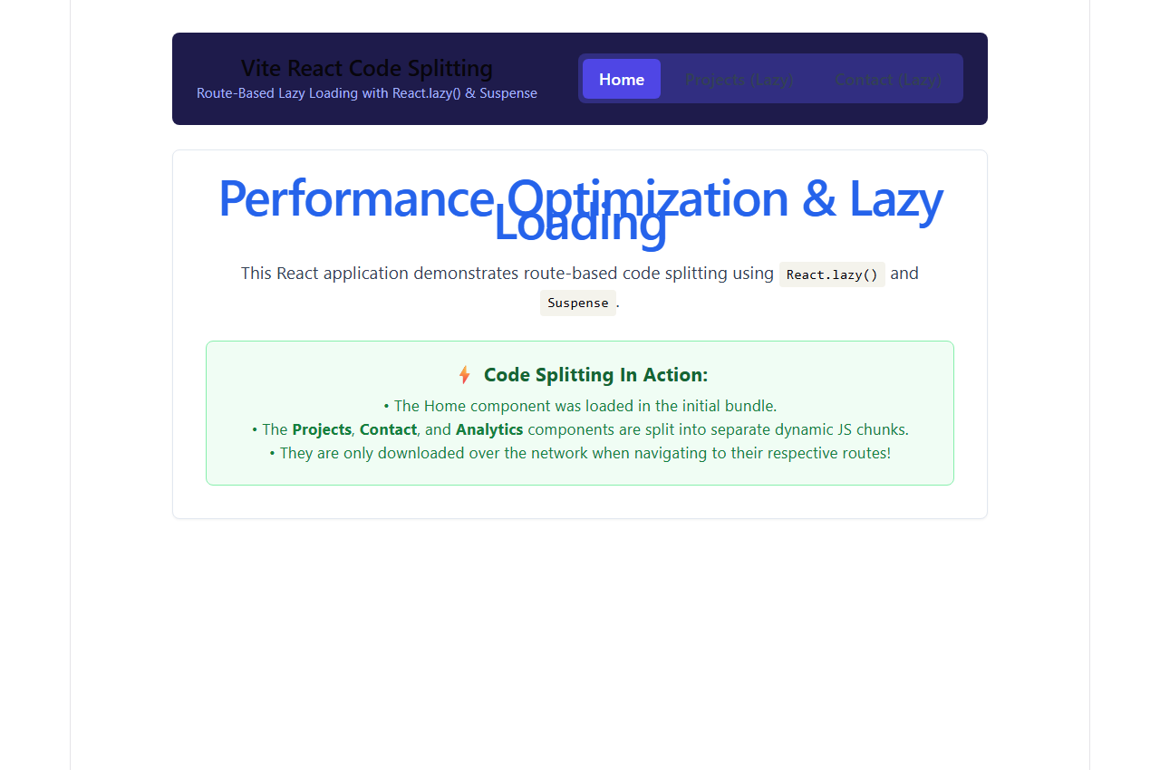
8.2 Dynamic Projects Chunk Downloaded On-Demand via React.lazy():
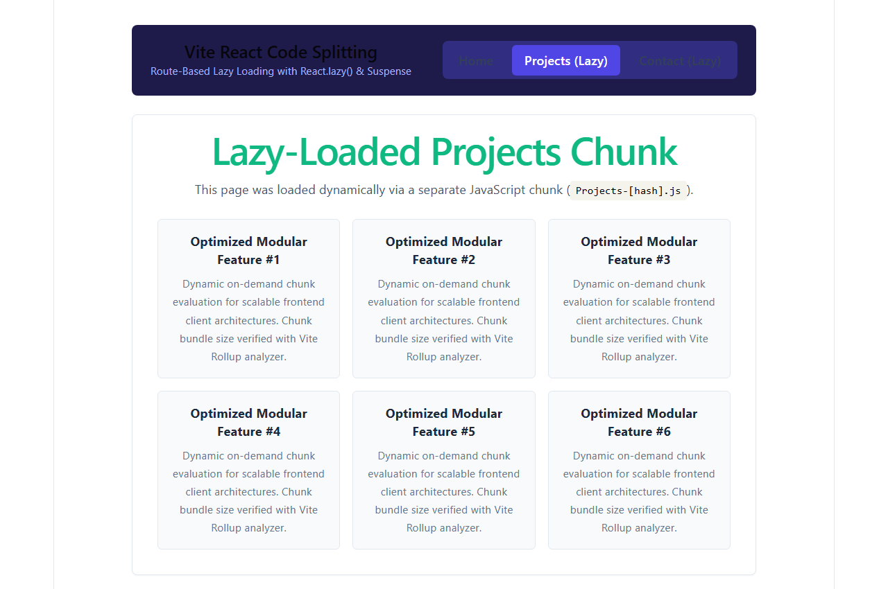
8.3 Dynamic Contact Chunk Downloaded with Suspense Fallback:
