CS3365 — Software Engineering
Team Project — Phase 2
Lottery Purchase System (LPS)
Texas Lottery Commission
Team 9
Maya Sulay Hattarki
Shadman Samir
Jelena Veselinovic
Chekwube Stanley Ononuju
Josue Isabel Jimenez
Spring 2026 — Texas Tech University

1. Class Diagram
The class diagram below models the Lottery Purchase System using UML notation. User is an abstract base class with two concrete subclasses, Customer and Admin, each inheriting authentication attributes (email, passwordHash) and behaviors (login, logout) while specializing the operations they expose. Customers browse, search, and purchase tickets; Admins manage tickets and run drawings.
Order and PurchasedTicket form a composition hierarchy: an Order owns between 1 and 10 PurchasedTicket instances (per spec), and the PurchasedTicket instances cannot exist independently of the Order. Each Order is associated with exactly one Ticket type (Power Ball, Mega Millions, Lotto Texas, or Texas Two Step) and one PaymentMethod (PayPal, Venmo, or Bank Account). Draws are aggregated by Ticket — a single Ticket type accumulates many historical Draws over time — and each PurchasedTicket is evaluated against the Draw for its week to determine matches and winnings.
The EmailNotifier utility class is a dependency of User, invoked on registration confirmation and win notification. SystemStats is an access-controlled view that only Admin can retrieve. PaymentMethod and OrderStatus are modeled as enumerations to enforce a closed set of valid values, which matches the Phase 1 constraints.
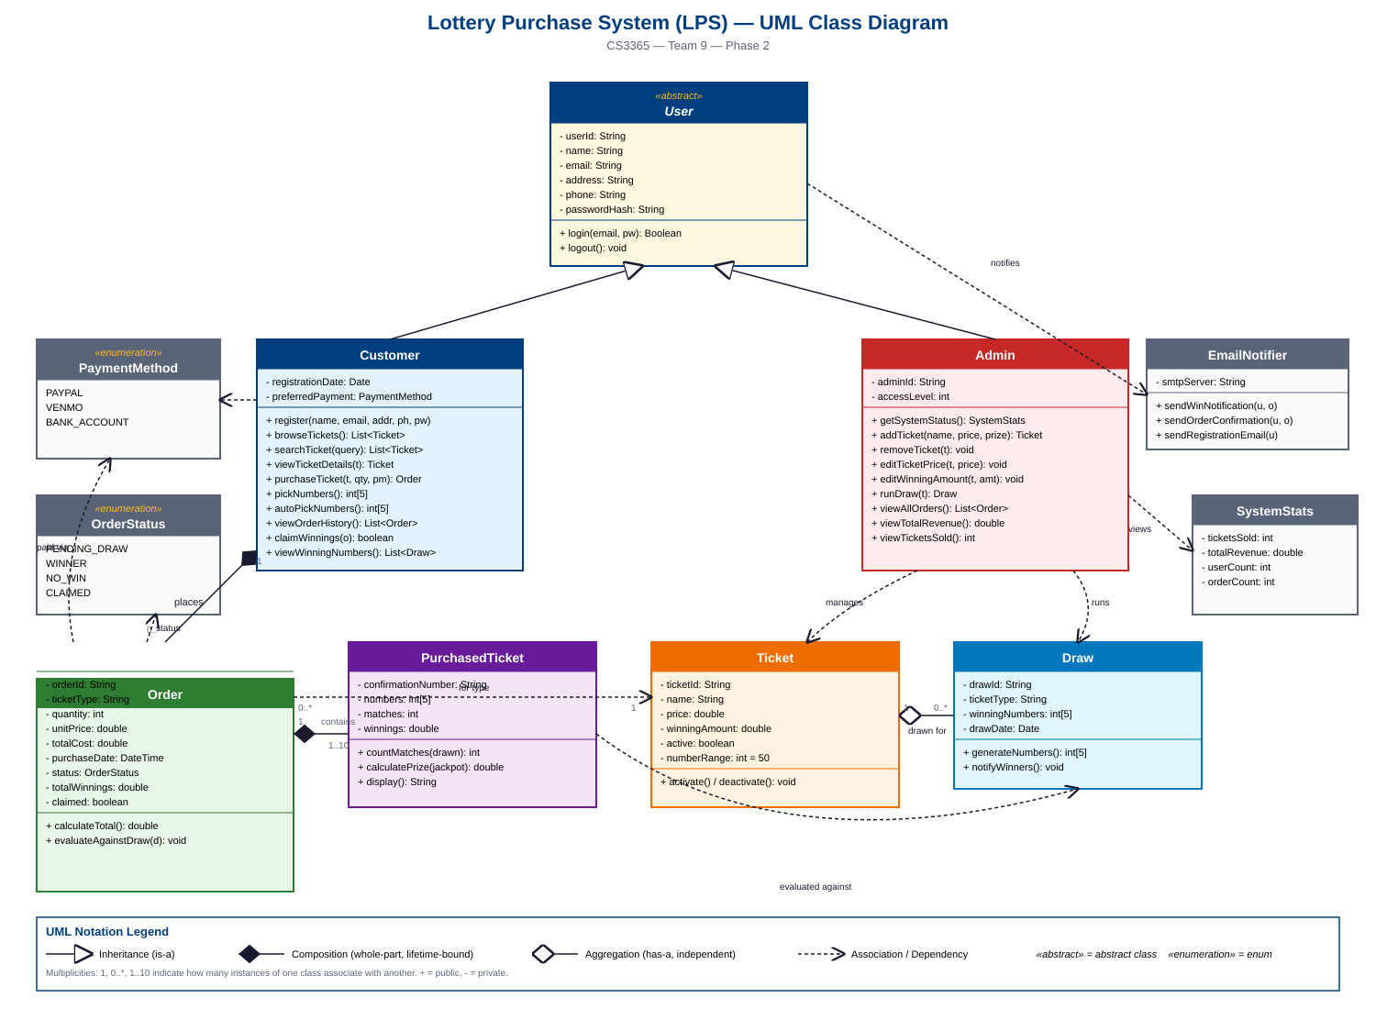

2. State Diagrams
The two most active objects in the Lottery Purchase System are the Order and the Ticket. The Order transitions through the most states during the system's normal execution path — from purchase, through payment, through the drawing cycle, and finally to claim. The Ticket has the longest-lived lifecycle from an administrative standpoint, moving through draft, active sale, scheduled draw, drawing, and eventual retirement. Each object is examined below with its own state diagram.

Object 1: Order
The Order object captures the customer-facing purchase lifecycle. It begins when a customer clicks Buy, moves through input validation and payment processing, waits in a PendingDraw state until the admin runs the weekly draw, and then is evaluated against the winning numbers. A guard on the match count determines whether it becomes a Winner or NoWin. Winners under $600 can be claimed online and deposited to the customer's payment method; winners of $600 or more must be claimed at a physical claiming center per the spec. Both claim paths lead to the final state.
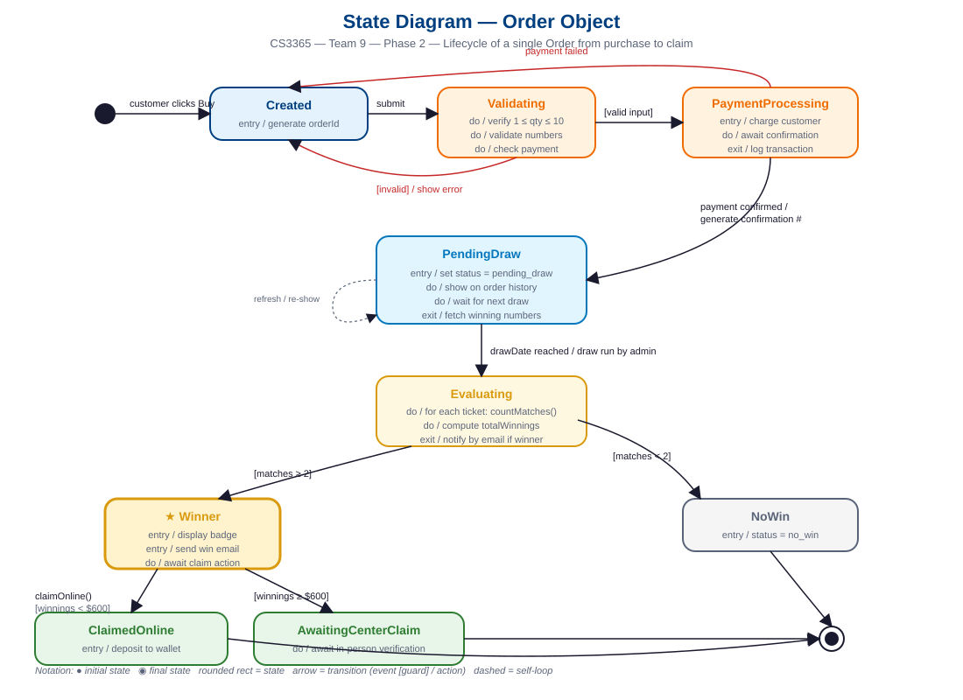

Object 2: Ticket
The Ticket object captures the administrative lifecycle of a lottery game offering. After the Admin creates a ticket in a Draft state (setting price, top prize, and rules), the ticket is published to Active, where it appears on the customer browse page and accepts purchases. Each weekly cycle drives the ticket through DrawScheduled and Drawing before returning it to Active. The Admin can Suspend a ticket (temporarily hide it without affecting existing orders) and later Reactivate, or permanently remove it to the Retired state, which preserves historical orders but prevents new purchases. Active is rendered with a thicker border because it is the dominant state — most tickets remain Active for their entire commercial life.
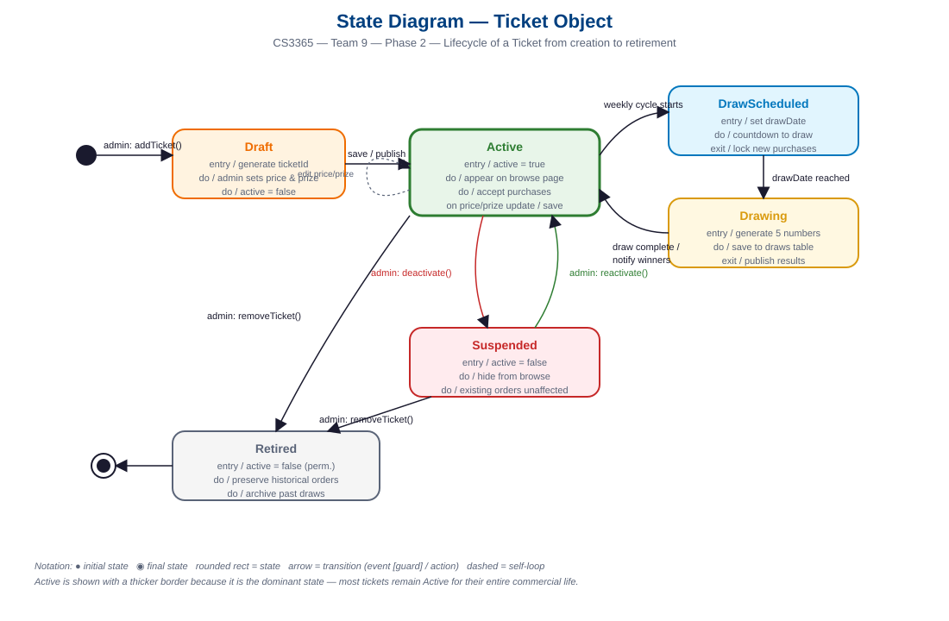

3. Working Program
The program is implemented as a Flask web application with a custom HTML/CSS/JavaScript frontend. It uses no third-party authentication, payment, or UI libraries — all core functionality is built in-house per the Phase 1 constraint. Data is persisted to a JSON file, so the system is fully self-contained and requires only a Python runtime and the Flask package to run.
How to Run
1. cd lps
2. pip install -r requirements.txt
3. python app.py
4. Open http://127.0.0.1:5000 in a browser.
Admin demo credentials: admin@lps.gov / admin123. Customer accounts are created via the in-app registration form.
Implemented Functionality
- User registration with name, email, address, phone, and password (in-house, no OAuth).
- Login and logout with session-based authentication and role-based routing (customer vs. admin).
- Home dashboard with navigation tiles to all customer-facing pages.
- Browse page listing all active lottery tickets with color-coded banner per ticket type.
- Search functionality that filters tickets by name from a single query parameter.
- Ticket detail page showing price, top prize, number range, next draw date, and prize-match table.
- Purchase flow supporting 1–10 tickets per order, per-ticket manual or auto number selection, and payment via PayPal, Venmo, or bank account.
- Electronic ticket generation with unique 8-character confirmation numbers per ticket.
- Order history page with Winner, Pending, and No-Win status badges, sortable by date.
- Order detail page showing matched numbers highlighted against the winning draw.
- Online claim flow for winnings under $600 that deposits to the customer's payment method; winnings of $600 or more are routed to a physical claiming center per spec.
- Winning-numbers page showing the latest draw across all ticket types.
- User profile page.
- Admin dashboard with live system status (tickets sold, total revenue, customer count, order count).
- Admin ticket management: add new ticket, edit price and prize, remove (deactivate) ticket — all through a dedicated graphical interface, no database access required.
- Admin draw management: run a new weekly draw for any ticket type, which updates winning numbers and re-evaluates pending orders.
- Demo-data reset button for re-running the walkthrough.
Video Demonstration
The team has recorded a video demonstrating each of the above functionalities in action. Each team member presents the section they authored. The video walks through registration, login, the full purchase flow (including manual and auto number picking), order history with winner detection, the online claim flow, and the complete admin suite including adding a new ticket and running a draw. The video link is included with the submission package.

4. Local and Global Impacts
Moving lottery ticket sales from physical retail to an online purchase system has meaningful consequences that extend well beyond the stated goal of reducing checkout lines. Our team considered these impacts along three axes: individual, organizational, and societal.
Impact on Individuals
The most significant individual-level impact is on accessibility. A digital-first system that is compliant with the Americans with Disabilities Act makes lottery participation possible for customers with mobility limitations, visual impairments (via screen reader support), and those living in rural areas without a nearby retailer. This is a net positive for equitable access. However, the same convenience that helps disabled and rural customers also dramatically lowers the friction for problem gamblers. A customer who previously had to drive to a physical store — a natural cooling-off period — can now purchase ten tickets in under a minute from their phone. Our system intentionally caps purchases at ten tickets per order as a mild guardrail, but a fully responsible implementation should add spending limits, cooling-off periods, and visible links to problem-gambling resources. We flag this as a known gap that a production version of LPS should close before deployment.
A second individual-level concern is data privacy. LPS stores home address, phone number, email, and linked payment accounts for every user. A breach would be materially worse than a retail breach because it ties financial accounts to gambling behavior. Even though we implemented in-house authentication with password hashing, a production system would need encrypted storage at rest, audit logging, and formal incident-response procedures.
Impact on Organizations
For the Texas Lottery Commission, the primary benefit is operational cost reduction. Retail commissions, physical ticket printing, claiming-center staff time for small prizes, and in-store reconciliation all decrease proportionally with online adoption. Our system's tiered claim flow — online deposit for winnings under $600 and in-person verification for amounts of $600 or more — aligns exactly with federal IRS reporting thresholds and preserves the existing tax-compliance workflow for larger prizes.
Retail partners who depend on lottery foot traffic, however, will see a negative impact. Convenience stores in Texas derive a meaningful portion of their secondary sales (snacks, gas, cigarettes) from customers who come in for lottery tickets. A shift to online purchasing reduces this foot traffic. The Commission should consider a hybrid model that preserves retail participation, perhaps by routing a portion of online purchases' revenue share to the customer's nearest registered retailer.
Impact on Society
At the societal level, lottery revenue in Texas funds public education. If LPS expands the purchasing base — reaching disabled, elderly, or rural customers who previously could not easily buy tickets — state education funding increases. This is the clearest net-positive societal outcome. Conversely, regressive-tax concerns intensify: lottery play is historically disproportionate among lower-income households, and an online system that makes purchasing frictionless will amplify that pattern unless responsible-play controls are built in.
Environmentally, the digital-first model eliminates the paper ticket stock, retail printing infrastructure, and customer travel associated with traditional lottery sales. Across a statewide deployment this represents a measurable reduction in paper waste and vehicle emissions.
Finally, LPS sets a precedent. A well-designed state-run online lottery can serve as a reference for how government digital services should handle authentication, payment, accessibility, and regulatory compliance (IRS reporting for $600-plus prizes). A poorly-designed one — one that neglects problem-gambling safeguards or accessibility — will be cited as a cautionary tale for years. Our team approached the design with full awareness that the decisions made in Phase 1 and implemented in Phase 2 have consequences far beyond a course deliverable.

5. Team Member Contributions
All five members of Team 9 contributed equally to Phase 2. The team met weekly to integrate work, review each other's contributions, and resolve integration issues collaboratively. Individual contributions are documented below.
Maya Sulay Hattarki | mhattark@ttu.edu
Work done: | Authored the UML class diagram using standard UML notation including inheritance (User → Customer, Admin), composition (Order → PurchasedTicket), aggregation (Ticket → Draw), associations, multiplicities, and enumerations. Verified the diagram against the Phase 1 specification to ensure every stakeholder-requested feature maps to a class, attribute, or operation. Authored the Class Diagram narrative section of this document. Tested the registration and login flows in the program.
Contribution: | 100%

Shadman Samir | ssamir@ttu.edu
Work done: | Authored the State Diagram for the Order object covering the full lifecycle from Created through PaymentProcessing, PendingDraw, Evaluating, Winner/NoWin, and claim states. Designed and implemented the Flask backend routes for the customer purchase flow including input validation, ticket generation with unique confirmation numbers, manual and auto number picking, and order persistence. Implemented the winner-evaluation algorithm that computes matches and applies the 100%/20%/5%/1% prize tiers from the spec. Authored the State Diagram narrative for Order.
Contribution: | 100%

Jelena Veselinovic | jveselin@ttu.edu
Work done: | Authored the State Diagram for the Ticket object covering the administrative lifecycle from Draft through Active, DrawScheduled, Drawing, Suspended, and Retired states. Implemented the admin backend routes for ticket management (add, edit, remove) and the draw management flow that runs new weekly drawings and re-evaluates pending orders. Implemented the admin dashboard statistics (tickets sold, total revenue, customer count). Authored the State Diagram narrative for Ticket and the Local and Global Impacts section of this document.
Contribution: | 100%

Chekwube Stanley Ononuju | cononuju@ttu.edu
Work done: | Owned the frontend in full. Designed and implemented the custom CSS design system (Texas Lottery color palette, typography, spacing, and component library) with zero third-party UI libraries. Built all fourteen Jinja templates: base layout with responsive navbar and flash messaging, authentication pages, home dashboard, browse and search, ticket detail, the interactive purchase page (including the dynamic JavaScript ticket-builder that toggles between manual and auto-pick modes and updates the total in real time), order history, order detail with matched-number highlighting, winning numbers, profile, admin dashboard, admin ticket management, and admin draw management. Implemented responsive breakpoints for mobile and tablet. Coordinated visual consistency across the customer and admin experiences.
Contribution: | 100%

Josue Isabel Jimenez | jim46965@ttu.edu
Work done: | Implemented the authentication backbone (registration, login, logout, password hashing with SHA-256, session handling, and role-based route protection). Designed the JSON data persistence layer and the seed-data generator. Implemented the order history evaluation logic that re-checks past orders against the current draw. Implemented the online claim flow including the $600 threshold routing to in-person claiming centers. Coordinated the team video recording and presented the admin functionality walkthrough. Authored the Working Program narrative section of this document.
Contribution: | 100%

