NMAP

Training Guide

Instructor: Travis Phillips
Date: 04/18/2020

Table of Contents
Section 1 – Overview of Document 4
Section 2 – Requirements 5
Section 3 – Installing VirtualBox 6
Section 3.1 – Adding the Oracle VirtualBox Repo 6
Section 3.2 – Adding Oracle’s Public Key to Apt 7
Section 3.3 – Updating Apt and Our Linux System 8
Section 3.4 – Installing VirtualBox via Apt 9
Section 4 – Configuring VirtualBox Host-Only Network Adapter 11
Section 5 – Installing NMAP, Help, and Setup 13
Section 5.1 – Installing NMAP 13
Section 5.2 – Getting NMAP Version and Help 13
Section 5.3 – NMAP Setup 13
Section 6 – Installing Metasploitable2 14
Section 6.1 – Downloading Metasploitable2 14
Section 6.2 – Extracting Metasploitable2 14
Section 6.3 – Adding Metasploitable2 to VirtualBox 15
Section 6.4 – Set VM to Use Host-Only Adapter 18
Section 6.5 – Getting the IP Address from the VM 19
Section 6.6 – Ping Metasploitable2 21
Section 7 – Verbosity and Output Formats 23
Section 7.1 – Verbosity Switch 23
Section 7.2 – Output File Formats 23
Section 7.2.1 – Normal (-oN) 23
Section 7.2.2 – XML (-oX) 24
Section 7.2.3 – Grepable (-oG) 25
Section 7.2.4 – All (-oA) 25
Section 8 – Host Discovery 26
Section 8.1 – Finding your Host-Only Adapter Subnet 26
Section 8.2 – Disable/Force DNS Resolution of Host 26
Section 8.3 – ICMP Ping & ARP Sweep Discovery 27
Section 8.4 – Skipping Host Discovery Entirely 27
Section 8.5 – Review So Far 27
Section 9 – TCP Scanning 28
Section 9.1 – Specifying Ports 28
Section 9.2 – TCP Connect Scan 28
Section 9.3 – SYN Scan (aka Stealth Scan) 30
Section 10 – UDP Scanning 34
Section 11 – Version Scanning 35
Section 12 – OS Detection 39
Section 13 - NSE (NMAP Scripting Engine) 41
Section 13.1 – High Level Overview of NSE 41
Section 13.2 – Script Categories 42
Section 13.3 – Running Scripts 43
Section 13.4 – Providing Arguments to Scripts 43
Section 13.5 – Getting Help on Scripts 43
Section 13.6 – Examples: SMB Enumeration 44
Section 13.7 – Examples: FTP Testing 47
Section 13.8 – Examples: distccd Vulnerability Scanning 48
Section 14 – Tie it all Together 49
Section 14.1 – Joining Scan Switches 49
Section 14.2 – The -A Switch 49
Section 14.3 – A Good Default Scanning 49
Section 15 – Zenmap 51
Appendix A – Further Reading 52

Section 1 – Overview of Document
This guide is provided as a companion to the training course present to the WSC on 04/18/2020. This document aims to provide the attendees with:

- Information about NMAP
- Instructions on how to install VirtualBox, and install and configure a Metasploitable2 VM as a target.
- Labs for students to experiment with via Metasploitable2 to learn more about NMAP.

The other purpose of this document is to provide a detailed guide of what’s covered in the course as a take home guide. There is a lot of content in the training course, and it maybe difficult to take it all in at the time its presented. However this guide will help you build a lab and provide exercises the reader may conduct in their own time later when they are ready to continue.

Section 2 – Requirements
The lab assumes that students have a laptop with some sort of Debian based system installed natively on it. The author of this document is using Debian 10. However it is worth noting that other Linux-based systems; such as Ubuntu, Kali, or Mint; should all work for these labs, however it should be observed that using those systems might have some hang-ups that the reader would need to troubleshoot to proceed. If in doubt, use Debian for the labs, as it mirrors what the author used. However Kali should also work smoothly and save you some time with installing NMAP as it is installed by default.

The laptop you use, should also have enough memory to run the Metasploitable2 VM. This VM was designed to be fairly light and has no GUI running. This allows this VM to run fairly smooth with about 512 MB of RAM. You should also consider the needs of the host OS into your RAM requirements. A machine with about 4 GB of ram should be able to execute these labs. The more RAM available, the better.

Section 3 – Installing VirtualBox
These instructions are written assuming the reader is using a Debian based system and follows the guide provided by Oracle at https://www.virtualbox.org/wiki/Linux_Downloads. The section below explains how the author setup VirtualBox 6.1 on his machine, which was running a amd64 build of Debian 10 using the KDE Plasma Desktop Environment.

Section 3.1 – Adding the Oracle VirtualBox Repo
The first thing that needs to be done is to add Oracle’s VirtualBox Repo to the system repo list. This will make it easier to install VirtualBox using the built-in package manager in our Linux system, which in the case of Debian is called “Apt”. This will also aid in keeping the software up to date anytime updates are run through the package manager. Apt works by maintaining a list of “repos” or “repositories”. These repos provide packages that can be downloaded and installed to the system, as well as updated later. Apt refers to these as “sources”

These sources are stored in a file at /etc/apt/sources.list. To edit this file you will need to be the root user, which is the main admin account on a Linux-based system. In a terminal, you can run a program as root by using the sudo command, or us su - if sudo isn’t setup. To edit this file we will use the following command:

sudo nano /etc/apt/sources.list

This should open up the file for edit in Nano, which is effectively a text editor for the command line. At the end of the file, we will add the following line for our system:

deb arch=amd64 https://download.virtualbox.org/virtualbox/debian buster contrib

The screenshot on the next page shows what this should look like. After that line is added, hit Ctrl+O to save the file, followed by Ctrl+X to exit Nano.

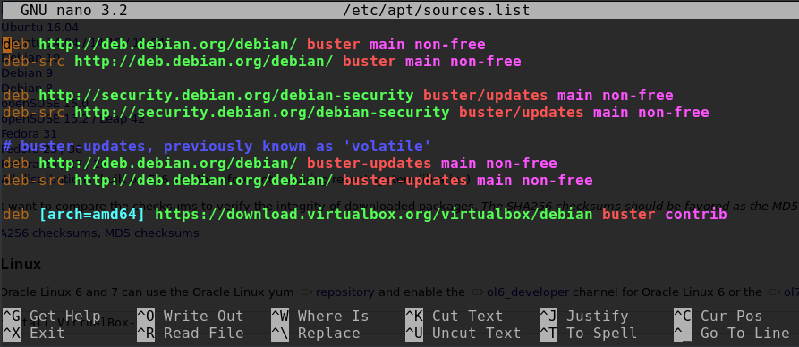
At this point you have added the repo to the list. However we will also need to add Oracle’s public key to our system. This key is used for signature verification of the packages to ensure they haven’t been tampered with in transit, such as via a man-in-the-middle attack. Trying to use apt right now will error out since that key isn’t installed. The next section will cover setting that up.

Section 3.2 – Adding Oracle’s Public Key to Apt
The next step is to add Oracle’s Public Key. This can be accomplished by running this one-liner, or two separate commands:

wget -q https://www.virtualbox.org/download/oracle_vbox_2016.asc -O- | sudo apt-key add -

or

wget https://www.virtualbox.org/download/oracle_vbox_2016.asc;
sudo apt-key add oracle_vbox_2016.asc;

The screenshot on the next page shows the two separate commands being executed.
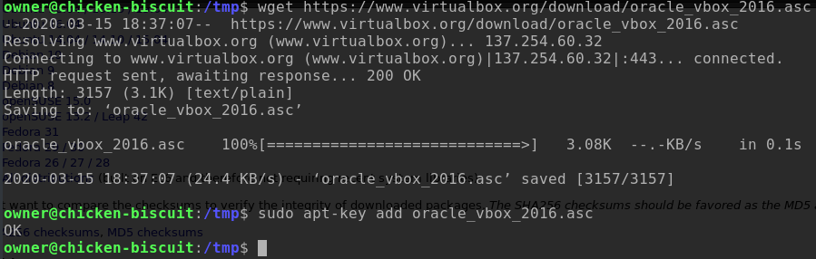
The important part is that you see “OK” on that second command. Next we will cover running an update on Apt to tell it to pull the list of available packages from the repo. This will enable apt to know the VirtualBox package is available for download. We will also update our system via the apt as well, since its a good idea to do so before we proceed to install VirtualBox.

Section 3.3 – Updating Apt and Our Linux System
The next step is to update Apt so it knows what packages are available. This can be done by simply running the command:

sudo apt update

The screenshot below shows what the output from this command will look like.

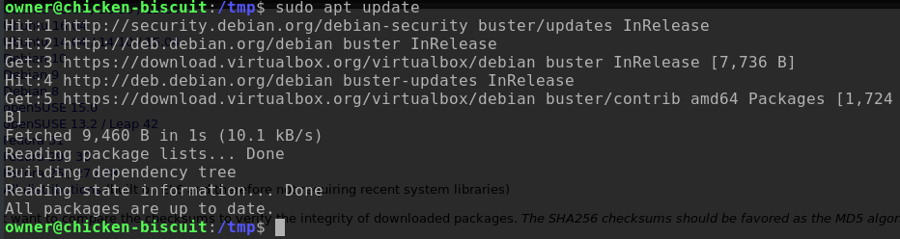

Next thing to do would be to update your OS via apt right now. This is done via the following command:

sudo apt dist-upgrade

It should ask you to confirm the updates, say “Y” to it and let it run it’s course to update your OS and installed packages. After that we can move on to installing VirtualBox!

Section 3.4 – Installing VirtualBox via Apt
Finally, we can install VirtualBox via apt. To do this, simply run the following command:

sudo apt install virtualbox-6.1

It should ask you to confirm what you are installing, say “Y” to it and let it run. Once it is done, you should have VirtualBox 6.1 installed. On my system, it shows up under the menus Applications > System as either “Virtual Machine” or “VirtualBox”. The great thing about this is anytime you run a dist-upgrade in the future with apt to install updates, VirtualBox will be updated as well. At this point, go ahead and start VirtualBox and you should see a screen like the one on the next page. This will be a great time to go ahead and configure a host-only network adapter, However you will need to reboot before configuring that. Just make sure it can launch at this point.

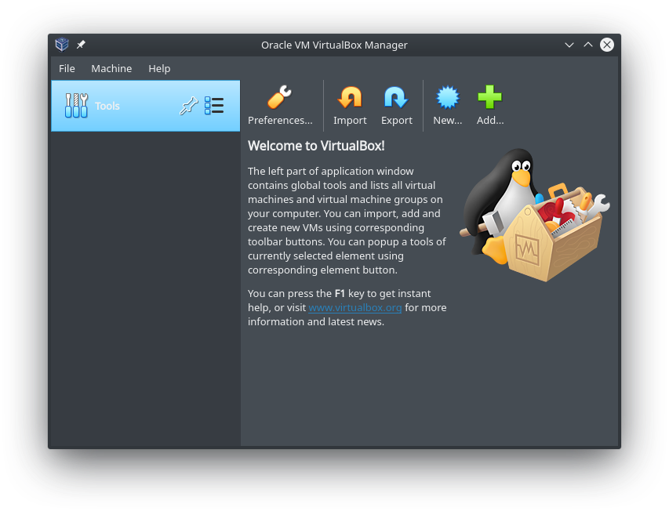

Section 4 – Configuring VirtualBox Host-Only Network Adapter
Now that we have VirtualBox installed, let’s go ahead and configure a host-only network adapter. This is a good idea, especially in a lab environment. This will create a network interface the Metasploitable2 VM can use, that can only talk to you machine. This will ensure it has no internet connection, and that no one else on the LAN can talk to your VM; just you. We will want to do that with Metasploitable2 as it is a vulnerable system, by design, to practice hacking on. If this machine is exposed to others, it will likely get pwned. While it is a VM, it is worth noting that caution should be taken with VMs as from time to time exploits come to light, known as VM escape exploits, that enable an attacker to jump from the VM to the host machine. Therefore, it is a good idea to keep the VM isolated from possible hostile network traffic.

Also, please ensure you have rebooted the machine since installing VirtualBox, or this next step will error out.

In the Virtual box window, you will notice a list item titled Tools, and on the right side of the list item is a small button with a few blue boxes and lines, click it and select “Network” .

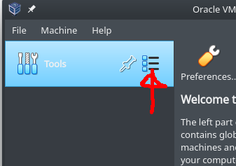

After you have clicked that, the right side of the window should have changed and should show a virtual network adapter screen, Click on the button at the top that looks like a network card with a green plus sign on it. It should automatically add the host-only adapter in as vboxnet0. The screenshot below show what that looks like if it was successfully added. If you get an error, please ensure you rebooted your machine since the setup.

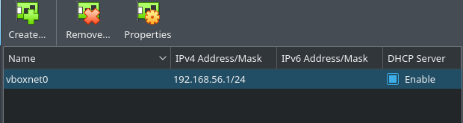
That’s it! You’ve created a host only adapter. Take note of the value of the “IPv4 Address/Mask” field, as this is the IP address and subnet of your host only adapter network.

Section 5 – Installing NMAP, Help, and Setup

Section 5.1 – Installing NMAP
If you are on Kali Linux, you may skip this sub-section and proceed to the next sub-section below. If you are on Debian or Mint, you will need to install NMAP, however this is trivial via the Apt utility. Just run the following command:

sudo apt install nmap

Section 5.2 – Getting NMAP Version and Help
Now that we have it installed, Let’s log the version number and information below.
Exercise: Run nmap --version or nmap -V. Log the output below.

Next, Let’s grab the help output below as well. This will be a pretty large amount of text.
Exercise: Run nmap --help or nmap -h. Log the output below.

Section 5.3 – NMAP Setup
Since we will be logging files and such, let’s go ahead and setup folder to work from. For this purpose, we will create a folder called wsc_nmap in the home directory. To create this folder run the following command.

mkdir ~/wsc_nmap

Going forward for all scans, please ensure you are in this directory by running the following command:

cd ~/wsc_nmap

Section 6 – Installing Metasploitable2
The next step to getting the lab setup is to install Metasploitable2 into VirtualBox. This will involve a few things, so we will break it down into a few steps. The first thing we need to do is download it.

Section 6.1 – Downloading Metasploitable2
It is the hopes of the author that students in the class have this downloaded in advanced. However if not, or if you are following along after the class, the file is downloaded from its project page on Sourceforge at https://sourceforge.net/projects/metasploitable/files/latest/download. The download is about 825 MB.

Once you have it downloaded, there are a few more things that need to happen. We will need to unzip it, import it, and setup it up to use the host-only adapter. These steps are covered in the next few sub-sections.

Section 6.2 – Extracting Metasploitable2
The download should have come in as a zip file. It needs to be extracted. In most Linux systems downloads will go to the folder ~/Downloads/. From a terminal we can extract it by running the following commands:

cd ~/Downloads/
unzip metasploitable-linux-2.0.0.zip

This process, will take a minute or so depending on your system specs. The next page has a screenshot of what you should see in your terminal. The finally location of the VM should be at ~/Downloads/Metasploitable2-Linux/. Next we will cover how to import this into VirtualBox.
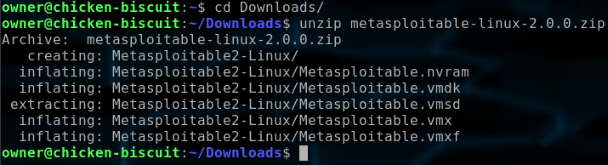

Section 6.3 – Adding Metasploitable2 to VirtualBox
This part requires a little bit of a side channel when being done, as Metasploitable2 was made for VMware, so make sure to follow the instructions here. First on the main window of VirtualBox, if you are still in the Network screen, click on “Tools” on the left list again, and click on the little icon on the right of the list item with the blue boxes and lines and select “Welcome” from that menu that pops up. Now the pane on the right will change back to the welcome screen, click on “New” at the top.

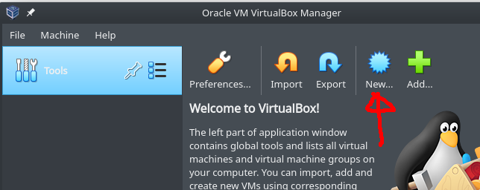

Next, It will bring up a “Create Virtual Machine” dialog, name it *EXACTLY* “Metasploitable2” without the quotes, the screenshot below shows an example. And for the OS select “Linux” and “Ubuntu (32-bit)”. Click “Next >”.

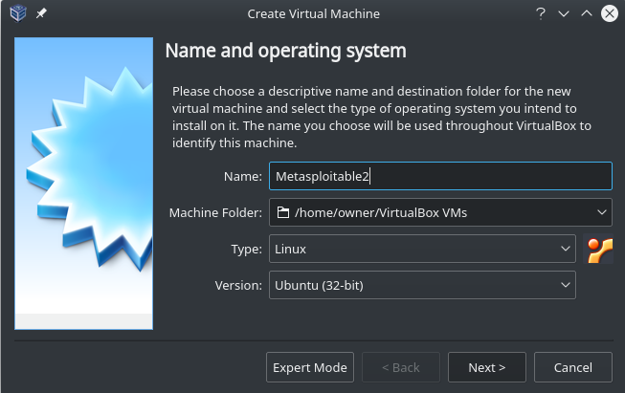
Now it should show the Memory Setting dialog. It should default to 1,024 MB. If you have enough RAM you can leave it there, or turn it down to 512 MB if you want to run leaner. Click “Next >”.

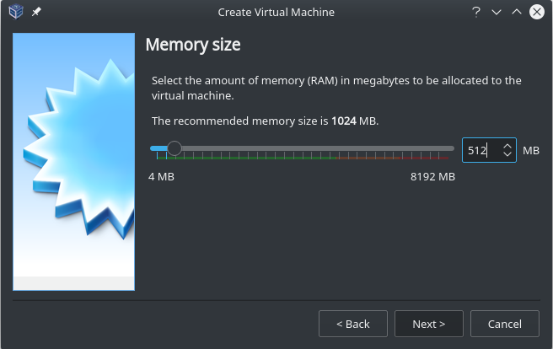
Next, comes the hard drive dialog. This is where the side channel stuff comes in. We will need to select the “Use an existing hard disk file” radio button. At this point, we need to launch a terminal and move the hard disk image to the folder VirtualBox is setting up for this machine. Launch a terminal and run the following command:

cp ~/Downloads/Metasploitable2-Linux/Metasploitable.vmdk ~/VirtualBox\ VMs/Metasploitable2/

Once you have done that, return to the hard drive dialog in VirtualBox and next to the entry box under the radio button we selected, there is a small “choose a file” icon button. Click on that.

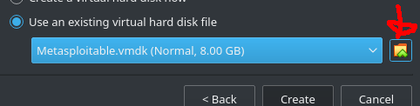

A hard disk Selector dialog will appear. Click the “Add” button on the top, and select the Metasploitable.vmdk file that is under ~/VirtualBox\ Vms/Metasploitable2. Once that has been added click “Okay”

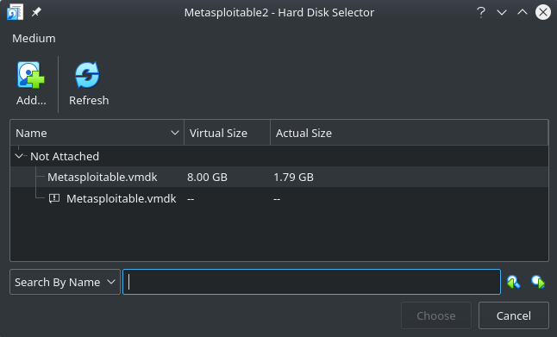
After that, you should be back at the Hard Drive dialog, click on “Create” and you should have a new Metasploitable2 VM. However, before we launch it. We need to make sure we have set it up to use the Host-Only Network Adapter.

Section 6.4 – Set VM to Use Host-Only Adapter
Since we established that we want to use the Host-Only adapter, we need to configure it that way. By default, it will be configured for NAT. In the main VirtualBox window, we should see the new Metasploitable2 VM on the left side of the window in the list. Click on it. Now at the top you should see a settings button. Click on that.

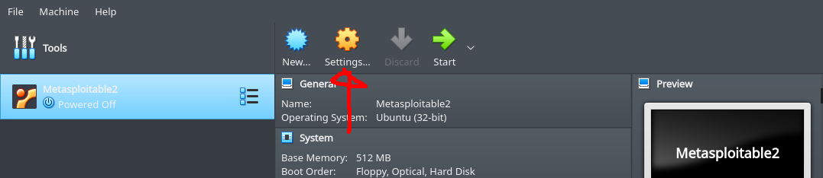
The Settings dialog should appear, on the left hand-side, click on “Network”. On the right side you should see an “Attached To:” option with a drop-down. In the drop-down, select “Host-Only Adapter”. A “Name” field should show up now and should already be populated with the name of the host-only adapter we created earlier. Click “OK” and you are done configuring the VM.

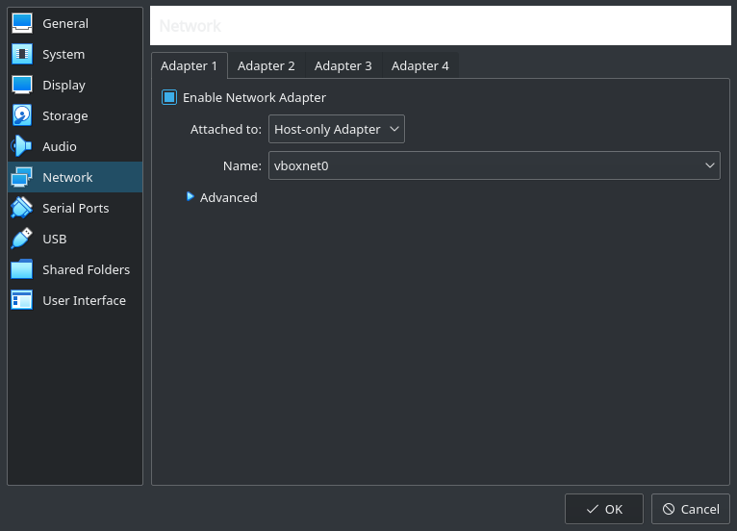

Section 6.5 – Getting the IP Address from the VM
Now is the time to start the VM since it’s all configured. Once in the VirtualBox main window again, click the Metasploitable2 VM in the list on the left and then at the top click the “Start” button.

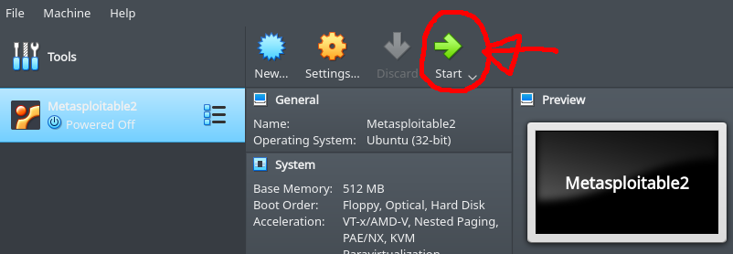

Once it is up and running, it will display a console and there will be some text scrolling by. However it will eventually reach this spot where it will display a text banner like the one below and a login prompt.

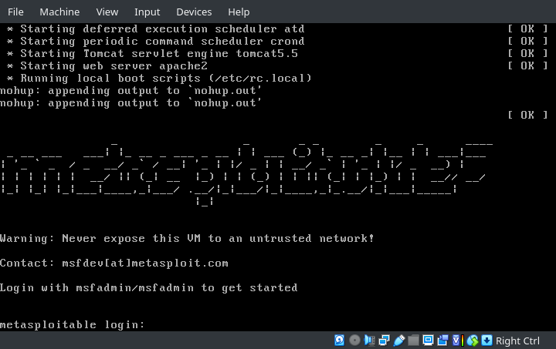
The default login to get into the machine is:

username: msfadmin
password: msfadmin

Login to the virtual machine and run the following command:

ifconfig eth0

This will get you the IP address of the virtual machine. Notice that the subnet (in my case, 192.168.56.101), matches the subnet of the host-only adapter (192.168.56.1) when you set it up.

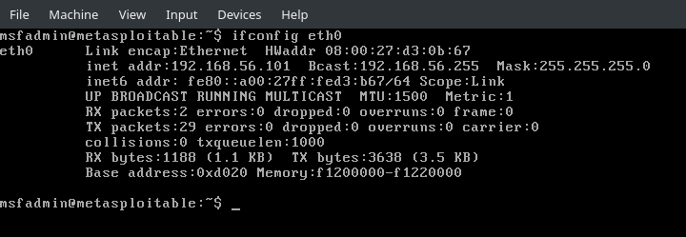
Exercise: What is the IP address of your Metasploitable2 machine?

Section 6.6 – Ping Metasploitable2
The last thing we want to do is test and ensure that we can ping the machine. Open a terminal on your host machine and run the following command:

ping -c 4 [IP_ADDRESS_OF_VM]
If it works, you should see something like the following:

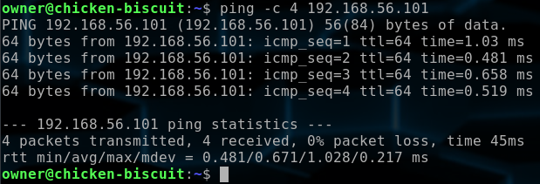
If you don’t get that sort of result, then troubleshooting is required. Check that the host-only adapter is setup properly, that the VM is setup in networking settings for the host-only adapter, and that the machine got an IP address in the subnet range of the host only adapter.

Section 7 – Verbosity and Output Formats
Before we go any further, I wanted to take a moment to cover two switches which should almost be used universally in your commands you issue for the reset of the lab, as well in the real world. Personally, I feel these are extremely useful. The verbosity option gives you a lot more output in real time so you are more informed about what’s going on. The output file format options give you file logging in various formats.

Section 7.1 – Verbosity Switch
The -v[vvvv] switch is for verbosity. The letter v can be stacked multiple times to increase the verbosity level of NMAP. The higher the level, the more information that NMAP will output. I personally usually go with -vvv myself. This gives quite a bit of output, but at least you know exactly how the scan is going. I generally don’t worry about the amount of output it generates because at the end of the scan NMAP will dump a report of the results, but anything at level 4 or above will add to the report, like offline host. I would recommend trying out the various levels of verbosity as you run through these scans to see how it affects the output. I will recommend in the labs -vvv likely, however feel free to switch that up from time to time.

Section 7.2 – Output File Formats
The output switches allow you to log to different types of file formats. This is something you will almost always want to do, be it a penetration test or capture the flag event. The reason for this is two fold. Reason number one is timestamps. The second reason is to only have to (ideally) do the scan one time. This serves to help document your results and keep notes. Without this, you might forget something, and find yourself scanning the machine a second time.

Section 7.2.1 – Normal (-oN)
The normal output format would output to a filename.nmap file the same text you saw on your terminal. The syntax of that command is as follows:

-oN [outfile_path.nmap]

It will however add a comment at the top and the bottom of the file. The one at the top will show something like the following:

# Nmap 7.70 scan initiated Fri Mar 27 20:17:33 2020 as: nmap -sT -vvvv -p 1-1024 -oN test.nmap 127.0.0.1

That line provides us with quite a bit of useful information that’s worth logging. The version of NMAP is present, the time and date the scan was started, and the exact command that I was running. Keeping this file around can help. After that will be the same output you saw on your terminal. This is nice as we don’t need to use redirect or pipes here to log all this information. Finally, at the bottom will be a line like the on that follows:

# Nmap done at Fri Mar 27 20:17:33 2020 -- 1 IP address (1 host up) scanned in 0.10 seconds

This line tells us a few things. It tells us the time and date the scan finished, number of IP addresses scanned, The number of host up, and finally, the total duration of the scan. This is the most basic format to output and can have it’s uses. However I generally still prefer the -oA switch discussed later in another sub-section.

Section 7.2.2 – XML (-oX)
The -oX switch is used to generate a log file in XML. The syntax of that command is as follows:

-oX [output_filepath.xml]

While this isn’t the most usable to humans, it is easy to parse for machines. There are a few tools out there that can make use of the XML file. Metasploit can import it into the database connection using the db_import command in msfconsole. Zenmap, the front end GUI for NMAP can allow you to import the XML file and browse host and scan results in the GUI, which we will cover in a later section. But my personal favorite, is that you can use this file with the xsltproc to generate an HTML report of the XML file and view your results in a browser. The command to do that is as follows:

xsltproc [nmap_xml_file.xml] -o [out_file.html]

Once that command Is done, you should now have an HTML file as well and can view it inside a normal we browser. If the xsltproc command is missing, it can be installed from the repos in Debian or Kali using the following command:

sudo apt update && sudo apt install xsltproc

Section 7.2.3 – Grepable (-oG)
The grepable format isn’t a format I’ve found too useful in the past, but it is worth it to mention it here since the -oA switch will generate this file format for you. This is designed to be a format that can be easily parsed using the grep command. This could be used to help run a scan and parse the results within a bash script.

Section 7.2.4 – All (-oA)
The -oA script will output 3 separate files. One for the normal format, XML format, and grepable format. The syntax for this works as follows:

-oA [filename_prefix]

Notice how there is no file extension on the output filename here. This is because it will generate 3 separate files here which will end in *.nmap (normal), *.xml (XML), and *.gnmap (grepable). This is my usual choice for output files since it captures all of them. This offers the flexibility of having them all, and consolidates three separate command switches into a single switch.

Section 8 – Host Discovery
This section is designed to cover host discovery. This example will be fairly limited, due to the fact that we have only one target, and it’s on our Host-Only Adapter subnet. However, it is worth running through the exercise to make sure you understand how to execute host discovery. In the previous section, we logged in and got the IP address, which is great, as you know what it is and can cross reference your work here with host discovery and make sure its accurate. However, we will proceed in this exercise as if we don’t know that IP address, and that we have just connected to the Host-Only Adapter subnet, and are looking for a target without prior knowledge.

Section 8.1 – Finding your Host-Only Adapter Subnet
The subnet for the interface can be found where you set it up in the VirtualBox software as covered in Section 4. It can also be found in Section 6.5 in the output from the ifconfig output. Either way, the general default would usually be 192.168.56.0/24. You will want to find this information before continuing with this section.

Exercise: What is the IP subnet of the Host-Only Adapter Subnet provided by VirtualBox?

Section 8.2 – Disable/Force DNS Resolution of Host
There are times where you will want to disable or force DNS resolution of host. In the case of scanning the Host-Only Adapter network, it can be useful to disable it since there isn’t really a proper DNS in that network. DNS can be disabled with a -n switch. It can be forced with a -R switch. Using the verbosity can help here as well as it would tell you it’s on that step and if it appears to be hanging there, than it might be worthwhile to shut it off.

You can also also tell it to use alternative DNS servers, which can be useful on a LAN if you know there is an internal DNS server, it might be able to help resolve hostnames. That can be specified using:

--dns-servers <serv1[,serv2],...>

Section 8.3 – ICMP Ping & ARP Sweep Discovery
The -sn switch is used for host discovery sweeps. It will do ICMP pings if the user isn’t root, and ARP request if the user is root. The reason for it is that the ARP packets have to be forged. ARP is often more reliable as some host-based firewalls block ICMP pings. However, most firewalls don’t block ARP packets as it’s used for routing, so it’s recommended to use it if possible.

The following exercise will be to do a discovery scan of the Host-Only Adapter subnet and find our metasploitable2 box and generate some report files for it. Remember in the last exercise you found the subnet, you will need to craft a command to run this action, there is an example command that would do a host discovery scan on the 192.168.56.1-254 class C subnet below. Attempt to do this exercise now, and when complete, check if it matches the IP address you found in section 4 when you ran ‘ifconfig’ on the metasploitable2 terminal. Also ensure you are in your ~/wsc_nmap/ directory so the output files will be logged there.

Exercise: Do a Host Discovery Scan of the Host-Only Adapter Subnet.
Example: sudo nmap -sn -n -oA nmap_host_only_discovery_scan 192.168.56.0/24
Your Command:
[Place command output here]

Section 8.4 – Skipping Host Discovery Entirely
Sometimes a host may have a really well tuned firewall that blocks every discovery method. At this point NMAP will believe the host is down and will not scan it. In cases like this, there is a switch that will make NMAP skip the host discovery phase, and just assume the host is online. That switch is the -Pn. If used, NMAP will treat the host as though it were online.

Section 8.5 – Review So Far
So far, we should see what host exist on the Host-Only Adapter Network, and have found the Metasploitable2 machine. This allowed us to find our target. Moving from here, we will attempt to find what ports are open on the machine and begin cataloging those.

Section 9 – TCP Scanning
TCP ports generally make up for most network services on machines. These ports are also usually the fastest and easiest to scan. Therefore this should be the best place to start scanning. In this section, we will really be focusing on two types of TCP scans and try to establish good uses cases for each of them. The first is the TCP connect scan and the second will be the SYN scan.

Section 9.1 – Specifying Ports
Regardless of if you want to scan TCP or UDP ports, there is a switch to specify ports of -p. The -p switch is optional, if it is not provided, it will scan the “top 1000 ports” for whatever protocol you are scanning. Top ports refers to the top 1000 ports by popularity, not by number. This is a good default, but you can specify the ports you want to scan directly.

The -p switch can take parameters in a number of ways. You can comma separate them like “-p 22,80,443” to scan the ports 22, 80, and 443 only. You can also provide a range with a low-dash-high format like “-p 20-30” would scan all ports between 20 and 30. You can also combine these formats and add multiple one-off ports and ranges, as long as there are no spaces, like “-p 22,23,100-150,443,445,8080-8090” would scan port 22, 23, the entire range between 100 and 150, port 443 and 445, and the entire range between 8080 through 8090.

There is also one more format that will scan every single port which is to include a dash by itself without a lower or upper number, like so: “-p -” or “-p-”. This is my default choice as a pentester because it catches odd number ports or non-default ports. With TCP this doesn’t add much time to the scan of a single machine, However if you were scanning a whole enterprise, this could be costly time wise, so keep that in mind. The entire port range scan is also costly time wise on UDP, and often takes several hours to complete.

Section 9.2 – TCP Connect Scan
The connect scan is usually my default scan of choice. This scan doesn’t require root like the SYN scan does. It’s also extremely reliable since it actually just follows the protocol the way it’s supposed to be used by establishing a full connection to the service. If it reports that it’s open, you can be confident in that finding. That said it simply works by opening the connection, if it does it successfully, then it will report it as open, if it fails, then it could end up in possibly another status such as closed or filtered. The reason I usually default to this scan is almost all my test are announced test and as a result, I don’t need to be “stealthy” with scanning activities; I want speed and reliability.

TCP connection scans are ran with the -sT switch to activate it. If specified without a -p switch, it will scan the top 1,000 most popular TCP ports. In the next exercise, we will run two scans. One with the default top 1,000 ports, and one with all ports. This will allow the reader a chance to compare the difference in results, as well as a slight time difference (keep in mine the network is virtual, and is local to your machine with no real-world physical routing). We will also have it output results to a file as covered in Section 7, so make sure you are in the ~/wsc_nmap directory when you try these commands. Also make sure you adjust the IP address to match the IP address of your Metasploitable2 VM which you found in Host Discovery in Section 8.

Exercise: Do a TCP Connect Scan of the Metasploitable2 machine using no -p switch to scan the top 1,000 ports.
Example: nmap -sT -vvv -n -oA nmap_tcp_connect_top_ports 192.168.56.101
Your Command:
[Place command output here]

Exercise: Do a TCP Connect Scan of the Metasploitable2 machine using the -p- switch to scan all ports on the machine
Example: nmap -sT -vvv -n -p- -oA nmap_tcp_connect_all_ports 192.168.56.101
Your Command:
[Place command output here]

Question: Review the results between the scans. What was the timing for both scans? Which was faster?
Answer:
Question: The two scans should have found a different amount of ports open. Of these two scans, how many additional ports did the all port scan find over the top 1,000 scan?
Answer:

Section 9.3 – SYN Scan (aka Stealth Scan)
In the last section, I pointed out that the TCP connect scan is my default choice. There are times however where the SYN scan still has it’s uses. The SYN scan will create what is known as a half open connection to establish if a port is open or closed, but never finish the connection. It does this by sending a SYN packet to establish the connection, then get the response from the server, then send a RST packet to ensure the connection is never fully built. As a result, this requires packet forging and as a result, will require root permissions.

The reason this is called a “stealth scan” sometimes is because it often doesn’t leave a log result of the connection in the server application’s logging. This is because generally an application will use a function called accept() to listen for a network connection. This call is what’s known as a blocking call; that is that it holds the program there until it is finished its function. It’s function is to wait for an incoming connection to be established. In most software design, it would log the connection after accept() returns a client connection. However, since the connection is never established, it wouldn’t get logged, hence the name “stealth scan”. However in the real world, networking monitoring would still see this for what it is.

There is however still one good use I find in this scan that takes advantage of the above information. This is in scanning a one-time use port. Let’s consider the following. Pretend you found an exploit that allows you to run a bind shell payload. This payload will start a listener on a port you specified and once you connect it starts a shell and you may interact with it. Most of the time, these payloads are one-time use ports. That means once you have connected and disconnected, the port goes away, and likely, the service you exploited crashes, and you might not be able to get back in until the service is restarted.

If we scanned our bind shell port with a TCP connect scan, then it would go away before we can actually use it. However, if we used a SYN scan, it would still remain open for a connection, and we still were able to determine if it was opened or not. As such, I feel this would be a good exercise for this section. We should try this on our local machine using Netcat and a scan of the open port with both a TCP connect and SYN scan.

Netcat is regarded as the Swiss army knife of TCP/IP utility. It can connect to things, and also bind sockets, and even (possibly dangerously) execute a program and pipe it to the socket upon connection. Surprisingly, that has a lot of utility. You can use this to chat, send large files from one machine to another, and even use it to bind a shell or send a reverse connection shell to another host. In our case we will just have it bind a socket, but not spawn a shell. However the program is set to terminate by default once a single connection has been established and terminated. This means that our TCP connect scan in theory would kill it, where our SYN scan should not.

For this exercise, you will need to launch two terminals. We will call these Terminal A and Terminal B respectively. Terminal A will host our Netcat listener. Terminal B will be our scanner. First let’s setup that listener in Terminal A with the following command:

nc -nlvp 31337

That command will tell Netcat to listen (-l) on port (-p) 31337, with verbosity enabled (-v) and to not do reverse lookups on the connecting IP (-n). Having verbosity on will make it report on the command-line when a client connects. This will also help see that when the SYN scan doesn’t finish the connection and the TCP connect scan does. Once you run that command, you should see it show a message that says it is listening on 31337 now like the image below.

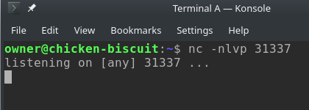

Now, let’s run our first scan against it from Terminal B using a SYN scan. We will also include the neighboring port 31338, which is closed as a reference and should report as closed. To do this, let’s run the following command:

sudo nmap -sS -vvv -n -p 31337,31338 127.0.0.1

This command requires sudo, but will tell NMAP to do a SYN scan (-sS) on ports 31337 and 31338 (-p 31337,31338) against 127.0.0.1 (127.0.0.1) without DNS (-n) and verbosity at level 3 (-vvv). The image below shows what the output would look like, and also show that Netcat doesn’t report a connection and still shows the port listening, yet NMAP shows it was able to determine that 31337 was an open port, and that 31338 is not.

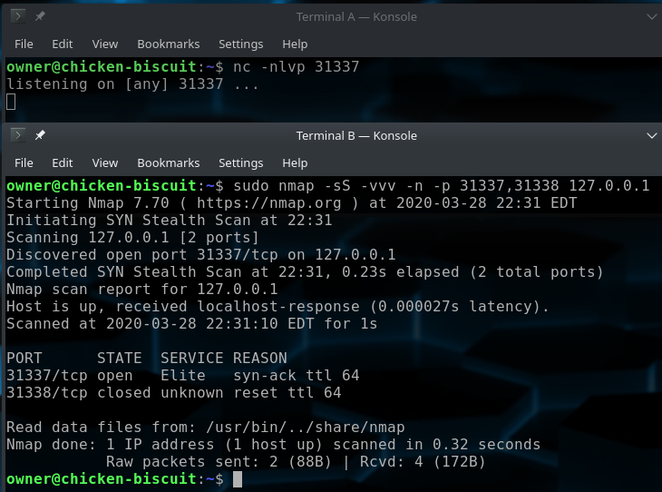
Now, let’s use Terminal B to run the same thing, but with a TCP connect scan, basically we will remove sudo, and switch out -sS for -sT. The full command will look like the following.

nmap -sT -vvv -n -p 31337, 31338 127.0.0.1

Ah, now we can see that Netcat saw the connection, and ended up closing down once NMAP closed the connection. The screenshot below let’s use see that in Terminal A at the top.

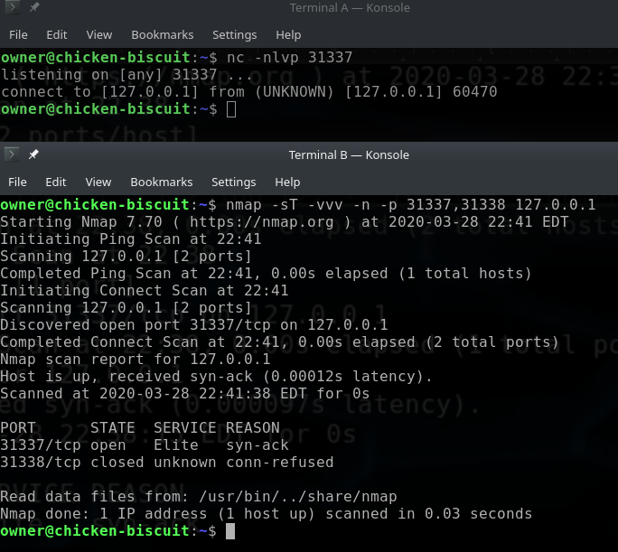
Now, run the same command again from Terminal B, and if you don’t restart the Netcat in Terminal A, it should be closed now.

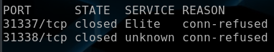

If you want to verify these results on the Metasploitable2 VM terminal, you can use the
netstat -nlt to see all open TCP ports on the system.

Section 10 – UDP Scanning
UDP is another common protocol that can be used in networking services. If differs in the fact that it is connectionless. Generally you just send a packet with data to and if the service understands it, you might get a response back. This actually makes scanning for UDP services a lot harder and slower as opposed to simply just connecting to it. However, sometimes this is worthwhile as sometimes these offer good services, such as DHCP, DNS, TFTP, NTP, VPN, or SNMP.

I generally do a full UDP scan on things when working. In a CTF or wargame, I generally skip it unless I get stuck on something and decide it times to return to enumeration because I feel I missed something. A full UDP scan of all ports on a machine can take hours. Most often, I see ~14 hours on these scans and heavy network loads can skew results. UDP scanning also requires sudo.

For this section, we will not be doing a full scan as an exercise in the class, however I would encourage trying it in your own time afterwards. For the class a limited number of open and closed ports will be provided to keep the range both small and interesting, and quick to scan. UDP scanning is done via the -sU switch.

Exercise: Do a UDP scan of the Metasploitable2 machine for ports 52, 53, 68, 69, & 111.
Example: sudo nmap -sU -vvv -n -p 52,53,68,69,111 -oA nmap_udp_ports_52_53_68_69_111 192.168.56.101
Your Command:
[Place command output here]

If you want to verify these results on the Metasploitable2 VM terminal, you can use the
netstat -nlu to see all open UDP ports on the system.

Section 11 – Version Scanning
Now that we know what ports are open on the machine (somewhat, given limited UDP scan), we might want to try to figure out what is running on those ports exactly. This is where version scanning comes in. Version scanning will attempt to send “probes”, which are little canned responses to the service. These probes are designed to get responses from various services. As a result, NMAP can determine what is running on a port based on those response, sometimes even down to the exact software and version. That said its worth noting that this requires connecting to the services and sending data, so you might as well skip a SYN scan if you are planning to use this, and it is highly recommended that you make use of version scanning.

Version detection is enabled with -sV. This can actually be combined on to the scan type switches. For example -sT for TCP connect scan can become -sTV instead, and will run a port scan and version scan. For this exercise, we will run a full TCP connect scan again, but this time with version scanning enabled. In the real world, you will likely default to just doing it that way, however this is all academic, so that’s why we have broken things out separately to learn the pieces standalone.

Exercise: Do a TCP connect scan of all TCP ports the Metasploitable2 machine with version detection.
Example: nmap -sTV -vvv -n -p- -oA nmap_tcp_version_scan_all_ports 192.168.56.101
Your Command:
[Place command output here]
Spend some time looking over these results. These alone give us a wealth of information. In fact with this new information, you might even see some services that make prime attack surfaces. This information is useful to pentesters because you can often search Google for the software and version with “exploit” or “vuln” or “cve” and possibly find exploits or security issues for it that have been reported publicly. Metasploitable2 is a VM that was vulnerable by design, and a little bit of time with it will result in some shells if you do your research right. For example let’s look at my results.

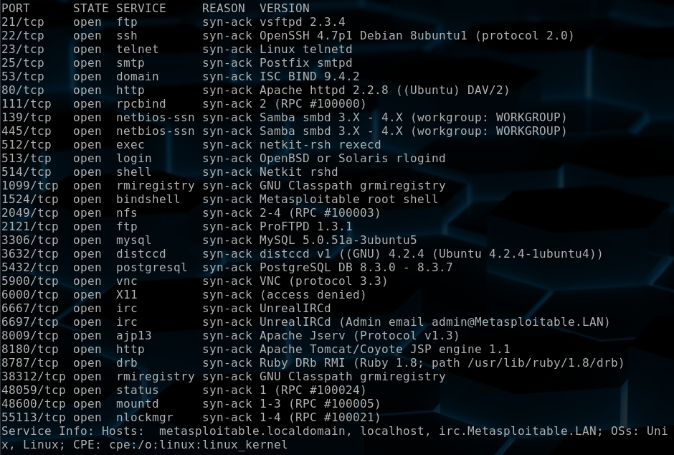
From these results we can already see some interesting stuff. For example, if found some possible hostnames for this machine that it carved out of the responses to the probes the version detection did. If you look at port 1524 on this scan vs previous scans, you can see it labeled it as “Metasploitable root shell”, this is literally a backdoor that will just give you a root shell for connecting to it (example: nc -nv 192.168.56.101 1524). A long time ago, this was obscured a bit, and wouldn’t have even showed up in a top 1,000 port scan, but NMAP reveals this one pretty easy now. We can also see port 3632 identified as distccd v1 4.2.4. A quick Google search of “distccd vuln” give us the following result.

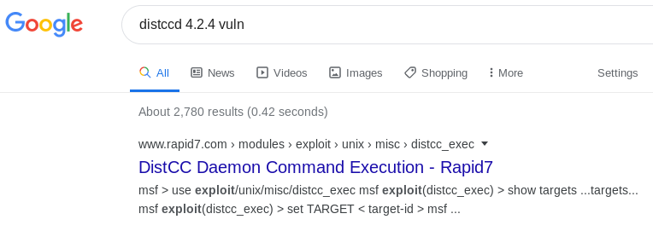
That first link is to Rapid7, the maintainers of Metasploit, an exploitation framework. It’s seems they have an exploit for this distcc daemon. If it exploits the version we have or not, well, more research is warranted. However, that would be a fine place to start looking as Metasploit modules will generally link to CVE’s or other resources about the vulnerability that it exploits. It might be possible this could get us a shell, and the exploit is already out there. Either way, I would probably add it to the list of top attack surfaces. In fact, we will revisit this service when we go into the section on NSE (NMAP Scripting Engine).

You could repeat this process for other exact versions of software that were detected and look for other promising attack surfaces if desired.

A word on the probes it sends. These are all sorted in a flat file on Debian under /usr/share/nmap/nmap-service-probes. This is a text file where data related to version detection is stored. The probes can have a one-to-many-hit relationship, and as such it works in the process of defining a probe, and then outline several possible response and what they mean. The list on the many possible response can get length, as such, they use comments to make it easy to find the start of the next probe in the format of:

##############################NEXT PROBE##############################

Writing probes and responses can take a little bit of effort to learn, but can be worth it since you could add your own to help identify services NMAP isn’t aware of, but you’ve learned how they work. It even supports regular expression syntax to allow you to scrape data from it and report it in the version results. For example, let’s look at the distccd example of how it identified distccd.

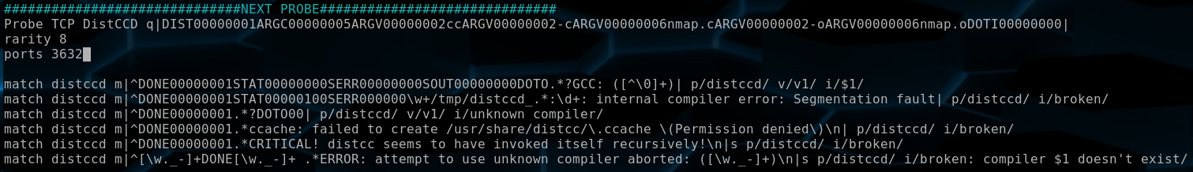
This may look like gibberish, but the probe is right under the comment line that starts with the keyword “probe”, it is the data that was sent to the service. The lines that start with “match” are possible responses that can identify what this is. You will see it in the format of:

match <identifier> m|[regex to match on]| <information to report>

Based on what we saw reported from the scan, and the format of the report and possible formatting reports from above matches. I assume the first line was matched. This is interesting because that means the 4.2.4 we saw it report, was actually the version of gcc installed on the machine. The $1 it used in the reporting information came from what is called a regex matching group from the match. This is the part between parentheses.

That’s a high-level overview on the matter, and as far as we will go into this since this would require a tutorial on regex and protocol analysis, and that’s beyond the scope of this document. But remember that NMAP is an open source tool, and this is a text file. Feel free to back up the file, roll up your sleeves, and tinker with it if you know something about a service that NMAP doesn’t! Worse case is you break the file and restore the original from backup.

Section 12 – OS Detection
OS detection is used ti try and identify the OS running on the target machine. NMAP generally does this in a few ways. The first and fuzziest is looking for small signatures in network responses. Various OS have small differences in their networking stack, often in the format of default packet options being somewhat unique to that OS or OS family. For example, the TTL value of a packet can give you a rough idea. In fact there is another tool outside of NMAP called p0f, which is “passive” OS detection, which just tries to identify host OS by listening to the network traffic. NMAP however is “active” in that it will send traffic to the host. As a result, this does require root permissions.

However NMAP will also take larger clues from version scanning as well, as some protocols will completely just tell you about the running OS. Like our version scan, many of the services would have the line “Ubuntu” appear in the version. That’s a really good hint. With that said, this also isn’t perfect, and while it can be helpful, ALWAYS TAKE OS DETECTION RESULTS WITH A GRAIN OF SALT.

In NMAP, OS detection is enabled using the -O switch (just to clarify, that is the capital letter O as in Oscar). This detection works best with version detection on, and also a few open and closed ports in your results (again, how an OS handles closed ports can be another tell). For this section, we will run a full TCP connect scan again, but make use of the -O flag as well. Make sure you are in your ~/wsc_nmap/ folder.

Exercise: Do a TCP connect scan of all TCP ports the Metasploitable2 machine with version and OS detection.
Example: sudo nmap -sTV -vvv -n -p- -O -oA nmap_tcp_os_version_scan_all_ports 192.168.56.101
Your Command:
[Place command output here]

Exercise: Login to the Metasploitable2 VM and get the real OS information using the following command.
Command: uname -a
[Place command output here]

Exercise: How close were the results of the OS detection results at the bottom of your scan, to the actual results reported by the OS. You should primarily focus on the kernel version.
[Place feedback here]

Section 13 - NSE (NMAP Scripting Engine)
Okay, there is a lot to cover here, and I will try to keep this section a little on the light side. NSE is the NMAP Scripting Engine. This is basically an engine in NMAP that allows you to provide LUA scripts to NMAP to increase it’s functionality. NSE provides an API to use information in the NMAP scanning results, and also help with common task. The increase in functionality can range from broadcast discovery, to information gathering, enhanced version detection, to brute force attacks against login, to vulnerability scanning. As a pentester or system admin, this is extremely useful as you could catch wind of a vulnerability in the wild, such as Heartbleed, and either find an existing script, or write your own, and scan your entire network for it and find systems that are subject to exploit.

In this section, we will set out to look at some of the basics of what NSE scripts are, how they are organized, how to invoke them, how to pass arguments to them. We will also look to use some of the non-default scripts to help enumerate services on this machine, and even confirm some of it’s exploitable issues.

Section 13.1 – High Level Overview of NSE
In the further reading section, there are a few links to the NSE documentation pages. These are suggested further reading. However this sub-section seeks to provide you with a 30,000 foot view of the system. NSE is a scripting system, and NMAP provides some scripts that are installed along side it. These system installed scripts are usually found under /usr/share/nmap/scripts/. These script files will end with the *.nse extension.

The scripts use a naming convention that can make it easy to find scripts related to a service. For example, we had some FTP services and might want to see what ftp services are available to us. The file naming convention is usually [service]-[scriptname].nse. So we could run a command like the following.

ls /usr/share/nmap/scripts/ftp*.nse

Running this will show something like the following:

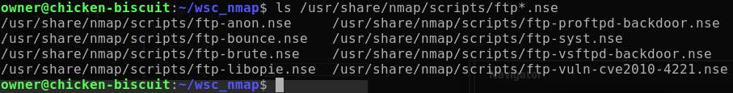
This is a list of the FTP scripts that are available to us from the base install of NMAP. We can already see some interesting scripts here popping up, like the vsftpd-backdoor script.

Section 13.2 – Script Categories
These scripts also support categories. These categories are designed to help us understand what the script is, and also we can invoke an entire category if we want to. However there are some provided categories by NMAP, and those should be noted. These are auth, broadcast, brute, default, discovery, dos, exploit, external, fuzzer, intrusive, malware, safe, version, and vuln. Details about each of those can be found at https://nmap.org/book/nse-usage.html#nse-categories.

This is also tracked by the file /usr/share/nmap/scripts/script.db. This is a text file that keeps a list of scripts in the /usr/share/nmap/scripts/ directory and catalogs the categories of each script. This allows us to invoke a category of scripts. There is a switch built right into NMAP that will update this DB if you manually install scripts later which is --script-updatedb. This will require root permissions to do.

You should also be mindful of these categories, as some of them such as dos, exploit, intrusive, brute, auth, vuln, & malware can all get pretty intrusive or crash systems. Again, remember to make sure you have permission to scan a machine before using these scripts, and also make sure you read the documentation on a script (and if possible, the code) to make sure you understand what the script is about to do, or attempt to do, to the remote system.

While there are these default categories, there is also nothing to stop you from creating your own categories as well when you make your own scripts. They can also be invoked by this category name assuming you put them in /usr/share/nmap/scripts/ and run the --script-updatedb update command before trying to use them.

Section 13.3 – Running Scripts
Scripts are invoked with the –script switch. It takes an argument which can be a direct path to a script file, a category of script in the script database, a path to a directory containing scripts, or just the name of a script in the /usr/share/nmap/scripts/ folder without the .nse at the end. You may also use a combination of these by separating them with commas (,) with no spaces between them; similar to combining ports. You may also use wildcards here as well, but I generally don’t recommend it because it will likely try to run a bruteforce or DoS script.

It is also worth noting that if a script fails, you can try troubleshooting with the -d switch, which enables debugging output. This works similar to the -v switch in that it can be stacked multiple times to increase the level of it for more output.

Section 13.4 – Providing Arguments to Scripts
Now that we know how to invoke scripts, it is worth noting that some scripts, may require arguments to work. For those scripts, you need to use the --script-args switch. This takes an arguments in key value pairs like ‘key=value’. You may comma separate multiple values.

Another option to provide arguments is using the --script-args-file, which allows you to pass it a file path of a file that has all the arguments in it.

Section 13.5 – Getting Help on Scripts
Most scripts contain some helpful information if the name isn’t enough to help. You can see this in NMAP by using the --script-help switch followed by the script in question. For example say we wanted to know more about the script “http-git” since that name is a bit short. We could run the following command:

nmap --script-help=http-git

NMAP will provide the following information to us.

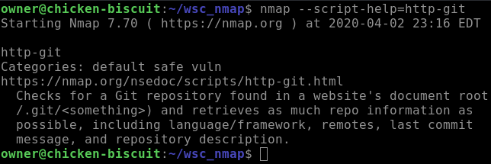
We can see the categories, a link to the NSE document page online for more information, and a quick summary of what this script would do. In this case, it checks if someone lazily cloned a git repo directly into the webroot and left the .git folder, which can usually be enumerated for useful information.

The other way to get help is via the NMAP NSE Documentation sit at https://nmap.org/nsedoc/ page which provides nicely formatted help, and sometimes even examples. It also allows you to browse by categories.

Section 13.6 – Examples: SMB Enumeration
We saw earlier that the Metasploitable2 VM had SMB services on port 135, 139, and 445 running a Samba server to provide them. This service is used to provide SMB and NetBIOS services that is common in Windows. This is what Windows uses to provide network file sharing. However this can be used for a lot more. NMAP has several scripts that can attempt to harvest information. In this sub-section, we will set out to look at what scripts are available to us, and how we can use them to obtain information. First let’s see what scripts are available to us.

Exercise: Run the command => ls -l /usr/share/nmap/scripts/smb-*
[Place command output here]

Exercise: Run the command => ls -l /usr/share/nmap/scripts/samba-*
[Place command output here]

On my machine, I got the following:

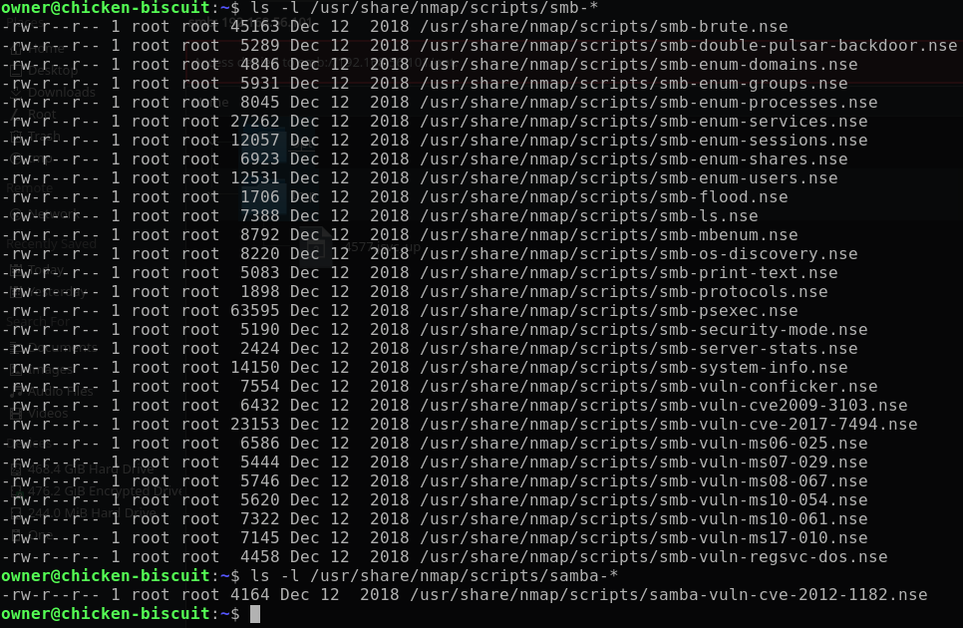
Personally, One of my favorite places to start with is the smb-enum-* scripts. These can usually generate a lot of useful information and due to the naming convention, be ran in one pass together. Let’s give that a shot now and review the results. Since these are for SMB, we can scan again, but only on ports 135,139, and 445. Also make sure you are in the ~/wsc_nmap/ directory as we will make sure to output this to a file.

Exercise: Run the smb-enum-* scripts against the SMB services on the Metasploitable2 VM.
Example: sudo nmap -sTV -vvv -n -p 135,139,445 --script=smb-enum-* -oA nmap_smb_enum 192.168.56.101
Your Command:
[Place command output here]

On my run, I had a few scripts that failed, but one stood out really well. That was the smb-enum-users script. It returned a full list of users on the system. A lot of them are service accounts, and show up with the flag “Account disabled”; these aren’t useful. However, there are a few that just show “Normal User Account”. Primarily are the user and msfadmin accounts.

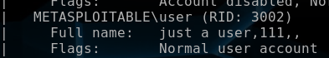

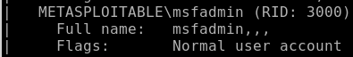

This effectively give us two valid usernames on the system and with a login being the username and a password, that’s half the battle already won. Next, let’s try the smb-os-discovery script.

Exercise: Run the smb-os-discovery script against the SMB services on the Metasploitable2 VM.
Example: sudo nmap -sTV -vvv -n -p 135,139,445 --script=smb-os-discovery -oA nmap_smb_os_discovery 192.168.56.101
Your Command:
[Place command output here]

From this scan, we gain even more insight. We already knew it was some sort of Debian/Ubuntu system, but it just told us the EXACT VERSION of Samba it is running.

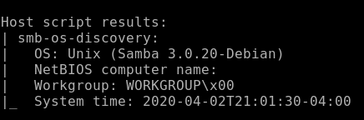

Knowing that information we can Google for known vulnerabilities for that version. I would highly recommend doing so, as Metasploit might be able to lend a hand here and get you a shell. You should also find several other CVEs for this version of Samba. Metasploit also has more enumeration tools that can help here as well that NMAP would have missed here.

Section 13.7 – Examples: FTP Testing
Metasploitable2 had two different FTP services on it. One was vsftpd and the other was proftd. The version information found in section 11 was enough that a Google search for that version would turn up interesting results. Specifically, vsftpd v 2.3.4. This version actually had a backdoor in it, that ended up making its way into the Ubuntu repos. NMAP has a script for testing for it. First let’s take a look at the FTP scripts NMAP offers.

Exercise: Run the command => ls -l /usr/share/nmap/scripts/ftp-*
[Place command output here]

On my machine, I got the following:

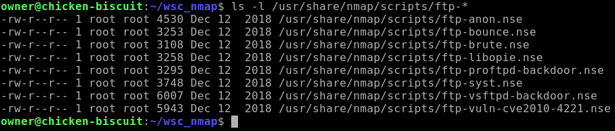
As we can see, there is a script there called ftp-vsftpd-backdoor. Let’s use that to test for the backdoor.

Exercise: Run the ftp-vsftpd-backdoor script against the vsftpd service on the Metasploitable2 VM.
Example: nmap -sTV -vvv -n -p 21 --script=ftp-vsftpd-backdoor -oA nmap_vsftpd_backdoor 192.168.56.101
Your Command:
[Place command output here]

This worked well on my run, and we can see it shows it as vulnerable. What’s really nice about this script is that in the “Exploit results” section, you can see it provides a proof that it got shell execution and ran the id command on the system. There are also links to the references of online reading material about this vulnerability.

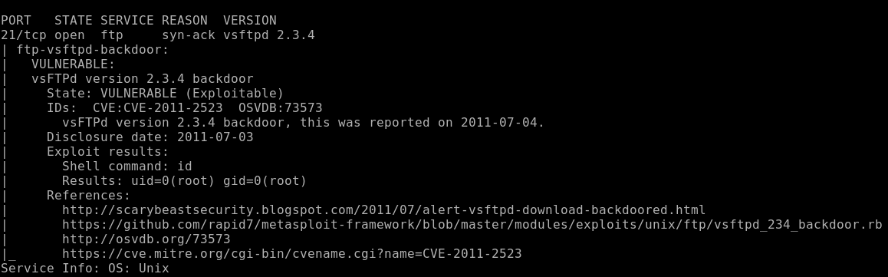

Section 13.8 – Examples: distccd Vulnerability Scanning
Earlier, we had discovered the distccd service, and did some research and hinted at it being an idea attack surface target. It’s time to test it via the NSE script. Running a search of the scripts for this one will only reveal the one script for testing for this one issue. So let’s run it.

Exercise: Run the distcc-cve2004-2687 script against the distccd service on the Metasploitable2 VM.
Example: nmap -sTV -vvv -n -p 3632 --script=distcc-cve2004-2687 -oA nmap_distccd_vuln 192.168.56.101
Your Command:
[Place command output here]

Section 14 – Tie it all Together
So far, we have covered a bunch of one-off switches. However NMAP understands a lot of these are common and makes it possible to combine a lot of these options we have discussed in to a single switch or joined switch.

Section 14.1 – Joining Scan Switches
We already touch on this a bit in the section on version scanning, but most of the switches for scanning (the ones that start with -s*), can be joined together. For example TCP connection scanning (-sT) and version scanning (-sV) can be joined as -sTV. We could also join UDP scanning (-sU) in that same combo and create -sTUV if we wanted to.

Section 14.2 – The -A Switch
NMAP realizes that a lot of task are common and joined several of them into a single switch. Using -A will enable OS detection, version detection, trace route, and run default category scripts against a target. This basically means: “-A” is the same as “-sV -O --script=default --traceroute”. That’s a nice feature to save some typing and memory on remembering all those switches.

Exercise: Do a TCP connect scan of all TCP ports the Metasploitable2 machine using a -A switch
Example: sudo nmap -sT -vvv -n -p- -A -oA nmap_tcp_dash_A_scan_all_ports 192.168.56.101
Your Command:
[Place command output here]

Section 14.3 – A Good Default Scanning
Personally, my normal go-to scans against a single target are below. I still run TCP and UDP separately, and might even skip UDP if time is tight, such as in a CTF:

sudo nmap -sTV -vvvv -p- -A -oA nmap_tcp_scan_$(date +"%Y%m%d_%H%M%S") [Target_IP];

sudo nmap -sUV -vvvv -p- -A -oA nmap_udp_scan_$(date +"%Y%m%d_%H%M%S") [Target_IP];

These commands will scan all ports, do default script scanning, version detection, OS detection, high verbosity, file logging in every format, and a trace route. These are pretty good general scans. If I have any scripts unique to a target, then I might include in the additional --script and --script-arg switches to bring those out. But in general this is a pretty solid start and the TCP scan is pretty quick against a single target. After it’s done I usually use a xsltproc to convert the XML results files to HTML and start skimming over the results. The output from the script files is visible here.

The $(date +"%Y%m%d_%H%M%S") part of the command will add a date and time stamp to the filename. The $(whatever) syntax is a command substitution format for bash. It will run whatever is inside the $() bracket; in this case date +"%Y%m%d_%H%M%S"; and replace the that $(whatever), with the output of the command it ran from inside $(). In this case of date +"%Y%m%d_%H%M%S", it will return the datetime stamp string in the format of YYYYMMDD_HHMMSS.

Section 15 – Zenmap
Zenmap is the GUI front end for NMAP. This was an important milestone as NMAP, the network mapper, can now actually draw a network map.

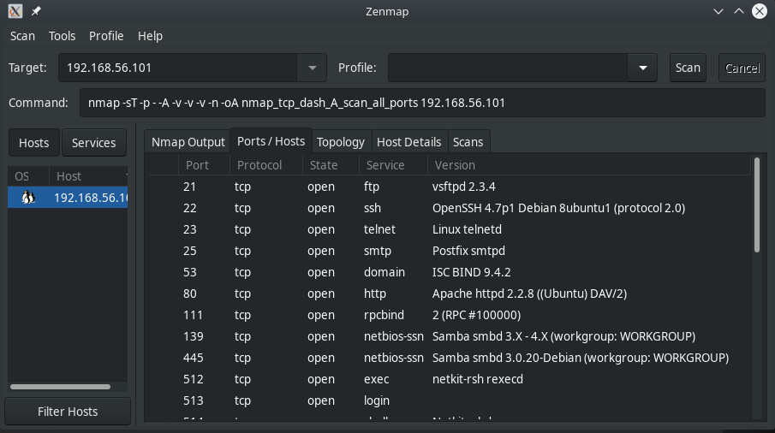
Personally, I don’t use it for scanning often; in fact almost never. However, it does allow you to import an XML file and provide a simple way to view the results, and also provide a network map. However I still prefer the HTML output over this, because the script output doesn’t seem available here where it is in the HTML. If you wanted to open an existing XML file, such as any of the XML files we’ve created to this point, go to “Scan > Open Scan” and select the XML you want to use.

Appendix A – Further Reading

Item | Description | Links
NMAP Book | The official NMAP book, by the author of the tool is the best resource about this tool. Part of this book, about half of it, can be read online for free from the official site. | https://nmap.org/book/  https://nmap.org/book/toc.html
TCP Protocol | Information about the TCP Protocol | https://en.wikipedia.org/wiki/Transmission_Control_Protocol
UDP Protocol | Information about the UDP Protocol | https://en.wikipedia.org/wiki/User_Datagram_Protocol
Regex | Information about Regular Expressions (Regex) | https://en.wikipedia.org/wiki/Regular_expression
MITRE CVE | MITRE CVE Database, used to store publicly disclosed vulnerability information. | https://cve.mitre.org/
Exploit DB | A repo of publicly disclosed exploits | https://www.exploit-db.com/
Netcat | The GNU Netcat Project Page | http://netcat.sourceforge.net/
NSE (Book) | The NMAP Book Pages regarding NSE | https://nmap.org/book/nse.html
NSE (Man) | NSE Manual | https://nmap.org/book/man-nse.html
NSE Reference Documentation | NSE Reference Documentation. Outlines available scripts with documentation, as well as libraries provided by NSE. | https://nmap.org/nsedoc/
P0f | Passive OS detection tool called p0f. This is an interesting side tool to NMAP’s OS detection that is passive (it listens to network traffic, but doesn’t actively send anything to the clients to try to determine the OS) | https://en.wikipedia.org/wiki/P0f

