**EducationCare**

**User Manual**

FYP REPORT

**Data-Driven Web Portal to Streamline School Application**

by

Chan Chi Wah (5478 5523)

Kwong Chun Yuen (5478 5406)

Lai Tsz Hin (5478 5559)

Siu Chi Ho (5478 5479)

Yuen Chung Man (5478 5443)

Group ISD-05

**EducationCare**

Advised By

Dr. Farah Yan

Submitted in partial fulfillment

of the requirements for AST20613

in the

Division of Applied Science and Technology

Community College Of City University

2017-2018

Date of Submission: April 30, 2018

Table of Contents

1 Introduction 1

1.1 Abstract 1

1.2 Objective 2

1.3 Software and Hardware Requirement 2

2 System Functions 3

2.1 Home Page 3

2.2 Mapping 5

2.3 Smart Form Filling 6

2.4 Ranking 8

2.5 Event Calendar 9

2.6 Registration 10

2.7 Log In 12

3 Acknowledgements 15

# Introduction

## Abstract

Hong Kong education always is a hot topic of society. However, from the parents’ view, what is the biggest concern of their child? It is no doubt that would be the quality of the school. This project can be a good helper for the parents to know more about schools in Hong Kong.

This project is created as an intelligent web portal to show useful information about schools, which contains all the primary schools in Hong Kong. Inside the system, elastic searching engine, database and a website layout design have been implemented. The core of this system is the information of school, which is collected by the searching engine and store data into the database automatically. The webpage will show the data from the database and analyze it to calculate the ranking or the scores of the school.

This school website can help to solve confusions of parents about schools and thus they can be more efficient to choose their preferred school for their child, help their child have the most appropriate education they deserve.

## Objective

Therefore here is a user manual that teaches the user how to use our web portal to find the most suitable school for their child. The following will show the main functions of our web.

1. Mapping
2. Smart Form Filling
3. Ranking
4. School Event Calendar
5. Subscription

## Software and Hardware Requirement

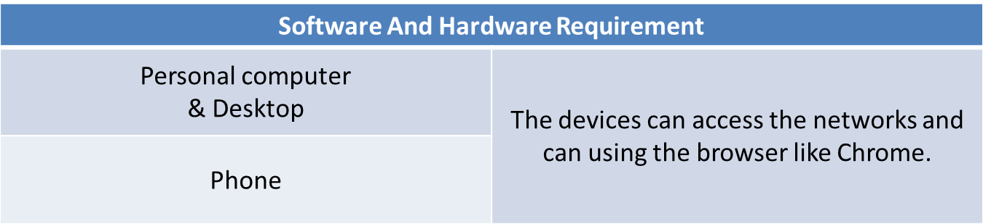

# System Functions

## Home Page

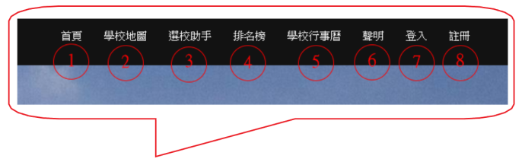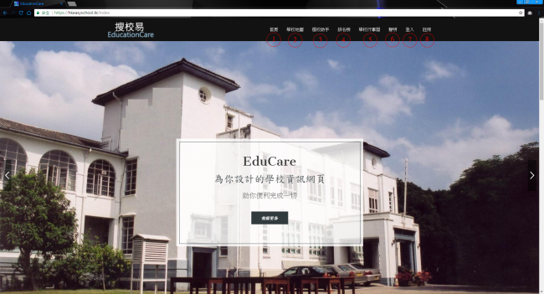This is the home page of our web portal. For the navigation bar, this is used to return to the home page, mapping, smart form filling, ranking, school Calendar, statement, login and registration.

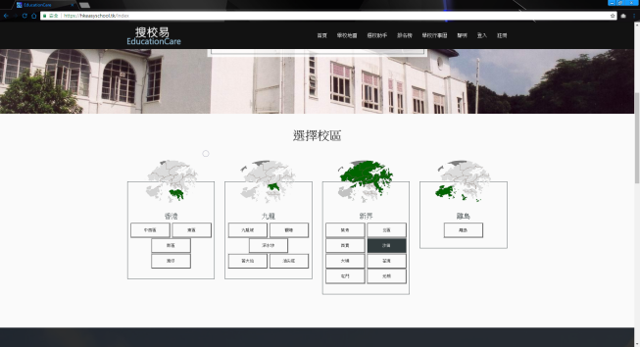

Figure 2 Home Page ( Select District )

Figure Home page

In the Figure 3, user can have a short tutorial show that how the functions work on the web.

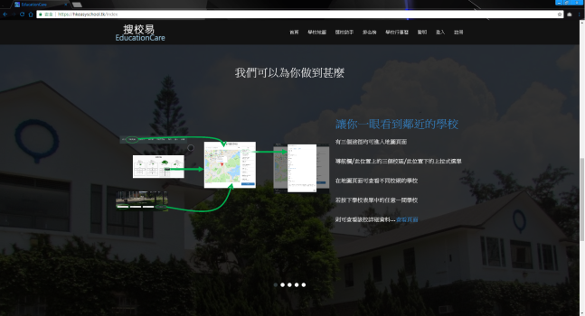

Figure 3 Home Page ( Tutorial )

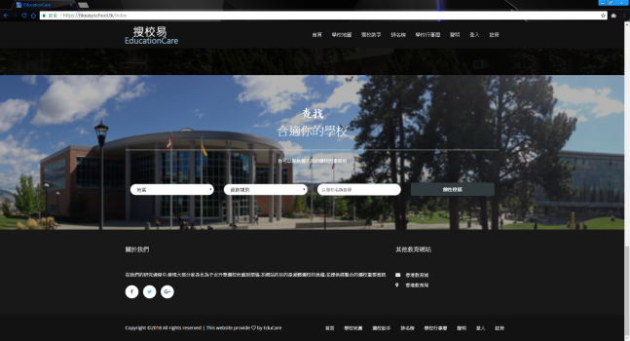

Figure 4 Home Page ( Search Engine )

## Mapping

First of all, in the mapping page, user can choose what district of school that you want to show in the . And then you can type the position in the search bar which in . Then we can help you to calculate the distance between your typed position and the school. For the , user can input the school name that they want to know more about. When the user Click the , they can jump to the questionnaire.

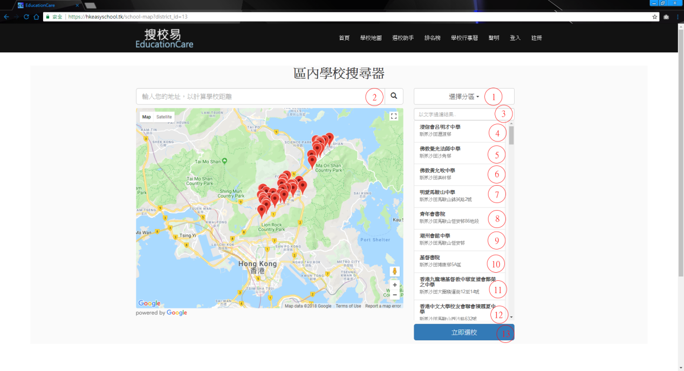

Figure 5 Mapping page

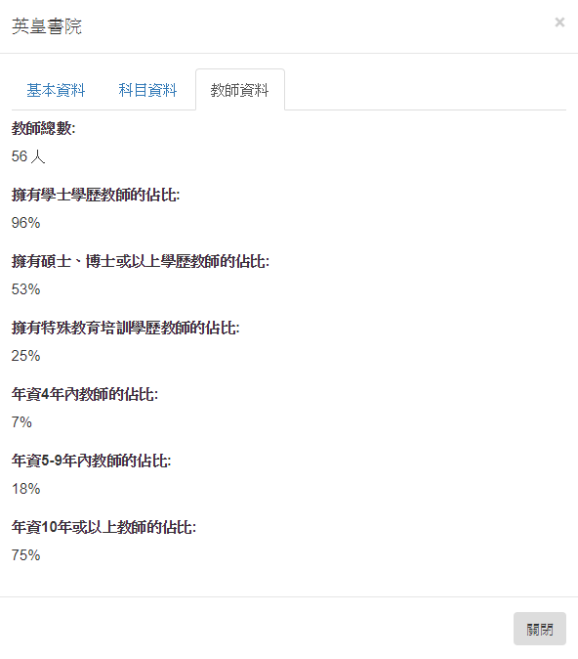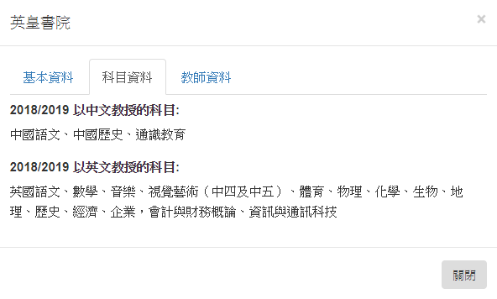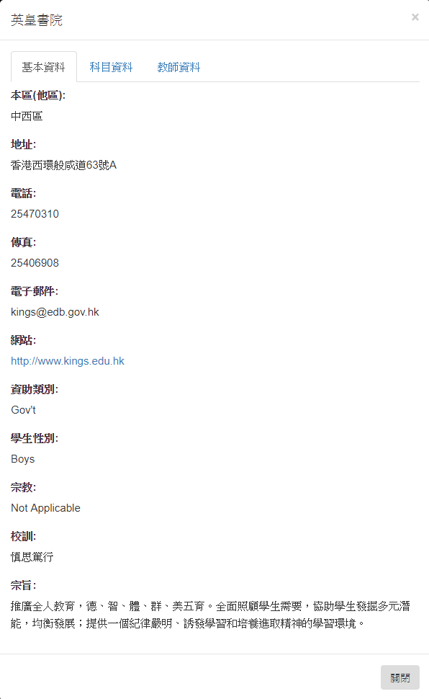By clicking the to the , there can show you the details of the school ( Figure 6-8 ).

.

Figure 7 School Details 2

Figure 8 School Details 3

Figure 6 School Details 1

## Smart Form Filling

For the questionnaire, it’s used to suggest the school is suitable for the user after finish it. Firstly, user input their sex, the district of their living, the average marks of their child in Figure 9.

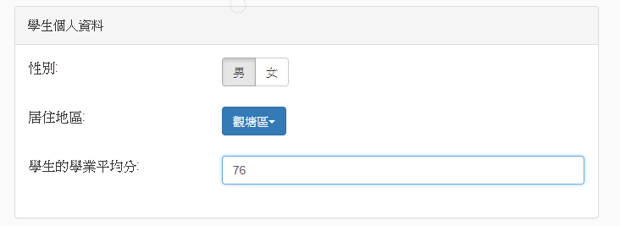

Figure 9 Questionnaire Part 1

Then rate which aspects are more important ( Figure 10 ). (1 star is the lowest, 10stars is most important)

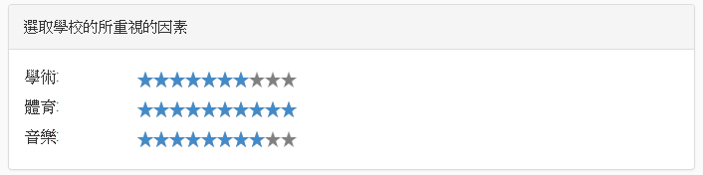

Figure 10 Questionnaire Part 2

Although it is optional, user can input which best 3 of school for their child and which religion are more prefer. Lastly press the submit button, it will submit the questionnaire and transform to an application form. ( Figure 11 )

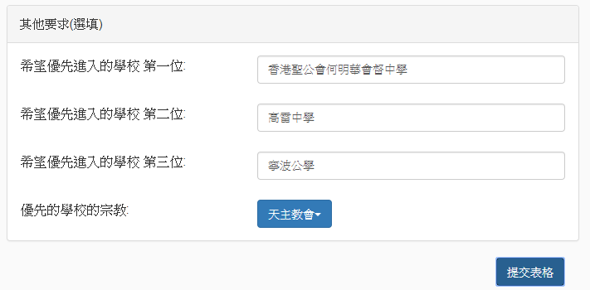

Figure 11 Questionnaire Part 3

Then it will result the form like Figure 12.

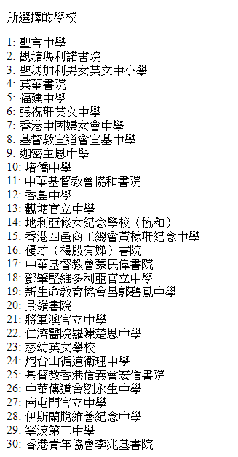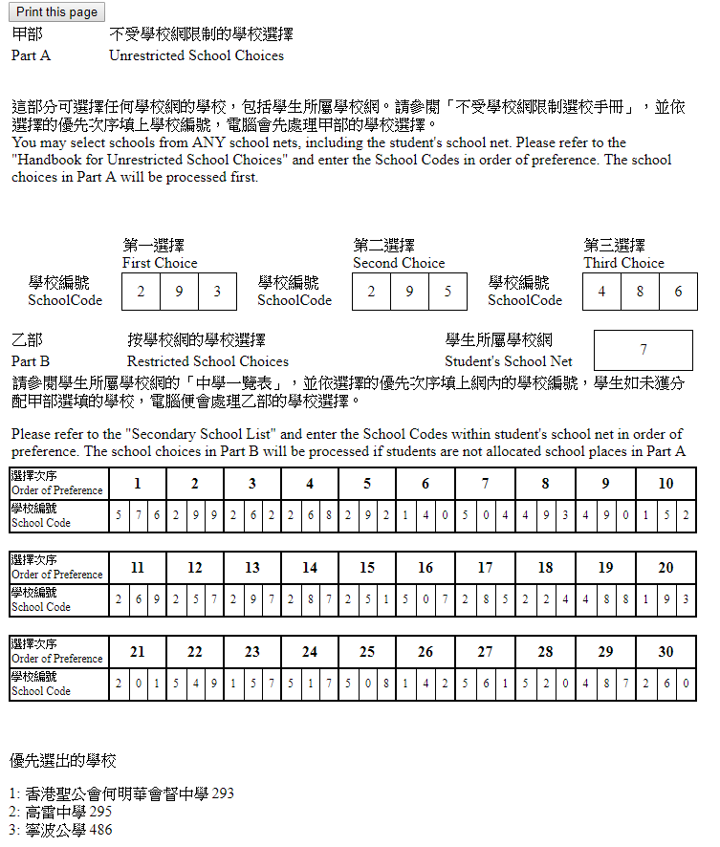

Figure 12 Application Form

Below the application form, there are 30 schools have been suggested according to the questionnaire that user have done before. ( Figure 13)

Figure 13 Suggested School

After that, user can click the print button to print out the application form.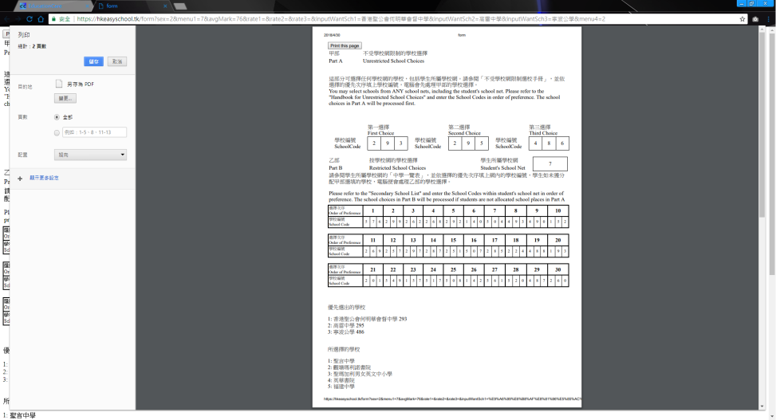

Figure 14 Print Form

## Ranking

For the ranking page, there have shown the top 10 school in each district. User can change the district to see top 10 schools by click the menu where have a symbol like . For sure that user can click the school name to know more details information about the school as well.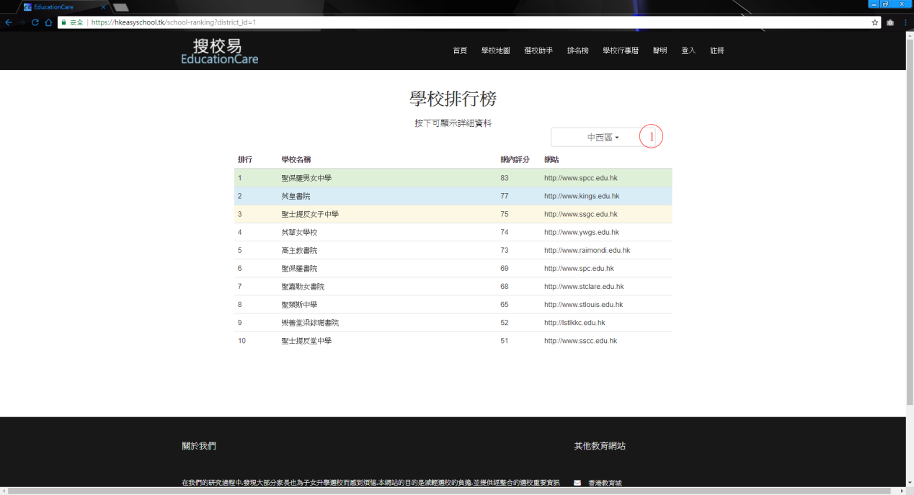

Figure 15 Ranking

## Event Calendar

For the event calendar, user can watch all the upcoming events. ( Figure 16 )

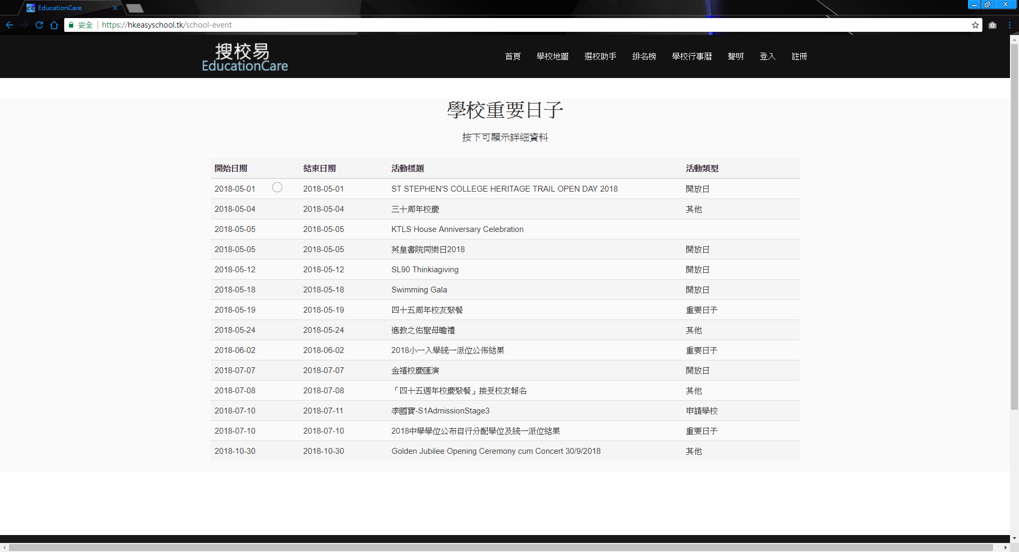

Figure 16 Event

When the user click on one of the event, then it will show the event details.( Figure 17 )

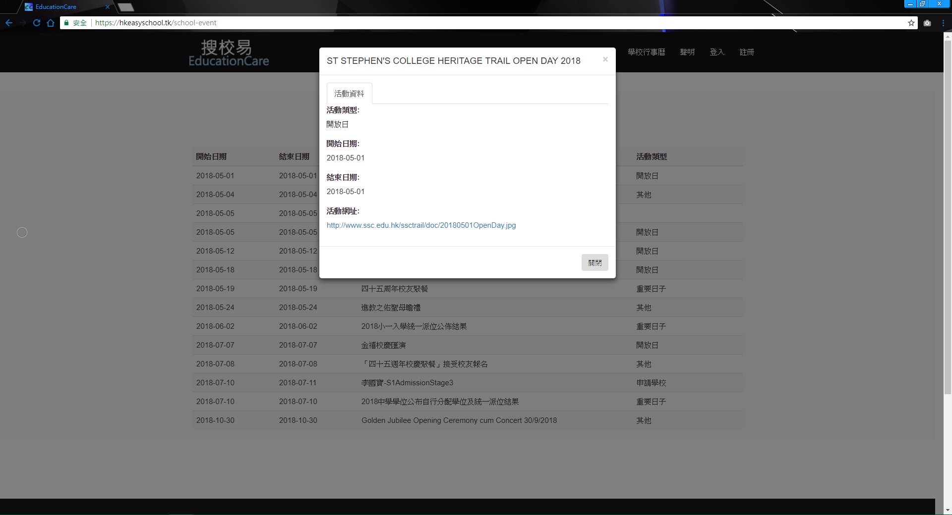

Figure 17 Event details

The event will follow the real time, when the event has been finish, then the record of that event will also dismiss.

## Registration

User can have a registration in this web.

Firstly, input your username in .

Second, input your email address in , but remember that user cannot use the same email twice for the registration.

Then, input the password in .

Moreover, re-input the password in and make sure that the password is the same with .

Finally click the register button which is .

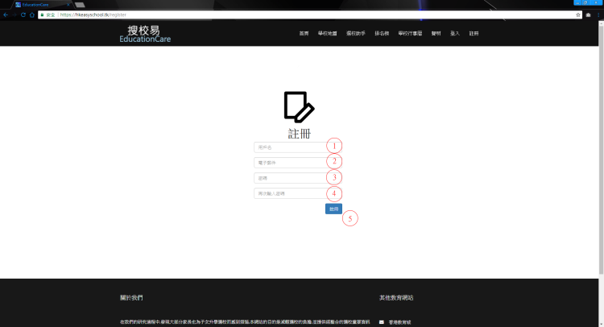If user register successfully, then will show register success.

Figure 18 Registration

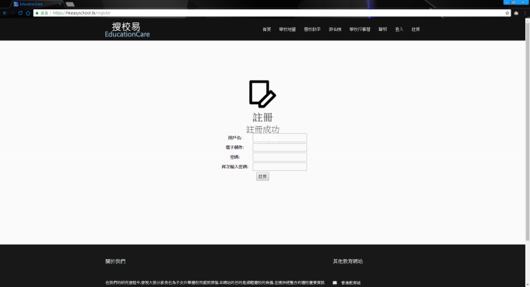

Figure 19 Successfully Register

On the other hand, the user will fail to register when using the same email twice for registration, and the type different password in and in figure 20 to 21.

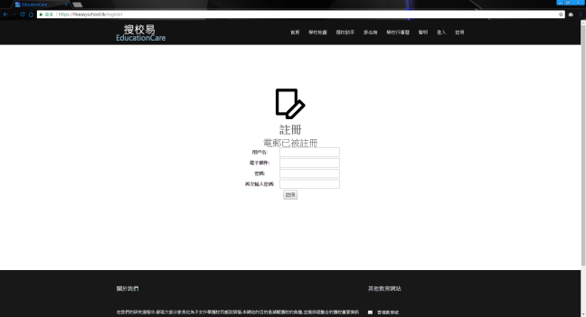

Figure 20 Fail to register case 1

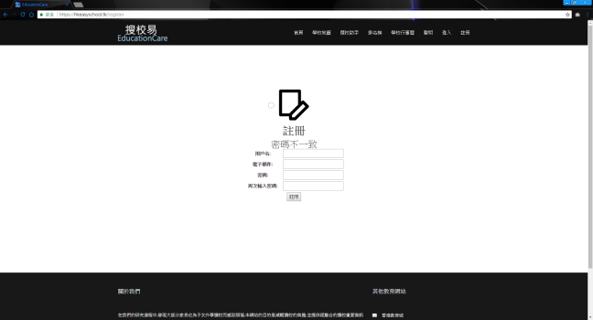

Figure 21 Fail to Register Case 2

## Log In

After the registration, user can input the username and password to login. ( Figure 22)

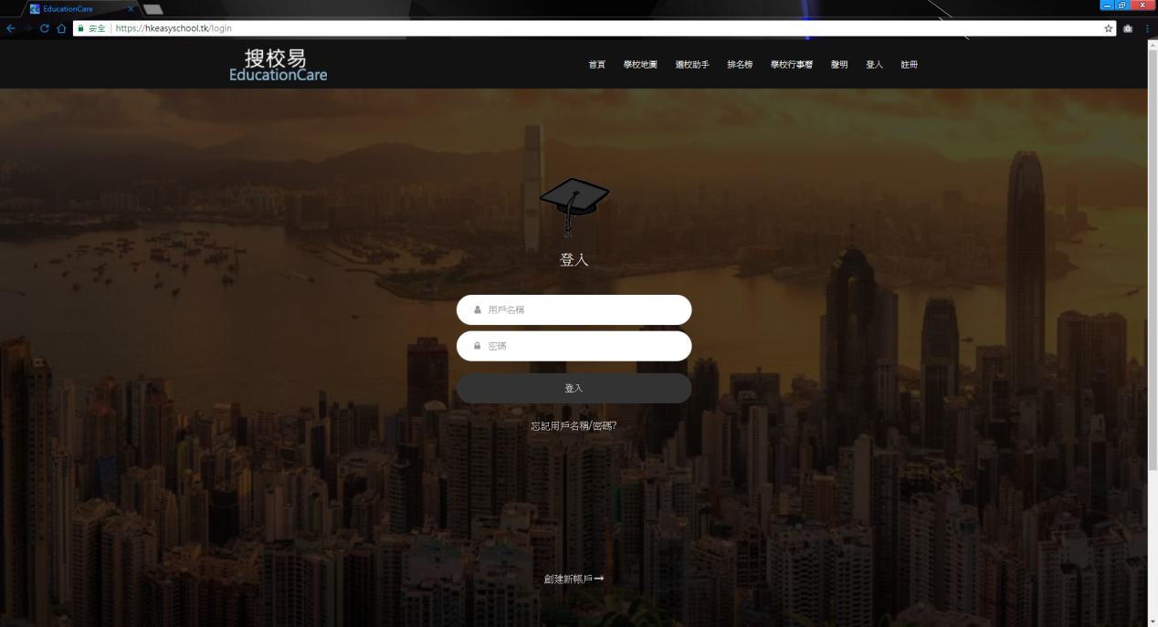

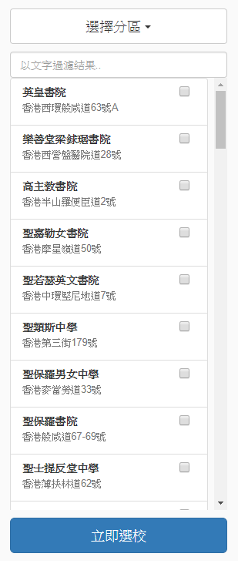Figure 22 Login Page

After Login the web, user is able to use subscribe function.

Firstly, the user can go back to the mapping page. There have some check box near the school name. ( Figure 23 ) It is used to let user to have a subscription of the school.

After click the school that user wants to subscribe, then it will show that the user successfully to add a school to the list( Figure 24).

Figure 23 Subscribe Check box



Figure 24 Successfully to add a list.

After that, user can click to the username with the red circle( Figure 25 ) to check out what school have been subscribe ( Figure 26 ).

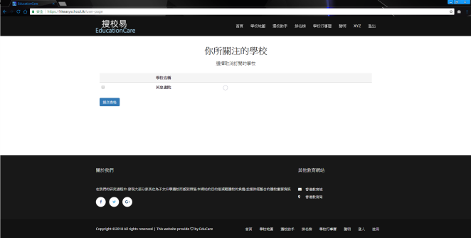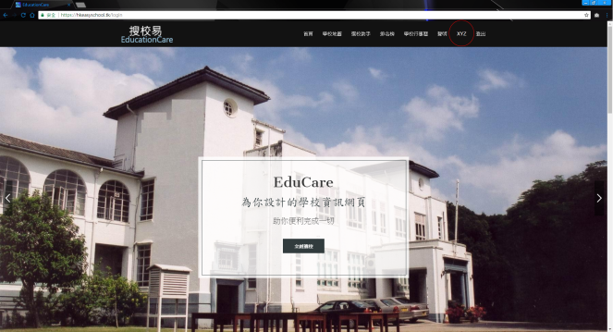

Figure 25 Subscribe

Figure 26 Subscription Check List

Then the user can press the submit button. When the school web site has some updates, we will send an email to the user automatically, and tell them there have a new update, let’s watch out ( Figure 27 ).

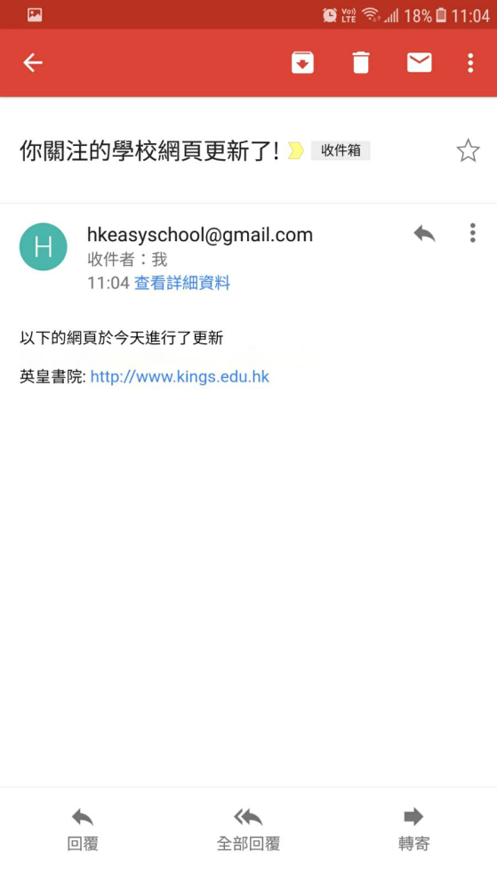

Figure 27 New update of Subscription

# Acknowledgements

We would like to express our gratitude to our Supervisor, Dr Farah Yan. Dr Farah Yan has been very helpful to contribute valuable suggestions and clear guides to us to finish this project. She encourages us to continue the system development and brainstorm the ideas.

We very much appreciate Advanced Security Technology and Research Laboratory Company Limited(AdvSTAR) for keep giving us huge support and great ideas during the development process of this live project.