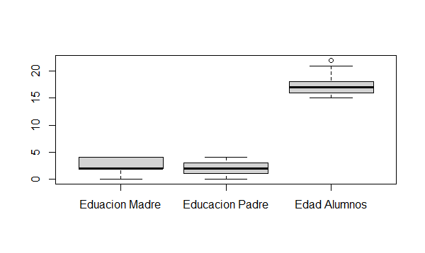

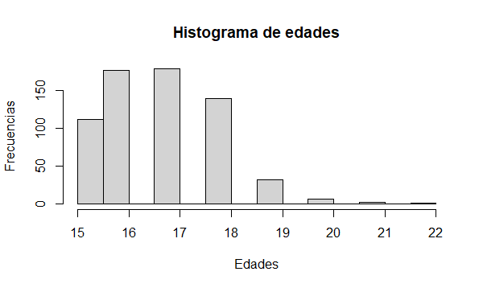

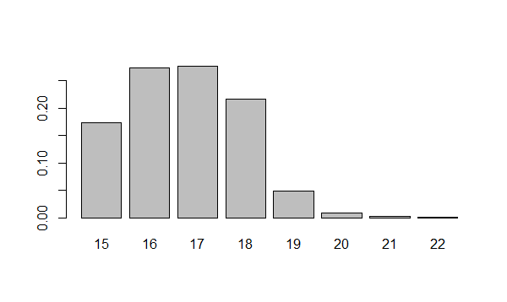

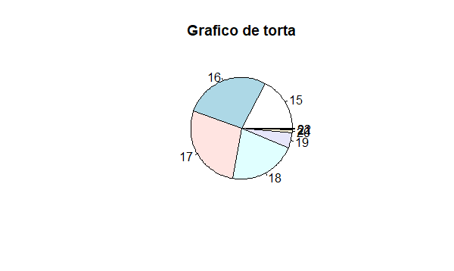

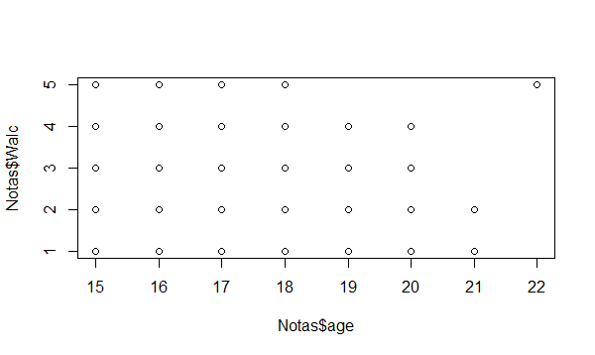

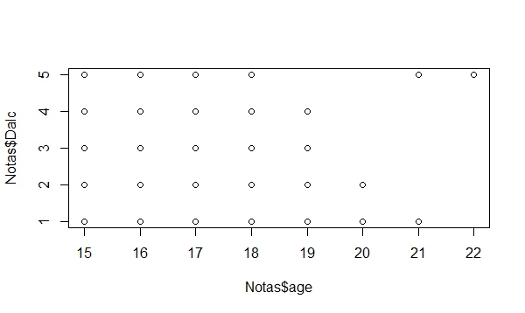

Gráficos tipo boxplot

boxplot(Notas$Medu)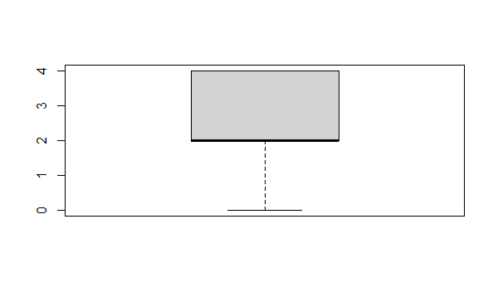

boxplot(Notas$age)

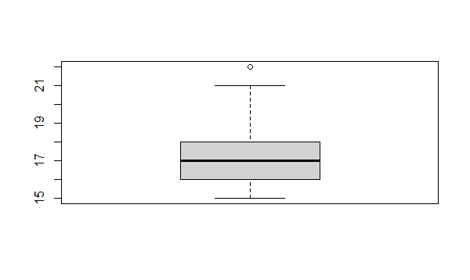

boxplot(Notas$Fedu)

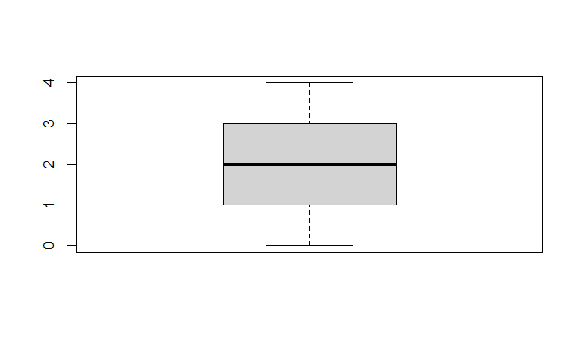

boxplot(Notas$traveltime)

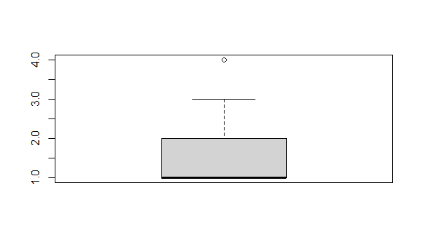

boxplot(Notas$studytime)

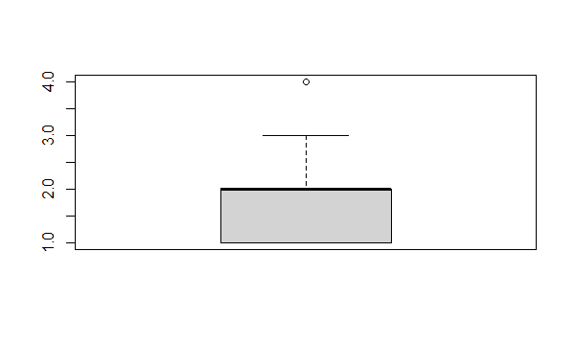

boxplot(Notas$failures)

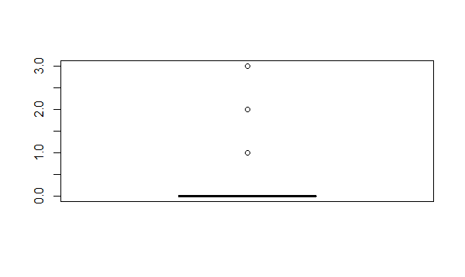

boxplot(Notas$famrel)

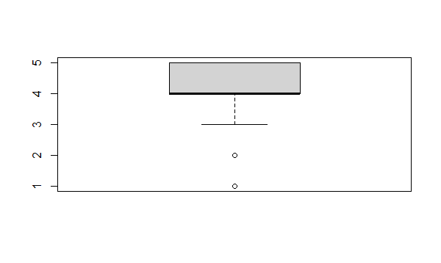

boxplot(Notas$freetime)

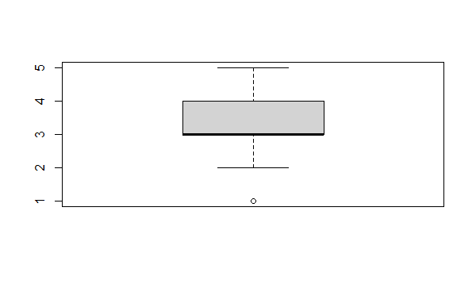

boxplot(Notas$goout)

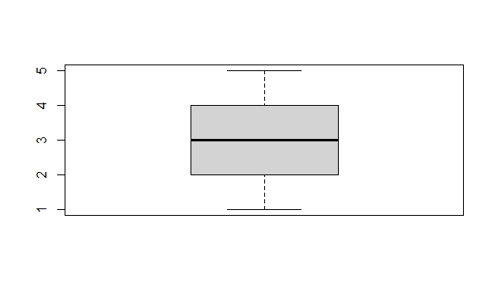

boxplot(Notas$Dalc)

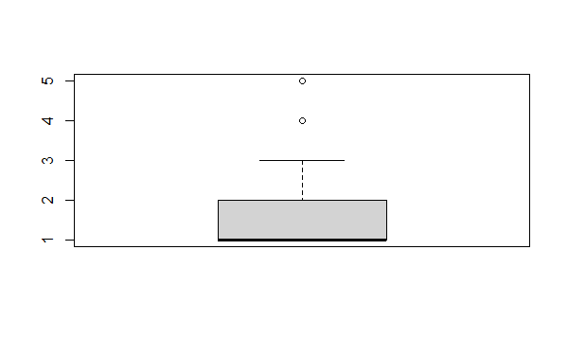

boxplot(Notas$Walc)

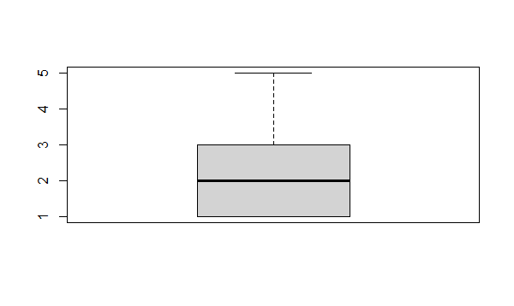

boxplot(Notas$health)

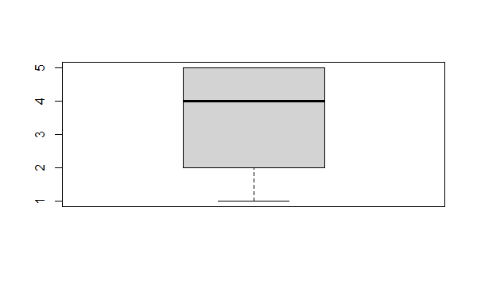

boxplot(Notas$absences)

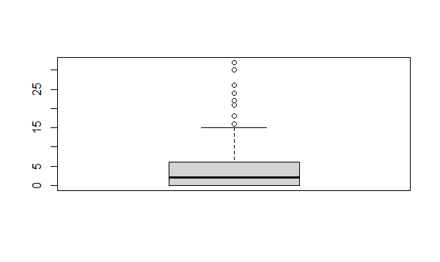

boxplot(Notas$G1)

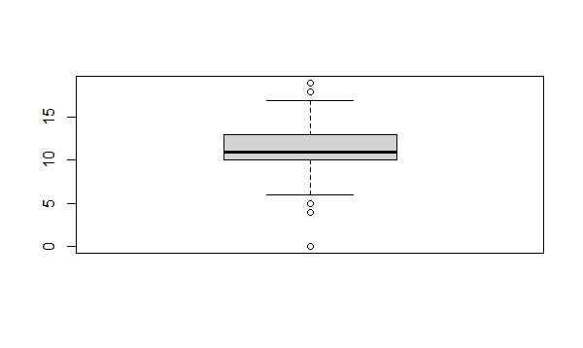

boxplot(Notas$G2)

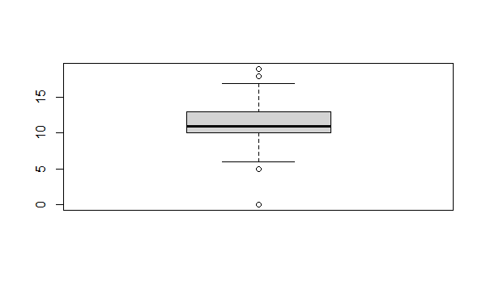

boxplot(Notas$G3)

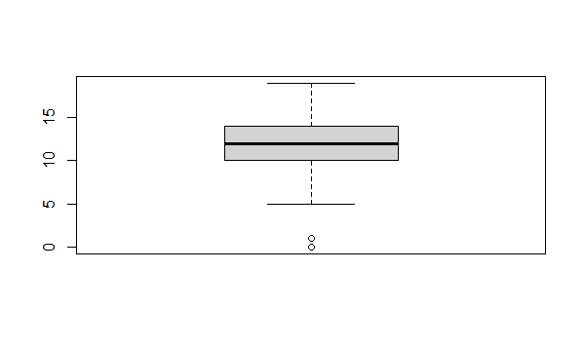

Gráficos de violín

ggplot(Notas, aes(x= factor(1), y= as))+

+ geom_violin()

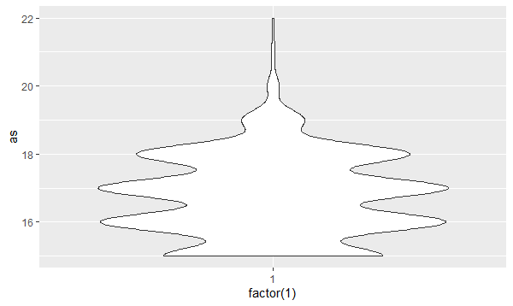

ggplot(Notas, aes(x= factor(1), y= asu))+

+ geom_violin()

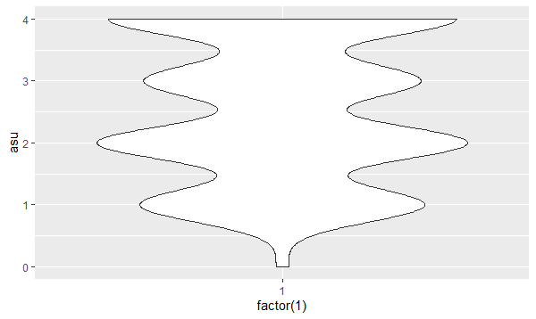

ggplot(Notas, aes(x= factor(1), y= asd))+

+ geom_violin()

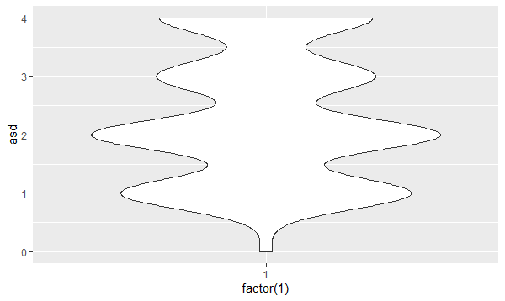

ggplot(Notas, aes(x= factor(1), y= ast))+

+ geom_violin()

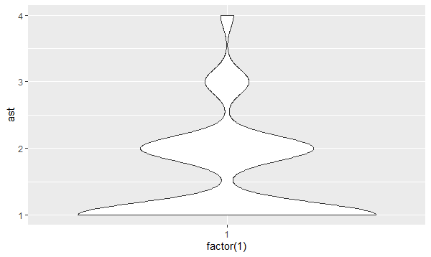

ggplot(Notas, aes(x= factor(1), y= asc))+

+ geom_violin()

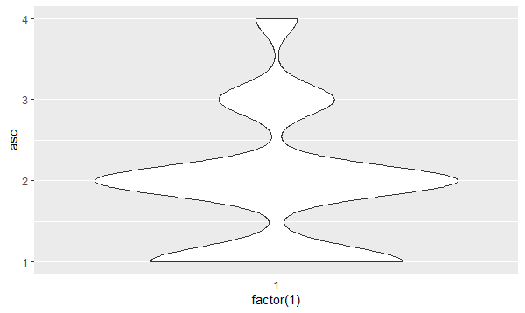

ggplot(Notas, aes(x= factor(1), y= ascc))+

+ geom_violin()

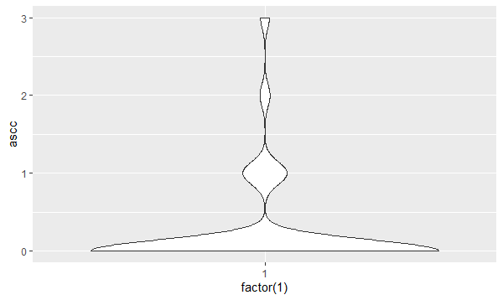

ggplot(Notas, aes(x= factor(1), y= ass))+

+ geom_violin()

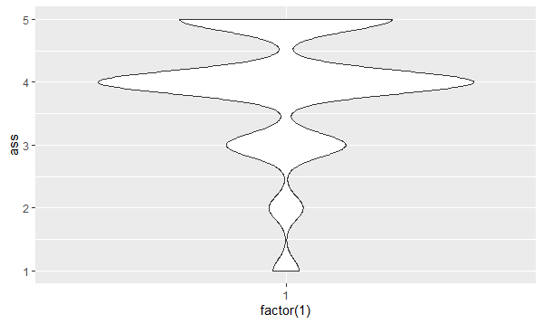

ggplot(Notas, aes(x= factor(1), y= assss))+

+ geom_violin()

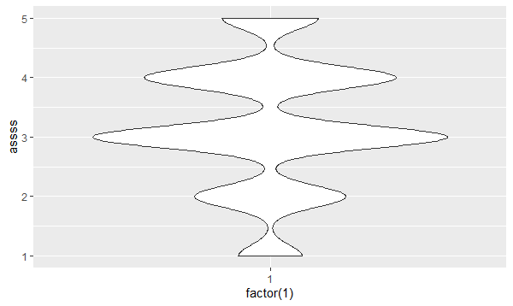

ggplot(Notas, aes(x= factor(1), y= aso))+

+ geom_violin()

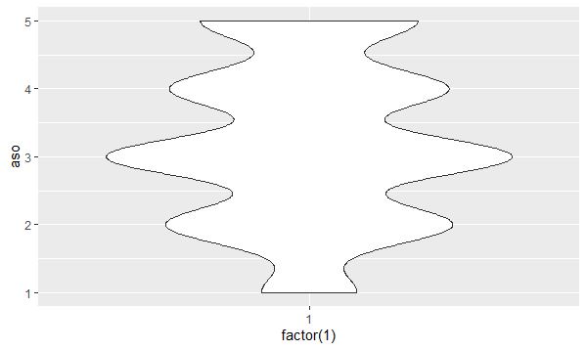

ggplot(Notas, aes(x= factor(1), y= asn))+

+ geom_violin()

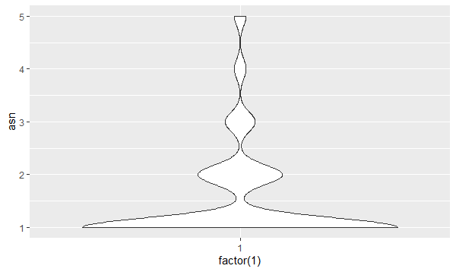

ggplot(Notas, aes(x= factor(1), y= asud))+

+ geom_violin()

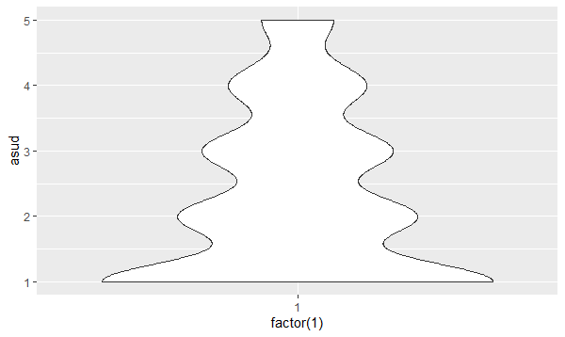

ggplot(Notas, aes(x= factor(1), y= asut))+

+ geom_violin()

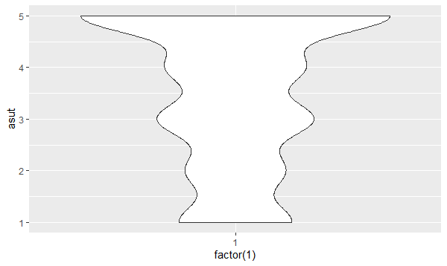

ggplot(Notas, aes(x= factor(1), y= asuc))+

+ geom_violin()

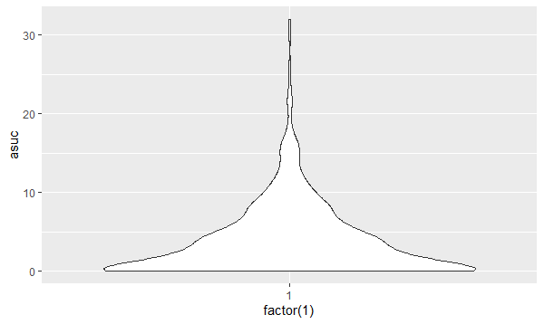

ggplot(Notas, aes(x= factor(1), y= asuci))+

+ geom_violin()

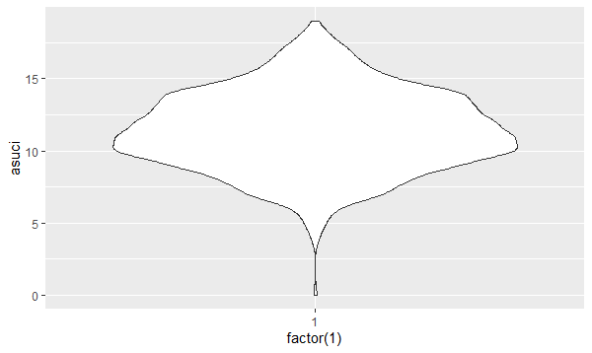

ggplot(Notas, aes(x= factor(1), y= asus))+

+ geom_violin()

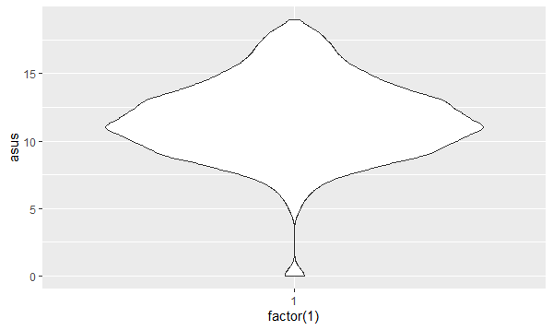

ggplot(Notas, aes(x= factor(1), y= asusi))+

+ geom_violin()

