OnlineForms

OnlineForms is an application designed for creating, customizing and saving forms and questionnaires. These forms of user input are key component of websites, thus the importance of this application is evident. To be able to create custom form for a website, for a reasonable amount of time, can speed up the website's building process.

Application is based on JavaScript and IndexedDB technologies. JavaScript is used to manipulate the DOM (Document Object Model), which represents website's main structure. IndexedDB is used to store data to local storage (web browser) which means that application works without internet connection.

Application contains two tabs (windows): Administration and Form.

Administration tab is used to create and customize forms, while the Form tab reads the stored forms, which you can fill and save under different versions.

When application loads, the Administration tab is opened, and browser should look something like this:

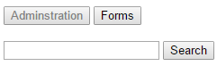

Fill the input field with a form name, and click search button. Application searches local storage. If there is a saved from with the provided name, application will render the form.

To create an element, a few properties must be defined. These properties are organized in rows. So each form consists of rows. Each row has several fields:

1. A label “Element” – to indicate new row
2. An input field (label of the form element to be created)
3. A dropdown list containing three options (textbox, checkbox and radio button). Chosen option represents the form's element's type.
4. A dropdown list containing three options (none, mandatory and numeric). Chosen option represents the validation type which will be performed when the form is being filled.

If the chosen element type is the radio button a new input field will show. Entered number (greater than two) represents number of wanted radio options. If we assume that entered number has a value of e.g. 2. After input, there are *2* new input fields, whose values represent radio options.

To add a new row to a form, click the add button. Once added, the row can’t be deleted, but can be changed. After doing some changes, to apply them, save button must be clicked.

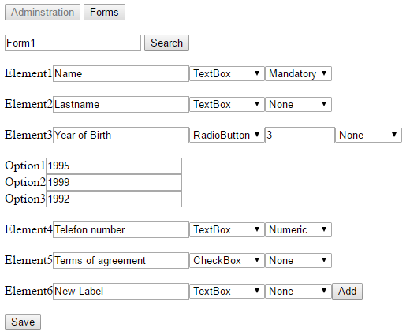

If form name is omitted, only one row (default row containing add button) is presented. After adding rows, to store the form, enter the form name and then click the save button. If the form name is omitted again, a proper alert block will pop up, and will prevent saving a nameless form.

If save was successful, a console message is presented saying that the new form has been stored.

By clicking on the Form button, application switches to Form tab. There are two input fields labeled „Form name“ and „Version“. The first one represents a name of the form to search for, while the other one represents a version of that form. Application then searches local storage for a form of the given name and version. If found, form will be rendered, and appropriate fields filled. These fields can be edited and saved, either by the new or the old version number.

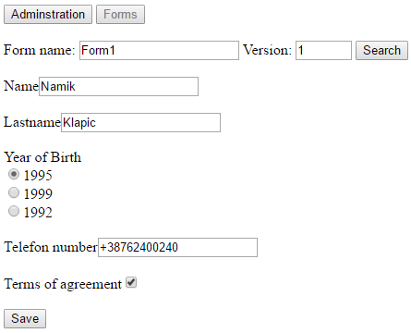

If version input is left blank or there is no form data for entered version, a blank form will be presented.

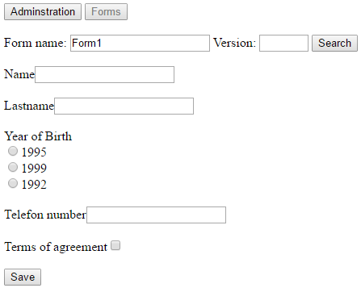

After filling all input fields, click save to store data. If version number is missing, a proper alert message will show.

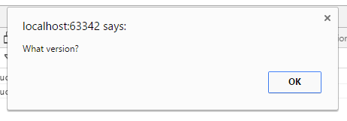

Before application actually saves the data, it first checks the validation types for every element of the form. If mandatory field is left blank, or a character is entered in numeric field, alert message will pop up to explain the particular error.

