miniPad-α
Finger Drum Pad
Operation Guide
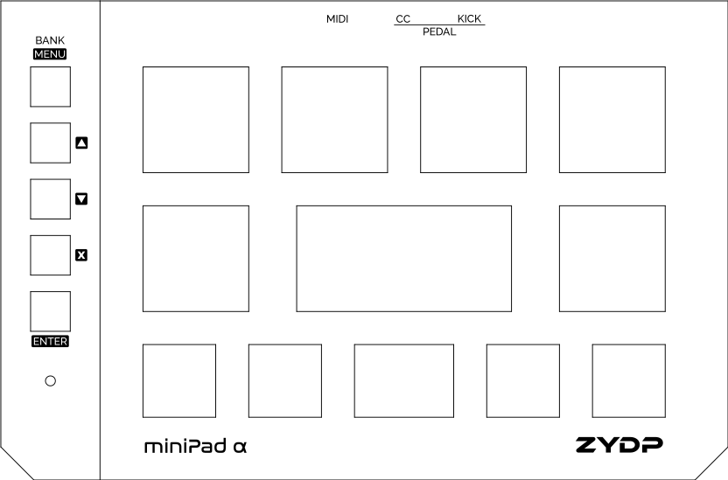
ZYDP

Table of Contents
Introduction to the miniPad 4
Parts of the miniPad 4
Quick Start 9
Setting Up the miniPad 9
Connecting pedals 9
Connecting the miniPad to External Synthesizer 9
Through the TRS MIDI output 9
Through the USB MIDI output 10
Playing the miniPad 10
Changing the MIDI Channel Number 10
Changing the Velocity Curve of the Pads 10
Other Common Operations of the miniPad 11
Interfaces of the miniPad 12
Main Interface 12
Banks and slots 12
Changing between slots 12
Changing between banks 12
Settings Interface 13
Entering the settings interface 13
Changing between settings 13
Changing the value of the selected settings 13
List of settings 13
Writing changes to the memory 14
Exiting the settings interface 14
Assignment Editing Interface 14
Entering the assignment editing interface 14
Editing the note/controller number assignment 15
Exiting the assignment editing interface 15
Writing changes to the memory 15
Specifications 16
Appendix 17
Default Pads Mapping 17
Using With FL Studio FPC Plugin 18

Introduction to the miniPad
The ZYDP miniPad is a MIDI finger drum pad which can be used to control external drum synthesizer or sampler. The user can choose between using the USB or TRS MIDI interface for the MIDI output. The miniPad also comes with ports for connecting kick pedal and the hi-hat controller, allowing actual drummers to play the instrument with ease.

Parts of the miniPad

- Pads
By hitting any of the pads, a MIDI note-on message will be sent through the USB MIDI output (and TRS MIDI depending on settings). The MIDI note assignment of each pads can be customized, refer to Editing the note/controller number assignment for more details. The pads are numbered as illustrated by the diagram below:

- Buttons
The buttons serve different purpose in different interface. The highlighted labels apply for any settings interface, while the non-highlighted apply in the main interface (for details on interface, refer to Interfaces of the miniPad). The details function of each buttons was summarized as follows:
Button 1 (BANK/MENU)
In the main interface: Cycle between the banks of the pads’ note number assignment. For more details on banks, refer to Banks and slots.
In the settings interface: Cycle between different settings. For more details on settings, refer to Settings Interface.
Button 2 ()
In the main interface: Change to memory slot 1 of the bank.
In the settings interface: Increment the value of the selected settings.
In the assignment editor interface: Increment the note/controller number of the selected pad/controller by 1.
Button 3 ()
In the main interface: Change to memory slot 2 of the bank.
In the settings interface: Decrement the value of the selected settings.
In the assignment editor interface: Decrement the note/controller number of the selected pad/controller by 1.
Button 4 ()
In the main interface: Change to memory slot 3 of the bank.
In the settings interface: Exit settings interface and return to main interface without writing changes to the memory. Any changes will be lost if the drum pad is restarted.
In the assignment editor interface: Exit assignment editor interface and return to main interface without writing changes to the memory. Any changes will be lost if the drum pad is restarted.
Button 5 (ENTER)
In the main interface: Change to memory slot 4 of the bank.
In the settings interface: Write any changes to the memory including settings and pad assignment.
- Status indicator LED
The status indicator LED display various state of the drum pad. The general statuses were summarized as follows:
Red/Green/Blue/Purple
Corresponds to currently selected slot (1-4) in the main interface.
White
The drum pad is in the settings interface.
Blinking slowly in red/green/blue/purple
The drum pad is in the assignment editor interface. The colour of the LED represent the slot selected.
Blinking quickly for X number of times
In the main interface: Currently selected bank is changed to bank X.
In the settings interface: Currently selected settings is settings X.
Blinking very quickly in white
Settings and pad assignment have been successfully written to the memory.
- Output ports
The output ports are for interfacing with external controller/to other devices. The ports and their corresponding function were labelled on the front panel of the drum pad. The functions of each ports were summarized as follows:
MIDI output
The MIDI output port is for connecting the drum pad to other instrument/drum synthesizer. The standard connection (Type A) as per MIDI specification for TRS MIDI is implemented in this drum pad, that is tip-sink, ring-source, and sleeve-shield. Any suitable MIDI TRS to DIN5 adapter may be used as long as the Type A connections were followed.
CC pedal
The CC (control change/continuous control) pedal can be connected to this port in order to control the assigned CC number. In the default assignment, the pedal is assigned to CC4 which control the hi-hat opening and closing in most drum sampler. The assignment can be customized on a per-slot basis.
Kick pedal
The kick pedal (which is essentially a foot controlled pad) can be connected to this port. In the default assignment, the pedal is assigned to MIDI note 36 (bass drum as per General MIDI 2 standard). However, the assignment can be customized on a per-slot basis as well.
- USB MIDI output
This USB output should be connected to a HOST device which can receive MIDI over USB. The USB connection is also used for serial communication (not yet implemented in alpha).

Quick Start

Setting Up the miniPad

Connecting pedals
The miniPad comes with two pedal unit: the kick pedal and the CC pedal. The pedals can be connected connected by using a 3.5mm TRS audio cable. Plug one end of the cable to the pedal unit and the other end to the corresponding port at the back of the miniPad.
Please note that the pedal need to be enabled in the settings before you can use it. The settings for enabling the kick pedal and CC pedal are located at 3rd and 4th index respectively. Refer to Settings Interface for how to change it.

Connecting the miniPad to External Synthesizer

Through the TRS MIDI output
The TRS MIDI output can be connected by using a 3.5mm TRS audio cable. Plug one end of the cable to the miniPad MIDI port while the other end to the synthesizer device. You may use TRS to DIN adapter if the synthesizer MIDI input requires a 5-pin DIN connector.
To power the miniPad, connect the USB port on the miniPad to a 5V USB power supply. This may be your phone charger, powerbank, or even just your laptop.
Please note that the TRS MIDI output need to be enabled in the settings before you can use it. The setting for enabling the TRS MIDI output is located at 2nd index. Refer to Settings Interface for how to change it.

Through the USB MIDI output
The USB MIDI output can be connected by using a micro-USB cable. Plug one end of the cable to the miniPad USB port while the other end to your device (computer/laptop). You can connect the miniPad to your phone or tablet by using an USB OTG adapter, providing that you have compatible drum sampler apps installed.
Then, select the miniPad as your MIDI input device in your sampler software. The exact procedure may differ from one software to another, you may need to refer to the software user manual.

Playing the miniPad
When the miniPad is powered up, it will enter the main interface by default. You can now play the drum pad by hitting the pad with your finger. A MIDI note-on message will be sent when you hit the pad, and the velocity of the MIDI message sent depends on how hard you hit the pad.

Changing the MIDI Channel Number
Depending on your synthesizer or sampler, some might requires the MIDI message to be sent over certain channel in order for it to create sound. The miniPad allows you to change the MIDI channel number in the settings by accessing the first index of the settings. The MIDI channel numbers that you can set are from 1 to 16, with an additional option to send to all channels. By default, the channel number is set to 1. Refer to Settings Interface for how to change it.

Changing the Velocity Curve of the Pads
The velocity curve of the pads refer to how sensitive the pads respond to finger hits. A soft velocity curve means that you can hit the pads lightly while still producing loud notes, while a hard velocity curve means that you need to hit the pads harder to produce loud notes. In general, hard velocity curve allows for wider dynamic range, although this is partly dependent on the synthesizer that you are using. By default, the velocity curve is set to medium.
To change the velocity curve, the settings is located at the 5th and 6th index for pads on the miniPad and the kick pedal respectively. For more details on the velocity curve settings, refer to Settings Interface.

Other Common Operations of the miniPad
For the other common operations that you can do on the miniPad, refer to the list below:
- Changing between banks and slots
- Customizing pads and pedal assignment
- Writing settings and assignments to the memory

Interfaces of the miniPad

Main Interface
The main interface is where you will be spending most of the time using the drum pad in. You will be able to change between different banks and memory slots, where you can define different note/controller number assignment to the pads and the controller.

Banks and slots
The miniPad has 4 banks, each bank containing 4 slots, totalling up to 16 different sets of pads assignment that can be customized and saved.

Changing between slots
By default when the drum pad is turned on, the first memory slot is selected (red). To change between slots, buttons 2-5 can be pressed one time to change to the corresponding memory slot. The status indicator LED will change its colour to match the colour of the slot button pressed.
Button | Memory Slot | Colour of Status Indicator LED
2 () | 1 | Red
3 () | 2 | Green
4 () | 3 | Blue
5 (ENTER) | 4 | Purple

Changing between banks
By default when the drum pad is turned on, the first bank is selected. Press the BANK/MENU button to cycle between banks. The status indicator LED will blink quickly for a number of times equal to the index of the selected bank when the BANK/MENU button is pressed.

Settings Interface
The settings interface is where you can change various behaviour of the drum pad, such as MIDI settings, external devices settings, and pads settings.

Entering the settings interface
To enter the settings interface, ensure the drum pad is at the main interface, then long press the BANK/MENU button. The status indicator will turn to white colour, indicating that you are currently in the settings interface.

Changing between settings
To cycle between the settings, press the BANK/MENU button. The status indicator LED will blink quickly for a number of times equal to the index of the selected settings.

Changing the value of the selected settings
To change the value of the selected settings, press button to increment the value and button to decrement the value. If the last value is reached and is pressed, the value will cycle back to the first value. If the first value is reached and is pressed, the value will cycle back to the last value.

List of settings
No. | Settings | Description | Value Range | Default Value
1 | MIDI channel | Set the MIDI channel number where the MIDI messages will be sent to. | 1-16, all channels | 1
2 | Toggle TRS MIDI | Enable/disable MIDI over TRS. | Enabled, disabled | Enabled
3 | Toggle kick pedal | Enable/disable kick pedal. | Enabled, disabled | Enabled
4 | Toggle CC pedal | Enable/disable CC pedal. | Enabled, disabled | Disabled
5 | Pads velocity curve | Change the sensitivity of the pads on the drum pad. | Soft, medium, hard | Medium
6 | Kick pedal velocity curve | Change the sensitivity of the kick pedal. | Soft, medium, hard | Medium

Writing changes to the memory
To write any changes in settings (including pad assignment) to the memory, press the ENTER button while you are in the settings interface. The status indicator LED will blink very quickly, indicating that the changes had been saved to the memory successfully.
Caution: Flash memory have a limited write cycle. Avoid unnecessary writes to the memory to prolong the lifetime of the memory.

Exiting the settings interface
To exit the settings interface, press the button. The drum pad will return to the main interface. Note that any changes in settings will not be automatically saved when pressing this button.

Assignment Editing Interface
The assignment editing interface is where you change what MIDI note will be triggered when the pads are triggered. The controller number mapped to the CC pedal is changed in this interface as well.

Entering the assignment editing interface
To enter the assignment editing interface, first select the bank and slot you want to edit (refer to Banks and slots for more details). Then double click the BANK/MENU button. The status indicator LED will start blinking slowly, indicating that you are in the assignment editing interface.

Editing the note/controller number assignment
After entering the assignment editing interface, hit the pad that you want to edit the note number assignment to select the pad for editing. Similarly for pedals, press the CC controller or the kick pedal to select either of them for editing.
To increment the note/controller number, press the button. To decrement the note/controller number, press the button. To increment or decrement the note number by one octave, long press the or buttons respectively. You can hit the pad/press the pedal while editing the assignment to determine what changes have been made.

Exiting the assignment editing interface
Press the button to exit the assignment editing interface. The drum pad will return to the main interface. Note that any changes in note/controller number assignment will not be automatically saved when pressing this button.

Writing changes to the memory
Writing the note/controller number assignment to the memory uses the same steps as writing settings to the memory. Refer to Writing changes to the memory for more details.

Specifications
Product Name |  | miniPad-α
Size | Dimension (W×D×H) | 220×145×35 mm
Size | Weight | Did not measure
Pads | Drum Pads | 12
Pads | Assignable Note Number | Yes
Other Interfaces | LED Indicator | RGB status indicator
Registration Memory | User | 4 Slots × 4 Banks
Connectivity | USB to Host | Micro B
Connectivity | TRS MIDI Out | 3.5mm TRS  Tip – Sink  Ring – Source  Sleeve – Shield
Connectivity | Kick Pedal | 3.5mm TRS
Connectivity | CC Pedal | 3.5mm TRS
Power Supply | Power Specification | 5V USB power adaptor
Power Supply | Current Consumption | Did not measure
Power Supply | Power Consumption | Did not measure

Appendix

Default Pads Mapping
By default the first bank is predefined, where the defined note number can be referred below.
Pad Number | Slot 1 | Slot 2 | Slot 3 | Slot 4
1 | 43 (High Floor Tom) | 43 | 46 | 46
2 | 41 (Low Floor Tom) | 41 | 37 | 37
3 | 36 (Bass Drum 1) | 37 (Side Stick) | 38 | 38
4 | 41 | 41 | 41 | 41
5 | 43 | 43 | 43 | 43
6 | 47 (Low-Mid Tom) | 47 | 42 | 42
7 | 38 (Acoustic Snare) | 38 | 50 (High Tom) | 50
8 | 47 | 47 | 45 (Low Tom) | 45
9 | 49 (Crash Cymbal 1) | 49 | 49 | 49
10 | 46 (Open Hi-hat) | 46 | 54 (Tambourine) | 55 (Splash Cymbal)
11 | 42 (Closed Hi-hat) | 42 | 57 (Crash Cymbal 2) | 57
12 | 51 (Ride Cymbal 1) | 51 | 51 | 51
Kick pedal | 36 | 36 | 36 | 36
CC pedal | CC4 | CC4 | CC4 | CC4

Using With FL Studio FPC Plugin
- Ensure that low-latency audio driver is selected and used. Go to Options → Audio settings, in the Device drop-down menu, select ASIO4ALL v2. Select buffer length of less than 256 samples.
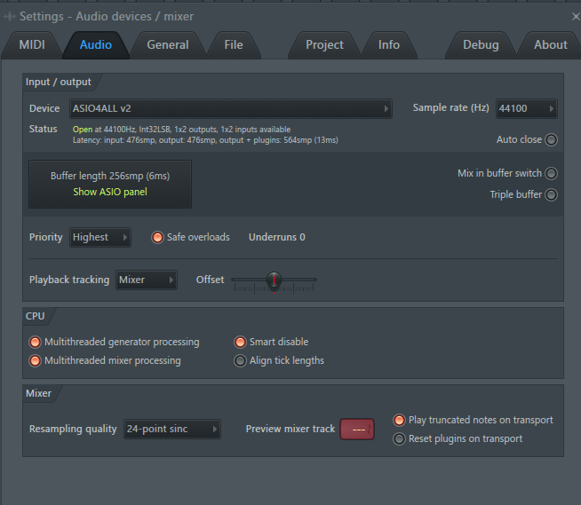
- Go to Options → MIDI settings and under the “Input” list select the miniPad and click “Enable”.
- Open the FPC plugin by going to Add → FPC.
- Hit any of the pads to confirm that you have successfully connected the drum pad.

