Flashing bootloader
No money to buy stlink? Flash using UART
First, grab bootloader from: https://github.com/rogerclarkmelbourne/STM32duino-bootloader/
- Flashing bootloader using stm32flash program (need to compile, linux, method used)
  - simple guide: https://pa1tech.github.io/anveshak/self/bootloadSTM32.html
    - RX-A9, TX-A10, VCC-5V, GND-G
  - stm32flash from: https://sourceforge.net/projects/stm32flash/
  - upload success:
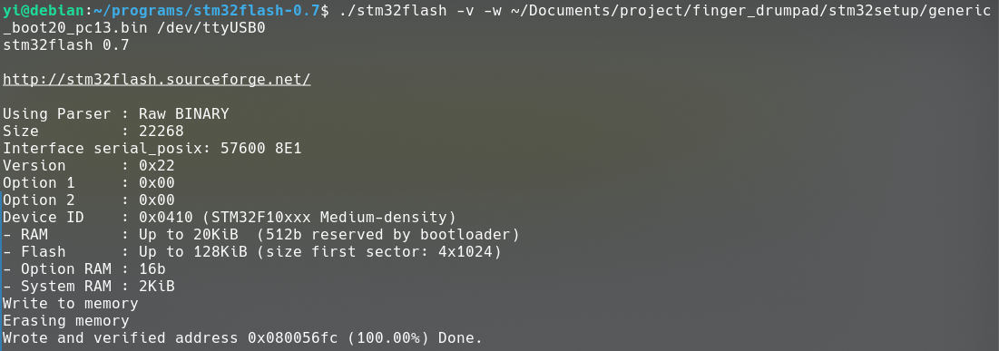
- Flashing bootloader using stm32loader python script (did not get it work, python version 2)
  - https://www.marrold.co.uk/2017/08/flashing-bootloader-on-to-stm32-blue.html
- Windows guide
  - https://circuitdigest.com/microcontroller-projects/programming-stm32f103c8-board-using-usb-port
  - Involve downloading sketchy exe file. Didnt get it work because windows need driver for ftdi, and can’t get the driver working

Trying to program the thing
Platformio ini file:
[env:genericSTM32F103C8]
platform = ststm32
framework = arduino
board = genericSTM32F103C8
board_build.core = maple
upload_protocol = dfu
build_flags = -D PIO_FRAMEWORK_ARDUINO_ENABLE_CDC -Os
lib_deps = arpruss/USBComposite for STM32F1@^1.0.9
Got the bootloader, just press upload right? Righ…..

Problem 1: upload-reset
Ran into this issue last time, didn’t document, but probably the following links are helpful.
- https://github.com/platformio/platform-ststm32/issues/225
- https://community.platformio.org/t/upload-reset-no-such-file-or-directory/8656/5

Problem 2: setDIR: TIOCMSET: Conection timed out
Press upload, bam nothing happens, press upload second time (advanced upload):
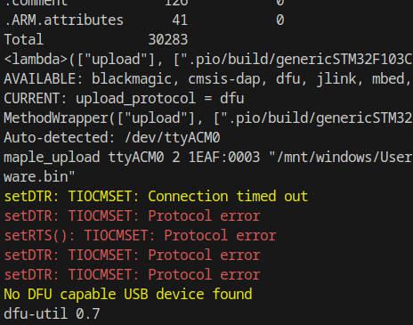
Wth even is this
- https://github.com/rogerclarkmelbourne/STM32duino-bootloader/issues/68
Workaround: press reset button when after reaching “Looking for upload port…”
Alternative upload with dfu-util directly:
dfu-util -a 2 -D <path to firmware.bin>
Remember we want to write to 0x8002000. Don’t ask why. Idk. List dfu device and check alt=2, hence the -a 2 argument in the command:
$ dfu-util -l
dfu-util 0.11
Copyright 2005-2009 Weston Schmidt, Harald Welte and OpenMoko Inc.
Copyright 2010-2021 Tormod Volden and Stefan Schmidt
This program is Free Software and has ABSOLUTELY NO WARRANTY
Please report bugs to http://sourceforge.net/p/dfu-util/tickets/
dfu-util: Cannot open DFU device 04f2:b729 found on devnum 3 (LIBUSB_ERROR_ACCESS)
Found DFU: [1eaf:0003] ver=0201, devnum=51, cfg=1, intf=0, path="1-1", alt=2, name="STM32duino bootloader v1.
0 Upload to Flash 0x8002000", serial="LLM 003"
Found DFU: [1eaf:0003] ver=0201, devnum=51, cfg=1, intf=0, path="1-1", alt=1, name="STM32duino bootloader v1.
0 Upload to Flash 0x8005000", serial="LLM 003"
Found DFU: [1eaf:0003] ver=0201, devnum=51, cfg=1, intf=0, path="1-1", alt=0, name="STM32duino bootloader v1.
0 ERROR. Upload to RAM not supported.", serial="LLM 003"

Also, this no longer happens after I changed the board type to genericSTM32F103C8, and uploads succeed with no intervention most of the time.

Problem 3: Upload success but device no longer detected
Was using this:
Changed to:
[env:genericSTM32F103C8]
platform = ststm32
board = bluepill_f103c8
framework = arduino
board_build.mcu = stm32f103c8t6
board_build.core = maple
upload_protocol = dfu
build_flags = -D PIO_FRAMEWORK_ARDUINO_ENABLE_CDC -Os
lib_deps = arpruss/USBComposite for STM32F1@^1.0.9
[env:genericSTM32F103C8]
platform = ststm32
framework = arduino
board = genericSTM32F103C8
board_build.core = maple
upload_protocol = dfu
build_flags = -D PIO_FRAMEWORK_ARDUINO_ENABLE_CDC -Os
lib_deps = arpruss/USBComposite for STM32F1@^1.0.9

- https://github.com/rogerclarkmelbourne/STM32duino-bootloader/issues/122
  - No useful response eventually
- https://community.platformio.org/t/can-not-upload-to-blue-pill-using-dfu/6431/4
- https://medium.com/@jobenas_25464/how-to-work-with-the-stm32-blue-pill-in-platformio-and-not-die-trying-1700250e54e2
  - The author added board variants parameter, but I couldn’t get this to work (compile error). Apparently the result is probably similar by adding the board_build.core=maple. Remember rogerclarkmelbourne bootloader=maple core

