PRACTICAL 16
Student Portal Admin Dashboard
Role-Based Access Control with PHP and MySQL

ITUE203: Web Development Frameworks
Academic Year 2026-27 | Odd Semester

Student Name: ____________________________________
Enrollment No.: 25DIT057
Date: __________________________________________

1. Aim
To examine and demonstrate a secure administrator dashboard in the StudentHub student portal using PHP sessions, role-based authorization, MySQL statistics, and authenticated record-management links.

2. Learning Outcomes
- Explain how a successful login establishes an authenticated PHP session.
- Differentiate student and administrator roles and enforce access on the server.
- Read dashboard summary counts and recent activity from a MySQL database.
- Verify that unauthorized users cannot open administrator-only pages.
- Capture and document a real result from the running student portal.

3. Background and Relation to Previous Practicals
This practical extends the Web Development Frameworks lab manual topics on registration, password hashing, login sessions, database access, administrator-only CRUD, JSON APIs, and dashboard statistics (Practicals 9-14). It uses the existing StudentHub portal rather than a separate mock-up. The registration flow creates student accounts; an authorized database administrator must explicitly promote a trusted account to the admin role.

4. Requirements
- XAMPP with Apache, PHP, and MySQL; a modern web browser.
- The StudentHub project and its MySQL schema (mysql/database-schema.sql).
- A local test account. Never promote an untrusted account or reuse a production password.

5. Setup and Procedure

5.1 Start the application
- Start Apache and MySQL in the XAMPP Control Panel.
- Import mysql/database-schema.sql into phpMyAdmin if the studenthub database has not been initialized.
- Open http://localhost/student_portal/ and create a local test account using the registration page.

5.2 Grant the administrator role
New registrations intentionally receive the student role. In phpMyAdmin, run the following statement only for the trusted local account you intend to use for this practical:
UPDATE users SET role = 'admin' WHERE username = 'your-username';
Sign out and sign back in so that the new role is loaded into the session. For this demonstration, a separate local account named practical_admin was created; its password is supplied separately and is not embedded in this editable report.

5.3 Verify the dashboard
- Sign in at http://localhost/student_portal/php/login.php.
- Confirm that the admin dashboard opens and displays portal statistics and recent registrations.
- Open Manage Records and confirm that the administrator-only link is available.
- Sign out, then try the dashboard URL while signed out; the page should return to login.
- Sign in as a student and try the admin dashboard; the student should be redirected to the student dashboard.

6. Implementation Notes
- Authentication: php/login.php verifies the stored password hash and starts a regenerated session containing the user ID, username, and role.
- Authorization: php/admin-dashboard.php checks the session role on every request. Missing sessions go to login; student accounts are sent to the student dashboard.
- Dashboard data: aggregate queries count users, students, events, and registrations. A joined query displays the latest event registrations.
- Management: administrator record operations are provided by php/manage-records.php and use session/CSRF protections.
- Session safety: the portal expires a session after 15 minutes of inactivity or 8 hours total; logout ends the session.

7. Test Cases and Expected Results
TC-01 — Valid admin credentials: login succeeds and the administrator dashboard is displayed.
TC-02 — Invalid password: login is rejected with a generic credential error.
TC-03 — Signed-out dashboard request: user is redirected to the login page.
TC-04 — Student opens admin dashboard: student is redirected to the student dashboard.
TC-05 — Admin dashboard data: four summary counts and recent registration rows are shown when the database is available.
TC-06 — Logout: the authenticated session is cleared; protected pages require a new login.

8. Result Screenshot
The following screenshot was captured from the running StudentHub portal after signing in with the local administrator account. The statistics reflect the local sample database at capture time.
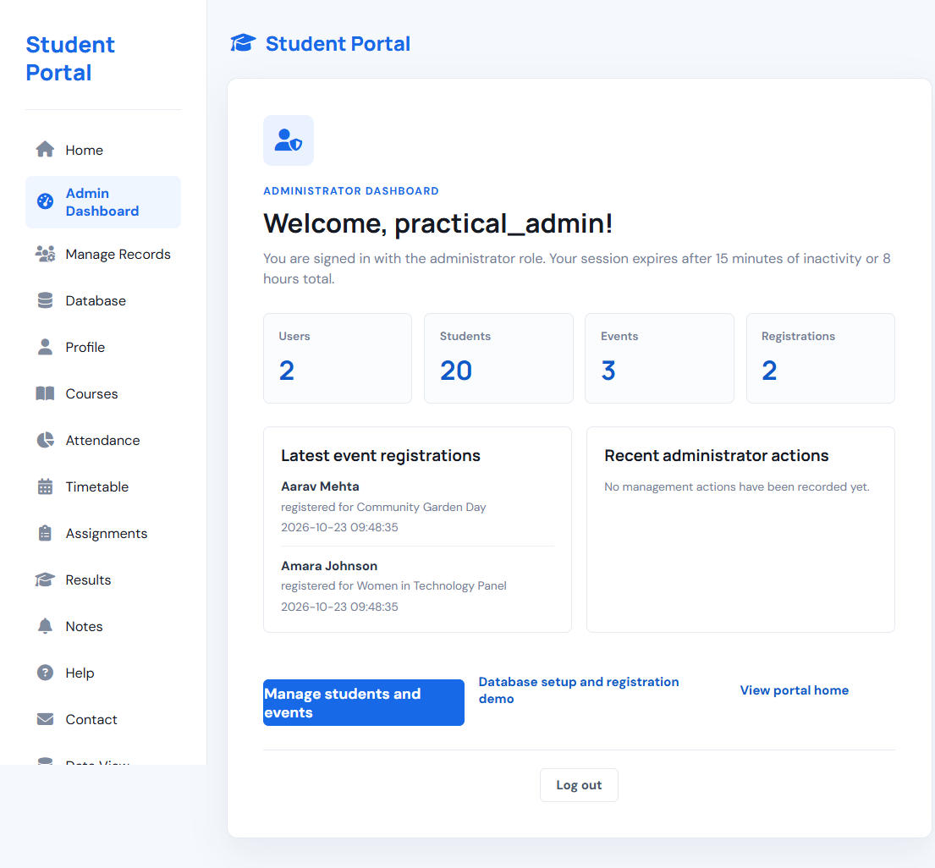
Figure 1. StudentHub administrator dashboard (captured 23 October 2026).

9. Conclusion
The administrator dashboard demonstrates server-side role checks, session-based authentication, and live summary data from MySQL. Registering a user does not automatically grant administrator privileges; a trusted account must be explicitly promoted. The captured result confirms that the local administrator can reach the protected dashboard and view the portal data.

10. Viva Questions
1. Why is a password hash stored instead of a plain-text password?
2. What is the difference between authentication and authorization?
3. Why must the role check be performed on the server for every protected request?
4. What security benefit does session_regenerate_id() provide after login?
5. Why should role promotion be limited to a trusted database administrator?

References
- ITUE203: Web Development Frameworks lab manual (attached reference, A.Y. 2026-27).
- StudentHub project README.md and php/DATABASE-SETUP.md.
- PHP documentation: Sessions and password_hash()/password_verify().

