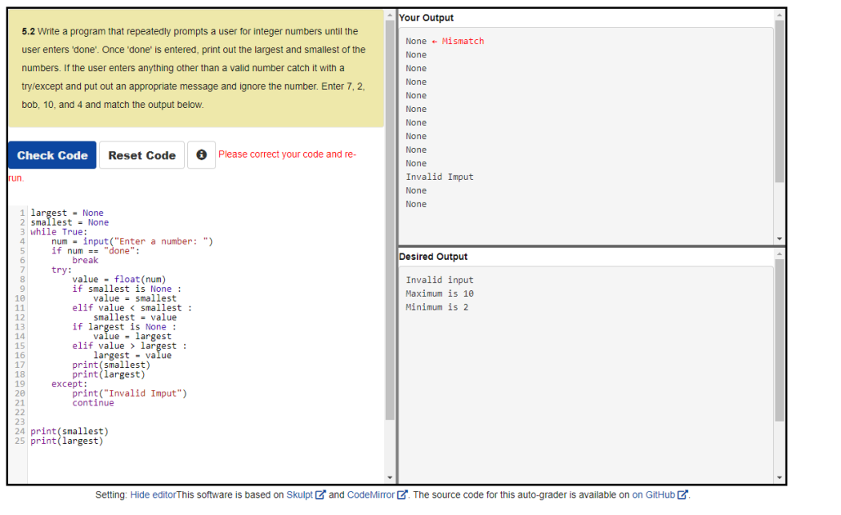
largest = None
smallest = None
while True:
num = input("Enter a number: ")
if num == "done":
break
try: value = float(num)
if smallest is None :
value = smallest
elif value < smallest :
smallest = value
if largest is None :
value = largest
elif value > largest :
largest = value
print(smallest)
print(largest)
except:
print("Invalid Imput")
continue

print(largest)
print(smallest)

