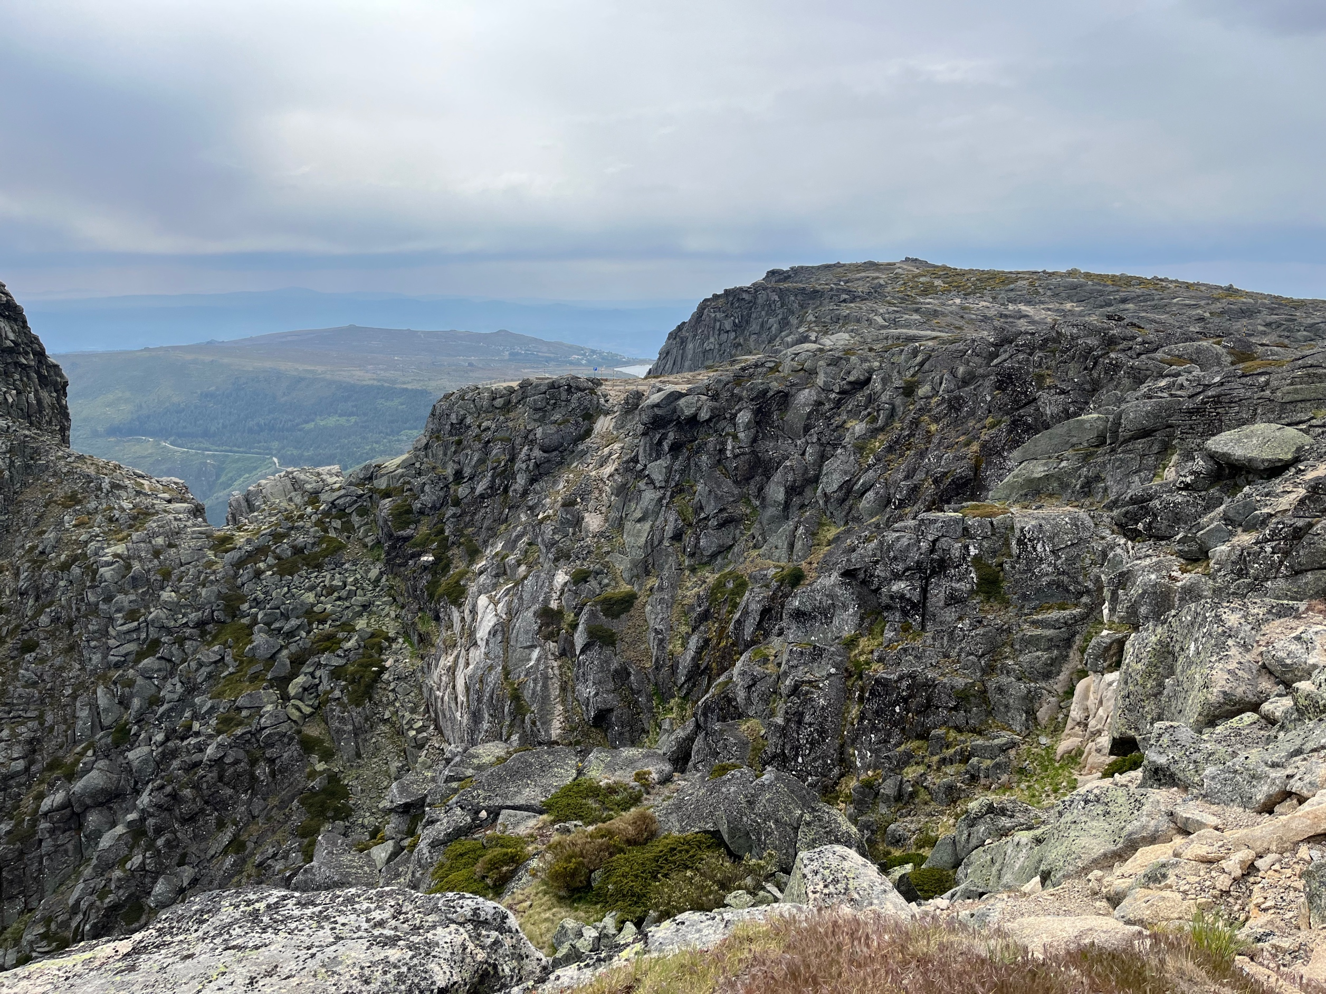This is a landscape page. The rules help you to determine the percentages of the scroll API.

The image is only there to make the demo look less boring.