Experiment No: 11
Implementation of Point Clipping Algorithm using OpenGL in Python
Aim:
To implement and analyze the 2D Point Clipping algorithm in Python using OpenGL, and to evaluate the visibility of arbitrary 2D points against a defined rectangular clipping window across interior, exterior, mixed, and boundary test cases.
Problem Statement:
Input / Setup:
A 2D rectangular clipping window defined by lower-left corner (Xmin, Ymin) = (100, 100) and upper-right corner (Xmax, Ymax) = (400, 300) on a 500 x 400 orthographic display canvas, together with an arbitrary set of input points P(x, y).
Process / Constraint:
For each point P(x, y), determine whether it lies within or on the boundaries of the clipping window by verifying the four standard boundary inequalities: Xmin <= x <= Xmax and Ymin <= y <= Ymax. Points satisfying all four conditions are accepted and retained for display; points failing any condition are rejected and discarded from the active rendering window.
Output:
A visual OpenGL window showing the rectangular clipping perimeter, with accepted points plotted in green, rejected points plotted in red, point coordinate annotations, and terminal diagnostic verification.
Theory:
Clipping is an essential procedure in computer graphics that extracts the visible portion of a scene relative to a defined display region (the clipping window) and discards geometry falling outside this region. This prevents redundant rasterization calculations and avoids rendering outside designated screen viewports.
1. Mathematical Basis of Point Clipping:
A point P(x, y) in a 2D Cartesian plane is accepted (visible) if and only if it satisfies the following four boundary inequalities simultaneously:
- x >= Xmin (point lies to the right of or on the left clipping boundary)
- x <= Xmax (point lies to the left of or on the right clipping boundary)
- y >= Ymin (point lies above or on the bottom clipping boundary)
- y <= Ymax (point lies below or on the top clipping boundary)
Combining these conditions gives the compound logical inequality:
- Xmin <= x <= Xmax AND Ymin <= y <= Ymax
2. Boundary and Corner Evaluation:
Because the clipping boundary lines are inclusive (using <= and >=), points that lie exactly on the edges or at the corner vertices of the clipping window are considered inside and are accepted. Points located even one coordinate unit beyond the boundary fail the inequality check and are rejected.
3. Computational Efficiency:
Point clipping requires at most four simple numerical comparisons per point: two for the x-axis and two for the y-axis. The time complexity per point is O(1), and processing a list of N points takes O(N) total time. It serves as the baseline test for more sophisticated primitives, such as line and polygon clipping.
Working Example / Visualizing the Process:
Consider the clipping window with Xmin = 100, Ymin = 100, Xmax = 400, Ymax = 300, and the five test points from Test Case 3 (Mixed Distribution). Each point is tested against the four individual boundary conditions:
Point P(x, y) | x >= 100 | x <= 400 | y >= 100 | y <= 300 | Combined Result | Visual Status
(60, 150) | False (60 < 100) | True | True | True | False | REJECTED (Red)
(200, 150) | True | True | True | True | True | ACCEPTED (Green)
(300, 250) | True | True | True | True | True | ACCEPTED (Green)
(450, 200) | True | False (450 > 400) | True | True | False | REJECTED (Red)
(250, 50) | True | True | False (50 < 100) | True | False | REJECTED (Red)
Table 11.1: Detailed inequality evaluation for Test Case 3 (Mixed Distribution)
Algorithm / Methodology:
The complete point clipping process follows six straightforward steps:
- 1. Initialize Clipping Window: Define boundaries Xmin, Ymin, Xmax, and Ymax.
- 2. Read Input Points: Obtain the coordinate pair (x, y) for each candidate point.
- 3. Horizontal Check: Verify whether x satisfies Xmin <= x <= Xmax. If false, flag point as REJECTED.
- 4. Vertical Check: Verify whether y satisfies Ymin <= y <= Ymax. If false, flag point as REJECTED.
- 5. Classification: If both horizontal and vertical checks succeed, flag point as ACCEPTED.
- 6. Render and Feedback: Display the clipping window, plot accepted points in green, plot rejected points in red, and print diagnostic decisions to the console.
Implementation:
The core clipping decision function and OpenGL rendering routine from point_clipping.py are shown below:
# clipping window boundaries
XMIN, YMIN = 100, 100
XMAX, YMAX = 400, 300
def clip_point(x, y):
# point is saved if it lies inside or right on the boundary
return XMIN <= x <= XMAX and YMIN <= y <= YMAX
def draw_points():
glPointSize(8)
for x, y in points:
if clip_point(x, y):
glColor3f(0.15, 0.7, 0.2) # green for accepted point
else:
glColor3f(0.85, 0.15, 0.15) # red for rejected point
glBegin(GL_POINTS)
glVertex2f(x, y)
glEnd()
# small offset so labels don't overlap points or borders
tx = x - 50 if (x < XMIN or x >= XMAX) else x + 6
ty = y + 8 if y > YMAX else (y - 14 if y == YMAX else y + 6)
draw_text(tx, ty, f'({x},{y})')
Test Cases:
Four comprehensive test cases were designed to evaluate all possible spatial relationships between points and the clipping window:
Test Case | Description | Total Points | Accepted (Green) | Rejected (Red) | Validation Status
TC1 | All points positioned strictly inside window | 4 | 4 | 0 | Pass
TC2 | All points positioned outside in exterior regions | 5 | 0 | 5 | Pass
TC3 | Mixed points distributed inside and outside | 5 | 2 | 3 | Pass
TC4 | Points located on window edges, corners, and 1 px outside | 8 | 6 | 2 | Pass
Table 11.2: Summary of Point Clipping Benchmark Test Cases
TC1 — All Points Inside:
Points: (150, 150), (250, 200), (350, 250), (200, 280). All four points satisfy 100 <= x <= 400 and 100 <= y <= 300, rendering in green.
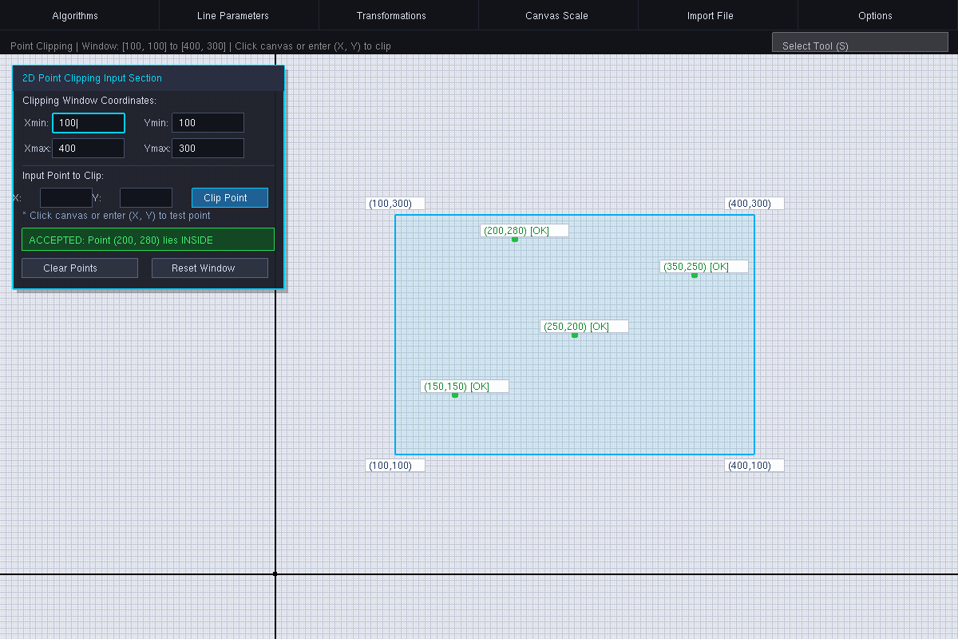
Figure 11.1: TC1 — All test points lie strictly inside the clipping window (4 accepted, 0 rejected).
TC2 — All Points Outside:
Points: (50, 50), (450, 350), (250, 350), (50, 200), (250, 50). All five points violate at least one boundary inequality, rendering in red.
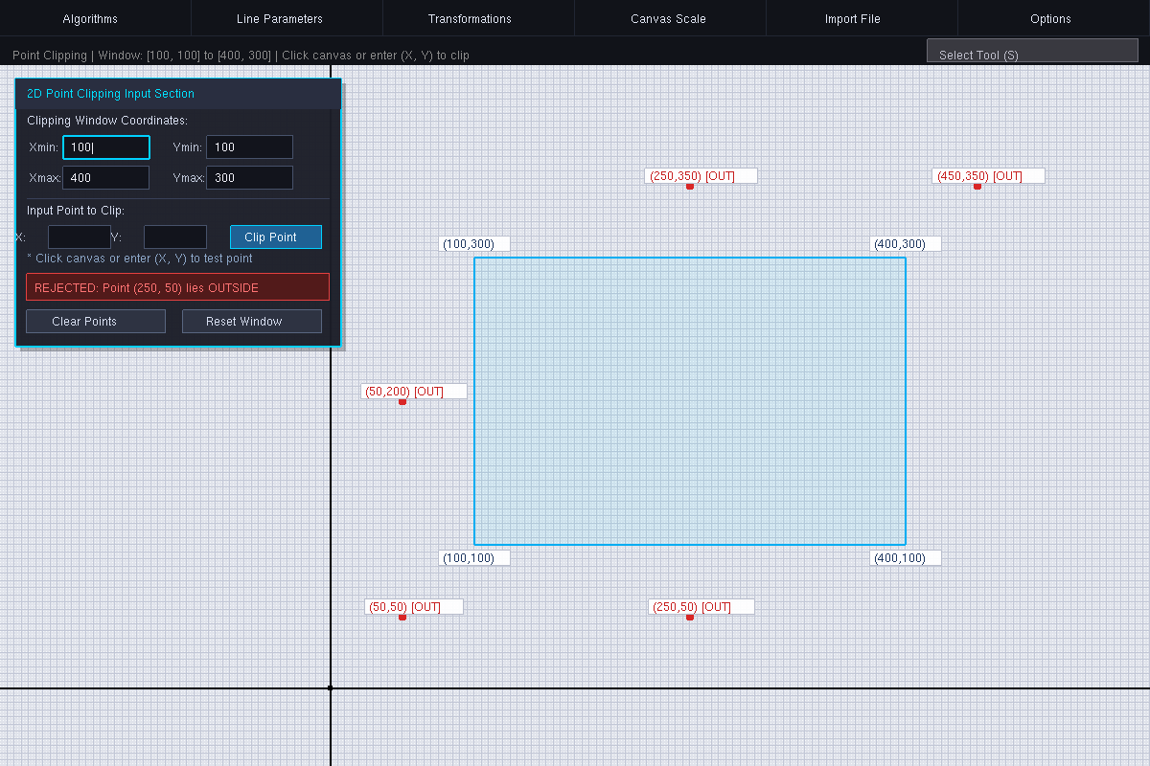
Figure 11.2: TC2 — All test points lie outside the clipping window in exterior zones (0 accepted, 5 rejected).
TC3 — Mixed Inside and Outside:
Points: (60, 150), (200, 150), (300, 250), (450, 200), (250, 50). Two points lie inside (green), while three points lie outside (red).
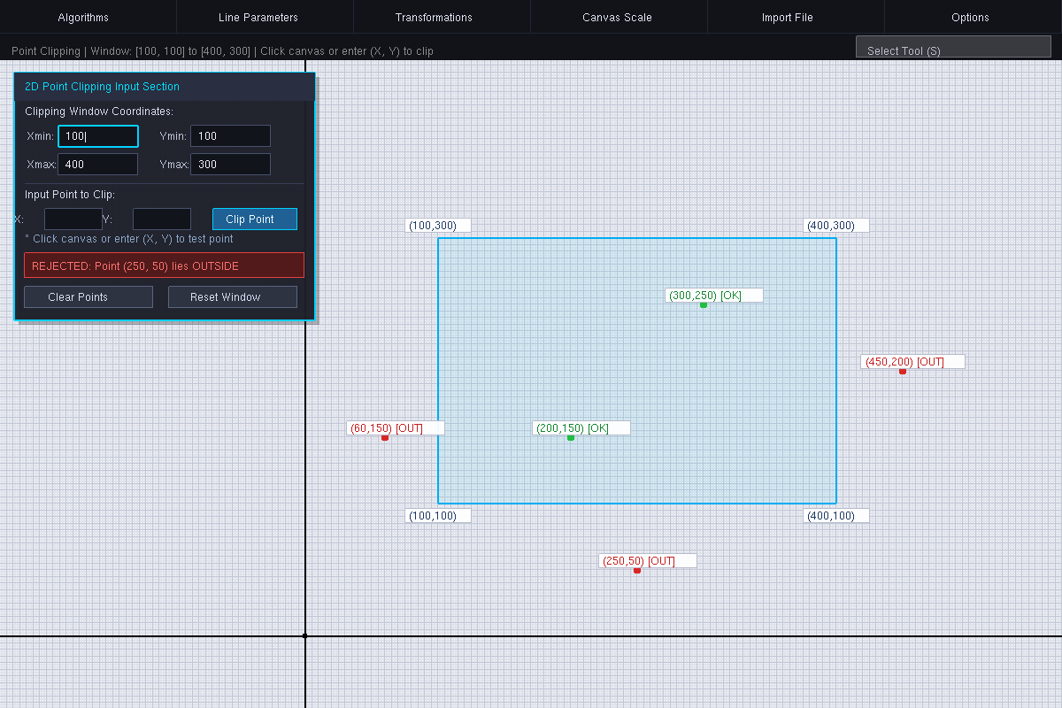
Figure 11.3: TC3 — Mixed distribution with 2 interior accepted points and 3 exterior rejected points.
TC4 — Boundary, Corner, and Adjacent Points:
Boundary points: (100, 100), (400, 300), (250, 100), (100, 200), (400, 150), (250, 300). These six points satisfy the inclusive inequalities and are accepted (green). Points (99, 200) and (250, 301) are offset by exactly 1 pixel outside the window and are rejected (red).
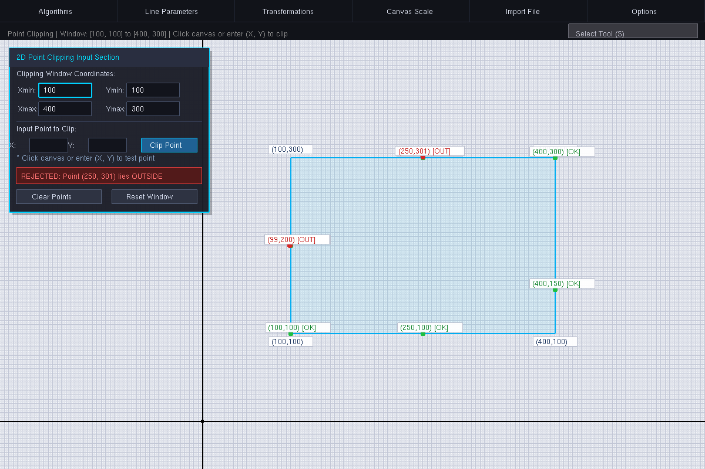
Figure 11.4: TC4 — Boundary and corner verification showing 6 accepted boundary points and 2 rejected 1-pixel exterior points.
Observations / Test Cases:
Test Case | Tested Coordinates | Expected Behavior | Observed Behavior | Status
TC1 | 4 points within [100, 400] x [100, 300] | All points accepted | 4 green points plotted | Pass
TC2 | 5 points outside bounds | All points rejected | 5 red points plotted | Pass
TC3 | 2 inside, 3 outside points | 2 accepted, 3 rejected | 2 green and 3 red points | Pass
TC4 | 6 on edges/corners, 2 outside by 1 px | Boundary accepted, 1px out rejected | 6 green and 2 red points | Pass
Table 11.3: Observation results for all point clipping test cases
Result:
- The Point Clipping algorithm was successfully implemented in Python using OpenGL and FreeGLUT.
- All four test cases (inside, outside, mixed, and boundary/corner conditions) executed correctly with exact visual color-coding and matching terminal diagnostics.
- Boundary precision was confirmed: points lying on the window perimeter (e.g. x = 100 or y = 300) were correctly accepted, while points lying just one coordinate unit beyond (e.g. x = 99 or y = 301) were rejected.
Conclusion:
Point clipping provides the conceptual foundation for all 2D clipping algorithms in computer graphics. By evaluating points against the four boundary inequalities, the algorithm provides an optimal O(1) time complexity per point with zero floating-point division or trigonometric overhead. The experiment confirms that inclusive inequality boundaries correctly retain edge and corner pixels, providing a clean, reliable filtering mechanism before rasterization.
Source Code and Analysis (GitHub):
https://github.com/TheNormalCoderr/computer_graphics_experiments

