Experiment 6
Implementation of 2D Basic Transformations using OpenGL in Python
Aim:
To implement the 2D basic geometric transformations (Translation, Scaling, and Rotation) in Python using homogeneous coordinates and PyOpenGL, and to render the visual comparison between the original and transformed polygon on an annotated Cartesian grid.
Problem Statement:
Given an n-sided 2D polygon defined by vertices V = {(x1, y1), (x2, y2), ..., (xn, yn)}, apply a specified basic geometric transformation with parameters (tx, ty for translation; sx, sy for scaling; and angle theta for rotation about the origin) to obtain the transformed vertex set V'. The transformation must be formulated using 3x3 homogeneous matrix representation, and both the original and transformed polygons must be displayed simultaneously on an interactive reference coordinate system.
Input / Setup:
A list of 2D coordinates representing polygon vertices; transformation type and associated numerical parameters; canvas resolution 960 x 700 pixels with a 20 x 16 reference grid.
Process / Constraint:
Compute the 3x3 homogeneous transformation matrix M; map each vertex [x, y, 1]^T to [x', y', 1]^T = M · [x, y, 1]^T; render original shape in blue and transformed shape in red.
Output:
Rendered comparison windows and exported PNG images demonstrating each transformation.
Theory:
Geometric transformations are fundamental operations in computer graphics used to reposition, resize, and orient objects within a scene. By using Cartesian coordinates alone, translation involves vector addition whereas scaling and rotation involve matrix multiplication. To unify all affine transformations into a single consistent matrix multiplication operation, homogeneous coordinates are used.
In homogeneous coordinates, a 2D point (x, y) is represented as a 3D column vector [x, y, 1]^T. The standard 3x3 transformation matrices are defined as follows:
- Translation: Displaces a point by (tx, ty): x' = x + tx, y' = y + ty.
- Scaling: Multiplies coordinate distances from the origin by factors sx and sy: x' = x · sx, y' = y · sy.
- Rotation: Rotates a point counter-clockwise about the origin by angle θ: x' = x cos θ - y sin θ, y' = x sin θ + y cos θ.
Algorithm / Methodology:
1. Input the polygon vertices V = {(x1, y1), ..., (xn, yn)} and transformation parameters.
2. Construct the 3x3 transformation matrix M according to the chosen transformation:
- Translation: M = [[1, 0, tx], [0, 1, ty], [0, 0, 1]]
- Scaling: M = [[sx, 0, 0], [0, sy, 0], [0, 0, 1]]
- Rotation: M = [[cos θ, -sin θ, 0], [sin θ, cos θ, 0], [0, 0, 1]]
3. For each vertex (x, y) in V, compute [x', y', 1]^T = M · [x, y, 1]^T.
4. Extract the transformed Cartesian coordinates (x', y').
5. Render the Cartesian grid, axes, original shape (blue), and transformed shape (red) using OpenGL.
Implementation & Test Cases:
Test Case | Original Vertices | Transformation | Parameters | Transformed Vertices
Test Case 1 - Translation (tx=4, ty=3) | [(2, 2), (5, 2), (5, 5), (2, 5)] | Translation | tx=4, ty=3 | [(6.0, 5.0), (9.0, 5.0), (9.0, 8.0), (6.0, 8.0)]
Test Case 2 - Scaling (sx=1.8, sy=1.5) | [(2, 2), (5, 2), (5, 5), (2, 5)] | Scaling | sx=1.8, sy=1.5 | [(3.6, 3.0), (9.0, 3.0), (9.0, 7.5), (3.6, 7.5)]
Test Case 3 - Rotation (theta = 45 deg about origin) | [(7, 2), (10, 2), (10, 5), (7, 5)] | Rotation | angle_deg=45 | [(3.54, 6.36), (5.66, 8.49), (3.54, 10.61), (1.41, 8.49)]
Table 6.1: Test Cases for 2D Basic Transformations
Relevant Implementation Code:
The following excerpt constructs the selected homogeneous matrix and applies it to every polygon vertex. The same function is used by the report generator and the interactive visualizer.
def apply_transformation(vertices, transform_name, params):
if transform_name == "translation":
M = translation_matrix(params["tx"], params["ty"])
elif transform_name == "scaling":
M = scaling_matrix(params["sx"], params["sy"])
elif transform_name == "rotation":
M = rotation_matrix(params["angle_deg"])
else:
raise ValueError(f"Unknown transformation: {transform_name}")
transformed = [mat3_transform_point(M, x, y) for x, y in vertices]
return transformed, M
Test Case 1 - Translation (tx=4, ty=3)
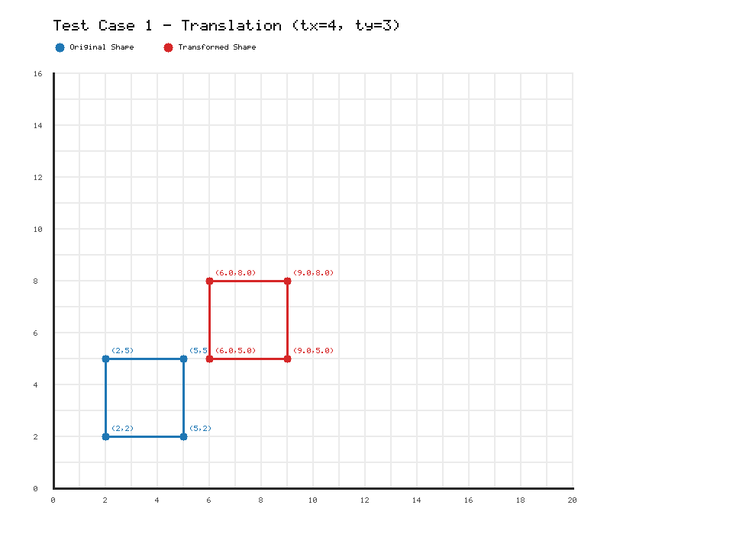
Visual result for Test Case 1 - Translation (tx=4, ty=3)
Test Case 2 - Scaling (sx=1.8, sy=1.5)
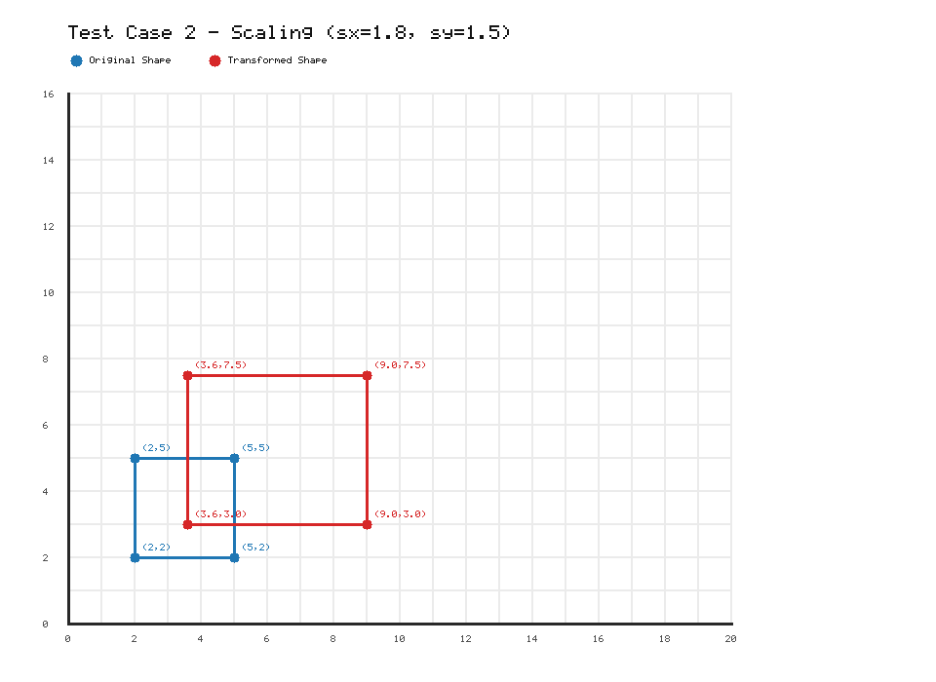
Visual result for Test Case 2 - Scaling (sx=1.8, sy=1.5)
Test Case 3 - Rotation (theta = 45 deg about origin)
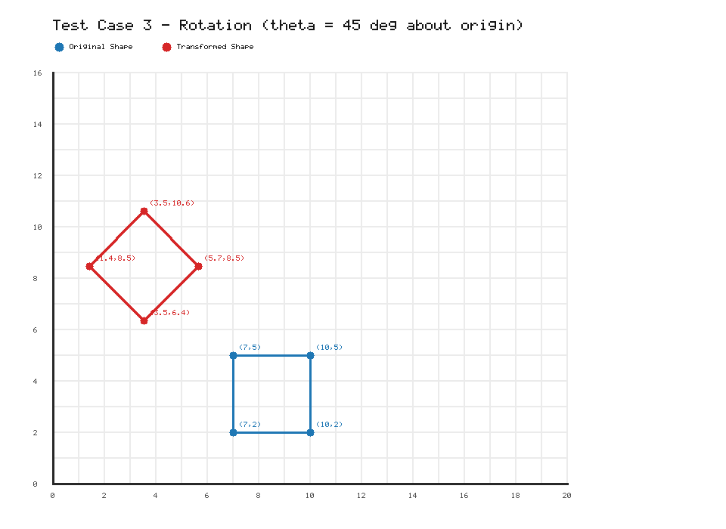
Visual result for Test Case 3 - Rotation (theta = 45 deg about origin)
Result:
The 2D basic transformation algorithms for translation, scaling, and rotation were successfully implemented using homogeneous coordinate matrices. All test cases produced mathematically accurate transformed vertices and visually verified plots rendered on the OpenGL canvas.
Conclusion:
Homogeneous coordinate representation enables all basic 2D geometric transformations to be treated uniformly as 3x3 matrix multiplications. This provides a clean mathematical foundation for the graphics pipeline, allowing seamless compounding and consistent hardware or software implementation.
Source Code and Analysis (GitHub):
https://github.com/TheNormalCoderr/computer_graphics_experiments

