Experiment 7
Implementation of 2D Composite Transformations using OpenGL in Python
Aim:
To implement 2D composite (concatenated) geometric transformations in Python using 3x3 homogeneous coordinate matrices and PyOpenGL, specifically evaluating rotation about an arbitrary pivot point, scaling about an arbitrary fixed point, reflection across an arbitrary axis, and multi-step composite transformation sequences.
Problem Statement:
Standard basic transformations operate exclusively relative to the coordinate origin (0, 0). In practical computer graphics applications, objects must be rotated about custom pivot points, scaled relative to arbitrary fixed points, or reflected across arbitrary lines. Applying each transformation sequentially to every vertex requires k x O(N) operations. The goal is to formulate and pre-multiply the sequence of elementary transformation matrices into a single 3x3 composite matrix M_composite, then apply M_composite to all vertices in a single pass O(N) while rendering both original and transformed shapes alongside reference markers.
Input / Setup:
Polygon vertices; parameters for arbitrary pivot point (xp, yp) and angle θ; parameters for fixed point (xf, yf) and scale factors (sx, sy); two endpoints (x1, y1) and (x2, y2) defining an arbitrary reflection axis; or parameters for a multi-step sequence.
Process / Constraint:
Compute composite matrix M = M_k · ... · M_1 using matrix multiplication in correct associative order; transform vertices [x', y', 1]^T = M · [x, y, 1]^T; render original shape (blue), transformed shape (red), and pivot or reflection axis (green).
Output:
Comparison graphics with labeled vertices, axes, pivot markers, and saved high-resolution PNG outputs.
Theory:
A composite transformation is formed by combining multiple elementary affine transformations. By representing transformations in 3x3 homogeneous coordinates, matrix concatenation is possible. Because matrix multiplication is associative but non-commutative, the chronological order of operations is preserved by pre-multiplying newer matrices from the left:
M_composite = M_n · ... · M_2 · M_1
Key composite transformations derived in this experiment include:
- Rotation About Arbitrary Pivot (xp, yp): Translate pivot to origin T(-xp, -yp), rotate by θ R(θ), then translate back T(xp, yp): M = T(xp, yp) · R(θ) · T(-xp, -yp).
- Scaling About Fixed Point (xf, yf): Translate fixed point to origin T(-xf, -yf), scale by (sx, sy) S(sx, sy), then translate back T(xf, yf): M = T(xf, yf) · S(sx, sy) · T(-xf, -yf).
- Reflection Across Arbitrary Axis (x1, y1) to (x2, y2): Translate axis to origin T(-x1, -y1), rotate by -θ to align with X-axis R(-θ), reflect across X-axis Ref_x, invert rotation R(θ), invert translation T(x1, y1): M = T(x1, y1) · R(θ) · Ref_x · R(-θ) · T(-x1, -y1).
- Multi-step Composite Sequence: Direct concatenation of translation, rotation, and scaling: M = S · R · T.
Algorithm / Methodology:
1. Define the input polygon vertices V = {(x1, y1), ..., (xn, yn)}.
2. Identify the required sequence of elementary transformations and their parameters.
3. For each elementary step, generate the corresponding 3x3 homogeneous matrix (T, R, S, or Ref).
4. Compute the net composite matrix M by multiplying the transformation matrices in sequential order.
5. For each vertex (x, y) in V, compute [x', y', 1]^T = M · [x, y, 1]^T.
6. Display the original shape (blue), transformed shape (red), pivot/axis indicators (green), and coordinate labels on the OpenGL canvas.
Implementation & Test Cases:
Test Case | Type | Original Vertices | Parameters | Transformed Vertices
TC1 - Rotation About Pivot (5,5) by 45 deg | pivot_rotation | [(3, 3), (7, 3), (7, 7), (3, 7)] | pivot_x=5.0, pivot_y=5.0, angle_deg=45.0 | [(5.0, 2.17), (7.83, 5.0), (5.0, 7.83), (2.17, 5.0)]
TC2 - Scaling About Fixed Point (3,3) | fixed_point_scaling | [(3, 3), (7, 3), (5, 6)] | fixed_x=3.0, fixed_y=3.0, sx=1.6, sy=1.6 | [(3.0, 3.0), (9.4, 3.0), (6.2, 7.8)]
TC3 - Reflection About Arbitrary Axis | axis_reflection | [(3, 6), (7, 8), (5, 10)] | x1=1.0, y1=2.0, x2=13.0, y2=11.0 | [(5.4, 2.8), (8.44, 6.08), (9.8, 3.6)]
TC4 - Scaling Along Arbitrary Axis (45 deg) | axis_scaling | [(4, 4), (7, 4), (7, 7), (4, 7)] | x1=2.0, y1=2.0, x2=12.0, y2=12.0, s_along=1.8, s_perp=0.8 | [(5.6, 5.6), (9.5, 7.1), (11.0, 11.0), (7.1, 9.5)]
TC5 - Composite: Translate -> Rotate -> Scale | general_sequence | [(2, 2), (5, 2), (5, 5), (2, 5)] | tx=2.0, ty=1.0, pivot_x=6.0, pivot_y=5.0, angle_deg=30.0, sx=1.2, sy=1.2 | [(6.32, 2.72), (9.44, 4.52), (7.64, 7.64), (4.52, 5.84)]
Table 7.1: Test Cases for 2D Composite Transformations
TC1 - Rotation About Pivot (5,5) by 45 deg
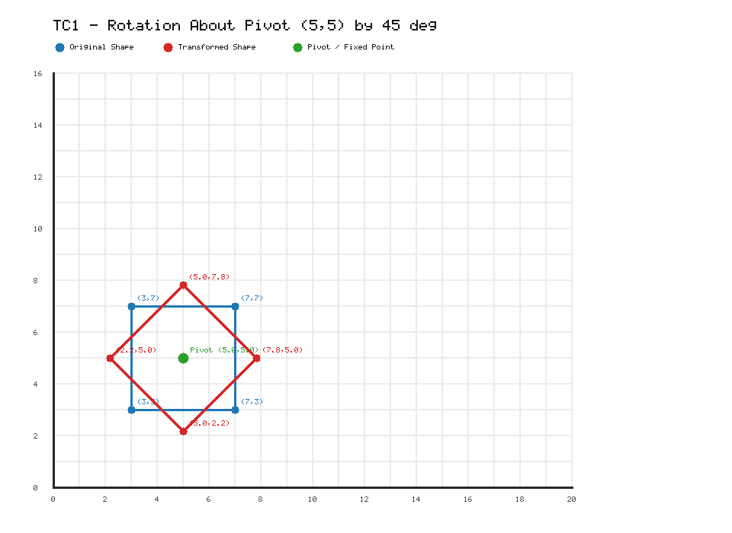
Visual result for TC1 - Rotation About Pivot (5,5) by 45 deg
TC2 - Scaling About Fixed Point (3,3)
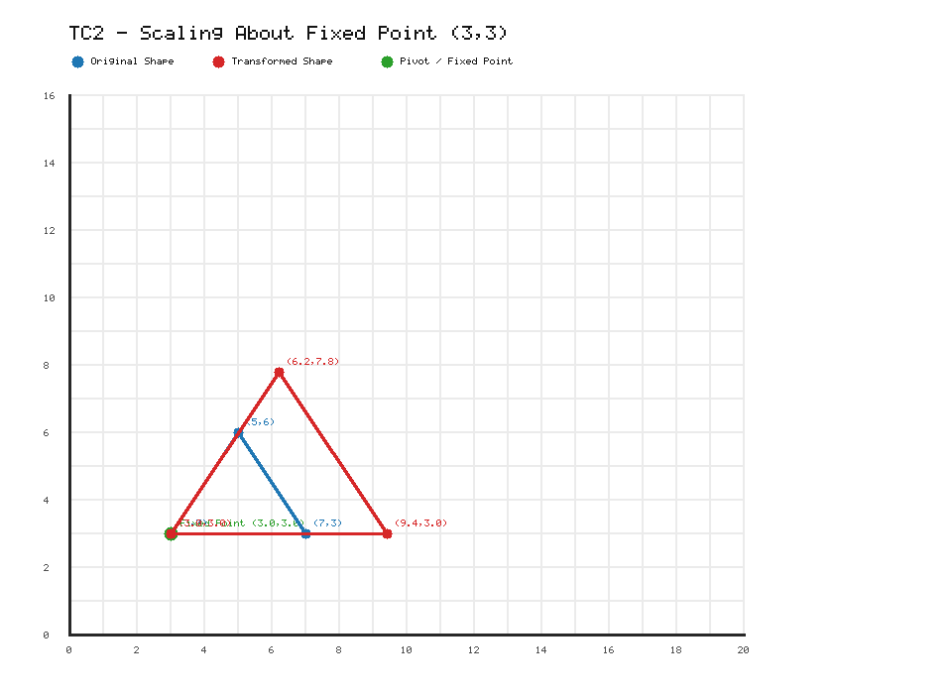
Visual result for TC2 - Scaling About Fixed Point (3,3)
TC3 - Reflection About Arbitrary Axis
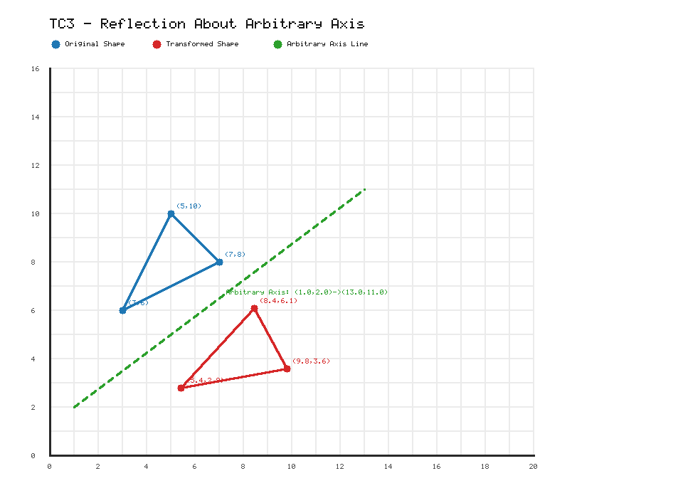
Visual result for TC3 - Reflection About Arbitrary Axis
TC4 - Scaling Along Arbitrary Axis (45 deg)
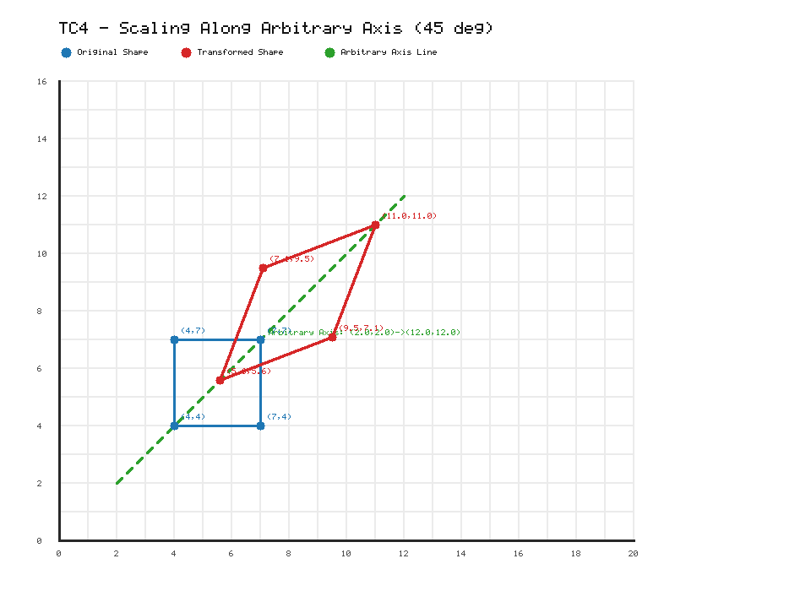
Visual result for TC4 - Scaling Along Arbitrary Axis (45 deg)
TC5 - Composite: Translate -> Rotate -> Scale
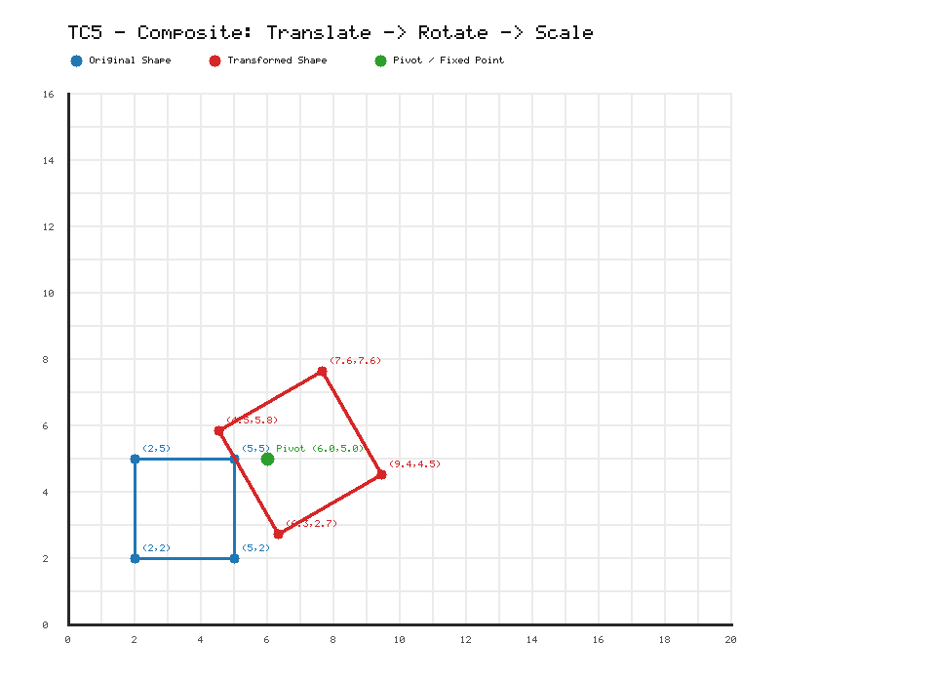
Visual result for TC5 - Composite: Translate -> Rotate -> Scale
Result:
All five composite transformation test cases (pivot point rotation, fixed-point scaling, arbitrary axis reflection, arbitrary-axis scaling, and general multi-stage sequence) were successfully evaluated and rendered. The pre-multiplied composite matrices produced mathematically exact transformed coordinates, confirmed by visual alignment with reference pivot points and axis lines.
Conclusion:
Matrix concatenation via 3x3 homogeneous coordinates drastically enhances computational efficiency in 2D computer graphics. Complex spatial manipulations such as arbitrary-axis reflections and arbitrary-pivot rotations can be reduced to a single matrix multiplication per vertex, proving the indispensability of homogeneous matrix formulations.
Source Code and Analysis (GitHub):
https://github.com/TheNormalCoderr/computer_graphics_experiments

