To access the Lab –

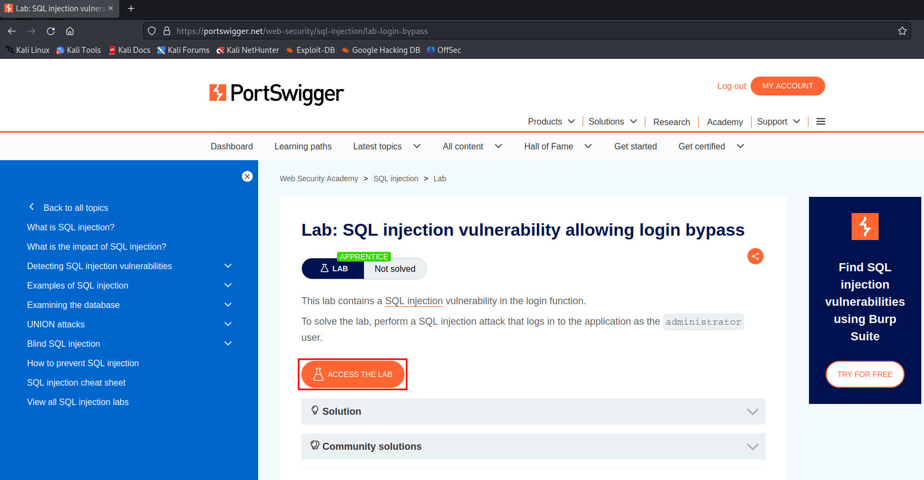

Open Burp and intercept the login page.

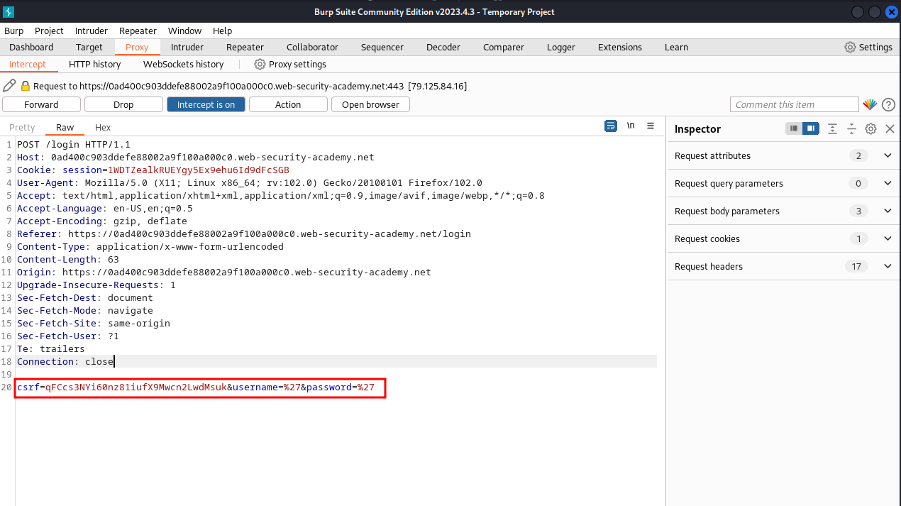

Here we can see the username and password parameter. Forward this to repeater.

To exploit this –

Just change the username parameter to administrator’ – and send it.

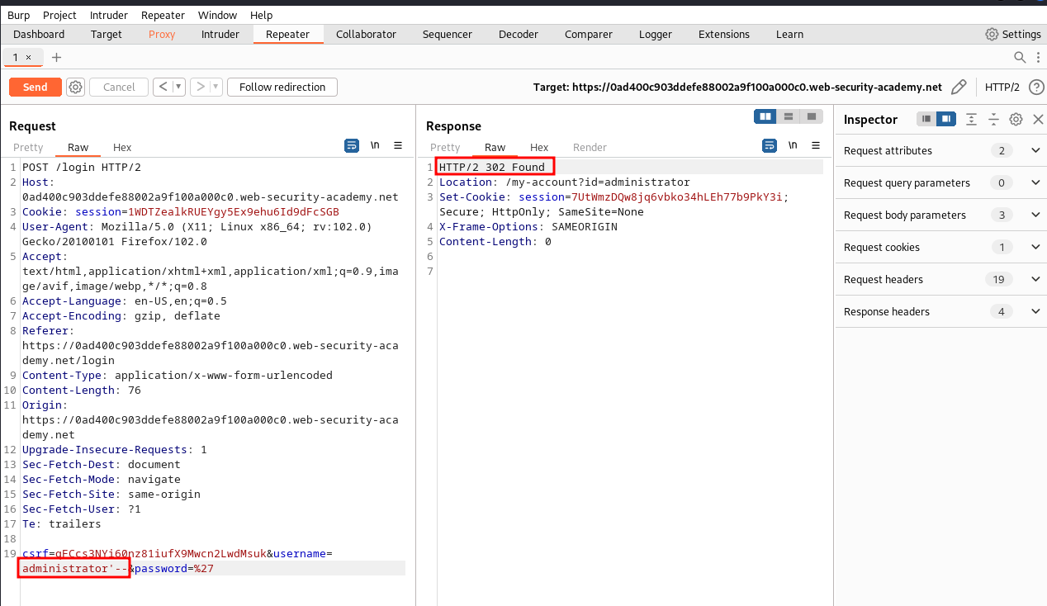

We can see that the forwarded request is successful and we get a login.

If we do the same thing using the website,

