To access the Lab –

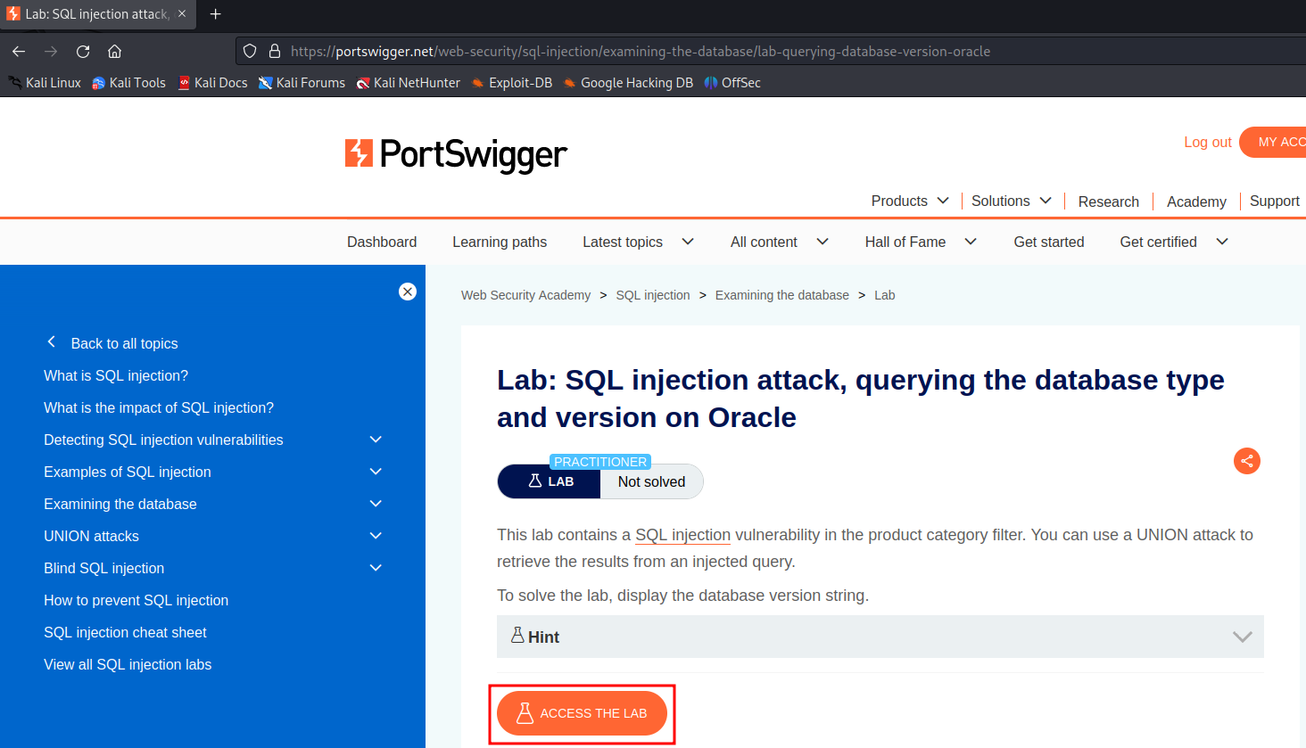

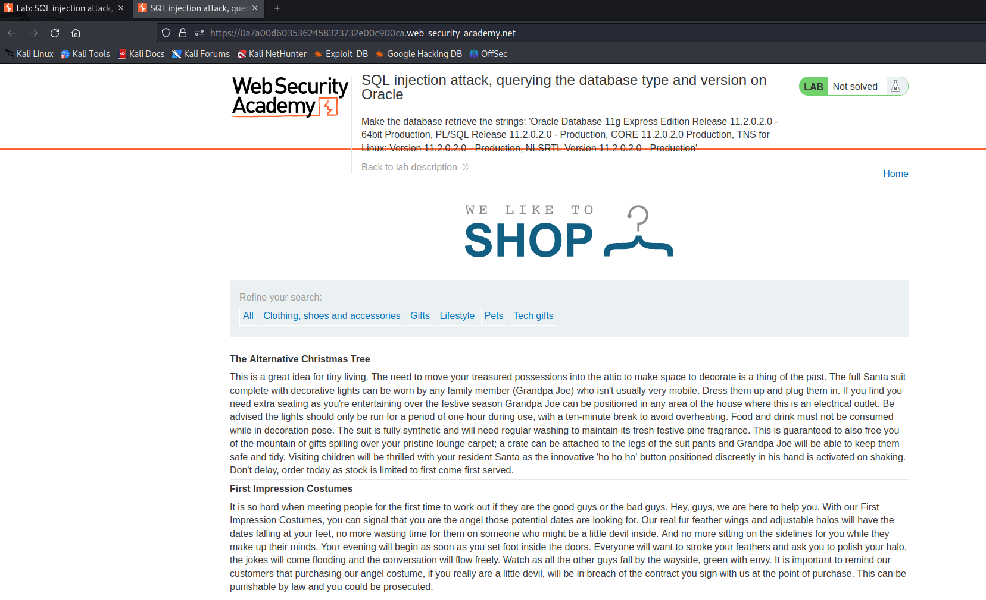

Intercept the request on Burp and send to repeater

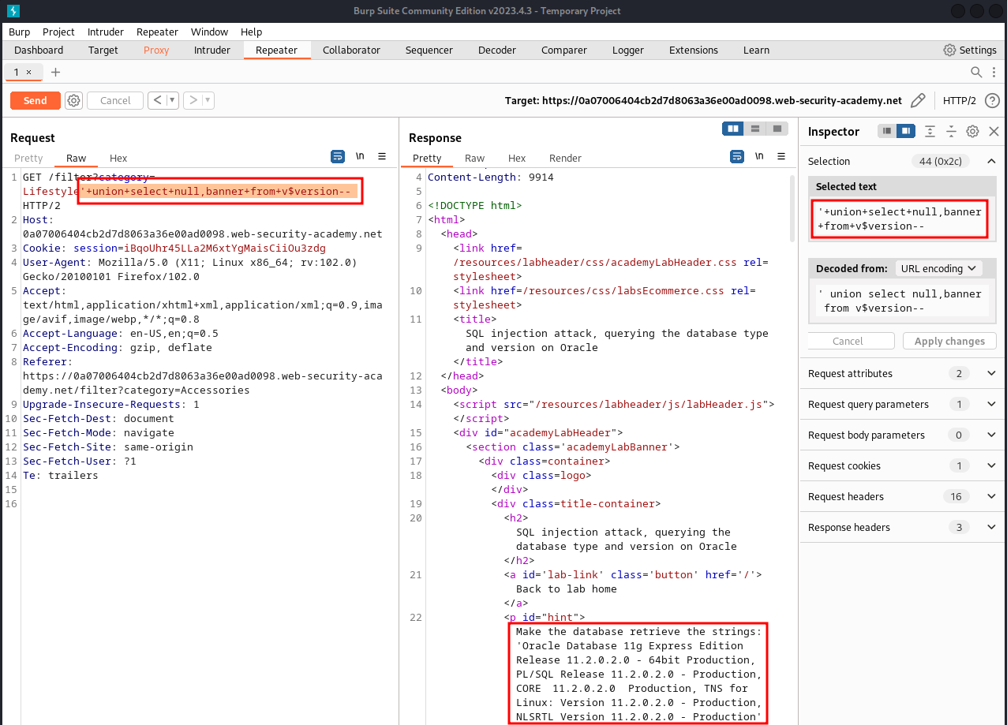

On repeater, URL – We can use the SQLi cheatsheet and get the version of Oracle database being used.

**'+union+select+null,banner+from+v$version—**

Here, we can see the version running is 11.2.0.2.0

