To Access the Lab –

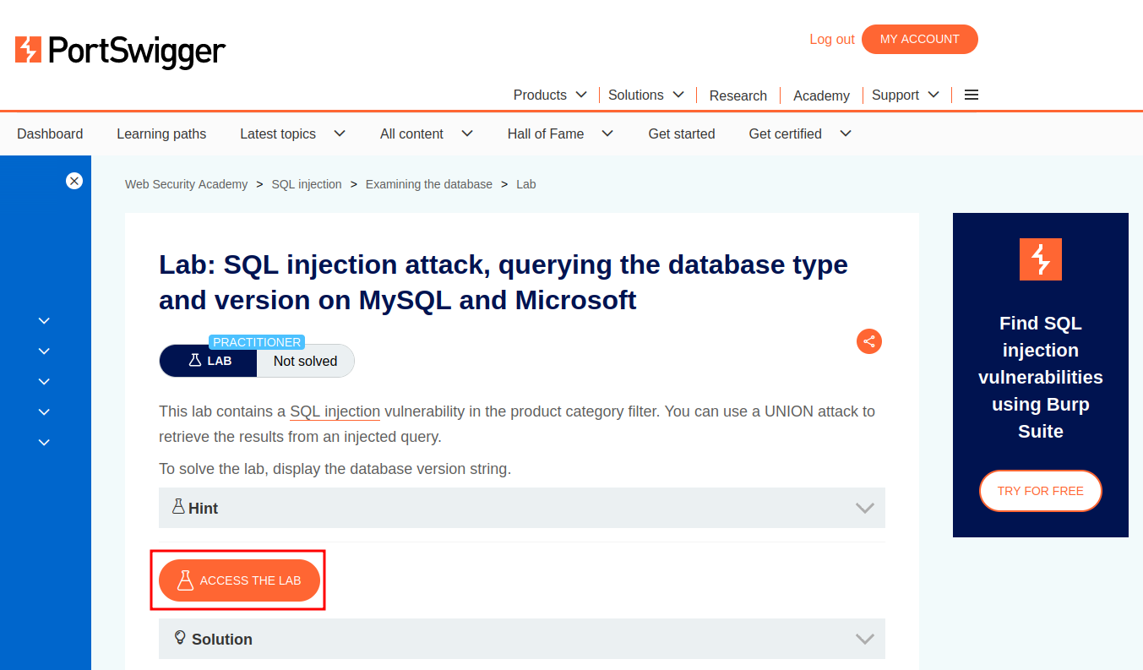

Intercept the request on Burp and send to repeater,

On repeater, URL – We can use the SQLi cheatsheet to determine the number of columns that are being returned by the query and which columns contain text data.

**'+UNION+SELECT+'abc','def'#**

Next, to display the database version,

**'+UNION+SELECT+@@version,+NULL#**

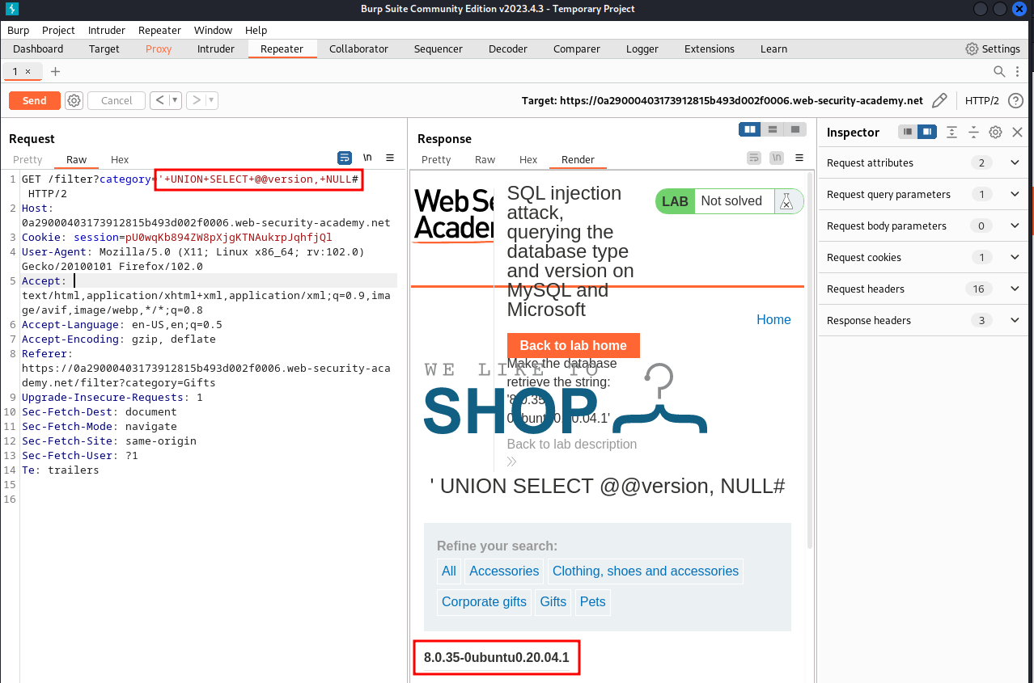

Once we forward the request, we can see the version.

