To Access the Lab –

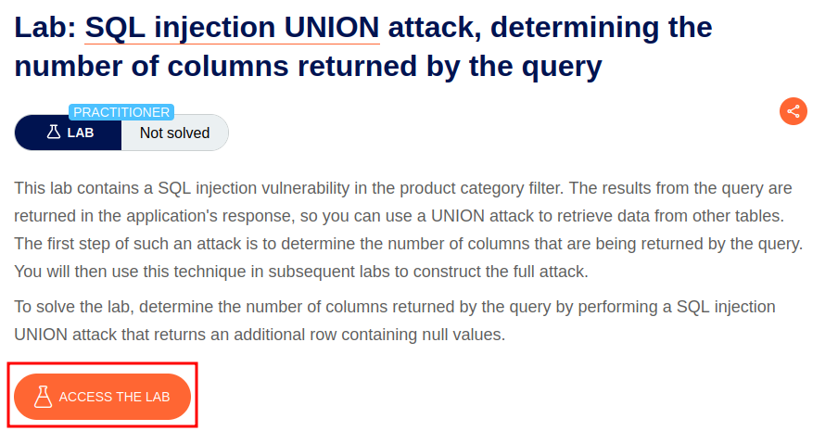

Intercept the request on Burp and send to repeater,

On repeater, URL – We can use the SQLi cheatsheet to determine the number of columns that are being returned by the query and which columns contain text data.

To retrieve the number of columns returned, we run the command

**'+UNION+SELECT+NULL,NULL,NULL--**

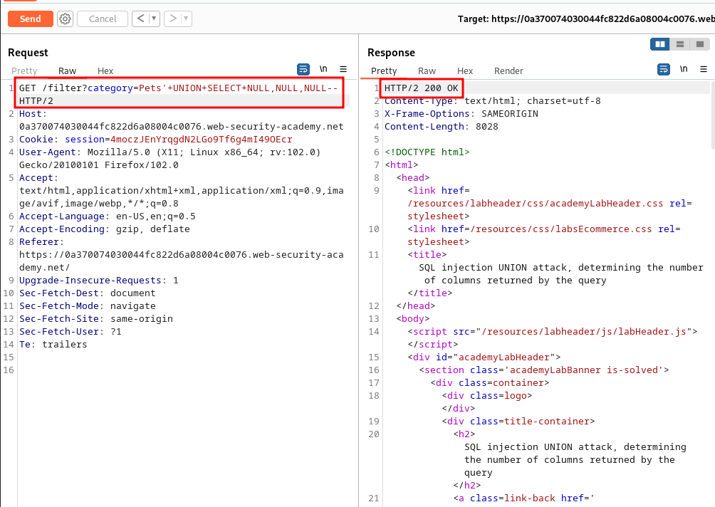

Once we forward the request, we get the successful message.

