To Access the Lab –

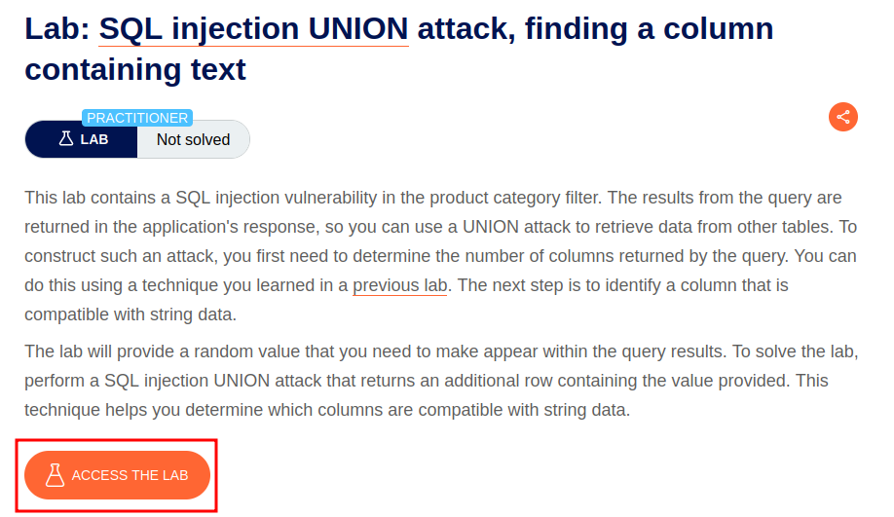

Intercept the request on Burp and send to repeater,

On repeater, URL – We can use the SQLi cheatsheet to determine the number of columns that are being returned by the query and which columns contain text data.

To find number of columns, we run the command

**'+UNION+SELECT+NULL,NULL,NULL—**

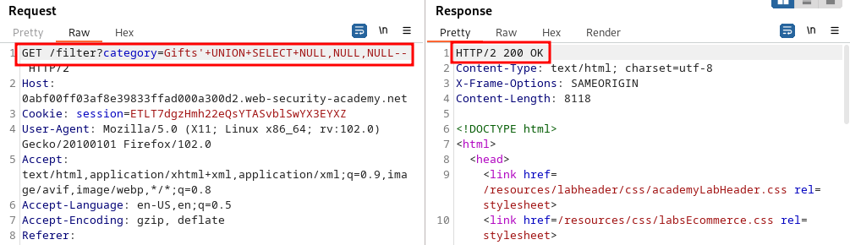

We can see there are 3 columns.

To find out which column has data which can be printed, we run the command

**'+UNION+SELECT+NULL,’gTPhsp’,NULL--**

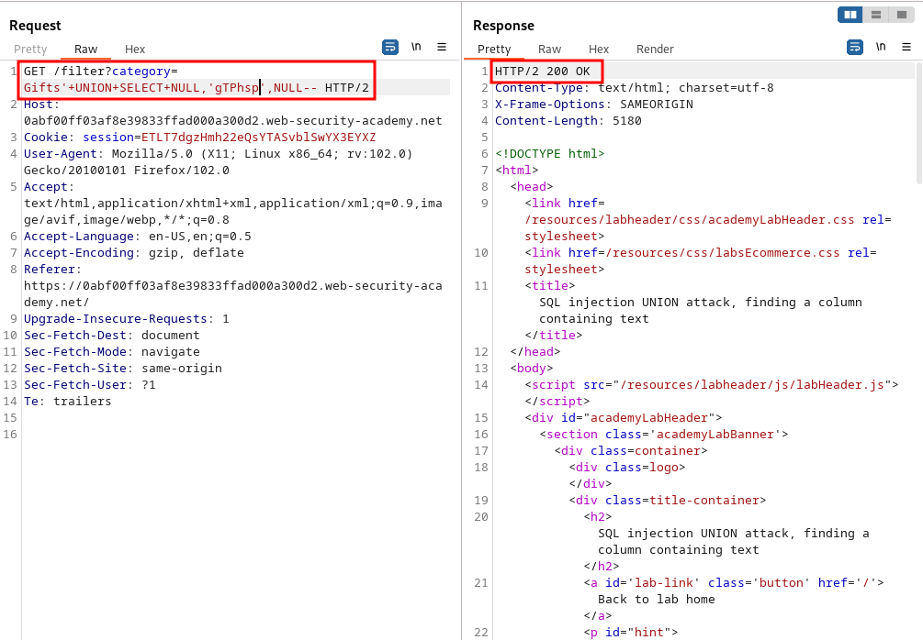

Forward the request.

