To Access the Lab –

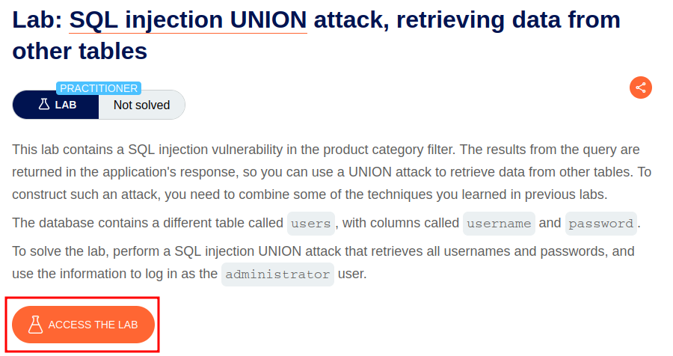

Intercept the request on Burp and send to repeater,

On repeater, URL – We can use the SQLi cheatsheet to determine the number of columns that are being returned by the query and which columns contain text data.

To get username and password from the users table

**'+UNION+SELECT+username,+password+FROM+users—**

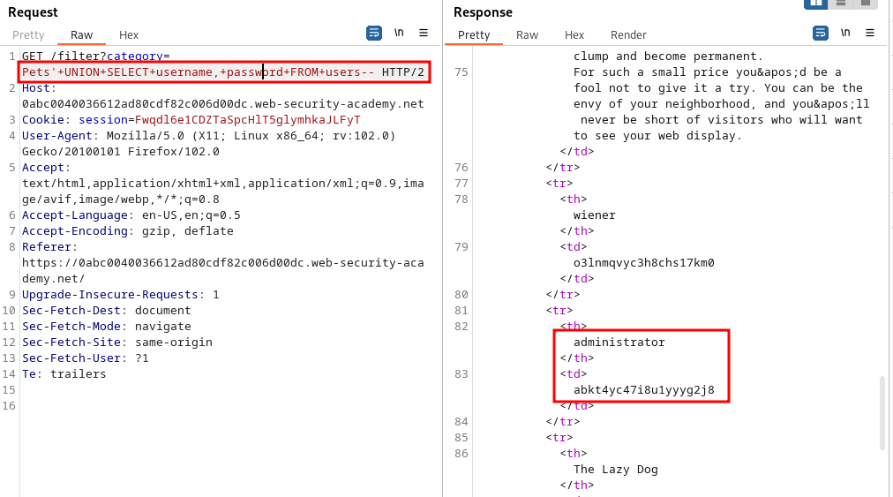

We can see the administrator password

Login to the account

