|  |  |  |  |
| --- | --- | --- | --- |
|  | 8/16/2013 |  | |
| |  |  | | --- | --- | |  |  | |  |  | |  |  | |  |  | | | Dang Chau Nguyen | |
| Silent Ruby Installer | | | |
|  |  | | |  |  |  | | --- | --- | --- | |  |  |  | |  |  |  | |  |  |  | |  |  |  | |  |  |  | |  |  |  | |
|  |  | |  |

Table of Contents

Install MingW32 for Windows 2

Download libcurl for MingW32 3

Install libcurl for MingW32 in Windows 4

Download and install libcurl for G++ under Cygwin 4

Intalling libcurl in Ubuntu 4

G++ Compiling 4

Make 5

Source code modifying 5

Attachments 5

# Install MingW32 for Windows

Get MinGW from <http://sourceforge.net/projects/mingw/files/latest/download?source=files> (Main page: <http://www.mingw.org/>)

This is what you need for setup MinGW

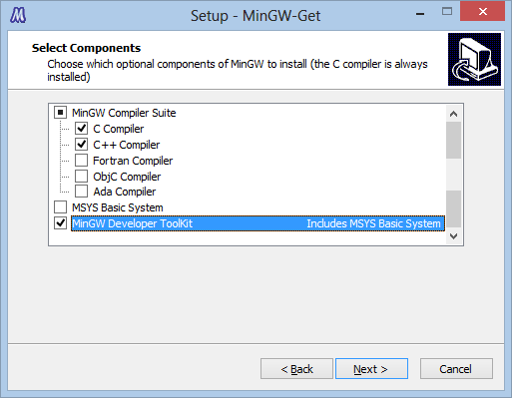

And also Add PATH to environment. To do this:

* In Windows XP:

1. Right-click **My Computer**, and then click **Properties**.
2. Click the **Advanced** tab.
3. Click **Environment variables**.
4. Click **PATH** in **System variables**, and then click Edit and look at the image below.

* In Windows Vista/7/8

1. Right-click **My Computer**, and then click **Properties**.
2. Click **Advanced sytem settings** on the left menu.
3. Click **Environment variables**.
4. Click **PATH** in **System variables**, and then click Edit and look at the image below.

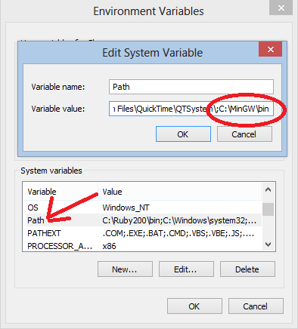

C:\MinGW\bin is where MinGW is installed in your computer.

# Download libcurl for MingW32

Firstly, we will need the correct libcurl for our program. It’s libcurl without SSL. The version in the main page have libcurl WITH SSL, and we will have to download OpenSSL library and compile and more dependency and more and more while our program only need default curl. URL to get is <http://curl.haxx.se/latest.cgi?curl=win32-devel> . Or you can go to Lastest Archives, Find Windows libcurl devel (Without any SSL). I will call this is our main archive.

I don’t know if further update will be good, but at the moment, normal version 7.17.1 lacks of zlib library. So we will have to download the full version to solve that. In <http://curl.haxx.se/download.html> , look at **Win32 – Generic.** On the 3rd column, we will get “Libcurl” (not binary, we are looking for library). There are a note SSL next to it, but we only need zlib from there. I will call this is our substitute archive.

In the attachment, there will be libcurl-7.17.1-win32-nossl.zip and curl-7.31.0-devel-mingw32.zip.

# Install libcurl for MingW32 in Windows

The path of MinGW32 of Cygwin in my computer is:

C:\MinGW

Note that there are 2 folders: include and lib. In the main archive, there are 2 folders include and lib, too. So you will get all of the file in include folder in the archive and put it to include folder of MingW32, and also from folder lib in archive to folder lib in MingW32.

In the lib folder, there should be libz.a, libz.dll.a and libzdll.a. If the archive doesn’t have it, extract the 3 needed files from the substitute archives.

# Download and install libcurl for G++ under Cygwin

Just make sure you have installed libcurl in Cygwin installer.

# Intalling libcurl in Ubuntu

The command is: sudo apt-get install libcurl4-gnutls-dev or if you use make, it will auto install for you

# G++ Compiling

G++/Cygwin (the only one that requires Cygwin): g++ -mwindows main.cpp -lcurl -o ruby-oneclick-1.9.3.exe

MinGW32/Cygwin: i686-pc-mingw32-g++ -static-libgcc -static-libstdc++ -mwindows main.cpp -o ruby-oneclick-1.9.3.exe -static -lcurl -lwldap32 -lws2_32 –lz

MinGW32/Windows: mingw32-g++ -static-libgcc -static-libstdc++ -mwindows main.cpp -o ruby-oneclick-1.9.3.exe -static -lcurl -lwldap32 -lws2_32 –lz

Or: g++ -static-libgcc -static-libstdc++ -mwindows main.cpp -o ruby-oneclick-1.9.3.exe -static -lcurl -lwldap32 -lws2_32 –lz

G++/Ubuntu: g++ main.cpp -lcurl -o ruby-oneclick-1.9.3

You can replace ruby-oneclick-1.9.3 to your custom name.

To run program under Cygwin:

c:\cygwin\bin\run.exe <unix path style to the program>

For example, my home folder is /home/Chau

c:\cygwin\bin\run.exe /home/Chau/ruby-oneclick-1.9.3.exe

Another example, I want to run C:\temp\ruby-oneclick-1.9.3.exe

c:\cygwin\bin\run.exe /cygdrive/c/temp/ruby-oneclick-1.9.3.exe

# Make

If you haven’t installed make on Windows, you can use mingw32-make, it’s similar, just the command is mingw32-make instead of make

* Default: make all
* Output file ruby-oneclick-1.9.3.exe: make all EXENAME=ruby-oneclick-1.9.3
* To compile the debug version: make debug

# Source code modifying

In file const.h, there are

#define DEFAULT_RUBY_VERSION "2.0.0" is default version

#define WINDOWS_TEMP_FOLDER "C:\\temp\\ruby-installer" is the temp folder to download to in Windows

#define UNIX_TEMP_FOLDER "~/.ruby_installer" is the temp folder to download to in Linux and Mac folder

#define WINDOWS_GEM_FOLDER "C:\\devkit" is the devkit gem folder

# Attachments

* **Source folder:** Full source code
* **Binary folder**: Compiled binary for Windows using MinGW32, MinGW32/Cygwin, G++/Cygwin and G++/Ubuntu
  + **Debug**: compiled with #define DEBUG_INFO
  + **Release**: compiled without #define DEBUG_INFO
* **curl-7.31.0-devel-mingw32.zip** and **libcurl-7.17.1-win32-nossl.zip**