**8 Aspects of Writing Grading Criteria**

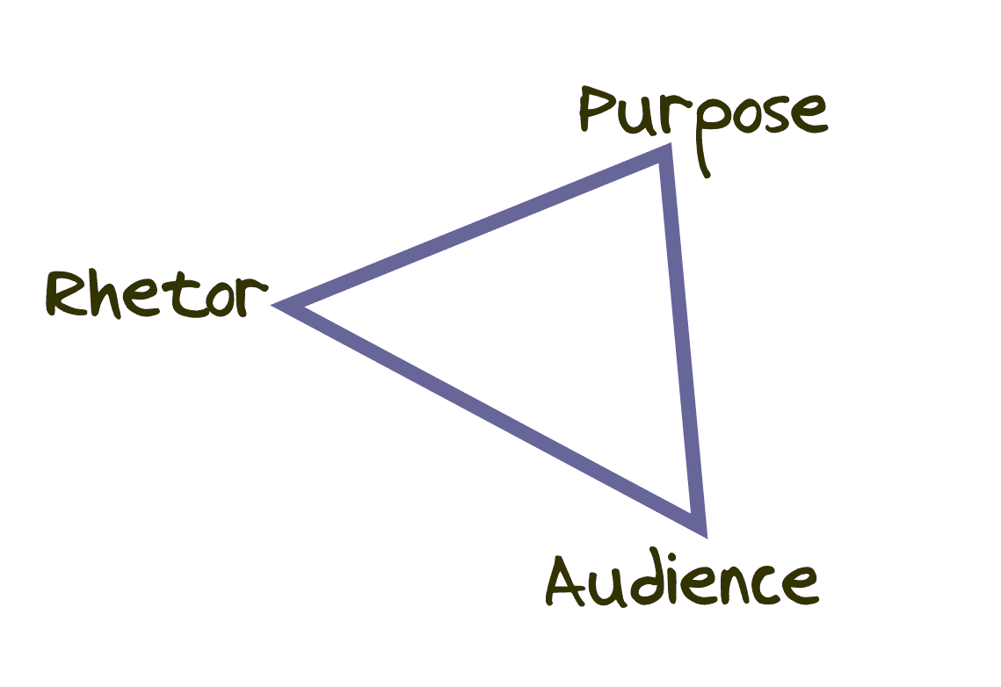**Rhetorical Aspect**

This aspect has 8 parts: Topic(scope), Audience, Purpose, Constraints (limitations), Genre, Visual Design, Exigence, and Writing Culture. Grading focuses on whether the thesis statement and any other claims/opinions are deep and supported by effective reasoning for the target audience. The student will earn less points if they have overly simple arguments/claims or use reductive language like always, never, no one, everyone, all the time, never, and the like.

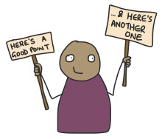 **Structural (Argumentation) Aspect**

This aspect focuses on the structural connections of the essay. For instance, things like effective signposting/transitions for the particular genre that help the reader create a map of the argument will earn the most points here. Use the title, thesis, and appropriate design features to signal the audience. Structuring introduction, conclusion, and body paragraphs effectively and according to genre conventions and the rhetorical purpose is also important.

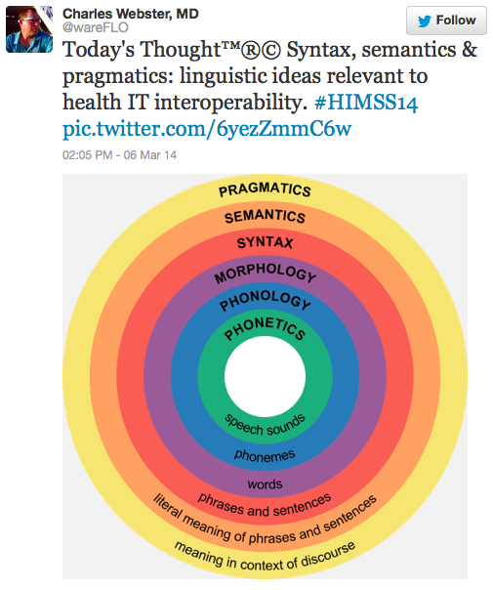**Linguistic Aspect**

Linguistics covers language use in multiple parts: Morphology, Syntax, Punctuation, Semantics, Pragmatics, to name a few. However, language and grammar norms are socially governed, so in most cases, for a college course, this aspect will be graded based on the socio-cultural expectations of academic SAE/SWE. Students will earn less points for confusing syntax or punctuation according to conventions established for academic audiences. This aspect primarily focuses on word error, sentence structure, or punctuation convention concerns. Language efficacy is more important than “perfect” or “proper” grammar as some call it.

 **Technological Aspect**

This aspect focuses on using context appropriate tools and technologies effectively, so this aspect is graded on whether conventions are used based on the expected technology of the genre. In traditional essays, often this aspect is connected to the formatting of the page and use of word processing tools (for instance, academic essays are rarely handwritten). MLA, APA, or other style formatting may show up here depending on how it overlaps with the scientific (research) aspect of writing. Writers should not be double docked points in both areas though.

**Analytical Aspect**

This aspect looks at the depth of thinking represented in the essay: Is a line of thought sustained, focused, and deep? The writing should do more than simply report statements of fact and should answer questions of why, how, or who is impacted. Writers should provide substantial commentary that builds on but goes beyond established knowledge. Commentary may be explanation, interpretation, evaluation, and critique.

**Socio-Cultural Aspect**

This aspect will be graded based on whether the writer considers the unique primary audience while considering potential collateral audiences as well. For a standard academic essay, the writing culture has academic norms like avoiding "you/your," “I think/I feel,” or contractions "can't, won't, I'm" and similar conventions. Citation style may be a factor as well, but for grading, this usually is addressed in the technological and scientific portions of the rubric.

 **Aesthetic Aspect**

Concerning beauty or effective audience engagement, whether it is interesting and fun to read. Use of varied, specific, and vivid language as well as visual design elements (depending on the genre) can earn the most points. Using vague pronouns or less concrete descriptions or being overly repetitive can cause a writer to earn less points.



**Scientific (Research) Aspect**

Focusing on research and displaying knowledge of the subject, writers earn the most points if they use appropriate, credible, academic sources with integrity and effectively. A style specific Works Cited/References page, in-text citations, and effective integrating/embedding of quotes and other types of data (surveys, interviews, etc) earns more points.