**Zhamsat Almat**

WEB Technologies 1 (Front End)

Assignment 2: Enhancing Your Webpage with CSS

Objective:

Create a webpage styled with CSS (Cascading Style Sheets) to improve its design, layout,

and visual appeal. You may continue with the HTML page from Assignment 1 or create a

new HTML page. This assignment focuses on using basic CSS selectors and properties,

requiring students to create their own class names and ID names.

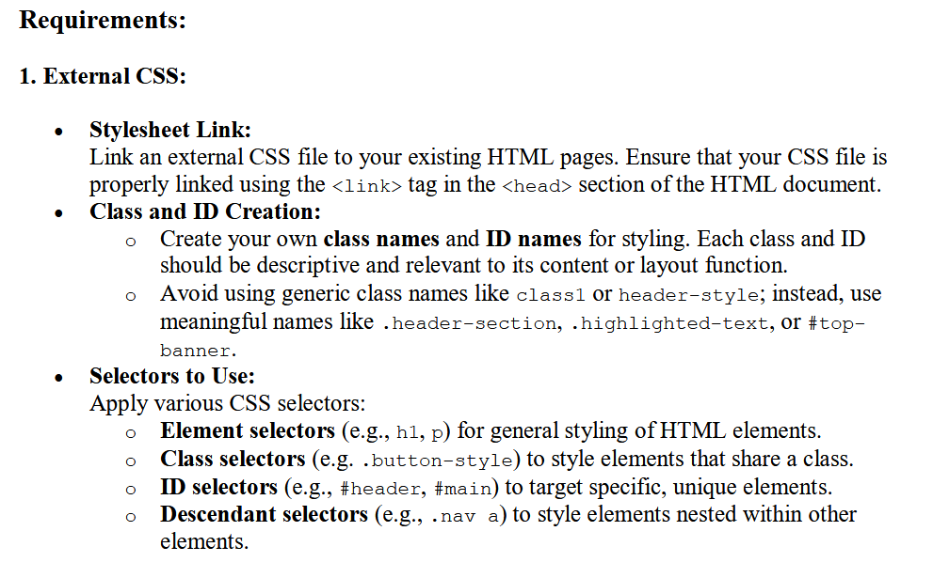

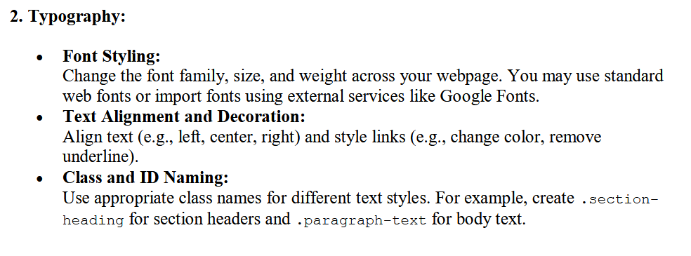

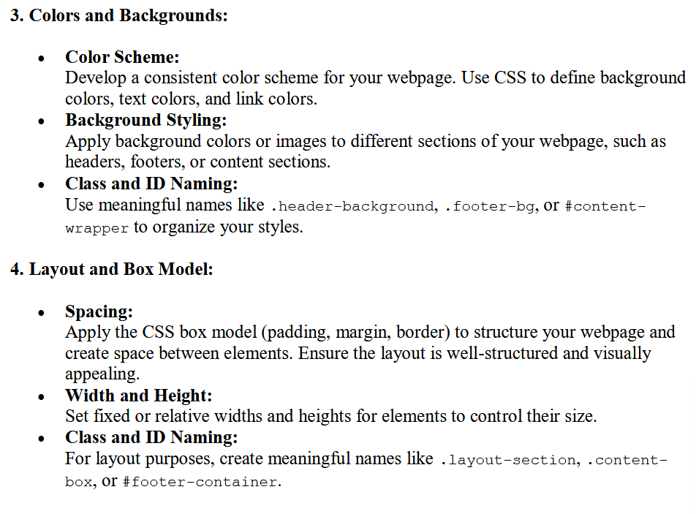

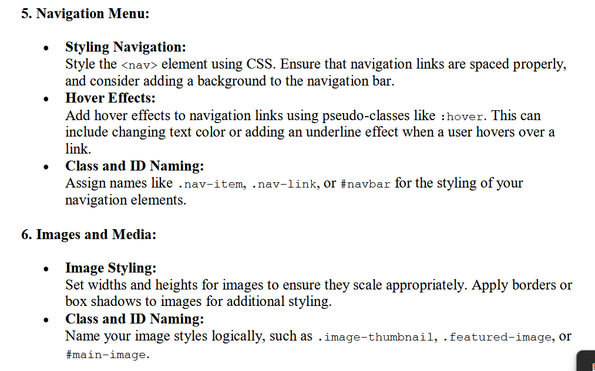

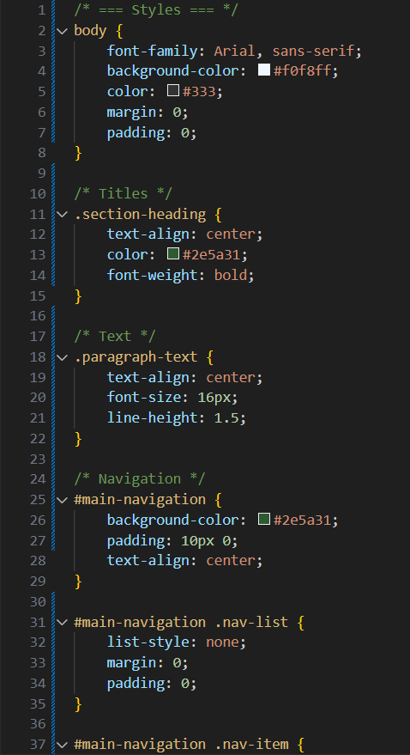

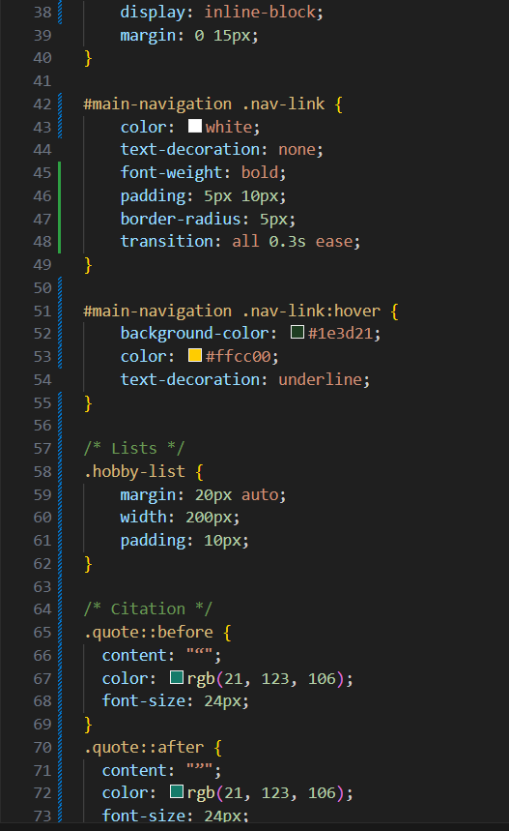

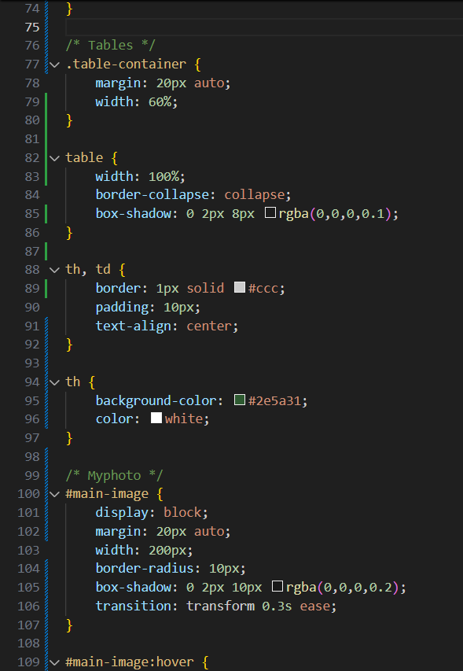

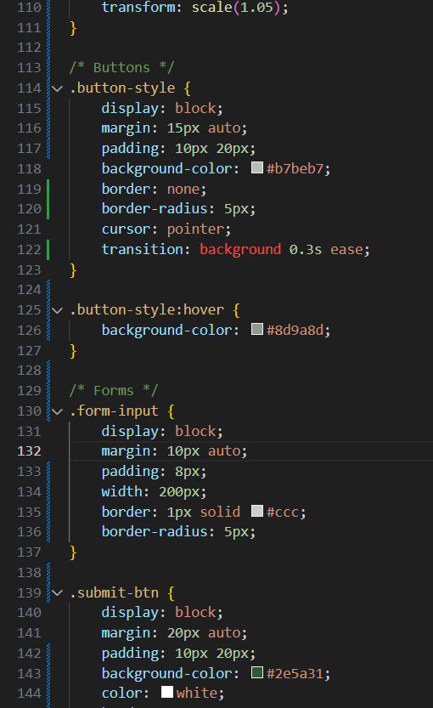

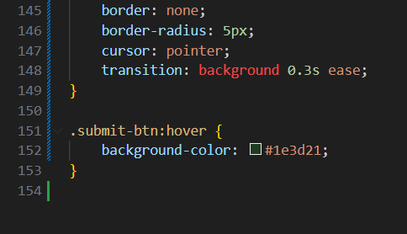

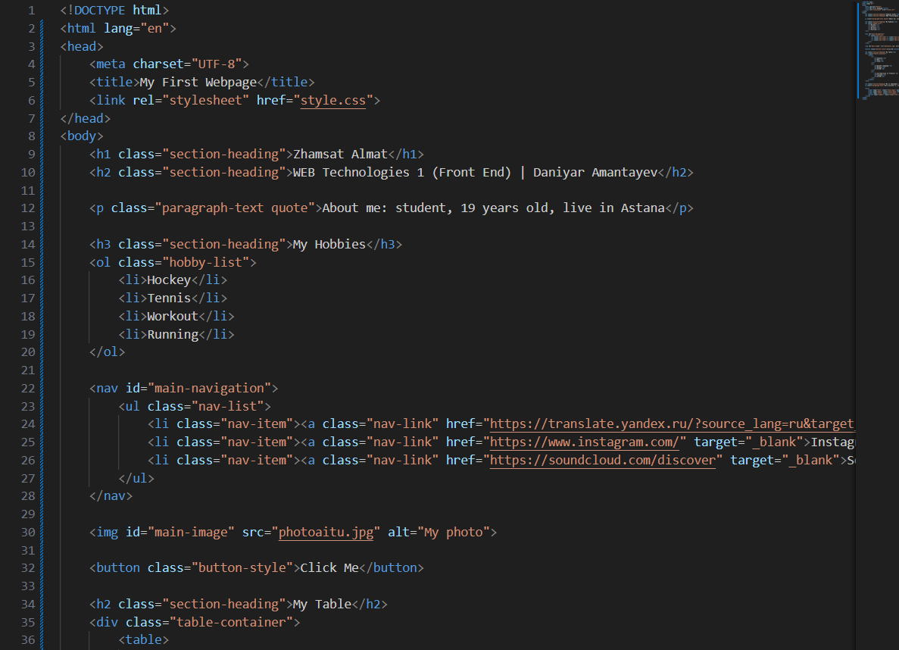

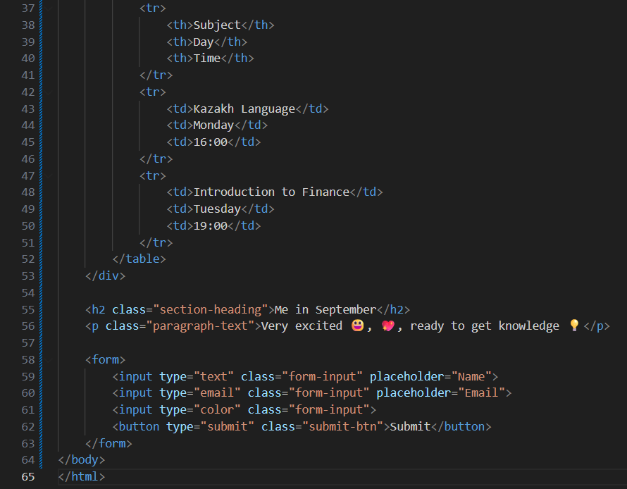

Link to website: <https://thenotsuspect.github.io/webAITU/>

Link to github: <https://github.com/TheNotsuspect/webAITU>