Assignment #3. Advanced CSS ( Flexbox & Grid)

Student: Zhamsat Almat

Group: SE-2422

Objective:

The goal of this assignment is to understand and apply advanced

CSS layout techniques using Flexbox and CSS Grid. By the end,

students will be able to build complex, responsive layouts

without relying on floats or external frameworks. This

assignment emphasizes modern layout practices, alignment,

responsiveness, and design efficiency.

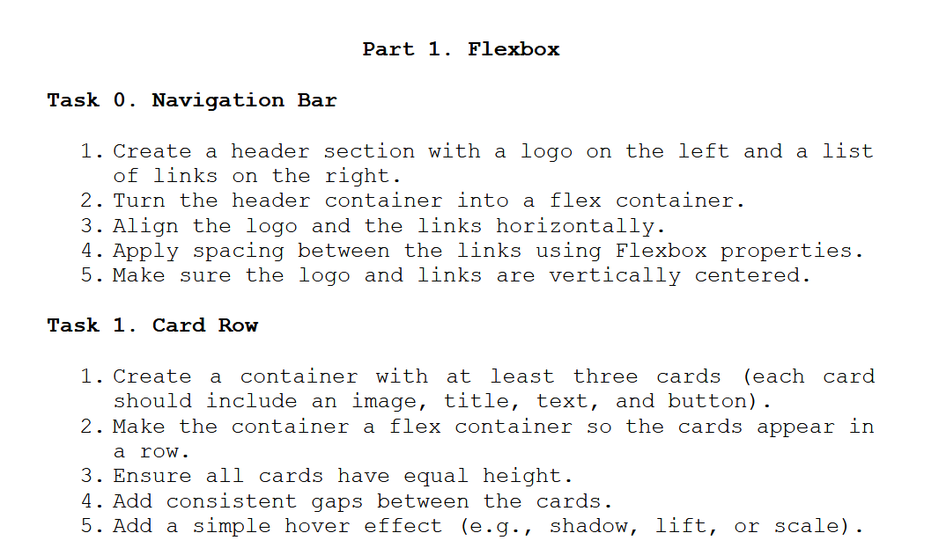

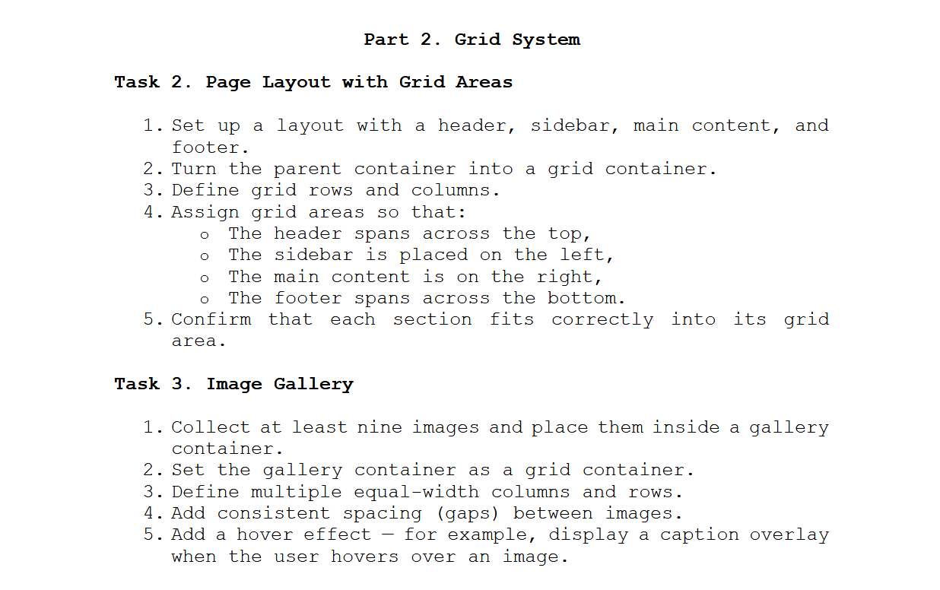

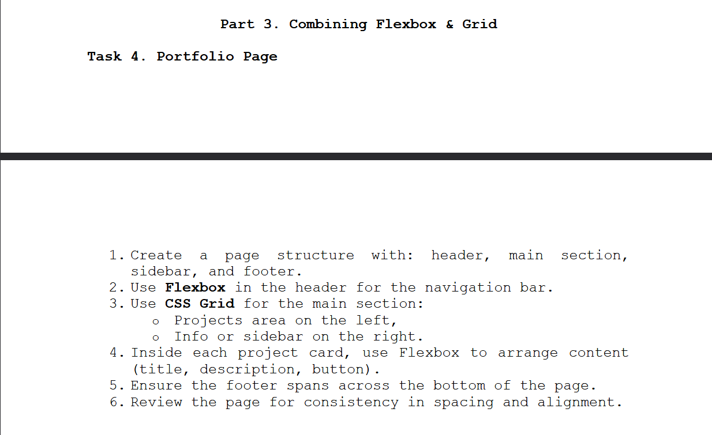

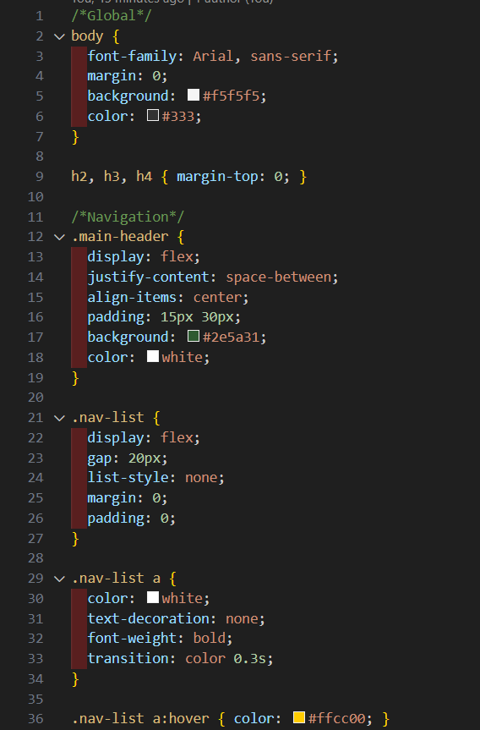

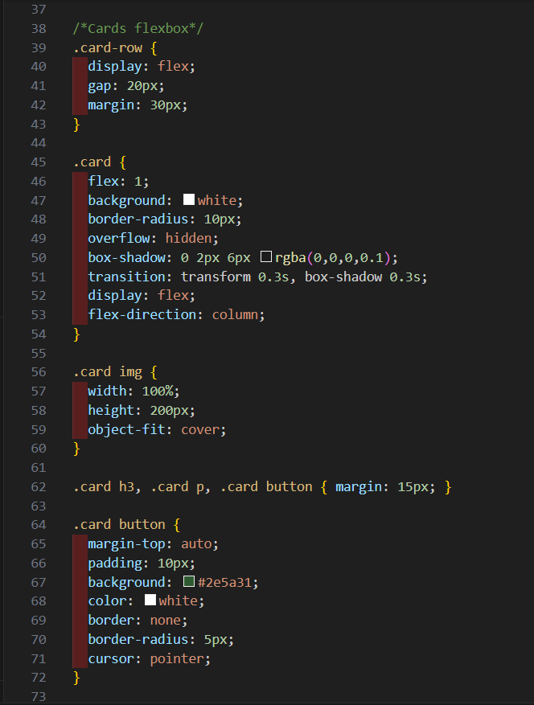

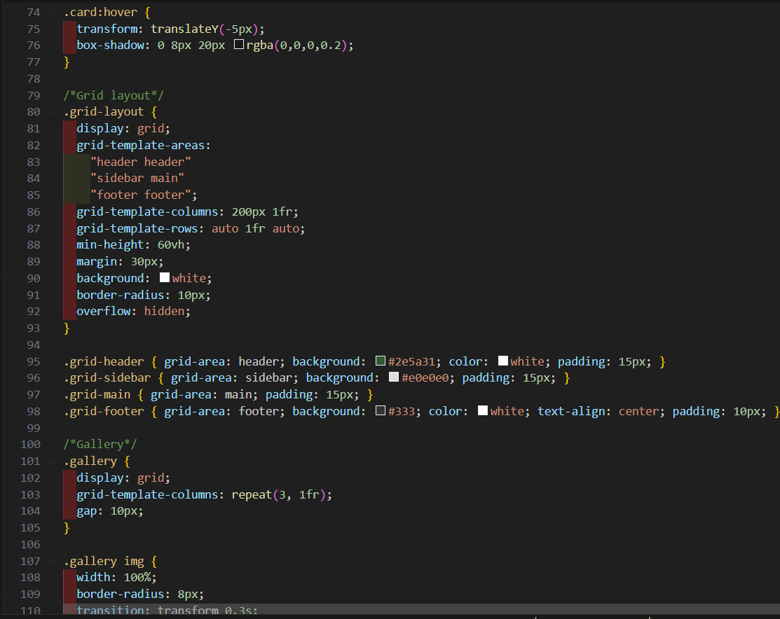

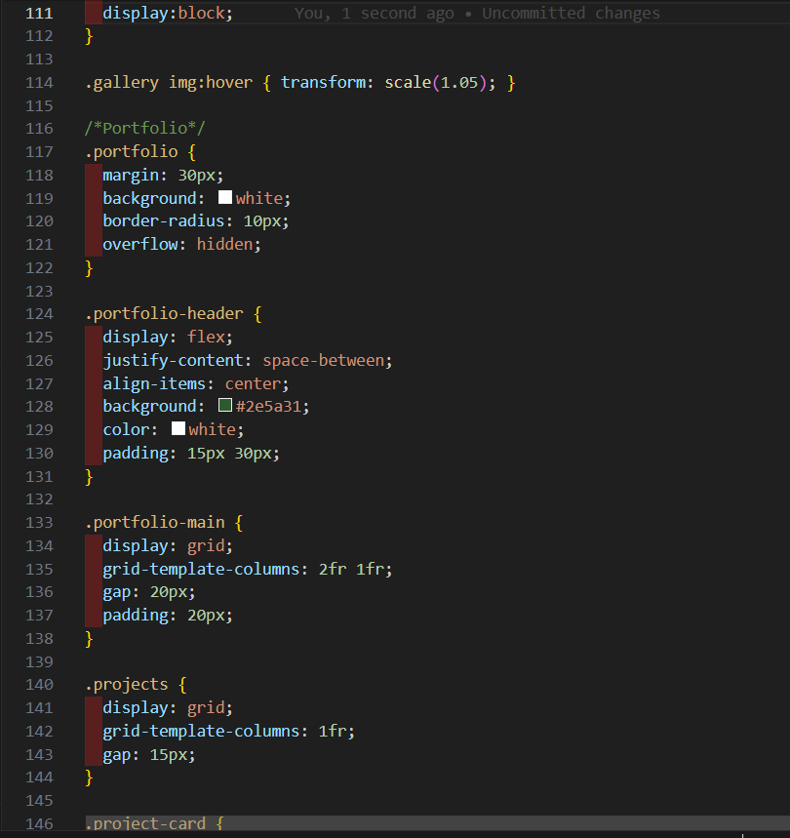

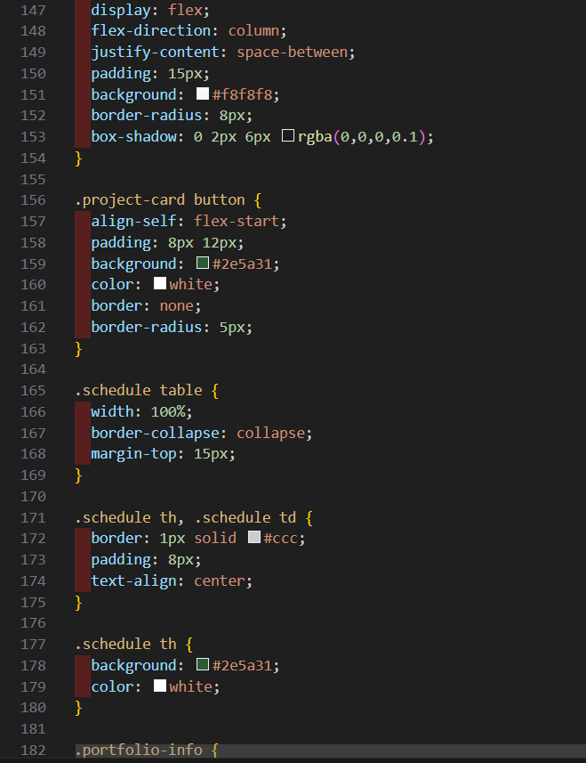

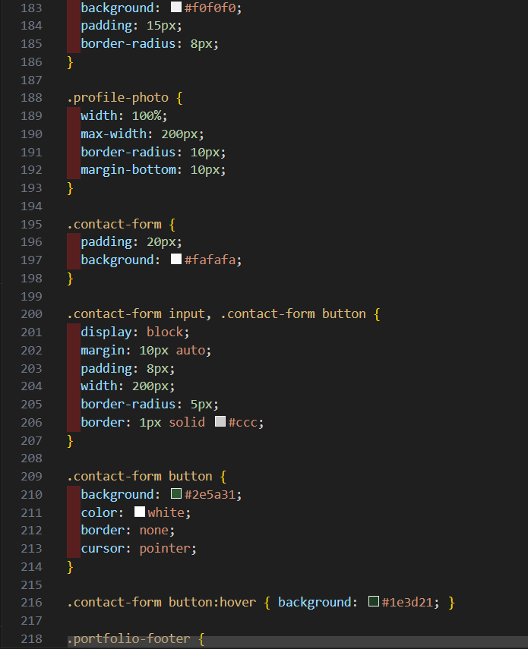

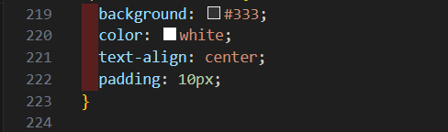

HTML:

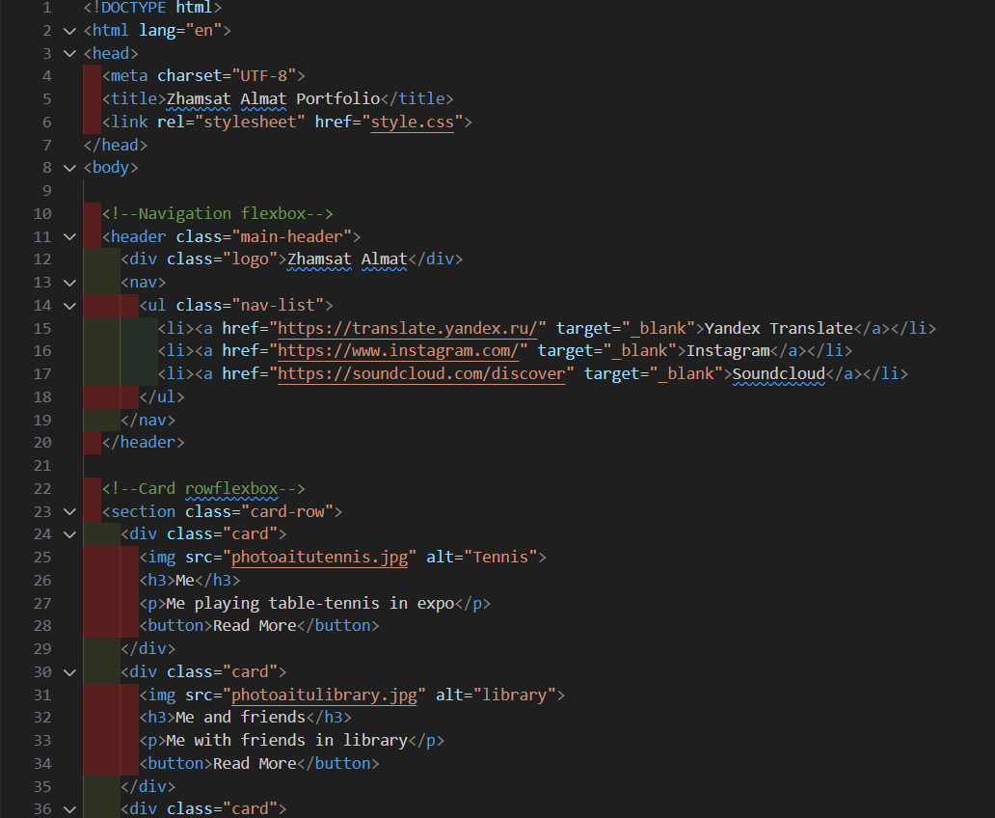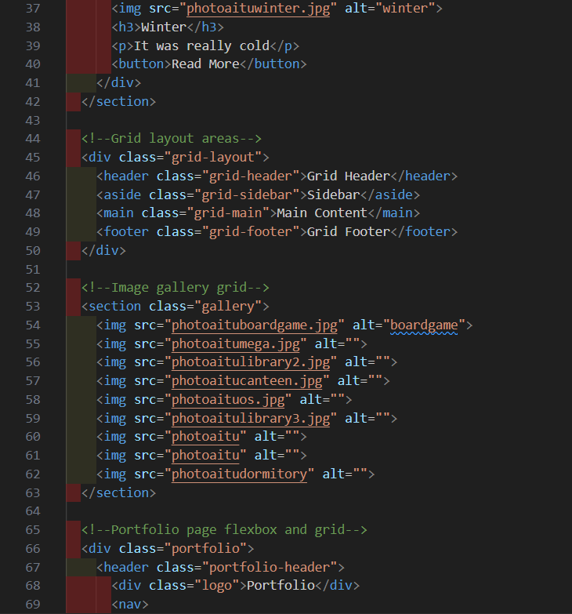

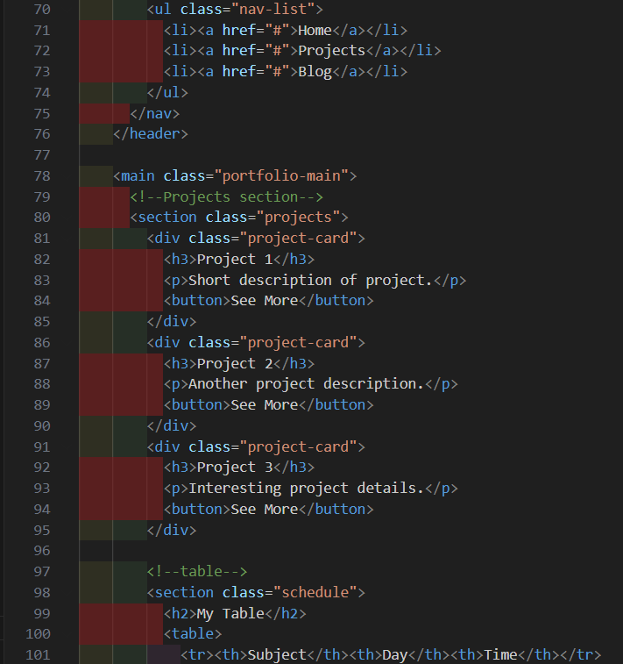

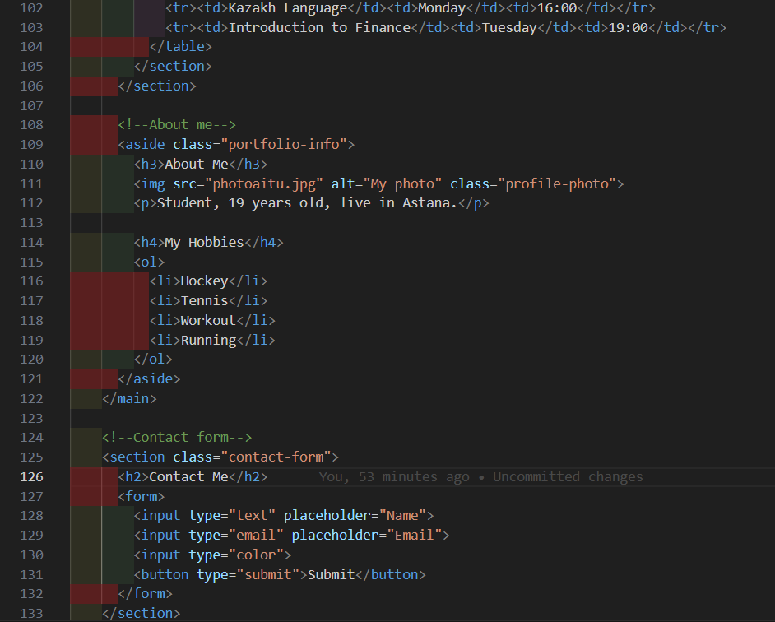

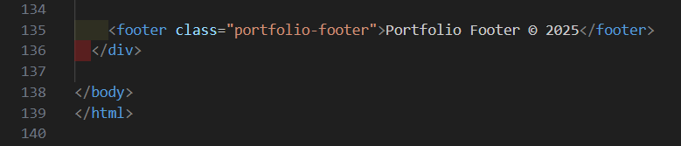

GITHUB: <https://github.com/TheNotsuspect/webAITU>

WEBSITE: <https://thenotsuspect.github.io/webAITU/>