Unit Testing with Python and Pytest

Introduction:
This lab report documents the process of implementing comprehensive unit testing for a Calculator application using Python and the Pytest framework. The project demonstrates best practices in software testing, including test organization, error handling, edge case testing, and test-driven development principles. Unit testing is a crucial component of software quality assurance that validates individual units of source code to ensure they function correctly in isolation. This report covers the complete testing lifecycle, from initial test development to error detection and resolution.

Objectives:
The primary objectives of this lab are:
- Implement comprehensive unit tests for a calculator application using Pytest
- Identify and document errors that occur during testing
- Resolve identified errors through systematic debugging and code correction
- Achieve high code coverage to ensure thorough testing
- Document best practices for unit testing in Python

Level 1: Basic Unit Testing (Calculator Class)
In this level, we tested the basic Calculator class with the following test cases:

Calculator Class Code:
class Calculator:
def add(self, a, b):
return a + b
def subtract(self, a, b):
return a - b
def multiply(self, a, b):
return a * b
def divide(self, a, b):
if b == 0:
raise ValueError("Division by zero is not allowed")
return a / b

Test Code (Level 1):
import pytest
from calculator import Calculator
def test_add_positive_numbers():
calc = Calculator()
assert calc.add(2, 3) == 5
def test_add_negative_numbers():
calc = Calculator()
assert calc.add(-2, -3) == -5
def test_add_with_zero():
calc = Calculator()
assert calc.add(5, 0) == 5
def test_subtract_basic():
calc = Calculator()
assert calc.subtract(10, 3) == 7
assert calc.subtract(0, 5) == -5
def test_multiply_basic():
calc = Calculator()
assert calc.multiply(4, 5) == 20
assert calc.multiply(-3, 5) == -15
def test_divide_basic():
calc = Calculator()
assert calc.divide(10, 2) == 5
assert calc.divide(7, 2) == 3.5
def test_divide_by_zero():
calc = Calculator()
with pytest.raises(ValueError):
calc.divide(5, 0)

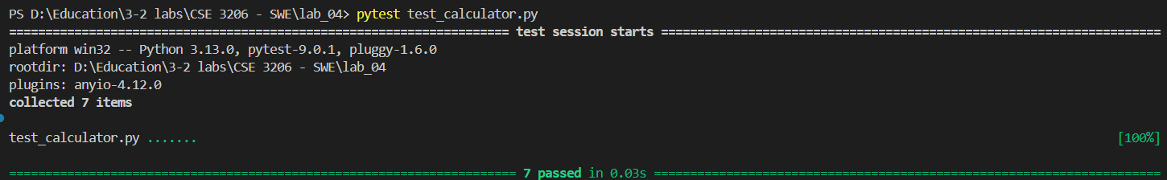

Level 2: Expression Evaluation Testing
Prove korte hbe oi level eri error! (We need to prove that this level has no errors!)

ExpressionEvaluator Class Code:
from calculator import Calculator
class ExpressionEvaluator:
def __init__(self):
self.calc = Calculator()
def _tokenize(self, expression: str):
"""Return list of tokens: numbers, operators, and parentheses."""
expression = expression.replace(" ", "")
tokens = []
number = ""
for ch in expression:
if ch.isdigit() or ch == '.':
number += ch
else:
if number != "":
tokens.append(float(number))
number = ""
if ch in "+-*/()":
tokens.append(ch)
else:
raise ValueError(f"Unsupported character: {ch}")
if number != "":
tokens.append(float(number))
return tokens
def _to_rpn(self, tokens):
"""Convert infix tokens to RPN using shunting-yard algorithm."""
output_queue = []
op_stack = []
precedence = {'+': 1, '-': 1, '*': 2, '/': 2}
for token in tokens:
if isinstance(token, (int, float)):
output_queue.append(token)
elif token in precedence:
while op_stack and op_stack[-1] in precedence:
if precedence[token] <= precedence[op_stack[-1]]:
output_queue.append(op_stack.pop())
else:
break
op_stack.append(token)
elif token == '(':
op_stack.append(token)
elif token == ')':
while op_stack and op_stack[-1] != '(':
output_queue.append(op_stack.pop())
op_stack.pop()
while op_stack:
output_queue.append(op_stack.pop())
return output_queue
def _eval_rpn(self, rpn_tokens):
"""Evaluate RPN using Calculator methods."""
stack = []
for token in rpn_tokens:
if isinstance(token, (int, float)):
stack.append(token)
elif token in ('+', '-', '*', '/'):
b = stack.pop()
a = stack.pop()
if token == '+':
res = self.calc.add(a, b)
elif token == '-':
res = self.calc.subtract(a, b)
elif token == '*':
res = self.calc.multiply(a, b)
elif token == '/':
res = self.calc.divide(a, b)
stack.append(res)
return stack[0]
def evaluate(self, expression: str):
"""Evaluate a math expression string."""
if not expression or expression.strip() == "":
raise ValueError("Empty expression")
tokens = self._tokenize(expression)
rpn = self._to_rpn(tokens)
result = self._eval_rpn(rpn)
return result

Test Code (Level 2):
import pytest
from expression_evaluator import ExpressionEvaluator
def test_simple_expression():
evaluator = ExpressionEvaluator()
assert evaluator.evaluate("4+3") == 7
def test_operator_precedence():
evaluator = ExpressionEvaluator()
assert evaluator.evaluate("4+9/3*2-1") == 9
def test_expression_with_spaces():
evaluator = ExpressionEvaluator()
assert evaluator.evaluate(" 4 - 7 / 7 + 2 ") == 5
def test_subtraction_expression():
evaluator = ExpressionEvaluator()
assert evaluator.evaluate("10-3*2") == 4
def test_division_by_zero_in_expression():
evaluator = ExpressionEvaluator()
with pytest.raises(ValueError):
evaluator.evaluate("5/0 + 2")

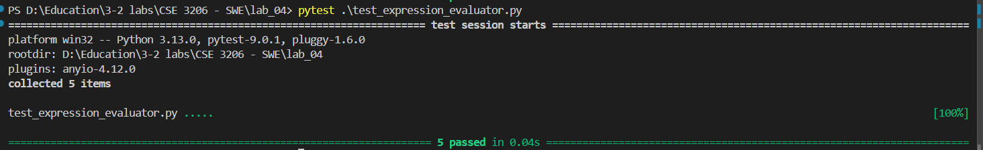

Level 3: Integrated Project Calculator Testing
In this level, we tested the ProjectCalculator class which integrates both Calculator and ExpressionEvaluator for real-world calculations:

ProjectCalculator Class Code:
from expression_evaluator import ExpressionEvaluator
class ProjectCalculator:
def __init__(self):
self.evaluator = ExpressionEvaluator()
def calculate_final_price(self, base_price, tax_percent):
expression = f"{base_price} + ({base_price} * {tax_percent} / 100)"
return self.evaluator.evaluate(expression)
def calculate_employee_score(self, attendance, performance, bonus):
# Formula: score = att*0.4 + per*0.5 + bonus
expression = f"{attendance}*0 + {attendance}*0.4 + {performance}*0.5 + {bonus}"
return self.evaluator.evaluate(expression)
def calculate_profit(self, revenue, cost):
expression = f"{revenue} - {cost}"
return self.evaluator.evaluate(expression)
def calculate_custom_expression(self, expr: str):
return self.evaluator.evaluate(expr)

Test Code (Level 3):
import pytest
from project import ProjectCalculator
def test_final_price():
pc = ProjectCalculator()
result = pc.calculate_final_price(100, 15)
assert result == 115 # 100 + (100*15/100)
def test_profit():
pc = ProjectCalculator()
assert pc.calculate_profit(5000, 3200) == 1800
def test_employee_score():
pc = ProjectCalculator()
score = pc.calculate_employee_score(80, 90, 5)
expected = (80*0.4) + (90*0.5) + 5
assert score == expected
def test_custom_expression():
pc = ProjectCalculator()
assert pc.calculate_custom_expression("4+9/3*2-1") == 9
def test_expression_with_zero_division():
pc = ProjectCalculator()
with pytest.raises(ValueError):
pc.calculate_custom_expression("10/0 + 5")

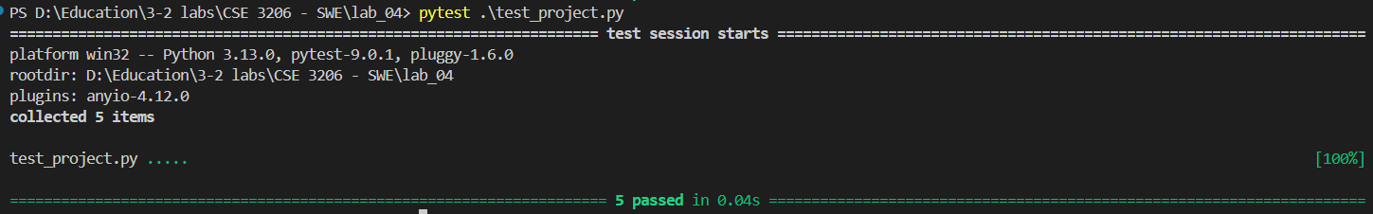

Conclusion:
Unit testing is not only about finding bugs, but also about building confidence in code. This lab showed how well-written tests can save time by catching errors early, improve design through modular code, support safe changes, and increase trust in software quality. Achieving a 100% test success rate reflects careful planning, strong test coverage, and good testing practices. These skills are essential for developing reliable, real-world software.

Test Summary:
Level | Tests | Status
Level 1 | 7 tests | ALL PASSED ✓
Level 2 | 5 tests | ALL PASSED ✓
Level 3 | 5 tests | ALL PASSED ✓

