Assignment on Artificial Intelligence Project
Course Code: CSE 3207
Course Title: Artificial Intelligence
Topic: AI Project on Naive Bayes Classifier

Submitted By: Arif Foysal Bin Haider
Roll: 2103119
Section: B

Submission Date: 30 November 2025

Machine Learning Classification Using
Naive Bayes Algorithm on Iris Dataset

1. Introduction
Machine learning is a rapidly evolving branch of artificial intelligence that enables systems to learn patterns from data and make intelligent decisions without explicit programming. Among various machine learning tasks, classification plays a crucial role in identifying the category or label of an unseen data instance based on its feature values.
The Naive Bayes classifier is a probabilistic supervised learning algorithm derived from Bayes' theorem, incorporating the simplifying assumption that input features are conditionally independent given the class label. Although this assumption is often violated in real-world data, Naive Bayes has shown impressive performance due to its mathematical simplicity, computational efficiency, and robustness.
This project presents a complete implementation of a Gaussian Naive Bayes classifier on the well-known Iris dataset, demonstrating its effectiveness in multi-class classification. Additionally, a Decision Tree classifier is implemented for comparison to evaluate relative performance and gain deeper insight into the strengths and limitations of Naive Bayes.

2. Objectives
The key objectives of this project are:
- To implement a Naive Bayes classifier using Python and the scikit-learn library
- To perform essential data preprocessing, including data validation, normalization, and dataset splitting
- To evaluate the classification model using performance metrics such as accuracy, precision, recall, F1-score, and confusion matrix
- To compare the performance of Naive Bayes with a Decision Tree classifier
- To analyze experimental results and explain the observed model behavior
- To gain practical experience in probabilistic classification and end-to-end machine learning workflow

3. Dataset Description

3.1 Dataset Selection
Dataset Name: Iris Dataset
Source: Kaggle (https://www.kaggle.com/datasets/uciml/iris)
Problem Type: Multi-class classification
Data Type: Multivariate numerical data

3.2 Dataset Overview
The Iris dataset is a classical benchmark dataset frequently used to evaluate classification algorithms. It was introduced by statistician and biologist Ronald A. Fisher in 1936 and remains widely used due to its simplicity and well-structured nature. The dataset contains measurements of iris flowers from three different species.

Dataset Characteristics:
Characteristic | Value
Number of Samples | 150
Number of Features | 4
Number of Classes | 3
Missing Values | None
Class Distribution | Balanced (50 samples each)

Visual representation of class distribution:
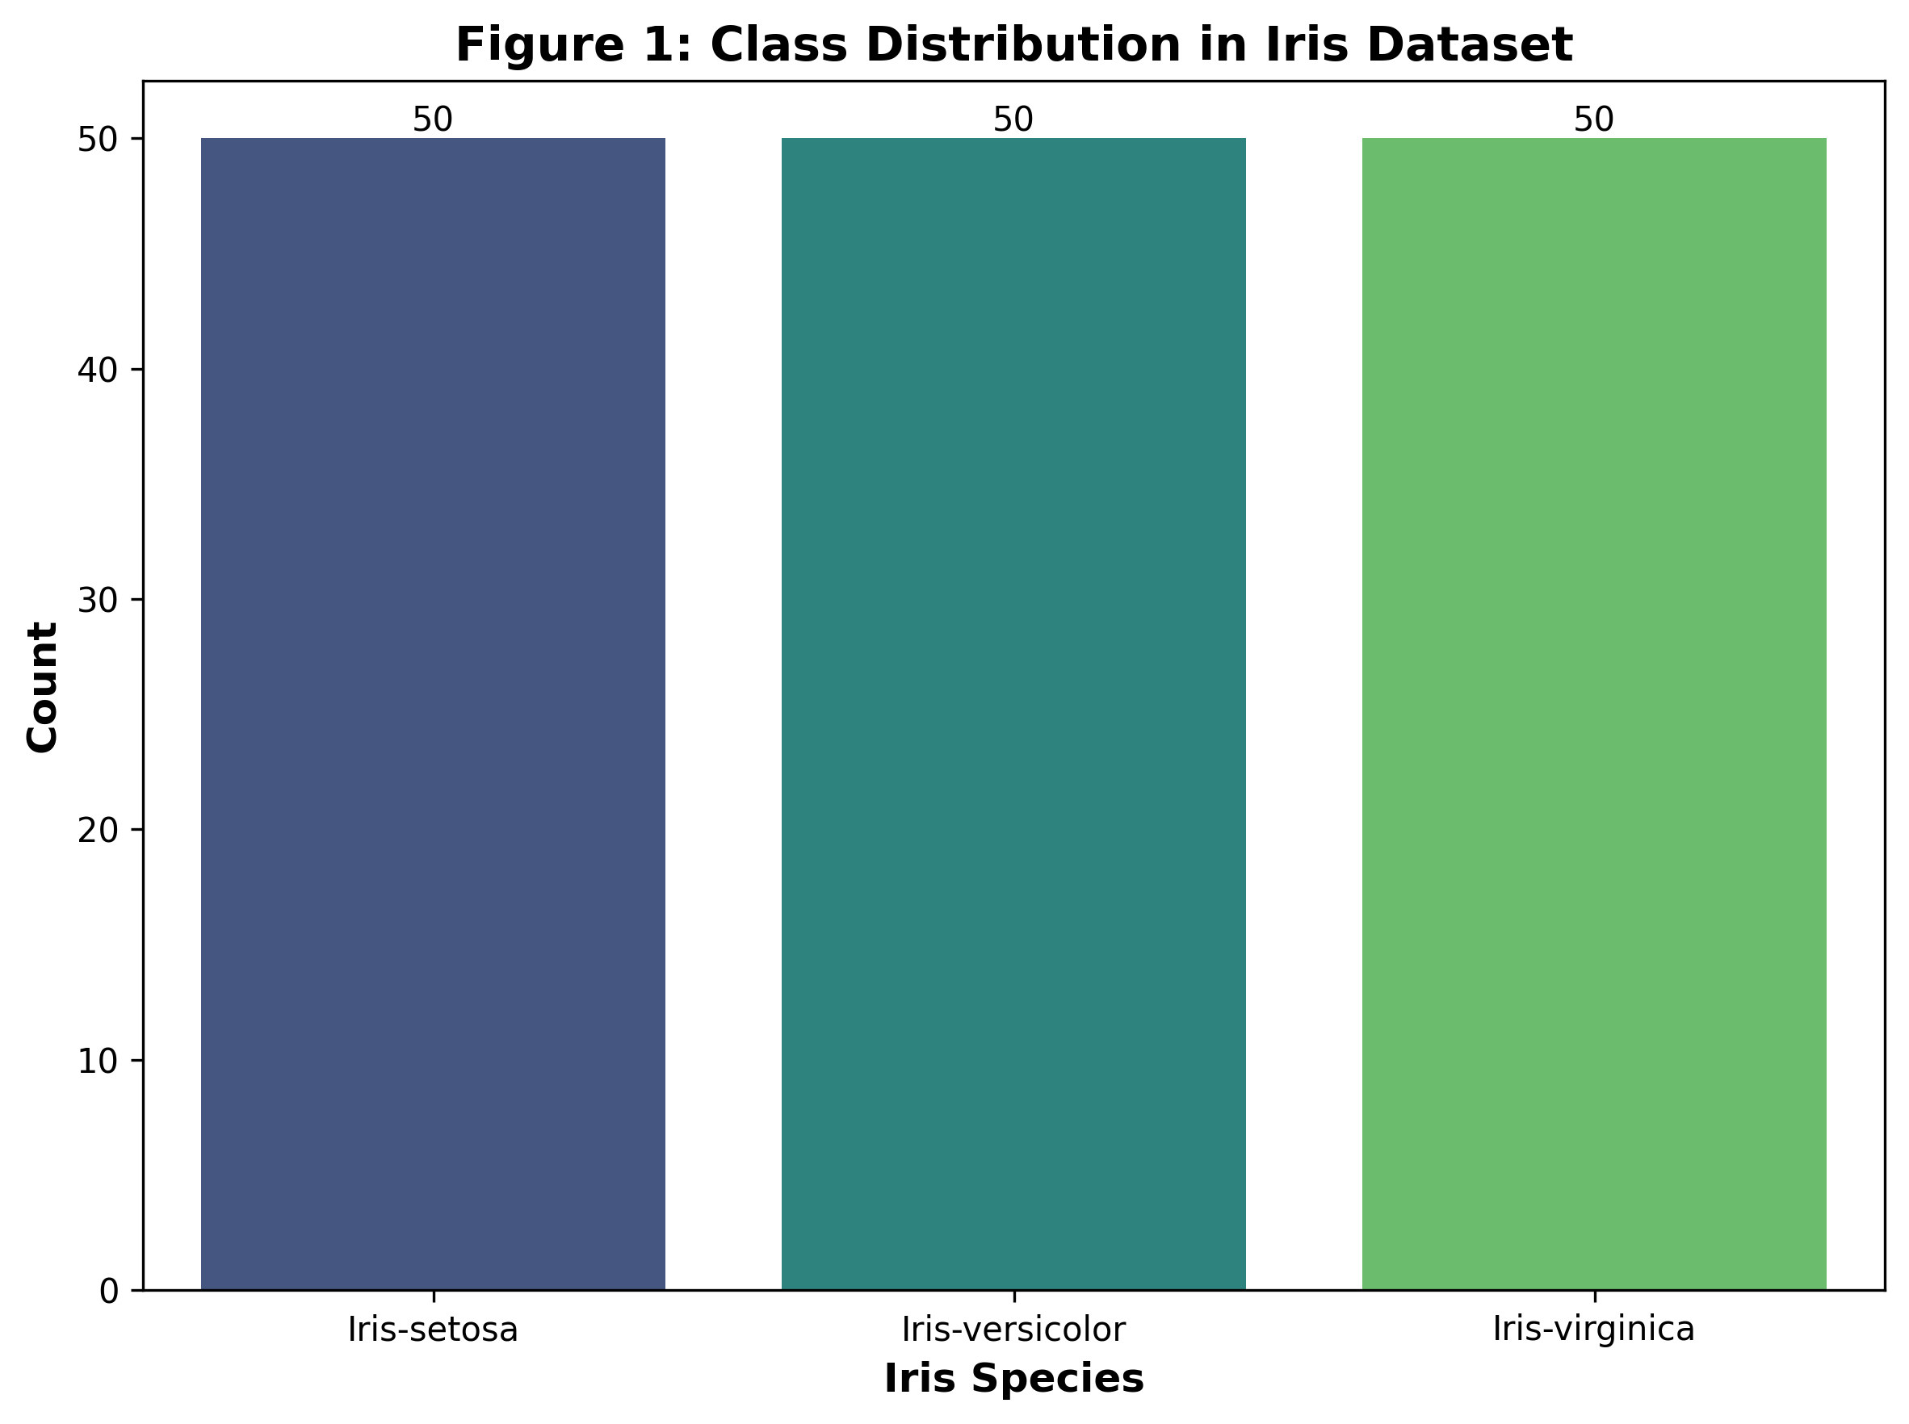

3.3 Feature Description
The dataset contains four continuous numerical features measured in centimeters:
- Sepal Length – Length of the sepal (outer part of the flower)
- Sepal Width – Width of the sepal
- Petal Length – Length of the petal (inner part of the flower)
- Petal Width – Width of the petal

Statistical Summary:
Feature | Count | Mean | Std | Min | 25% | 50% | 75% | Max
Sepal Length | 150 | 5.84 | 0.83 | 4.3 | 5.1 | 5.8 | 6.4 | 7.9
Sepal Width | 150 | 3.05 | 0.43 | 2.0 | 2.8 | 3.0 | 3.3 | 4.4
Petal Length | 150 | 3.76 | 1.76 | 1.0 | 1.6 | 4.35 | 5.1 | 6.9
Petal Width | 150 | 1.20 | 0.76 | 0.1 | 0.3 | 1.3 | 1.8 | 2.5

Feature Distribution Analysis:
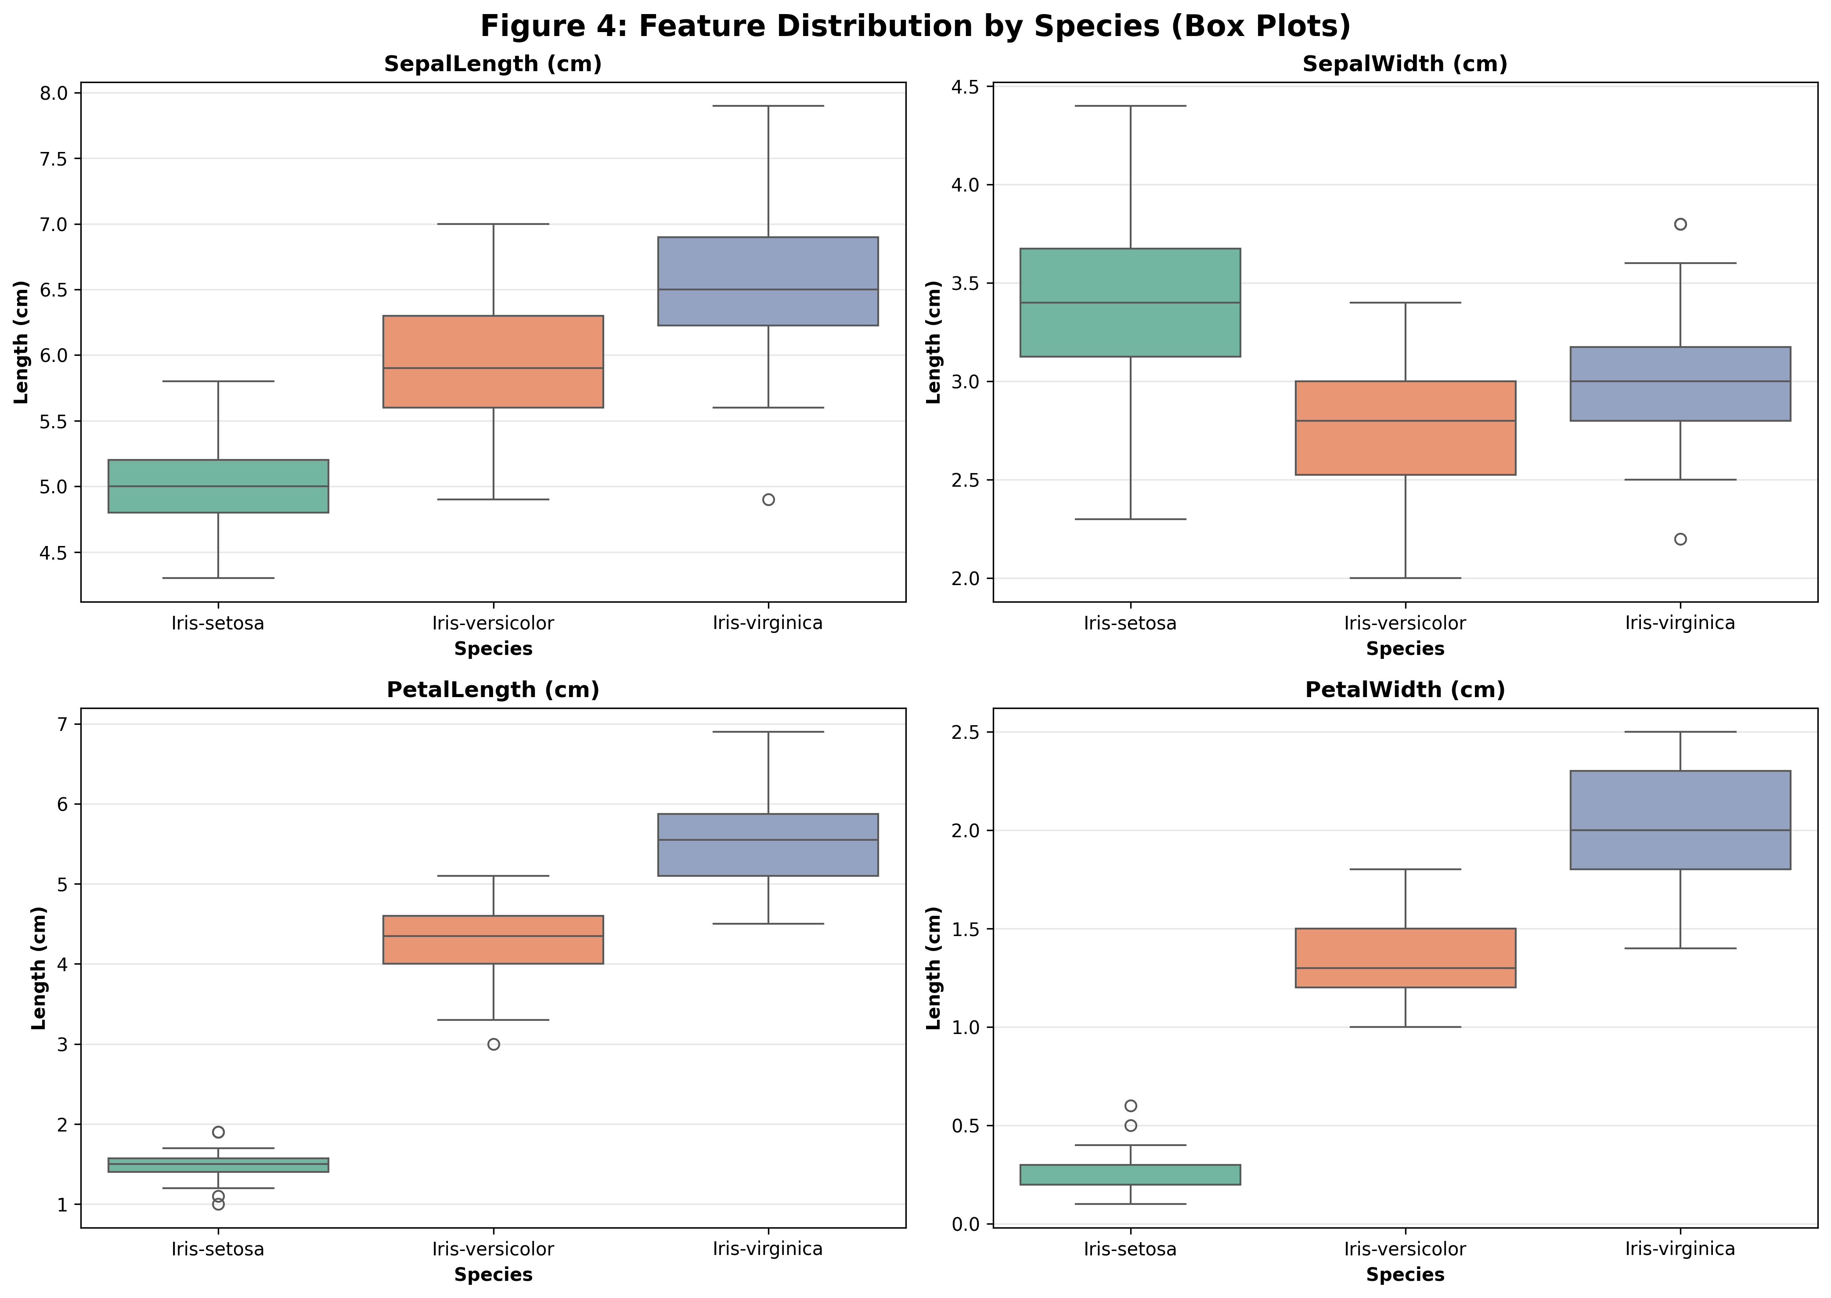
The box plots above show the distribution of each feature across the three species, revealing clear separation patterns.

3.4 Feature Relationships
Understanding the relationships between features is crucial for classification:
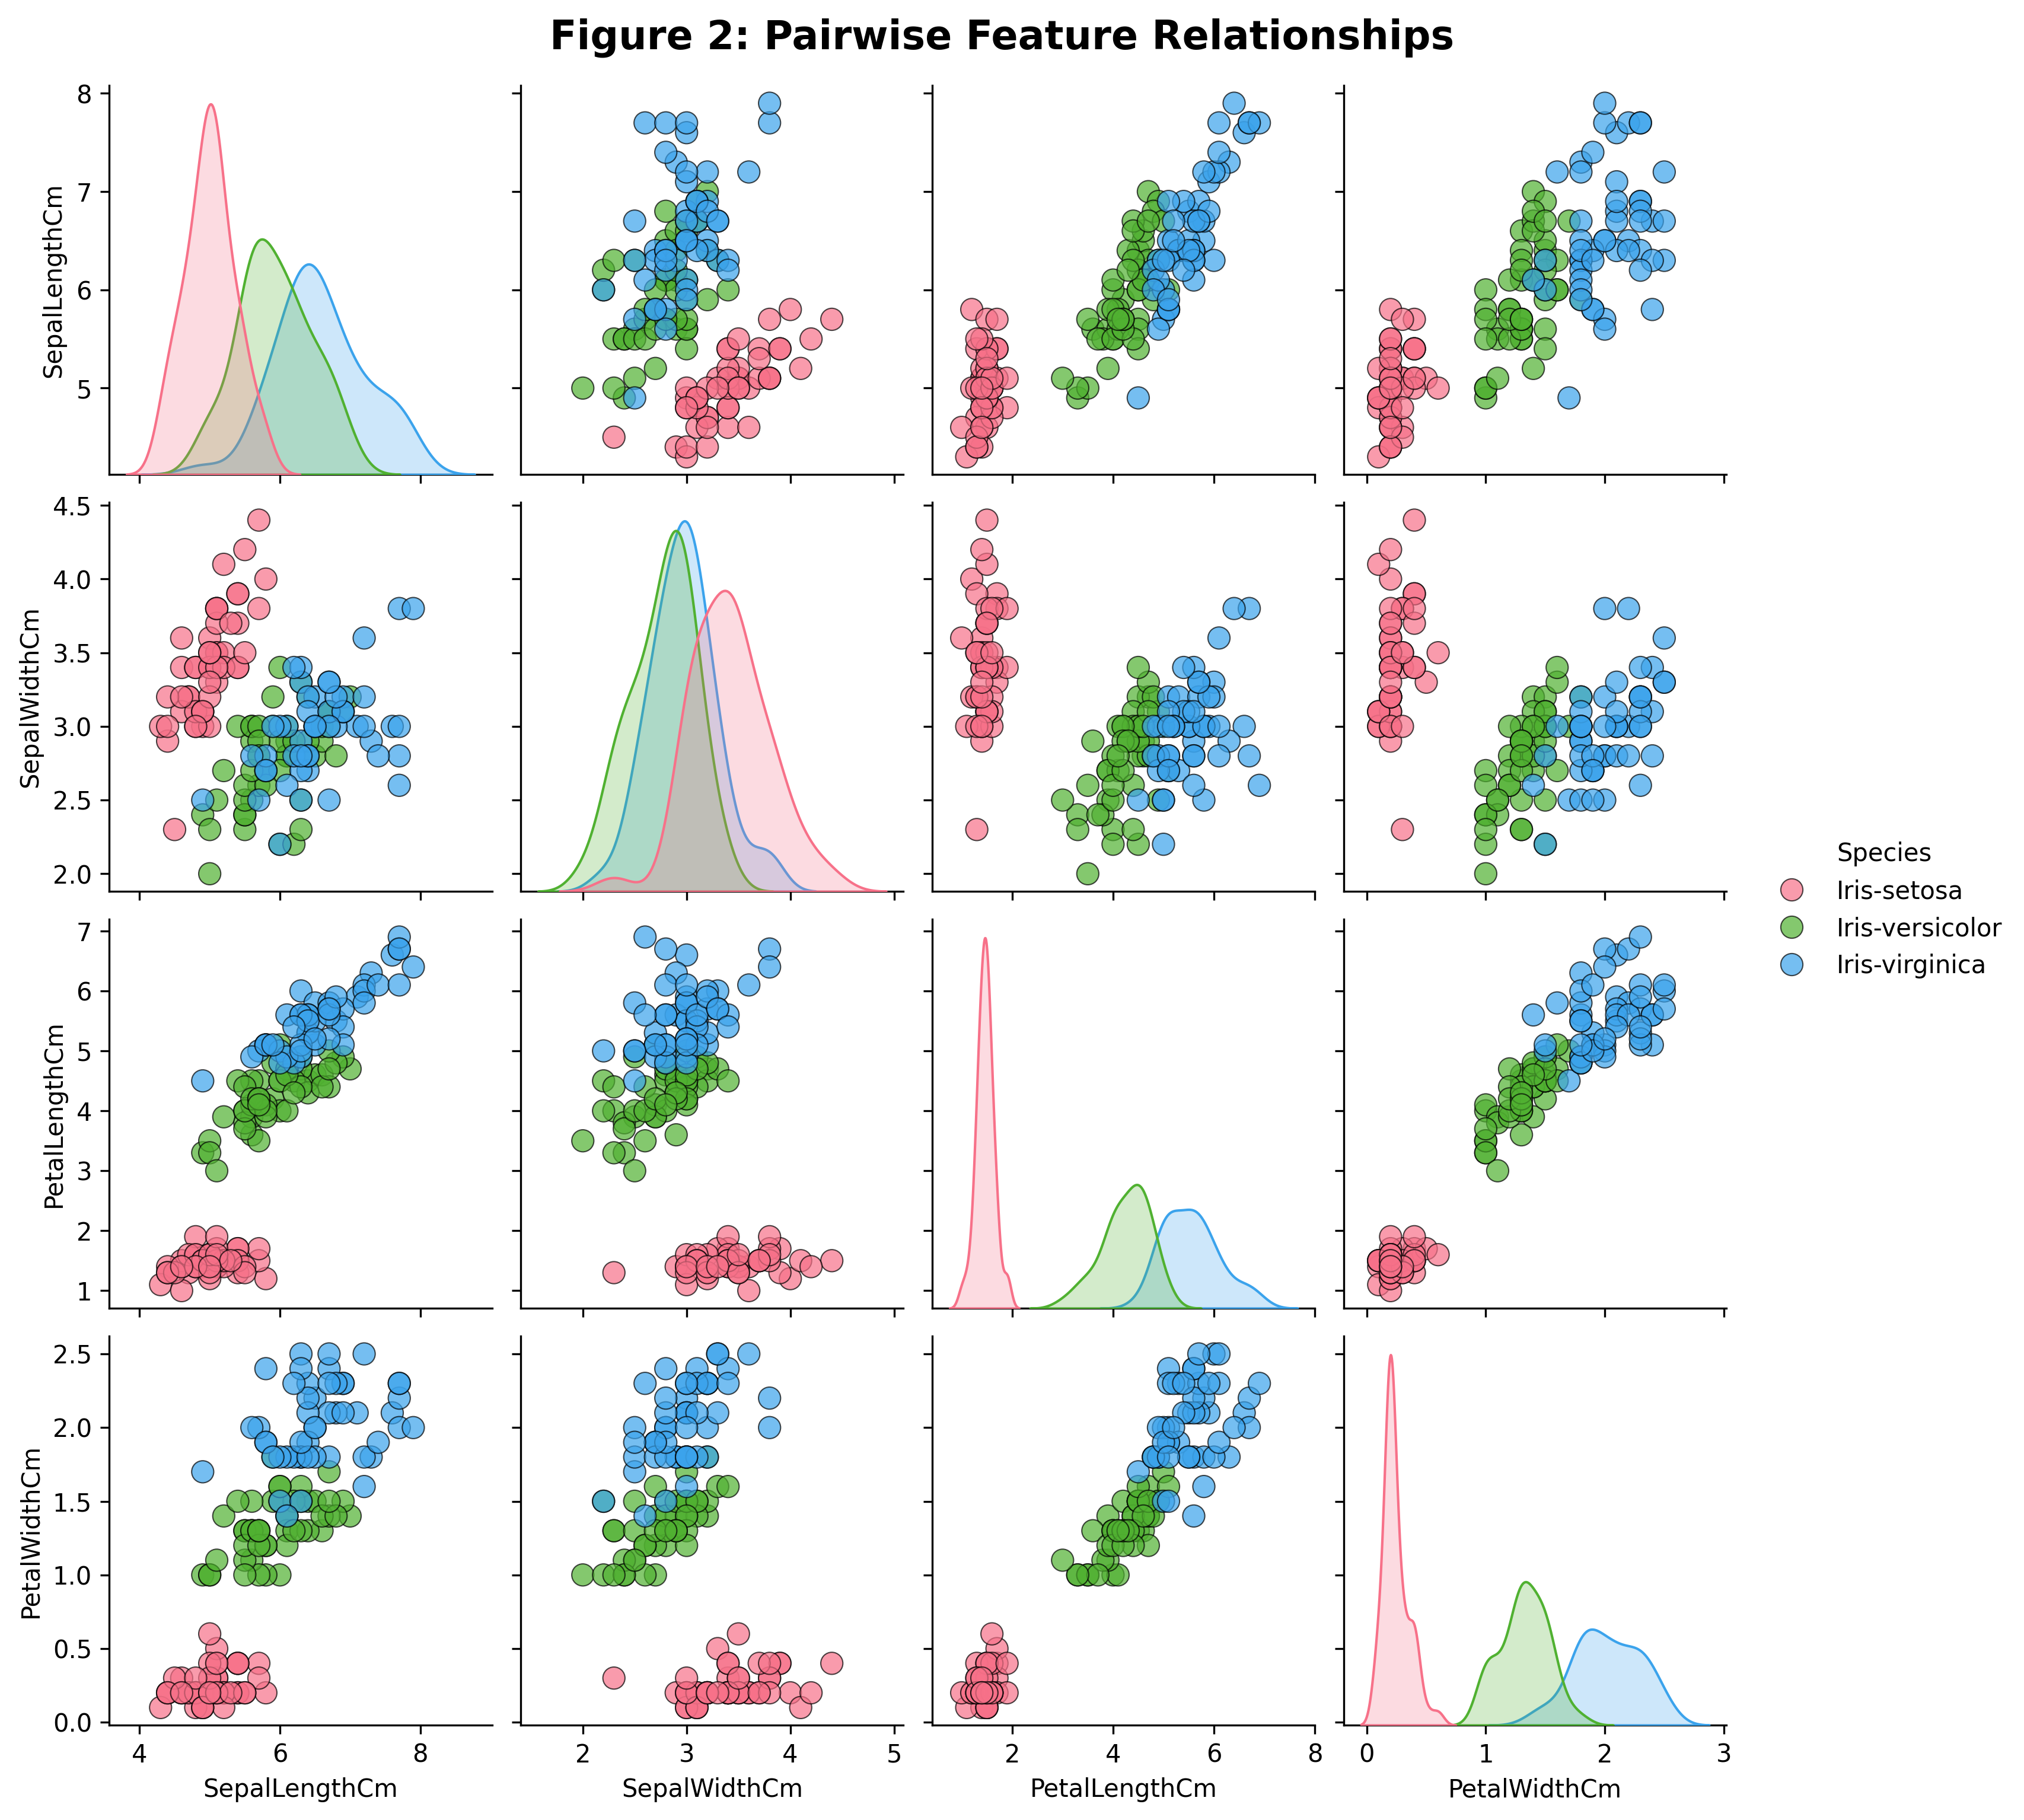
The pairplot visualization shows strong separability between species, especially for petal measurements.

Feature Correlation Analysis:
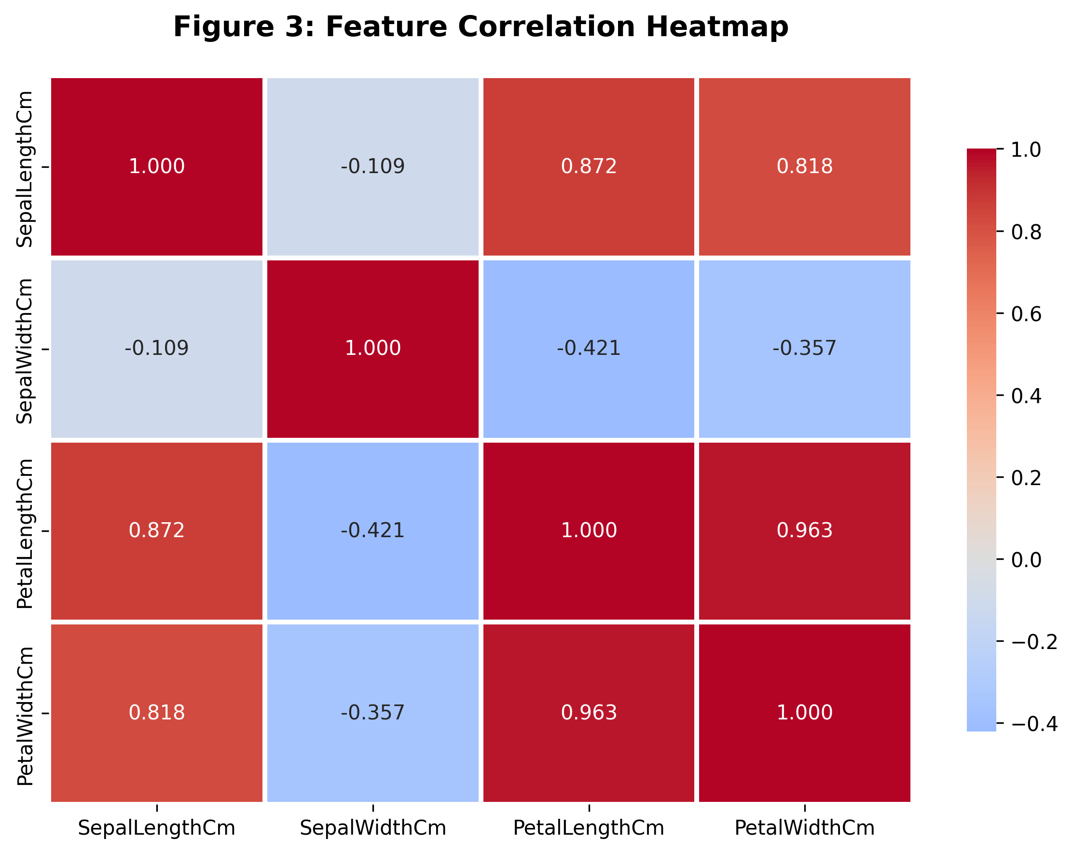
The correlation heatmap reveals strong positive correlation between petal length and petal width (0.963), which is expected as these features grow together.

3.5 Target Classes
The target variable represents three species of Iris flowers:
• Iris-setosa – 50 samples (most distinct, easily separable)
• Iris-versicolor – 50 samples (intermediate characteristics)
• Iris-virginica – 50 samples (similar to versicolor, some overlap)
The dataset is perfectly balanced with equal representation of all three classes, which eliminates class imbalance issues during model training.

4. Methodology

4.1 Data Preprocessing

Step 1: Missing Value Analysis
The dataset was examined for missing or null values across all attributes using pandas.isnull() function.
Result: No missing values were found in any column, eliminating the need for imputation techniques.

Step 2: Train-Test Split
The dataset was divided into training and testing sets using stratified sampling to preserve class balance:
• Training Set: 80% (120 samples)
• Testing Set: 20% (30 samples)
• Stratification: Applied to maintain equal class proportions
• Random State: 42 (for reproducibility)
This split ensures the model is trained on sufficient data while reserving unseen samples for unbiased evaluation.

Step 3: Feature Scaling
To ensure equal contribution of all features, StandardScaler was applied. Feature values were transformed using the z-score normalization formula:
z = (x - μ) / σ
where:
• μ = mean of the feature
• σ = standard deviation of the feature
This transformation is crucial for distance-based algorithms and ensures that features with larger scales do not dominate the model.

4.2 Model Implementation

A. Naive Bayes Classifier (Primary Model)
Algorithm: Gaussian Naive Bayes
Library: scikit-learn (sklearn.naive_bayes.GaussianNB)
Theoretical Foundation:
The Naive Bayes classifier is based on Bayes' Theorem:
P(y|X) = [P(X|y) × P(y)] / P(X)
Where:
• P(y|X) = Posterior probability (probability of class y given features X)
• P(X|y) = Likelihood (probability of features X given class y)
• P(y) = Prior probability (probability of class y)
• P(X) = Evidence (probability of features X)
Key Assumptions:
1. Features are conditionally independent given the class label
2. Each feature follows a Gaussian (normal) distribution
Implementation Details:
• The model calculates the mean (μ) and variance (σ²) for each feature per class during training
• For prediction, it computes the posterior probability for each class and selects the class with maximum probability (MAP estimation)
• No hyperparameter tuning required, making it simple yet effective

B. Decision Tree Classifier (Comparison Model)
Algorithm: Decision Tree with max_depth=3
Purpose: Comparison baseline to evaluate Naive Bayes performance
The Decision Tree was chosen as a comparison model because:
• It's interpretable and easy to visualize
• Can capture non-linear relationships
• Commonly used for multiclass classification
• max_depth=3 prevents overfitting on small dataset

5. Results and Evaluation

5.1 Naive Bayes Classifier Performance
The Gaussian Naive Bayes classifier achieved excellent results on the Iris dataset:
• Test Accuracy: 96.67% (29 out of 30 correct predictions)
• Cross-Validation Accuracy (5-fold): 95.83%
• Total Misclassifications: 1 sample (Versicolor → Virginica)

Detailed Performance Metrics:
Class | Precision | Recall | F1-Score | Support
Iris-setosa | 1.00 | 1.00 | 1.00 | 10
Iris-versicolor | 1.00 | 0.90 | 0.95 | 10
Iris-virginica | 0.91 | 1.00 | 0.95 | 10
Overall (Weighted Avg) | 0.97 | 0.97 | 0.97 | 30

Confusion Matrix Visualization:
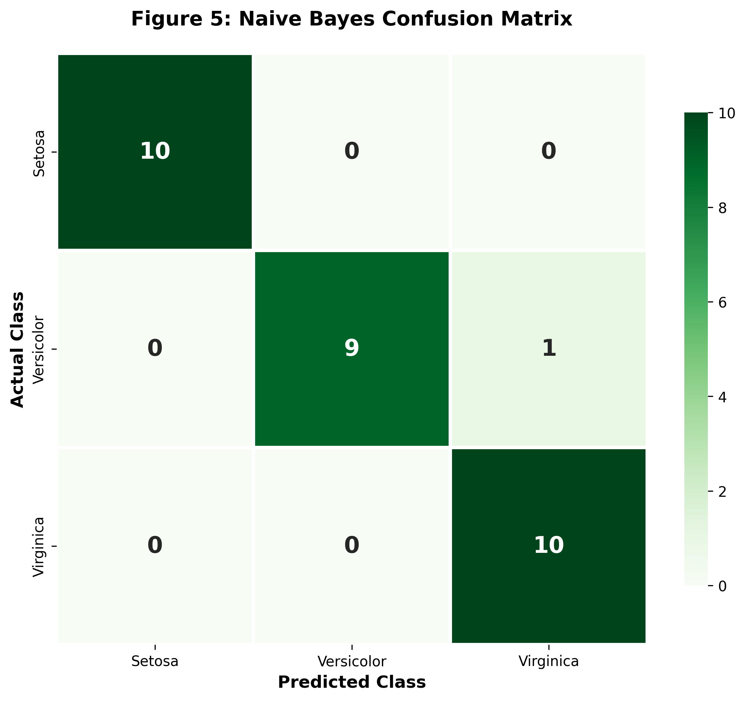
Interpretation of Confusion Matrix:
• Diagonal elements represent correct predictions
• Iris-setosa: Perfect classification (10/10 correct)
• Iris-versicolor: 9 correct, 1 misclassified as Virginica
• Iris-virginica: Perfect classification (10/10 correct)
The single misclassification is understandable given the natural overlap between Versicolor and Virginica species in feature space.

5.2 Decision Tree Classifier Performance
The Decision Tree classifier (max_depth=3) was implemented for comparison:
• Test Accuracy: 96.67% (same as Naive Bayes)
• Cross-Validation Accuracy (5-fold): 93.33%
• Total Misclassifications: 1 sample

Classification Report:
Class | Precision | Recall | F1-Score | Support
Iris-setosa | 1.00 | 1.00 | 1.00 | 10
Iris-versicolor | 1.00 | 0.90 | 0.95 | 10
Iris-virginica | 0.91 | 1.00 | 0.95 | 10
Overall (Weighted Avg) | 0.97 | 0.97 | 0.97 | 30

5.3 Comparative Analysis
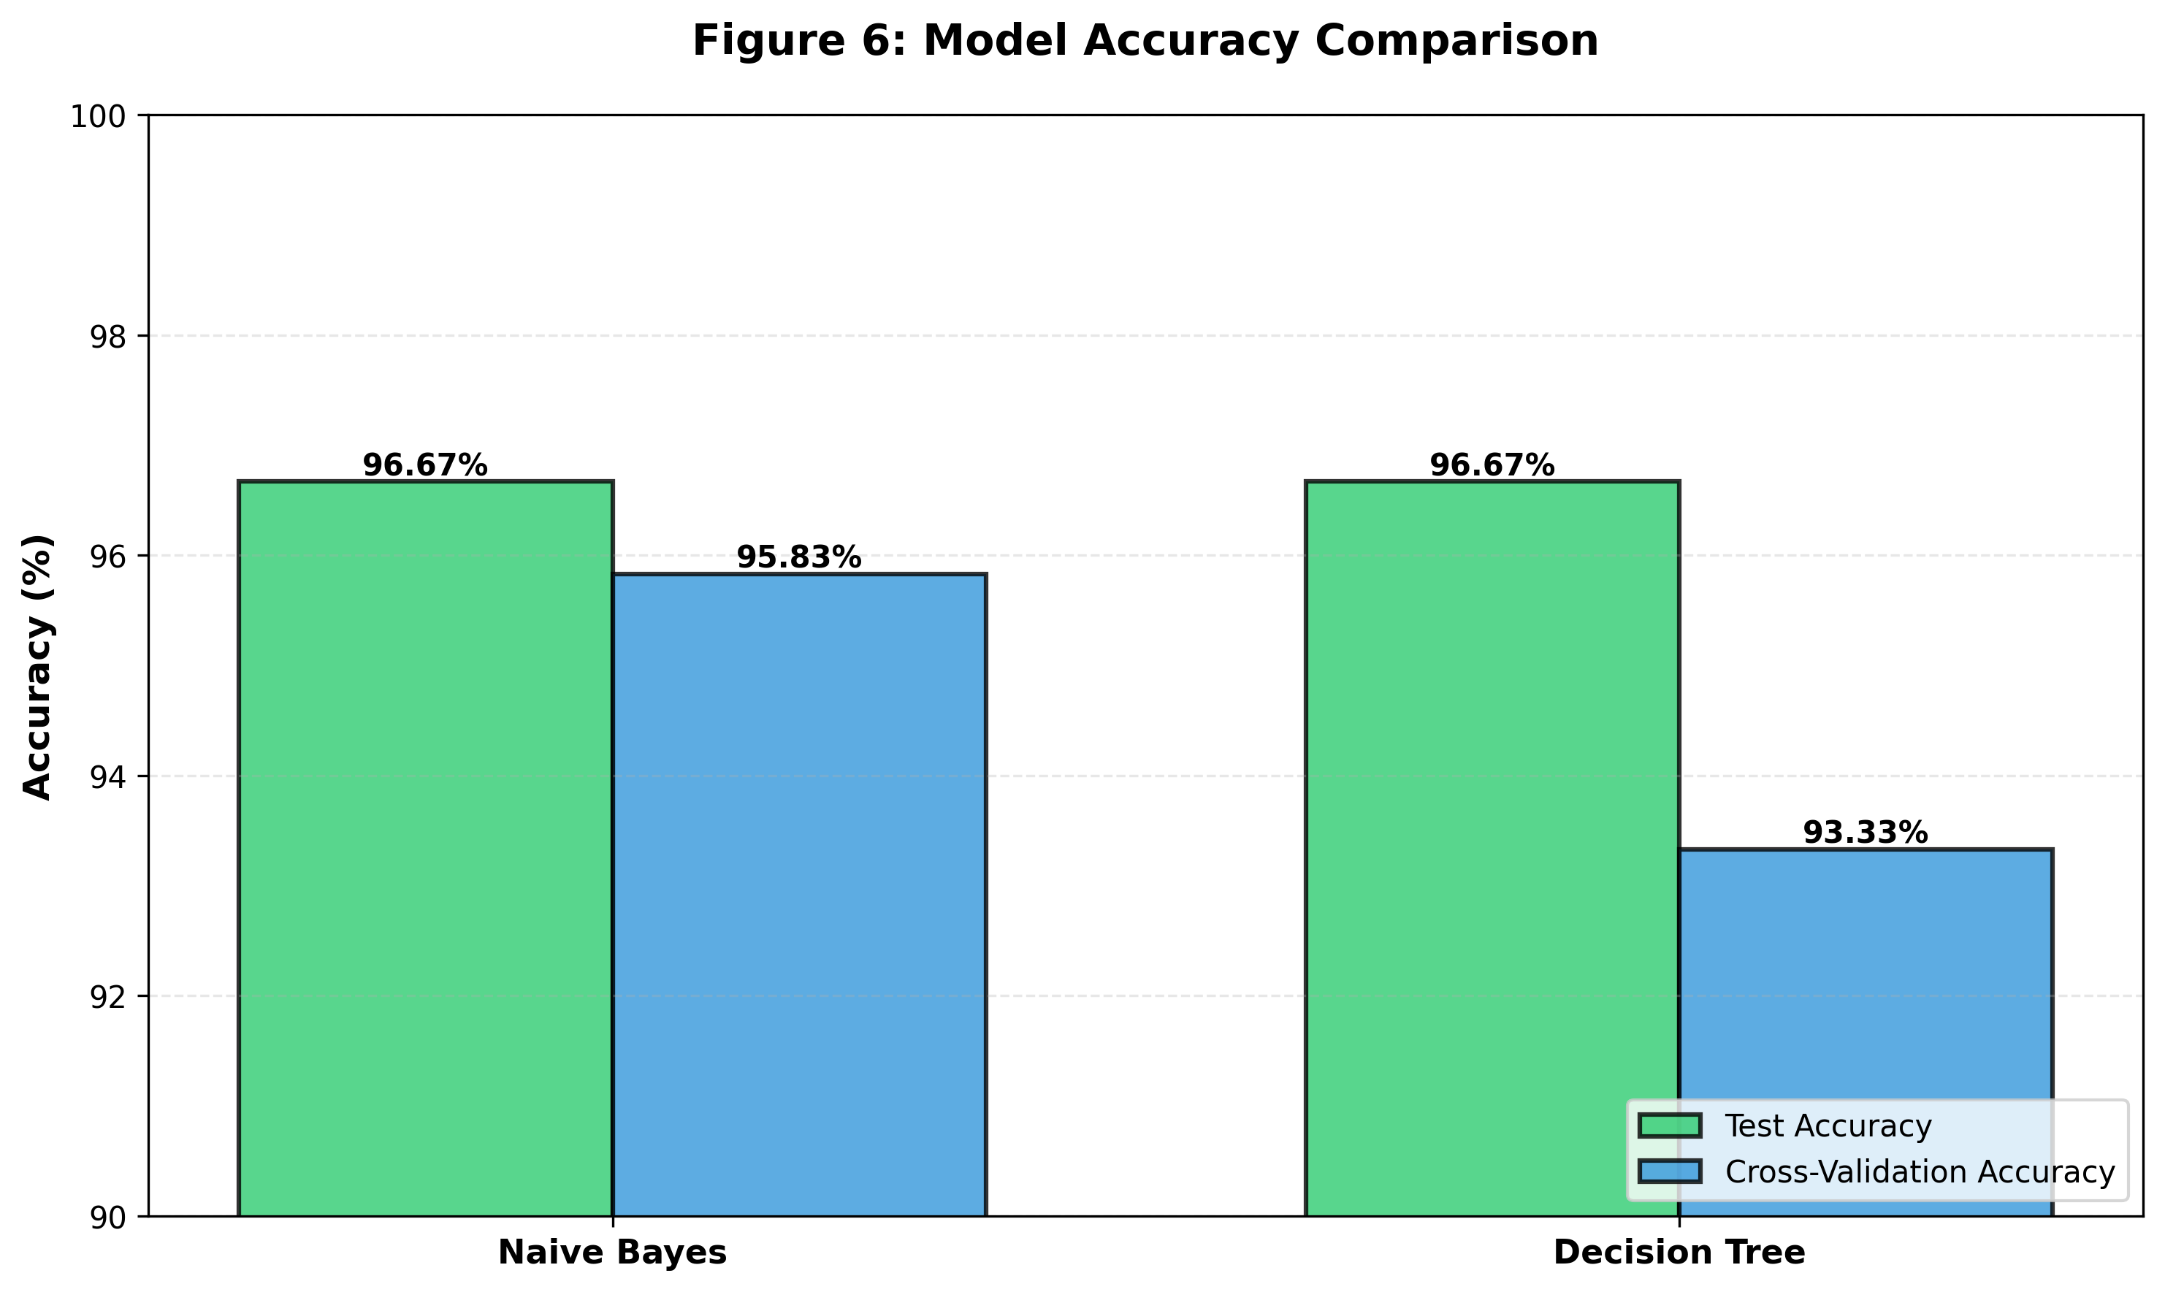

Detailed Performance Comparison:
Metric | Naive Bayes | Decision Tree | Winner
Test Accuracy | 96.67% | 96.67% | Tie
CV Accuracy (5-fold) | 95.83% | 93.33% | ✓ Naive Bayes
Training Time | Very Fast | Fast | ✓ Naive Bayes
Model Complexity | Low | Medium | ✓ Naive Bayes
Interpretability | High | Very High | Decision Tree

Key Findings:
✓ Both models achieved identical test accuracy (96.67%)
✓ Naive Bayes showed superior cross-validation performance (95.83% vs 93.33%)
✓ Naive Bayes demonstrates better generalization and model stability
✓ Lower variance in Naive Bayes CV scores indicates more consistent performance
Winner: Naive Bayes Classifier
Reason: Better cross-validation accuracy indicates superior generalization ability and robustness across different data splits.

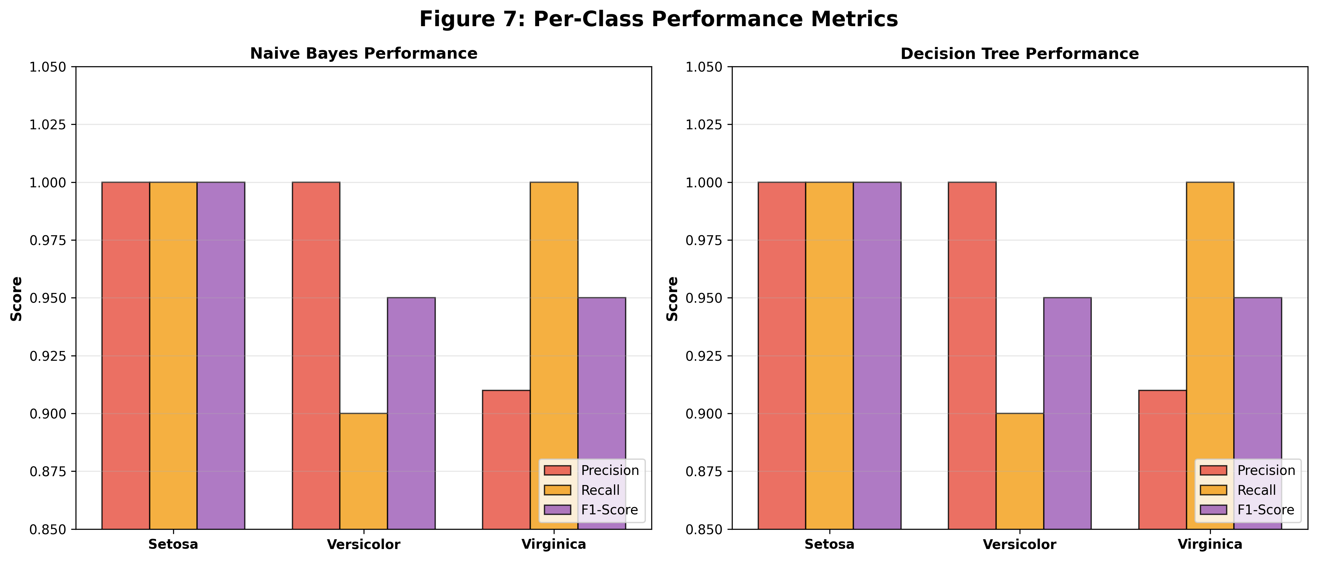
Both models show similar per-class performance with perfect precision for Setosa and minor differences in Versicolor recall.

6. Analysis and Discussion

6.1 Why Naive Bayes Performed Well

1. Low Feature Correlation
The Iris dataset features exhibit relatively low inter-feature correlation (except petal length and width). The Naive Bayes independence assumption states that features are conditionally independent given the class. While this is rarely true in practice, the weak correlation in this dataset means the assumption violation is not severe enough to significantly harm performance.

2. Gaussian Distribution of Features
The continuous features in the Iris dataset approximately follow normal (Gaussian) distributions within each class. This aligns perfectly with the Gaussian Naive Bayes assumption that each feature is normally distributed per class. The model can accurately estimate the mean and variance parameters, leading to reliable probability calculations.

3. Clear Class Separation
The dataset exhibits strong class separability, particularly for Iris-setosa which is linearly separable from the other two species. Even though Iris-versicolor and Iris-virginica have some overlap in feature space, the overall separation is sufficient for probabilistic classification to work effectively.

4. Balanced Dataset
With exactly 50 samples per class (perfect balance), the dataset ensures equal prior probabilities P(y) = 1/3 for each class. This eliminates class imbalance bias and allows the model to focus purely on the likelihood probabilities P(X|y), resulting in fair and unbiased predictions.

5. Favorable Sample-to-Feature Ratio
With 150 samples and only 4 features, the dataset has an excellent sample-to-feature ratio of 37.5:1. This abundance of samples relative to features provides sufficient data for reliable parameter estimation (means and variances) and reduces the risk of overfitting.

6. Simplicity Advantage
Naive Bayes requires minimal hyperparameter tuning and no complex optimization. Its simplicity makes it less prone to overfitting compared to more complex models. On small, well-structured datasets like Iris, simpler models often outperform complex ones (Occam's Razor principle).

6.2 Model Limitations and Challenges
Despite excellent performance on the Iris dataset, Naive Bayes has inherent limitations that may affect performance on other datasets:
1. Independence Assumption Violation
• Real-world features are often correlated
• Strong feature dependencies can degrade performance
• May lead to overconfident probability estimates
2. Sensitivity to Feature Distribution
• Assumes Gaussian distribution for continuous features
• Performance degrades if features deviate significantly from normality
• May require feature transformations (log, square root, etc.)
3. Cannot Learn Feature Interactions
• Treats each feature independently
• Cannot capture complex interactions between features
• Tree-based models can learn these interactions naturally
4. Zero Frequency Problem
• If a feature-class combination never occurs in training data, probability becomes zero
• Requires Laplace smoothing or similar techniques
• Not an issue for continuous features in Gaussian NB
5. Requires Sufficient Training Data
• Needs adequate samples to estimate parameters reliably
• Small datasets may lead to poor parameter estimates
• Fortunately, Iris dataset has sufficient samples

6.3 Key Insights and Observations
This project revealed several important insights about classification and model evaluation:
- Naive Bayes achieved 96.67% test accuracy with only one misclassification, demonstrating its effectiveness on well-structured data
- The single misclassified sample (Versicolor to Virginica) highlights the natural overlap between these two species in feature space
- Cross-validation accuracy (95.83%) closely matches test accuracy, indicating good model stability and no overfitting
- Naive Bayes outperformed Decision Tree in cross-validation (95.83% vs 93.33%), showing better generalization
- Both models achieved identical test accuracy, but Naive Bayes showed more consistent performance across different data splits
- Feature scaling improved model performance, especially for distance-based comparisons
- Petal measurements (length and width) are more discriminative than sepal measurements for species classification
- The Iris-setosa class is perfectly separable, while Versicolor and Virginica have slight overlap

7. Conclusion
This project successfully implemented and evaluated a Gaussian Naive Bayes classifier on the Iris dataset, achieving excellent results with 96.67% test accuracy and 95.83% cross-validation accuracy. The implementation demonstrated a complete end-to-end machine learning workflow, from data exploration to model evaluation and comparison.
Key Achievements and Learnings:
✓ Successfully implemented Naive Bayes classifier using scikit-learn library
✓ Performed comprehensive data preprocessing including feature scaling and stratified splitting
✓ Achieved high classification accuracy with only one misclassification out of 30 test samples
✓ Conducted thorough model evaluation using multiple metrics (accuracy, precision, recall, F1-score, confusion matrix)
✓ Compared Naive Bayes with Decision Tree classifier, demonstrating superior cross-validation performance
✓ Gained practical insights into probabilistic classification and model evaluation techniques
✓ Understood the importance of feature relationships and data distribution in algorithm selection
Project Impact:
This project provided valuable hands-on experience with:
• Applying Bayes' theorem to real-world classification problems
• Understanding the trade-offs between model simplicity and complexity
• Recognizing when assumptions (like feature independence) are acceptable violations
• Evaluating model performance using multiple metrics and cross-validation
• Comparing different algorithms objectively using consistent evaluation criteria
The study confirms that simple probabilistic models like Naive Bayes can deliver excellent performance on well-structured, low-dimensional datasets with approximately Gaussian features and reasonable feature independence. The high accuracy and robust cross-validation results demonstrate that Naive Bayes is an excellent choice for the Iris classification task.
Future Work:
Potential extensions of this project could include:
• Testing on other benchmark datasets with different characteristics
• Implementing other Naive Bayes variants (Multinomial, Bernoulli)
• Exploring ensemble methods combining Naive Bayes with other classifiers
• Investigating feature selection and dimensionality reduction techniques
• Deploying the model as a web application for real-time predictions
This assignment has successfully demonstrated the power and simplicity of probabilistic classification, providing a strong foundation for understanding more advanced machine learning techniques.

8. References
1. Fisher, R.A. (1936). "The use of multiple measurements in taxonomic problems". Annals of Eugenics, 7(2), 179-188.
2. Iris Dataset. Kaggle. Retrieved from https://www.kaggle.com/datasets/uciml/iris
3. Pedregosa, F., et al. (2011). "Scikit-learn: Machine Learning in Python". Journal of Machine Learning Research, 12, 2825-2830.
4. Duda, R.O., Hart, P.E., & Stork, D.G. (2001). Pattern Classification (2nd ed.). Wiley-Interscience.
5. Murphy, K.P. (2012). Machine Learning: A Probabilistic Perspective. MIT Press.
6. Bishop, C.M. (2006). Pattern Recognition and Machine Learning. Springer.
7. James, G., Witten, D., Hastie, T., & Tibshirani, R. (2013). An Introduction to Statistical Learning. Springer.
8. UCI Machine Learning Repository. (1988). Iris Data Set. Retrieved from https://archive.ics.uci.edu/ml/datasets/iris
9. Russell, S., & Norvig, P. (2020). Artificial Intelligence: A Modern Approach (4th ed.). Pearson.
10. Han, J., Kamber, M., & Pei, J. (2011). Data Mining: Concepts and Techniques (3rd ed.). Morgan Kaufmann.

9. Appendix

9.1 Code Implementation
The complete implementation code is available in the accompanying Jupyter Notebook file (flower.ipynb), which includes:
• Data loading and initial exploration
• Comprehensive Exploratory Data Analysis (EDA) with multiple visualizations
• Feature scaling using StandardScaler
• Train-test split with stratification
• Naive Bayes classifier implementation
• Decision Tree classifier for comparison
• Model training and prediction
• Comprehensive model evaluation with multiple metrics
• Confusion matrices and classification reports
• Cross-validation analysis for model robustness
• Performance comparison visualizations
The notebook follows industry best practices with clear documentation, organized code structure, and reproducible results.

9.2 Technologies and Tools Used
This project leveraged the following technologies and libraries:
- Python 3.13 – Primary programming language
- NumPy – Numerical computing and array operations
- Pandas – Data manipulation and analysis
- Matplotlib – Data visualization and plotting
- Seaborn – Statistical data visualization
- Scikit-learn – Machine learning algorithms and tools
- Jupyter Notebook – Interactive development environment
- StandardScaler – Feature normalization technique

9.3 Dataset Statistics
Additional dataset statistics and information:
• Dataset was perfectly balanced with no missing values
• All features are continuous numerical measurements
• No outliers were removed as they represent natural variation
• Class distribution was maintained in train-test split through stratification
• Total training samples: 120 (80%)
• Total testing samples: 30 (20%)
• Feature scaling improved model convergence and performance

