SD ASSIGNMENT1 DOCUMENTATION

OLAR ALEXANDRU-LUCIAN

GR 30434

1.PROJECT REQUIREMENTS

The project consists of a copy of StackOverflow that has a database with users that can ask questions and then be able to answer those questions. Users have names passwords etc, questions have titles and text, and answers have texts. The users can vote on the questions and the questions have tags # that can help the users fnd specific topics easier(I didn’t do both of these)

Basically I had to implement the CRUD functionalities for users, answers and questions keeping in mind that I have some many to one relationships. To implement the data bases and to test stuff in postman. Also oop architecture is required.

2. USE CASE MODEL(NO DRAWING SORRY ☺)

-Create user

-Update user data

-Delete user

-Read user by id and print all users

-Create question

-Update question data

-Delete question

-Read question by id and print all questions

-Create answers

-Update answer data

-Delete answer

-Read answer by id and print all answers

3. DIAGRAMS FOR PACKAGES

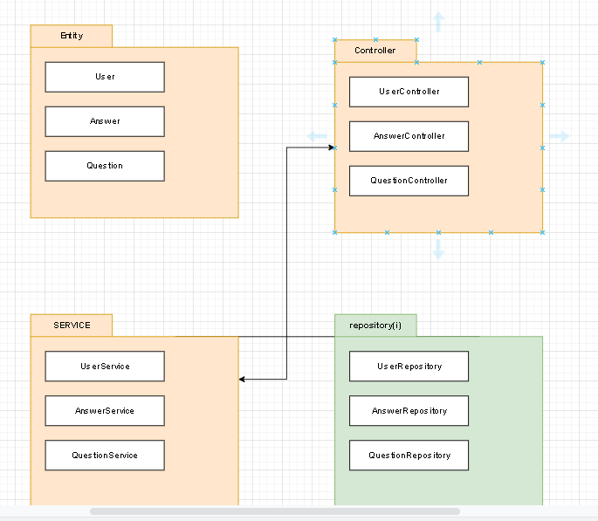

4. DIAGRAMS FOR CLASSES

