**STɅDI**

**TECHNICAL DOCUMENTATION**

**Table of Contents**

Revision History 3

Application Overview 4

Development Specification 5

Source Code  6

Development Methodology 8

Test Data  9

Acknowledgement 13

**Revision History**

|  |  |  |  |
| --- | --- | --- | --- |
| **Version** | **Date** | **Name** | **Description** |
| 1 | 06/07/20 | Ama Daniel Eze | Initial Document, UI/UX Software Development and Design |

**Application Overview**

The purpose of this document is to describe the architecture and design of the STɅDI application in a way that would make any other web developer easily continue with the process of improving the system.

This application is a SaaS (Software as a Service) integrated school management system which aims to bring much needed simplicity to Administration of an Enterprise especially in the field of Education.

Once this application is implemented in a school, it enables this inbuilt user roles- (**Super-Admin**, **Admin**, **Teacher**, **Accountant**, **Librarian, Receptionist**, **Student** and **Parent**) to log-in to the system from any internet enabled device and perform various activities like making leave requests, arranging PTA meetings, publishing exam scores etc. One can also assign user roles that are not defaults on the application like **Drivers, Store-keeper** e.t.c. While similar products in the market do not allow the parent and student to login, our solution aims to further bridge the gap between parents, students and teachers and creates a standardized platform for meaningful collaboration to happen (even between schools in a group).

This application was created to perform three main functions; namely **making institution management easier, making education fun** and **providing guidance to the administration to help future decision making**.

Due to the fluid and responsive design method used, this application can be viewed on all hardware device be it tablets, phones, computers e.t.c

**Development Specification**

**Technologies Used**

JavaScript JS, JavaScript JSON, HTML, CSS, PHP, SQL

**Software Version**

PHP 7.x, PHP 5.x, PHP 5.4, PHP 5.5, PHP 5.6, MySQL 5.x

**Framework**

FYNIX, Bootstrap

**Compatible Browsers**

IE9, IE10, IE11, Firefox, Safari, Opera, Chrome, Edge

**Desireable Platforms**

Smart phones, Tablets, PC Computers, Mac

**Source Code**

The Source Code can be located in Jencube’s GitHub repository. Once downloaded and installed on any local server, the URL to access to view the UI shell is: http:// [Server-Domain] / [Project-Folder](optional) / public

**UI Template Folders and Files**

Core UI files are located in the **Templates** Folder. Different Templates can be designed and placed in this folder for user variety. It only has one Template for now with the name “*origin*”, a .*htaccess* file and an *index.php* file which is the initial UI template trigger. The below image shows the list of folders contained in the “*origin*“ Template folder:

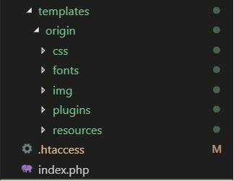

*Figure 1.0*: Theme-Origin Template Folder Hierarchy

1. **templates -> origin**: This is the default template residing as a sub folder of the templates folder.
2. **templates -> origin -> css**: All CSS (Cascade Style Sheets) files are saved in this folder except for the bootstrap’s framework CSS file which is stored in FYNIX stylesheets folder.
3. **templates -> origin -> fonts**: All fonts (icon fonts included) used for the design are stored here
4. **templates -> origin -> img**: All images used for the design except the applications logo are stored here
5. **templates -> origin -> plugins**: All JavaScript and JQuery related libraries and plugins are stored here but only one JavaScript library “*template.script.js*” which is responsible for the dynamics on the UI design template is stored here.
6. **templates -> origin -> resources**: All pages to be rendered including the design layouts are stored in this folder.

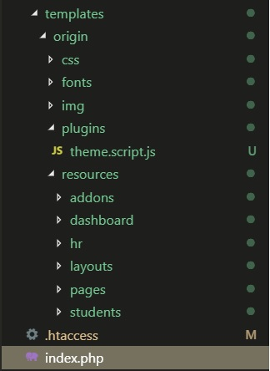

**Development Methodology**

For this project, PearSDC standard development model for software development was implemented. A brief overview of the phases is as follows below:

**Requirement Analysis**: In consultation with the customer, PearSDC studies the complete system in-depth as given on the contract and the related supporting documents or instructions related by the customer, such that each process linked to the final preparation of the software is clearly understood. The Software Requirement Specification (SRS) document will be prepared, containing the application overview, scope, objectives, need and purpose, software and hardware interfaces, any issues or concerns, and more.

**Software Design Phase**: Based on the software requirements and operation concepts documented in the base lined SRS, detailed design solutions are worked out depending upon performance, availability of reusable components, and integration with other applications. TSD (Technical Support documents) are produced and base lined.

**Development and Integration**: Coding is done based on base lined TSD and the SRS. Unit testing is done on completion of development of each unit.

**Testing**: Product testing will be done at the stage by the QC (Quality Control) team in accordance with the test plan and test cased.

**Releases**: The product will be released to the client after the bug fixing and successful product verification by the QC team.

**Post Production Support and Maintenance**: Post production and support is provided on the project. In case of maintenance a change request log is maintained in order to keep track of changes and support requests.

**Test Data**

Working on it

**Test Analysis**

Working on it

**Acknowledgement**

I certify that this software development document is complete, the unit STɅDI defined in this document has successfully passed development and unit testing, and the unit is ready to be base lined and integrated into the system

**Date:** _____________________ **Team Lead Developer**: _________________

**Chief Technical Officer**: __________________ **Managing Director**: __________________

**Head of Department**: __________________