**Practical 03**

**Boot Sequence**

***Access the BIOS Setting***

1. Navigate to settings. You can get there by clicking the gear icon on the Start menu.

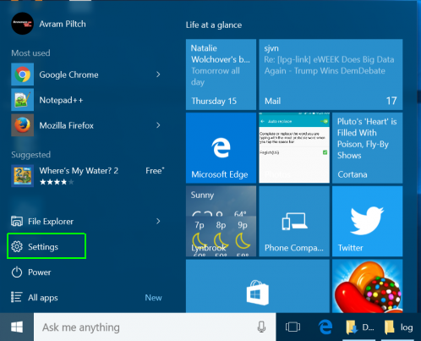

1. click on “Update & Security” at the bottom of the window.

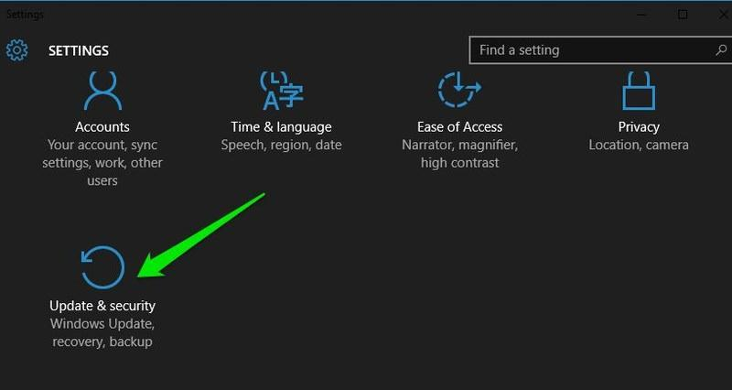

1. Here move to the**“Recovery”** option and click on **“Restart now”** under**“Advanced startup”** option. Your PC will now restart into advanced boot options.

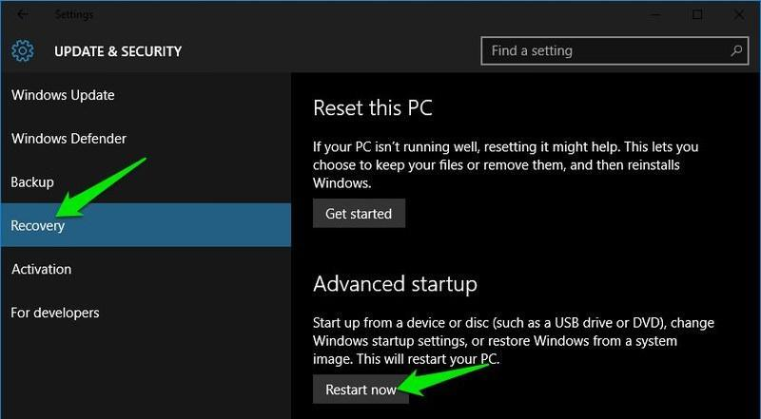

1. **Click Advanced options.**https://img.purch.com/o/aHR0cDovL3d3dy5sYXB0b3BtYWcuY29tL2ltYWdlcy93cC9wdXJjaC1hcGkvaW5jb250ZW50LzIwMTUvMTAvMTQ0NDk0OTU4OV81NTE0MDAuanBn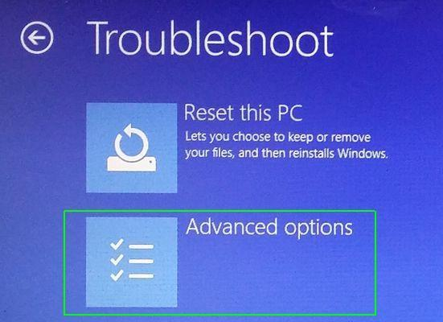Click Advanced options
2. **Select UEFI Firmware Settings.**If you don't see this icon, then press Startup Settings, instead. When your PC is restarting, tap F1 (or F2) to access the BIOS.  
   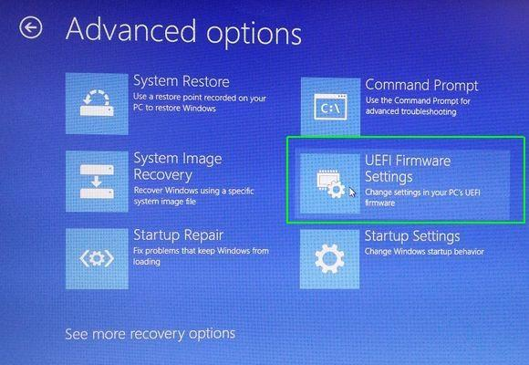

8. **Click Restart.**

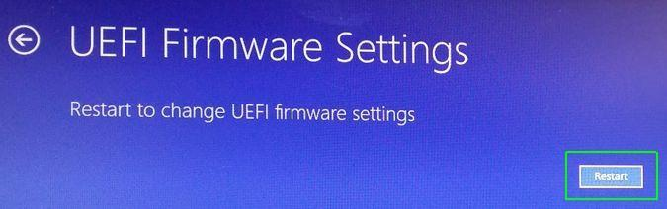

Your system will restart and take you to the BIOS.  
  
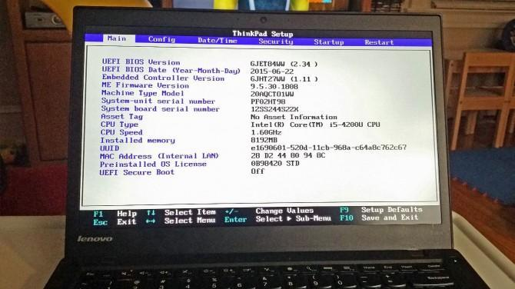

| Windows 10 gives you a lot of options you can configure directly within the operating system, but on every computer, there are some settings you can only change in the BIOS (basic input / output system). The BIOS is the software that is built into your computer's motherboard and controls everything from the boot order of your drives to preboot security options to whether the Fn key on your keyboard activates a function key or a media control.  Unfortunately, because the BIOS is a pre-boot environment, you can't access it directly from within Windows.  Reference: <https://www.laptopmag.com/articles/access-bios-windows-10> |
| --- |

What are different boot options for your PC? what is BIOS?

| The definition of BIOS is Basic Input Output System. It is the software that is built into the  motherboard that controls everything from the boot order of your drives. My PC’s boot options are as following: 1. SSD (INTEL SSDPEKNW512GZL)  2. USB Boot 3. PXE Boot to LAN  4. IPv4 PXE first |
| --- |

**Practical Reflection**

Suggested contents:

1. What have you learnt?
2. Why is it important?
3. Any difficulty encountered in the practical and how do you solve the problem?

| 1. I have learnt that the BIOS starts up first before booting up to check if the functions of the computer is ok before booting up 2. It is important for the BIOS to start up so that it can configure your hardware before handing off to a boot device 3. The difficulty faced during the practical is finding the boot drive of my laptop as it wasn’t stated in the inside the BIOS. So I have to boot into my laptop and find the properties of my drive. |
| --- |

*End of Practical*