**Practical 04 Digital Presentation**

**Representing colour in RGB**

1. Go to web site <https://www.w3schools.com/colors/colors_picker.asp>  
   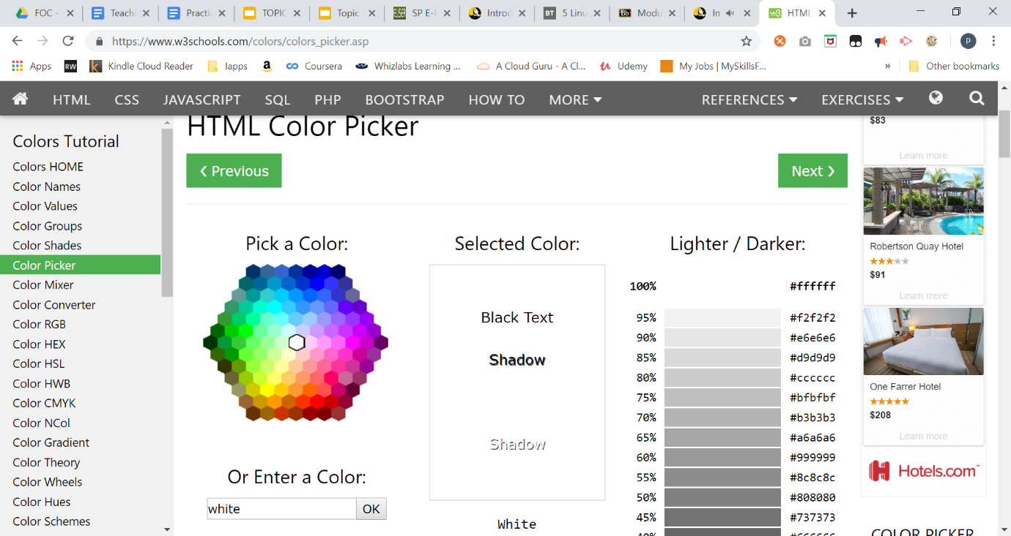

| **Colour** | **RGB in decimal** | **RGB In Hex** |
| --- | --- | --- |
| Black | **rgb(0, 0, 0)** | **#000000** |
| White | **rgb(255, 255, 255)** | **#ffffff** |
| Your favourite colour | **rgb(255, 179, 255)** | **#ffb3ff** |

Access the File Header

1. Using notepad, create a text file named “file1.txt”

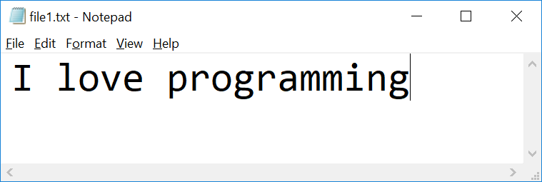

1. Check the file properties

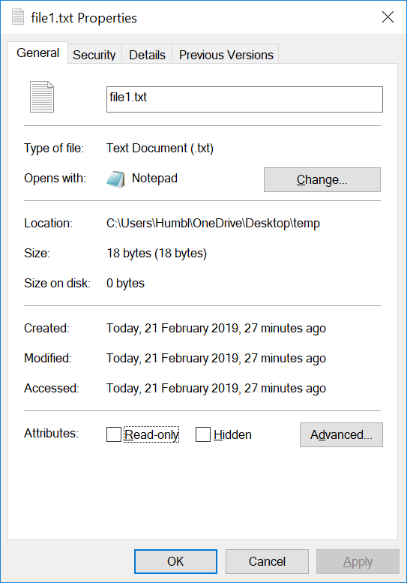

What is the size of the file in bytes?

| 18 bytes |
| --- |

1. Visit HexEd at <https://hexed.it/>

or download HxD Hex Editor

<https://download.cnet.com/HxD-Hex-Editor/3000-2352-10891068.html?part=dl-HxDHexEdi&subj=uo&tag=button>

1. Open file1.txt using HxD
2. Observe the Hex code  
   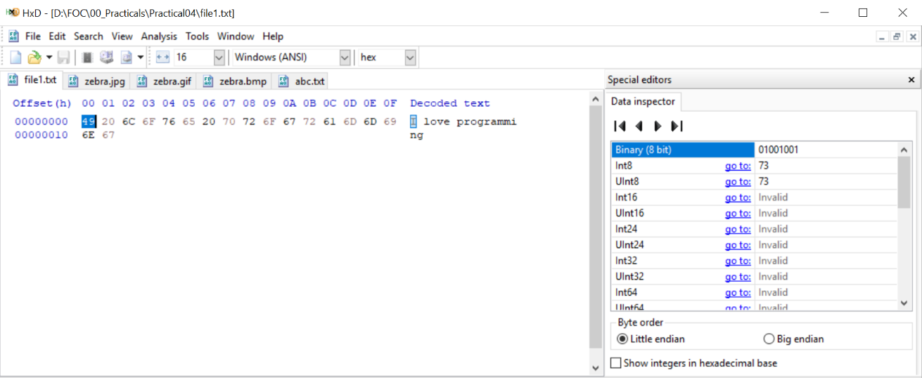

| **Character** | **Hex** | **Binary(8 bit)** |
| --- | --- | --- |
| I | 49 | 01001001 |

1. Using HxD to observe how character “o” and space character are represented

| **Character** | **Hex** | **Binary(8 bit)** |
| --- | --- | --- |
| o | 6F | 01101111 |
| space | 20 | 00100000 |

1. Download the following image and save it as zebra.**jpg**, zebra.**gif** and zebra.**bmp**  
    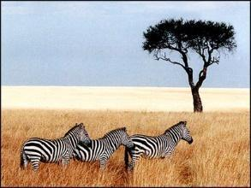
2. Open **zebra.gif** in HxD

Observe the Hex code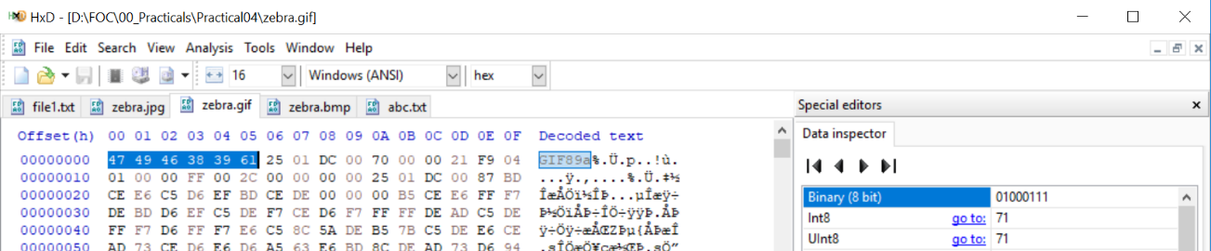

What are the **first 6 bytes** decoded?

| **offset** | **00** | **01** | **02** | **03** | **04** | **05** |
| --- | --- | --- | --- | --- | --- | --- |
| Byte | 47 | 49 | 46 | 38 | 39 | 61 |
| Character | G | I | F | 8 | 9 | a |

1. Visit web site <https://en.wikipedia.org/wiki/List_of_file_signatures> to find out the meaning of above hex code

| It means that the image file is encoded in the Graphics Interchange Format (GIF) |
| --- |

1. Open **zebra.jpg** in HxD  
     
   Observe the Hex code

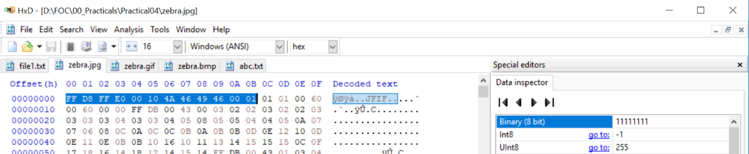

What are the **first 12 bytes**?

| **offset** | **00** | **01** | **02** | **03** | **04** | **05** | **06** | **07** | **08** | **09** | **0A** | **0B** |
| --- | --- | --- | --- | --- | --- | --- | --- | --- | --- | --- | --- | --- |
| Byte | FF | D8 | FF | E0 | 00 | 10 | 4A | 46 | 49 | 46 | 00 | 01 |
| Character | ÿ | Ø | ÿ | à | . | . | J | F | I | F | . | . |

1. Visit web site <https://en.wikipedia.org/wiki/List_of_file_signatures> to find out the meaning of above hex code

| It means a JPEG raw or in the JFIF or Exif file format |
| --- |

1. Open **zebra.bmp** in hex editor

Observe the Hex code   
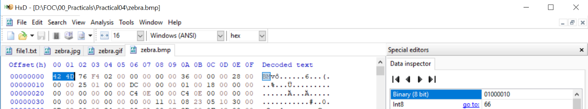

What are the **first 2 bytes**?

| **offset** | **00** | **01** |
| --- | --- | --- |
| Byte | 42 | 4D |
| Character | B | M |

1. Visit web site <https://en.wikipedia.org/wiki/List_of_file_signatures> to find out the meaning of above hex code

| It means a BMP file, a bitmap format used mostly in the Windows world |
| --- |

1. (optional)  
   Download the file at <https://drive.google.com/open?id=1vf0SBkI1LdWQvYmK9yM5AyJ0fHKE6DHR>

How can you view it as an image?

| Check the first few hex code to identify what file format to save abc.txt in (because it starts with BM, it is a bitmap). Therefore, to view it as an image, you have to change the file extension to bmp in order to see that the image contains zebras. |
| --- |

**Hint:**

* Open the file using HxD
* Visit web site <https://en.wikipedia.org/wiki/List_of_file_signatures> to find out the meaning of above hex code
* Rename the extension of the file

**Practical Reflection**

Suggested contents:

1. What have you learnt?
2. Why is it important?
3. Any difficulty encountered in the practical and how do you solve the problem?

| 1. I have learned that the first few hex codes determines what kind of file extension the file will be in order to see what it contains 2. It is important as saving the file under a different file format will deem the file unreadable/ for a image file, unviewable. 3. There is no difficulty in doing this practical as the only difficulty is the inability to download the zebra image when doing this practical because I was doing it on google drive |
| --- |

*End of Practical*