ICCPDM 2026 – PROJECT PROPOSAL

Project Title:
SustainaMine: Solar-Powered Dewatering System for Mining Operations

Problem Statement:
Mining sites often depend on diesel or grid-powered pumps for dewatering, which leads to high costs, pollution, and unreliable performance—especially in remote areas. Interruptions can cause flooding, downtime, and equipment damage.

Proposed Solution:
We propose a solar-powered intelligent dewatering system integrated with IoT-based monitoring to ensure continuous, efficient, and sustainable water removal in mining environments. The system eliminates dependency on diesel generators and ensures uninterrupted operation using renewable energy.

Objective:
To design and implement a sustainable, solar-powered dewatering system integrated with IoT-based monitoring that ensures continuous, reliable, and cost-effective water removal in mining operations, while reducing environmental impact, minimizing dependency on fossil fuels, and supporting scalable deployment across remote and off-grid sites.

Key Features:
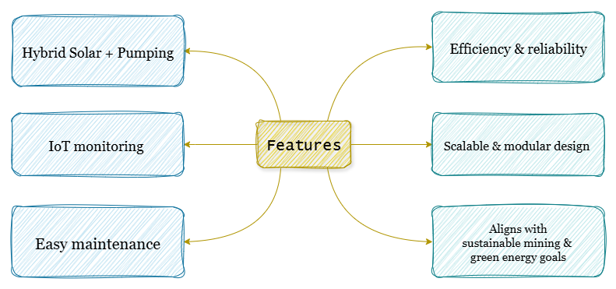

Technical Approach (Block Diagram):
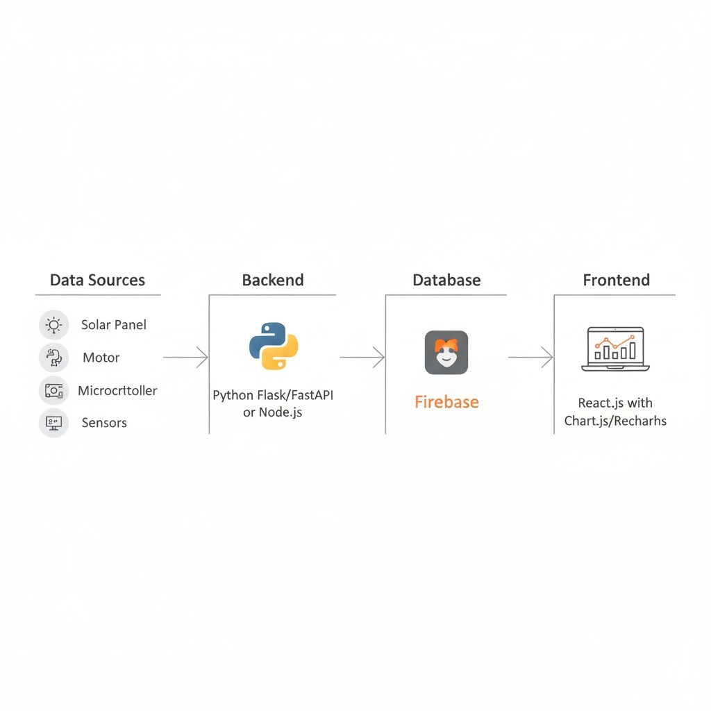

Feasibility & Viability:
- Technical: Proven solar pumping technology with reliable hybrid backup ensures continuous operation
- Economic: Significant reduction in fuel and maintenance costs over time
- Market: Increasing demand for renewable energy and ESG compliance in mining sector
- Financial: Government incentives and green financing improve affordability and adoption

Impact & Benefits:
- Financial:
  - Eliminates long-term fuel costs.
  - Reduces maintenance expenses compared to diesel systems.
- Operational:
  - Ensures reliable and continuous dewatering in remote areas.
  - Easily scalable for different mining sizes
- Environmental & Social:
  - Reduces carbon emissions and noise pollution.
  - Improves worker safety and prevents flooding hazards.
- Business Potential:
  - Generates revenue through leasing, maintenance, and IoT analytics.
  - Aligns with ESG and renewable energy goals.
  - Scalable across multiple mining sites.
Conclusion:
SustainaMine presents a sustainable, cost-effective, and scalable solution to modern mining challenges by combining solar energy and smart monitoring. This system enhances operational efficiency, reduces environmental impact, and ensures reliable dewatering, making it a strong candidate for real-world deployment.

