|  |  |  |
| --- | --- | --- |
|  | **Job Title:** Placeholder | **Team:** Recruitment |
| **Created on:** 9/21/2022 | **Template ID:** XXX-YYY-ZZ |
|
|

# How to use this Document

## Steps

1. Adjust the document’s custom fields. They will adjust accordingly in the document when you are done.
   1. 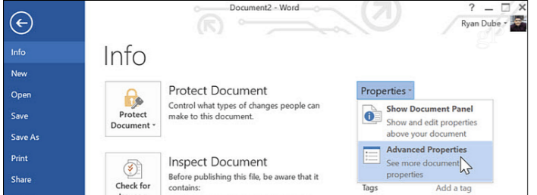Select ***File*** from the ribbon above the toolbar
   2. 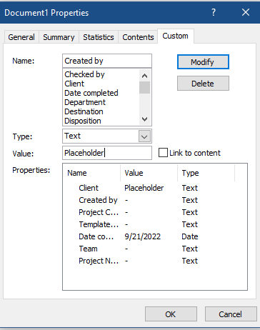 Select Info if not selected, then ***Advanced Properties***
   3. Switch to custom and edit the following fields:
      1. Client
      2. Project Name
      3. Project Code
      4. Created by
      5. Date Completed
      6. Template ID
      7. Team
   4. Once done, head over to the cover page:
      1. 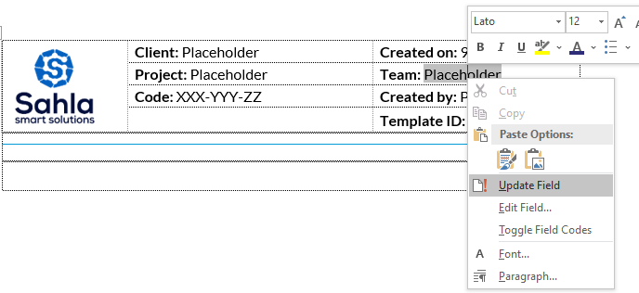Right click on every placeholder text and press ***Update Field***
2. Fill out the needed sections within the document
   1. Make sure that your titles use the proper headings paragraph styles

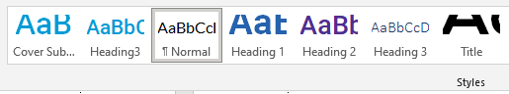

1. 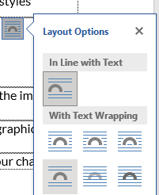When inserting images, please make sure that the ***Layout Options*** of the image is set to “***Top & Bottom***”
2. After making sure everything is in order, delete this section, and the graphics resources section.
3. 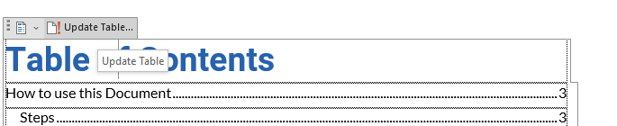Head over to the table of contents (Page 2) and update it to reflect your changes
4. Make sure the table of contents has no entry for “***How to Use this Document***” or “***Graphic Resources***”
5. It is of the utmost importance to follow the aforementioned steps correctly, as they will be used to compute your score in the firm’s gamification system.
6. Once satisfied with your document, forward it to your supervisor for review.

# Graphic Resources

Delete this section upon document completion.

This section is intended to be a graphic repository for items you may use during the writing of this document.

## Colors

Only these colors are allowed within this document. (Formatted text can have any color as long as it is wrapped within the frame below)

|  |  |  |  |
| --- | --- | --- | --- |
| Primary | 2662AF | 2D2E77 | 4D2E8F |
| Secondary | 0F9BD4 | 394CA0 |  |
| Grayscale | D4D4D4 | AAAAAA | 808080 |
| Grayscale | 555555 | 2A2A2A | 000000 |

## Notes

Note Title

Lorem ipsum dolor sit amet, consectetuer adipiscing elit. Maecenas porttitor congue massa. Fusce posuere, magna sed pulvinar ultricies, purus lectus malesuada libero, sit amet commodo magna eros quis urna.

Nunc viverra imperdiet enim. Fusce est. Vivamus a tellus.

Pellentesque habitant morbi tristique senectus et netus et malesuada fames ac turpis egestas. Proin pharetra nonummy pede. Mauris et orci.

Aenean nec lorem. In porttitor. Donec laoreet nonummy augue.

Suspendisse dui purus, scelerisque at, vulputate vitae, pretium mattis, nunc. Mauris eget neque at sem venenatis eleifend. Ut nonummy.

## Pasting Code

For placing code in this document, make sure you are copying FORMATTED text, and just paste as usual, but use the following template for code placement and noting.

Some Code goes here.

Meep Morp.

**Note or title**

# Create an effective Job Description

**READ THIS BEFORE WRITING ANYTHING IN THE DOCUMENT BELOW!**

**What is the purpose of a job description?**

* To advertise an open job position.
* To establish a job summary.
* To list the responsibilities of the job.
* To list the required expertise and qualifications for the job.

**How do you write job roles and responsibilities?**

* Do your research on the role and list all key responsibilities.
* Make use of action words.
* Provide sufficient details.
* Thoroughly communicate your expectations.
* Explain your company's standards.

**What makes an effective job description?**

An effective job description is concise, short, and detailed. To ensure that the candidates understand and feel compelled to apply, the job description should leave no or little room for further questions or confusion on the jobs' KPIs and requirements.

## Key Elements of the job Description document and how to use them

**Job Overview:**

* Provide a brief, four-sentence description of the role, what success in the position looks like, and how it fits into the company or organization overall.

**Reports to:**

* Mention the role of the person supposed to supervise or oversee the potential worker
* List the essential duties of the supervisor
* List the qualifications and supposed help the worker should get from their supervisor
* List what the supervisor will look for in the potential worker’s work

**Responsibilities and Duties:**

* List the essential duties required to carry out this job.
* List them in order of importance.
* Use complete sentences.
* Start sentences with verbs.
* Use the present tense.
* Use gender-neutral language.

**Qualifications:**

* Education level.
* Experience.
* Specific skills.
* Personal characteristics.
* Certifications.
* Licenses.
* Physical abilities.

**Compensation:**

* The manner of compensation (equity/salary/etc)
* Frequency of compensation
* Potential bonuses & incentives

ONCE DONE, DELETE EVERYTHING FROM HERE UPWARDS EXCEPT THE TITLE PAGE

# Job Overview

Lorem ipsum dolor sit amet, consectetuer adipiscing elit. Maecenas porttitor congue massa. Fusce posuere, magna sed pulvinar ultricies, purus lectus malesuada libero, sit amet commodo magna eros quis urna.

Nunc viverra imperdiet enim. Fusce est. Vivamus a tellus.

Pellentesque habitant morbi tristique senectus et netus et malesuada fames ac turpis egestas. Proin pharetra nonummy pede. Mauris et orci.

Aenean nec lorem. In porttitor. Donec laoreet nonummy augue.

Suspendisse dui purus, scelerisque at, vulputate vitae, pretium mattis, nunc. Mauris eget neque at sem venenatis eleifend. Ut nonummy.

## Job Title & Description

Lorem ipsum dolor sit amet, consectetuer adipiscing elit. Maecenas porttitor congue massa. Fusce posuere, magna sed pulvinar ultricies, purus lectus malesuada libero, sit amet commodo magna eros quis urna.

Nunc viverra imperdiet enim. Fusce est. Vivamus a tellus.

Pellentesque habitant morbi tristique senectus et netus et malesuada fames ac turpis egestas. Proin pharetra nonummy pede. Mauris et orci.

Aenean nec lorem. In porttitor. Donec laoreet nonummy augue.

Suspendisse dui purus, scelerisque at, vulputate vitae, pretium mattis, nunc. Mauris eget neque at sem venenatis eleifend. Ut nonummy.

## Reports to

Lorem ipsum dolor sit amet, consectetuer adipiscing elit. Maecenas porttitor congue massa. Fusce posuere, magna sed pulvinar ultricies, purus lectus malesuada libero, sit amet commodo magna eros quis urna.

Nunc viverra imperdiet enim. Fusce est. Vivamus a tellus.

Pellentesque habitant morbi tristique senectus et netus et malesuada fames ac turpis egestas. Proin pharetra nonummy pede. Mauris et orci.

Aenean nec lorem. In porttitor. Donec laoreet nonummy augue.

## Responsibilities & Duties

Lorem ipsum dolor sit amet, consectetuer adipiscing elit. Maecenas porttitor congue massa. Fusce posuere, magna sed pulvinar ultricies, purus lectus malesuada libero, sit amet commodo magna eros quis urna.

Nunc viverra imperdiet enim. Fusce est. Vivamus a tellus.

Pellentesque habitant morbi tristique senectus et netus et malesuada fames ac turpis egestas. Proin pharetra nonummy pede. Mauris et orci.

Aenean nec lorem. In porttitor. Donec laoreet nonummy augue.

Suspendisse dui purus, scelerisque at, vulputate vitae, pretium mattis, nunc. Mauris eget neque at sem venenatis eleifend. Ut nonummy.

## Qualifications

Lorem ipsum dolor sit amet, consectetuer adipiscing elit. Maecenas porttitor congue massa. Fusce posuere, magna sed pulvinar ultricies, purus lectus malesuada libero, sit amet commodo magna eros quis urna.

Nunc viverra imperdiet enim. Fusce est. Vivamus a tellus.

Pellentesque habitant morbi tristique senectus et netus et malesuada fames ac turpis egestas. Proin pharetra nonummy pede. Mauris et orci.

Aenean nec lorem. In porttitor. Donec laoreet nonummy augue.

Suspendisse dui purus, scelerisque at, vulputate vitae, pretium mattis, nunc. Mauris eget neque at sem venenatis eleifend. Ut nonummy.

## Compensation

Lorem ipsum dolor sit amet, consectetuer adipiscing elit. Maecenas porttitor congue massa. Fusce posuere, magna sed pulvinar ultricies, purus lectus malesuada libero, sit amet commodo magna eros quis urna.

Nunc viverra imperdiet enim. Fusce est. Vivamus a tellus.

Pellentesque habitant morbi tristique senectus et netus et malesuada fames ac turpis egestas. Proin pharetra nonummy pede. Mauris et orci.

Aenean nec lorem. In porttitor. Donec laoreet nonummy augue.

Suspendisse dui purus, scelerisque at, vulputate vitae, pretium mattis, nunc. Mauris eget neque at sem venenatis eleifend. Ut nonummy.