|  |  |  |
| --- | --- | --- |
|  | **Client:** | **Created on:** |
| **Code:** | **Team:** |
| **Project:** | **Created by:** Placeholder |
| **Template ID:** SFT-RPT-03 |

Project Report

Project Name

Table of Contents

How to use this Document 3

Steps 3

Graphic Resources 5

Colors 5

Notes 5

Pasting Code 5

Project Overview 6

Project Goals 6

Project Scope 6

Work Context 6

Requirements 7

Functional 7

Non-Functional 7

Assumptions & Constraints 8

Client side 8

Developer side 8

Outcomes of the Project 9

System Design 9

System Features 9

System Constraints 9

Test Plans 11

Project Goals 11

Project Scope 11

Project Issues 12

Appendix 13

# How to use this Document

## Steps

1. Adjust the document’s custom fields. They will adjust accordingly in the document when you are done.
   1. 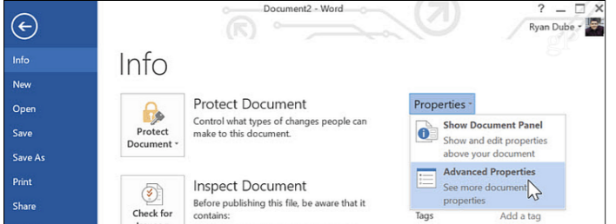Select ***File*** from the ribbon above the toolbar
   2. 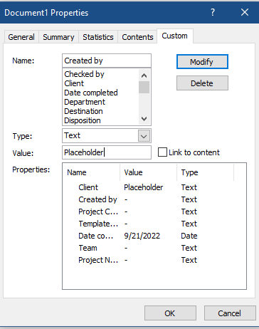 Select Info if not selected, then ***Advanced Properties***
   3. Switch to custom and edit the following fields:
      1. Client
      2. Project Name
      3. Project Code
      4. Created by
      5. Date Completed
   4. Once done, head over to the cover page:
      1. 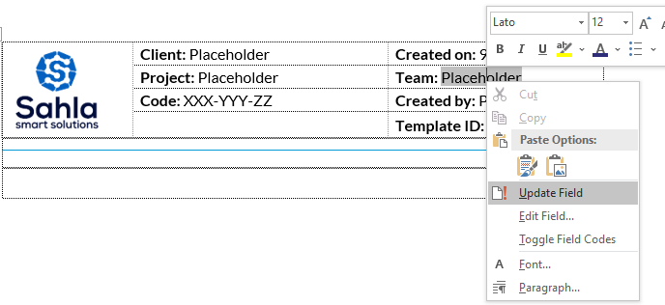Right click on every placeholder text and press ***Update Field***
2. Fill out the needed sections within the document
   1. Make sure that your titles use the proper headings paragraph styles

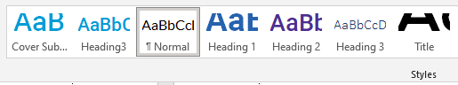

1. 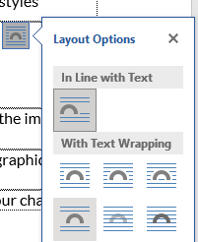When inserting images, please make sure that the ***Layout Options*** of the image is set to “***Top & Bottom***”
2. After making sure everything is in order, delete this section, and the graphics resources section.
3. 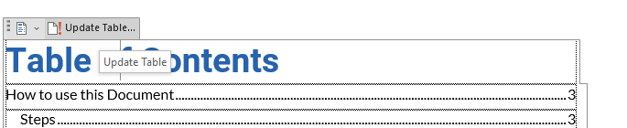Head over to the table of contents (Page 2) and update it to reflect your changes
4. Make sure the table of contents has no entry for “***How to Use this Document***” or “***Graphic Resources***”
5. It is of the utmost importance to follow the aforementioned steps correctly, as they will be used to compute your score in the firm’s gamification system.
6. Once satisfied with your document, forward it to your supervisor for review.

# Graphic Resources

Delete this section upon document completion.

This section is intended to be a graphic repository for items you may use during the writing of this document.

## Colors

Only these colors are allowed within this document. (Formatted text can have any color as long as it is wrapped within the frame below)

|  |  |  |  |
| --- | --- | --- | --- |
| Primary | 2662AF | 2D2E77 | 4D2E8F |
| Secondary | 0F9BD4 | 394CA0 |  |
| Grayscale | D4D4D4 | AAAAAA | 808080 |
| Grayscale | 555555 | 2A2A2A | 000000 |

## Notes

Note Title

Lorem ipsum dolor sit amet, consectetuer adipiscing elit. Maecenas porttitor congue massa. Fusce posuere, magna sed pulvinar ultricies, purus lectus malesuada libero, sit amet commodo magna eros quis urna.

Nunc viverra imperdiet enim. Fusce est. Vivamus a tellus.

Pellentesque habitant morbi tristique senectus et netus et malesuada fames ac turpis egestas. Proin pharetra nonummy pede. Mauris et orci.

Aenean nec lorem. In porttitor. Donec laoreet nonummy augue.

Suspendisse dui purus, scelerisque at, vulputate vitae, pretium mattis, nunc. Mauris eget neque at sem venenatis eleifend. Ut nonummy.

## Pasting Code

For placing code in this document, make sure you are copying FORMATTED text, and just paste as usual, but use the following template for code placement and noting.

Some Code goes here.

Meep Morp.

**Note or title**

# Heading 1

Lorem ipsum dolor sit amet, consectetuer adipiscing elit. Maecenas porttitor congue massa. Fusce posuere, magna sed pulvinar ultricies, purus lectus malesuada libero, sit amet commodo magna eros quis urna.

Nunc viverra imperdiet enim. Fusce est. Vivamus a tellus.

## Heading 2

Lorem ipsum dolor sit amet, consectetuer adipiscing elit. Maecenas porttitor congue massa. Fusce posuere, magna sed pulvinar ultricies, purus lectus malesuada libero, sit amet commodo magna eros quis urna.

Nunc viverra imperdiet enim. Fusce est. Vivamus a tellus.

Pellentesque habitant morbi tristique senectus et netus et malesuada fames ac turpis egestas. Proin pharetra nonummy pede. Mauris et orci.

Aenean nec lorem. In porttitor. Donec laoreet nonummy augue.

Suspendisse dui purus, scelerisque at, vulputate vitae, pretium mattis, nunc. Mauris eget neque at sem venenatis eleifend. Ut nonummy.

## Heading 3

Lorem ipsum dolor sit amet, consectetuer adipiscing elit. Maecenas porttitor congue massa. Fusce posuere, magna sed pulvinar ultricies, purus lectus malesuada libero, sit amet commodo magna eros quis urna.

Nunc viverra imperdiet enim. Fusce est. Vivamus a tellus.

Pellentesque habitant morbi tristique senectus et netus et malesuada fames ac turpis egestas. Proin pharetra nonummy pede. Mauris et orci.

Aenean nec lorem. In porttitor. Donec laoreet nonummy augue.

## Work Context