# Employee.csv

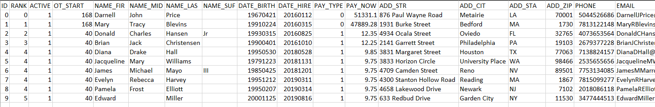

* ID
  + Unsigned int32 (0 to 4,294,967,295)
  + Automatically assigned when creating a new employee.
  + Once created and saved, an employee can be edited but not deleted.
* Rank
  + Unsigned int16 (0 to 65,535)
  + Values from ranks.csv
    - See ranks.csv section of this document for more information.
* Active
  + Bool (0 or 1)
  + “Active 0” means the employee is excluded from new schedules.
  + “Active 1” means the employee is available for all functions of the program.
* OT_Start “Overtime Start”
  + Unsigned byte (0 to 255)
  + The number of hours an employee can work during that pay week before having to bill for overtime.
  + “OT_Start 168” will not ever charge employee for overtime (because… logic).
* NameFir, NameMid, Name_Las, and NameSuf
  + String (“code-set” limit of 64 characters for each value).
  + “NameFir” and “NameLas” must have at least 3 characters. “NameMid” and “NameSuf” can be blank.
  + Only a-z, A-Z, and dash ‘-‘ characters are allowed. Spaces are allowed.
* Date_Birth and Date_Hire
  + String (“code-set” requirement of 8 characters).
  + yyyyMMdd format (easy in code… no explanation needed).
* Pay_Type
  + Unsigned byte (0 to 255)
  + Current “code-set” values:
    - 0: Salary 1: Hourly 2: Unpaid
* Pay_Curr
  + Float (“code-set” requirement of 0.00 to 999999999.99).
  + Rounded to two decimal places.
* Add_Str “Street Address”
  + String (“code-set” requirement of 3 to 128 characters).
  + Only a-z, A-Z, 0-9, and dash ‘-‘ characters are allowed. Spaces are allowed.
* Add_Cit “City Address”
  + String (“code-set” requirement of 3 to 64 characters).
* Add_Sta “State Address”
  + String (“code-set” requirement of 2 characters).
  + Only A-Z characters are allowed. No spaces.
* Add_Zip “Zip Code Address”
  + String (“code-set” requirement of 5 characters).
  + The ZIP+4 format is not used for the program.
  + The .csv file could format this incorrectly. In the code, add ‘0’ in front if length is not five.
  + Only 0-9 characters are allowed. No spaces.
* Phone
  + String (“code-set” limit of 5 characters).
  + Phone numbers never start with zero so the .csv file formatting should not cause any problems.
  + Only 0-9 characters are allowed. No spaces.
* Email
  + String (“code-set” limit of 256 characters).
  + Only A-Z, a-z, 0-9, and .!#$%&'*+-/=?^_`{|}~@ characters are allowed. No spaces.

# Ranks.csv

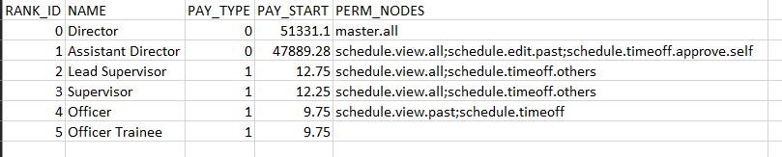

* Rank_ID
  + Unsigned byte (0 to 255).
  + Automatically assigned when creating a new rank.
  + Once created and saved, a rank can be edited but not deleted.
* Name
  + String (“code-set” requirement of 1 to 16 characters).
  + Only a-z, A-Z, 0-9, and dash ‘-‘ characters are allowed. Spaces are allowed.
* Pay_Type
  + Unsigned byte (0 to 255)
  + Current “code-set” values:
    - 0: Salary 1: Hourly 2: Unpaid
  + This value is used as a default for creating a new employee of a set rank.
* Pay_Start
  + Float (“code-set” requirement of 0.00 to 999999999.99).
  + Rounded to two decimal places.
  + This value is used as a default for creating a new employee of a set rank.

# Permission Nodes

* (default)
  + Allowed to view present, and future official weekly schedules.
  + Not allowed to view past schedules.
  + Not allowed to view unofficial future schedules.
  + Not allowed to request time off.
  + Not allowed to view other employee’s time off requests.
  + Not allowed to approve/deny any time off.
* master.all
  + Wildcard to add all permission nodes.
* schedule.view.past
  + Allowed to view past, present, and future official weekly schedules.
  + Not allowed to view unofficial future schedules.
* schedule.view.all
  + Allowed to view past, present, and future official weekly schedules.
  + Allowed to view unofficial future schedules.
* schedule.edit
  + Allowed to edit present and future weekly schedules.
  + Not allowed to edit past weekly schedules.
* schedule.edit.past
  + Allowed to edit past, present, and future weekly schedules.
* schedule.timeoff
  + Allowed to view employee’s own time off requests.
  + Allowed to request time off.
* schedule.timeoff.others
  + Allowed to view all employee’s time off requests.
  + Allowed to request time off.
* schedule.timeoff.approve
  + Allowed to approve/deny time off requests by employees whose rank is below theirs.
  + Not allowed to approve/deny employee’s own time off request.
* schedule.timeoff.approve.self
  + Allowed to approve/deny time off requests by employees whose rank is below theirs.
  + Any time off request made will automatically get approved by that employee.
* schedule.timeoff.approve.all
  + Allowed to approve/deny any time off request.
  + Any time off request made will automatically get approved by that employee.