Tennis

* Vlad Liviu Alexandru
* Sandu Victor Iulian

1. Creating a SAS data set from the external file

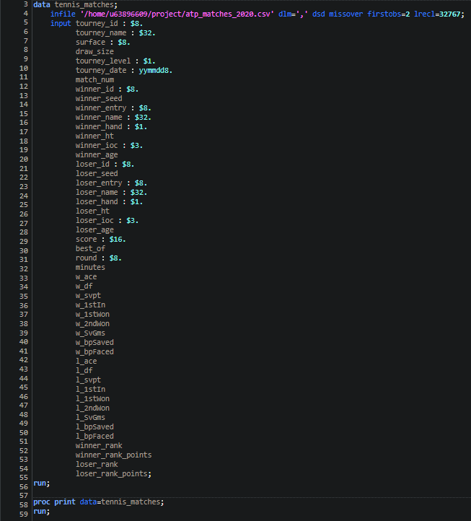

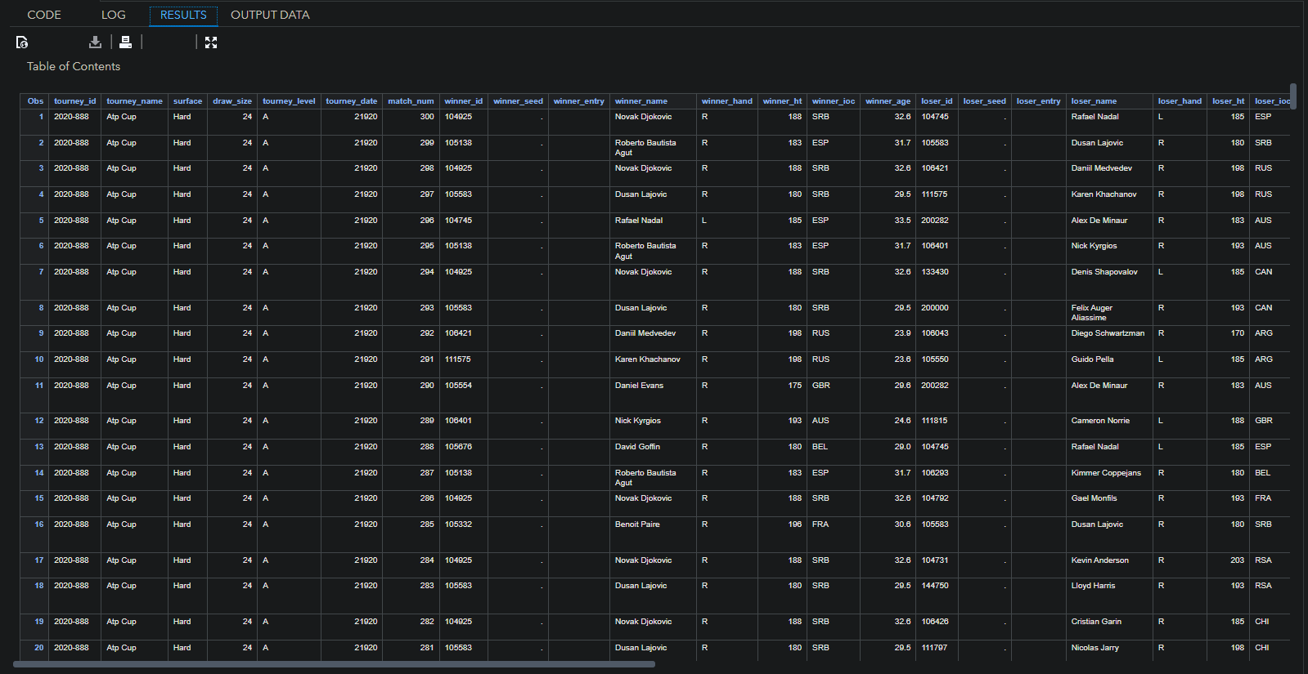

2.1 creating and using user-defined formats

We create formats for the number of aces to categorize performance

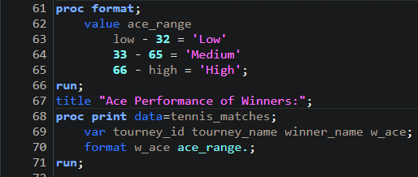

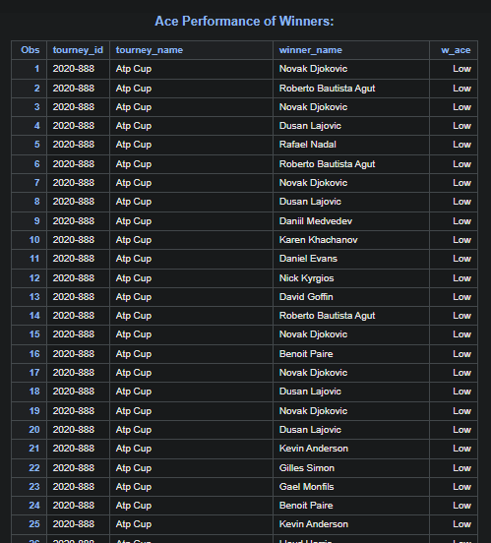

2.2 Using “FREQ”

We analyze the frequency of match outcomes based on the surface type

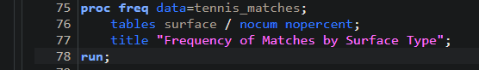

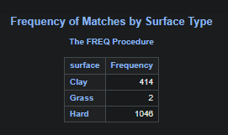

3. iterative and conditional processing of data

3.1 Conditional

We identify players with high aces and high serve points

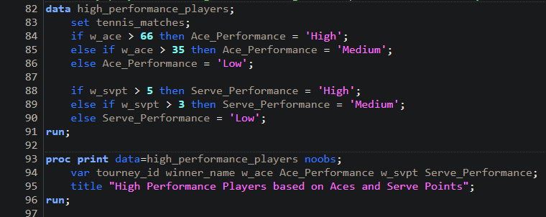

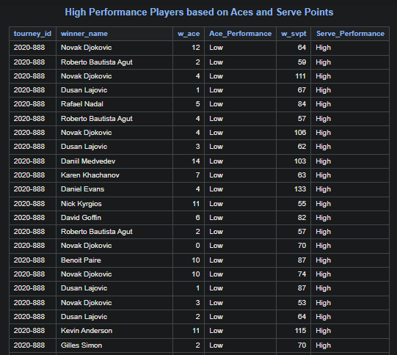

3.2 Iterative

We analyze the average serve points and break points saved

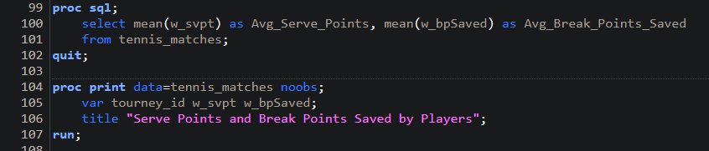

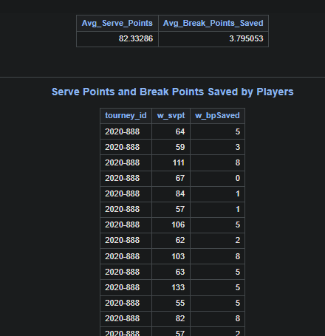

4. Array + using SAS functions

