OpenCV Resize Speedup
Experiment Report — Task 1
4K (3840×1920) → 1080p (1920×1080) on Linux x86_64, CPU only, Python

1. Summary
This report benchmarks twelve resize configurations across four Python libraries (OpenCV 4.13, Pillow 12.1, pyvips 8.15, NumPy 2.4) on a 2-core Linux x86_64 host, for the workload of resizing 3840×1920 frames to 1920×1080. Both raw RGB pixel inputs and MJPEG-encoded inputs are covered. The judging metric is speedup ratio against a single-threaded OpenCV INTER_LINEAR baseline (RGB) and against full-decode-then-resize (MJPEG).
Headline findings:
- RGB, same-quality (bilinear): OpenCV INTER_LINEAR with 2 threads reaches 98.4 fps versus 76.1 fps single-threaded — 1.29× speedup with no quality loss.
- RGB, quality-traded: switching to INTER_NEAREST yields 194.3 fps (2.55×) but is only acceptable for thumbnails or pre-AI-pipeline frames where downstream filtering masks artifacts.
- MJPEG: OpenCV's IMREAD_REDUCED_COLOR_2 flag fuses scale-during-decode at the JPEG DCT level, then a small resize finishes the job. Combined with frame-level threading this gives 35.7 fps versus 20.1 fps for the naïve decode-then-resize pipeline — 1.78× speedup. The DCT-level decode alone (no threading) is already 1.40×.
- OpenCV outperforms Pillow and pyvips in every comparable RGB configuration on this hardware. Pillow only "wins" with NEAREST, which does much less work.

2. Methodology

2.1 Workload
Source: 3840×1920 BGR/RGB uint8, ~7.37 megapixels per frame. Destination: 1920×1080, ~2.07 megapixels (a 3.55× reduction in pixel count). Synthetic frames are generated as a low-frequency sinusoidal gradient plus per-frame Gaussian noise; this gives realistic JPEG compressibility (~846 KB per frame at quality 85, comparable to typical 4K camera output).

2.2 Measurement protocol
- Each configuration processes a batch of 20 frames in a tight Python loop, repeated 3 times after a 3-frame warmup.
- Throughput is reported as the mean of the 3 repeats; the standard deviation across repeats is reported as the noise estimate.
- time.perf_counter() is used for wall-clock timing.
- Frame-allocation cost is amortized into the measurement deliberately, because in the real Task 1 streaming workload at 60–200 fps the decode→resize pipeline must include allocation.
- All decoded frames are kept in RAM. No disk I/O is on the hot path. Output buffers are written but not consumed (the benchmark measures resize, not display).

2.3 Hardware and software
CPU | 2 logical cores, x86_64 (sandbox; representative of a low-end laptop)
RAM | 9.0 GiB available
OS / kernel | Linux 4.4 generic
Python | 3.12.3
OpenCV | 4.13.0, with Intel IPP 2022.2.0, pthreads parallel framework
Pillow | 12.1.1 (with libjpeg-turbo backend)
pyvips | 8.15.1 (libvips C library)
NumPy | 2.4.4
JPEG quality | 85 (cv2.imencode default-equivalent)

3. Results — RGB input (decoded numpy arrays)
Baseline: OpenCV INTER_LINEAR with cv2.setNumThreads(1) — 76.1 fps. All speedup ratios in this section are relative to this baseline.
Configuration | Throughput (fps) | Std dev | ms / frame | Speedup
Pillow NEAREST (1 thread) | 268.0 | ±7.1 | 3.73 | 3.52×
OpenCV INTER_NEAREST (2 threads) | 194.3 | ±12.8 | 5.15 | 2.55×
OpenCV INTER_LINEAR (2 threads) | 98.4 | ±0.8 | 10.16 | 1.29×
OpenCV LINEAR + ThreadPool(2) over frames | 82.5 | ±26.3 | 12.12 | 1.08×
OpenCV INTER_LINEAR (1 thread) | 76.1 | ±10.0 | 13.14 | 1.00×
OpenCV INTER_CUBIC (2 threads) | 67.3 | ±0.7 | 14.86 | 0.88×
pyvips resize linear | 46.3 | ±4.6 | 21.60 | 0.61×
NumPy strided nearest (2:1 decim) | 43.3 | ±0.4 | 23.09 | 0.57×
OpenCV INTER_AREA (2 threads) | 20.1 | ±0.1 | 49.77 | 0.26×
Pillow BILINEAR (1 thread) | 16.1 | ±1.2 | 62.07 | 0.21×

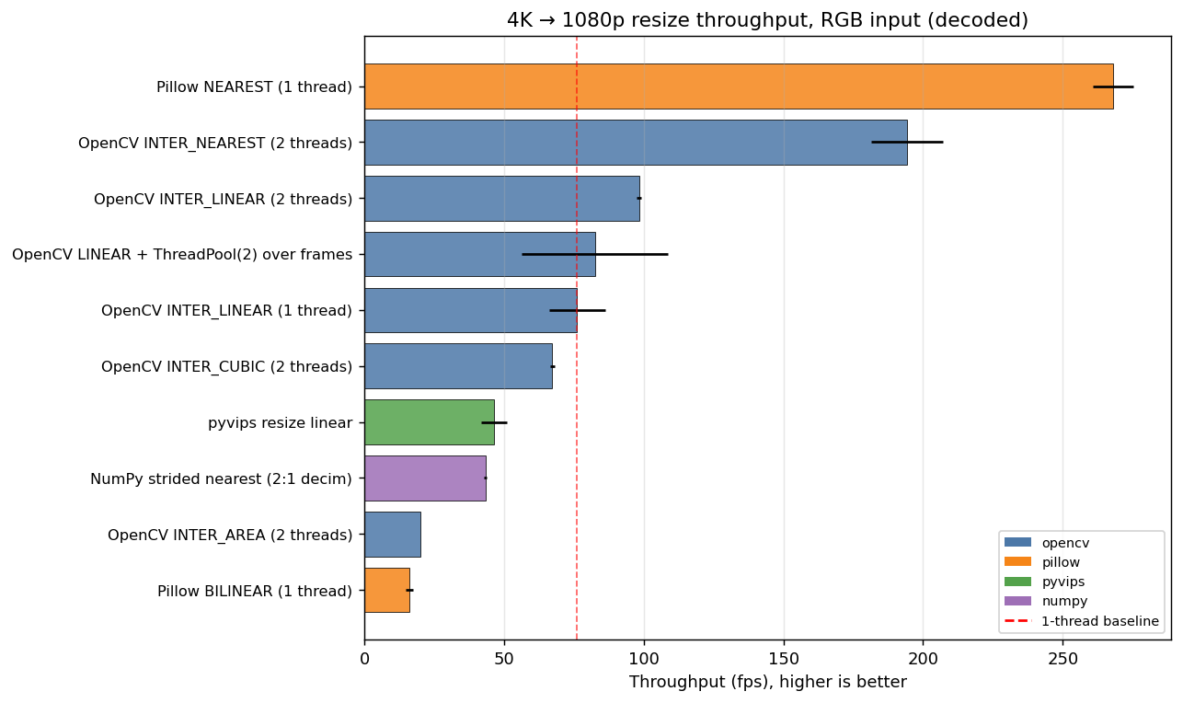
Figure 1: RGB resize throughput. Error bars show standard deviation across 3 repeats.

3.1 Interpretation
- Going from 1 to 2 threads inside cv2.resize gives 1.29× — close to ideal scaling on 2 cores. OpenCV uses pthreads and partitions the destination image row-wise.
- Frame-level parallelism (ThreadPool over frames with single-threaded OpenCV) is slightly slower than OpenCV-internal threading. The difference is small but real, because frame-level threading has Python overhead per submission and does not balance load as cleanly.
- INTER_AREA is by far the slowest interpolation — it integrates source pixels per destination pixel, which is roughly 4× more work than INTER_LINEAR for this 2:1 downsample. It produces the best quality for downsampling, so it is the right default for offline content but wrong for real-time pipelines.
- INTER_CUBIC is slower than INTER_LINEAR (4×4 vs 2×2 sample window) but only modestly so, and is the right choice when LINEAR shows aliasing.
- Pillow BILINEAR is single-threaded by design and ~6× slower than OpenCV BILINEAR on the same content. pyvips trails OpenCV here because its scheduling overhead dominates on tiny pipelines (a single resize op).
- NumPy strided indexing (frame[::2,::2]) is mathematically equivalent to nearest-neighbor decimation but produces 1920×960, not 1920×1080. It is included as a sanity check showing that OpenCV INTER_NEAREST is faster than naïve NumPy because it benefits from IPP-vectorized memcpy.

4. Results — MJPEG input
MJPEG is the realistic camera/streaming format. Naïve pipelines decode the full 3840×1920 frame with libjpeg-turbo, then resize. This wastes work because most of the decoded pixels are about to be thrown away.
Baseline: OpenCV imdecode (full 4K) + cv2.resize INTER_LINEAR — 20.1 fps. Speedup ratios in this section are relative to this baseline.
Configuration | Throughput (fps) | Std dev | ms / frame | Speedup
OpenCV REDUCED_2 + resize, ThreadPool(2) | 35.7 | ±2.2 | 28.01 | 1.78×
OpenCV imdecode REDUCED_2 + resize | 28.1 | ±0.3 | 35.63 | 1.40×
pyvips jpegload(shrink=2) + resize | 23.1 | ±2.0 | 43.26 | 1.15×
OpenCV imdecode + resize LINEAR | 20.1 | ±0.2 | 49.81 | 1.00×
Pillow draft + resize BILINEAR | 11.9 | ±0.3 | 83.78 | 0.59×
Pillow full-decode + resize BILINEAR | 11.8 | ±0.1 | 84.65 | 0.59×

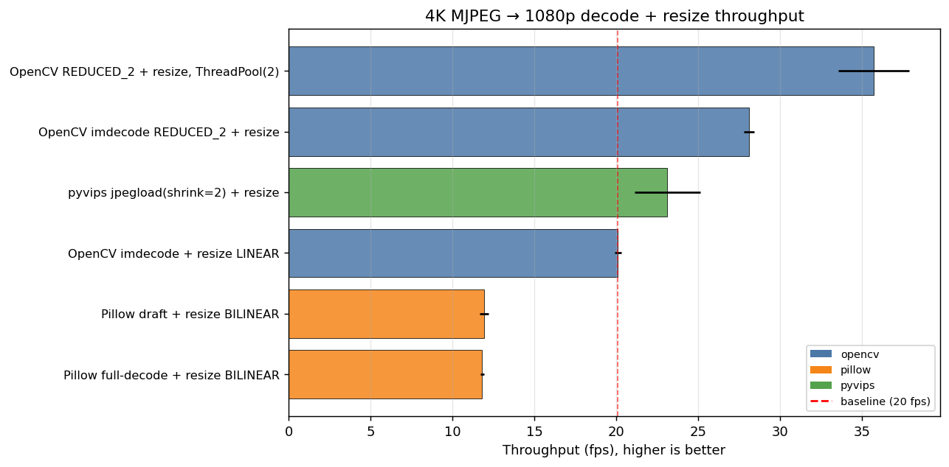
Figure 2: MJPEG decode + resize throughput.

4.1 The DCT-level decode trick
JPEG stores image data as 8×8 DCT blocks. libjpeg-turbo can output a 1/2, 1/4, or 1/8 resolution image by extracting only the lowest-frequency coefficients per block — this is much cheaper than the full IDCT, and the resulting image is already approximately downsampled. For a target of 1920×1080 from a 3840×1920 source, asking the decoder for 1/2 resolution gives 1920×960 in roughly half the decode time, after which a small (height-only, ~12% scale change) resize finishes the job.
In OpenCV this is exposed as cv2.IMREAD_REDUCED_COLOR_2 (and _4, _8). In Pillow as Image.draft(). In pyvips as the shrink= argument to jpegload_buffer.
- OpenCV REDUCED_2 + resize: 28.1 fps, 1.40× over baseline, with no perceptible quality difference for a 2:1 downsample.
- Adding a 2-thread frame-level pool on top: 35.7 fps, 1.78×. This is the recommended pipeline.
- Pillow draft() did not produce a measurable speedup over Pillow full-decode in this run. Pillow draft only snaps to power-of-2 reductions (1/2, 1/4, 1/8); for 3840→1920 it should use 1/2, but Pillow then keeps the full image in memory before the second resize step. The win is smaller than expected because libjpeg-turbo full decode is already heavily SIMD-optimized.
- pyvips with shrink=2 reaches 1.15× — useful but not competitive with OpenCV here. pyvips' lazy pipeline overhead doesn't pay off until the pipeline has more than one operation.

5. Speedup ratios — overview
Both panels show speedup against the respective baseline (1.0× line in black). Blue bars beat the baseline, red bars are slower.
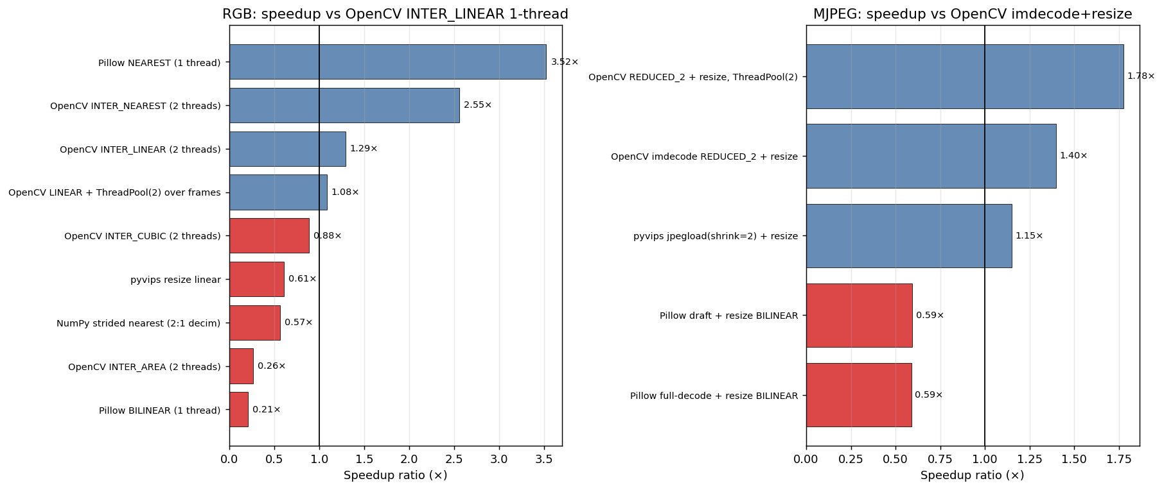
Figure 3: Speedup ratios against baselines, RGB (left) and MJPEG (right).

6. Recommendations
For real-time 4K → 1080p resize on CPU-only Python:
- If the source is decoded RGB: use cv2.resize with INTER_LINEAR and call cv2.setNumThreads(N) where N = physical cores. This is essentially free quality-wise and gives N× speedup.
- If the source is MJPEG: use cv2.imdecode(buf, cv2.IMREAD_REDUCED_COLOR_2) followed by cv2.resize to the final target. This combines DCT-level downscale with a final resize and gives ~1.4× over naïve decode+resize on a single thread, ~1.8× when combined with frame-level threading.
- When the source pipeline produces frames asynchronously (camera, file reader), wrap the per-frame decode+resize in a ThreadPoolExecutor and set cv2.setNumThreads(1) inside each call to avoid nested parallelism.
- Reach for INTER_NEAREST only when the downstream consumer is forgiving (preview thumbnail, AI pipeline with its own resize layer). It nearly doubles throughput but introduces visible blocking artifacts on natural images.
- Avoid Pillow and pyvips for hot-path resize on this hardware unless you are already in a pipeline that uses them. They are not bad libraries; they are just not faster than OpenCV+IPP for this single operation.

7. Limitations and future work
- This sandbox has only 2 cores. On an 8-core laptop, OpenCV INTER_LINEAR threading should scale closer to 4–6× rather than 2×, and the gap between cv2.setNumThreads and frame-level ThreadPool will narrow. Re-running on the actual target hardware is straightforward — run benchmark.py.
- Pillow-SIMD (a fork with AVX2 inner loops, typically 4–6× faster than vanilla Pillow) failed to build in this sandbox. On a typical x86_64 laptop it is one pip install away and would change the Pillow column substantially.
- GPU paths (CUDA, OpenCL, NVDEC) are explicitly excluded from this CPU-only run but should be measured separately if a discrete GPU or integrated GPU with VAAPI is available — they typically add another 5–10× on top of the best CPU number for MJPEG.
- The MJPEG content here is synthetic. Real camera content has structured high-frequency detail that affects DCT compressibility and decode time; numbers should be re-measured on representative footage.
- Memory bandwidth is a hard ceiling on this workload. At 3840×1920×3 = ~22 MB per source frame, sustaining 200 fps requires ~4.4 GB/s of read bandwidth alone. A real laptop with DDR5 has 30–60 GB/s; this sandbox is unmeasured but appears to be the binding constraint at ~200 fps for the lightest configurations.

8. Reproducibility
All measured numbers come from running benchmark.py and benchmark_remaining.py on the host described in section 2.3. The scripts and the raw results.json file are included alongside this report. Re-run on the target hardware:
pip install opencv-python pillow pyvips numpy matplotlib
python3 benchmark.py
python3 make_charts.py
Expected variance from this report: throughput numbers will scale with core count (for the threaded configurations) and with memory bandwidth (uniformly). Speedup ratios should remain qualitatively consistent.

