Literature Review of AI Assisted Educational Content Generation
  - Lumori FYP | Supervisor Progress Review | 16 October 2026

1 Focus of the review
This review examines nine studies that inform the proposed design of Lumori, a system for helping teachers prepare course-based explanations, quizzes and assignments. The central question is how to move from fluent generated text to teaching materials that have a clear educational purpose, identifiable source support and an appropriate level of demand for the intended learners.
The selected studies cover three connected areas: educational question generation, retrieval and context use, and evaluation. Each discussion explains the research problem, the method, the main finding and the limits of its transfer to this project. Four figures from the original papers illustrate the mechanisms or experimental evidence most useful for understanding the design choices.

Selected studies
Educational question generation: Du et al. [1] on neural passage-based generation; Gong et al. [2] on deep educational questions; Cheng et al. [3] on alignment with educational objectives.
Retrieval and context use: Lewis et al. [4] on retrieval-augmented generation; Liu et al. [5] on the use of relevant information in long contexts.
Difficulty and evaluation: Park et al. [6] on learner-dependent difficulty estimation; Gao et al. [7] on citation support; Es et al. [8] on RAG evaluation; Deroy et al. [9] on feedback-based evaluation of generated questions.

How the studies connect
The question-generation literature establishes that an answerable question can still lack educational depth or fail to match a learning objective. Retrieval can provide course evidence, but the context-use literature shows that supplying evidence does not ensure that a model uses it reliably. Evaluation therefore needs to examine the question, its answer, its supporting material and its intended learner together.
For Lumori, these findings suggest a workflow in which a learning objective guides drafting, retrieved passages remain visible, and a teacher can review and revise the result. This is a proposed direction derived from the literature. Its practical value should be investigated through controlled comparisons and independent review of the resulting materials.

2 Educational question generation

2 1 Du et al 2017
Learning to Ask Neural Question Generation for Reading Comprehension [1]
Du, Shao and Cardie investigate how a model can generate natural questions from text passages. They use an attention-based sequence-to-sequence approach and compare sentence-level input with a model that also incorporates paragraph information. The work uses reading-comprehension data derived from SQuAD and evaluates the outputs with automatic metrics and human judgments.
The authors report improvements over a rule-based baseline, including more natural questions in human evaluation. The comparison is useful because it makes the input context part of the generation design. However, its task is passage-based reading comprehension. It does not establish whether a generated question fits a curriculum, has effective distractors or targets an appropriate cognitive demand for a particular class.
For Lumori, the main lesson is to define the generation unit carefully. A question should be accompanied by its source passage, reference answer and explanation, so that a teacher can evaluate the connection between them. This paper is a methodological starting point rather than a recommendation to train the same model. A practical comparison could hold the generator fixed while varying the amount of relevant course context supplied.

2 2 Gong et al 2022
KHANQ A Dataset for Generating Deep Questions in Education [2]
Gong, Pan and Hu focus on questions that express a learner’s attempt to understand course content more deeply. They construct KHANQ from Khan Academy discussions, producing 1,034 curated examples. Each example combines a context, a prompt describing background knowledge or a condition, and a question. This formulation gives the model information about both the material and the learner’s perspective.
The study evaluates generation with dimensions including appropriateness, coverage, coherence and complexity. Models successful on conventional question-generation tasks still struggle to match human educational questions. The contribution is therefore both a dataset and a challenge to shallow evaluation. Its learner-raised science questions differ from teacher-set examinations, so the results should not be treated as direct evidence about multiple-choice test quality.
Compared with Du et al., KHANQ makes the educational purpose and learner context more explicit. For Lumori, this motivates including prior knowledge and the intended learning objective in the request. It also suggests evaluating whether a question requires explanation, application or reasoning rather than rewarding fluency alone. These criteria should be applied to the selected course instead of assuming that a question beginning with why or how is necessarily deep.

2 3 Cheng et al 2025
From Objectives to Questions A Planning based Framework for Educational Mathematical Question Generation [3]
Cheng et al. study the generation of mathematical questions aligned with multiple educational objectives. They introduce EduMath, containing approximately 16,000 questions with educational annotations, and EQGEVAL for assessing generated questions. Their EQPR method treats question improvement as a sequence of decisions, using Monte Carlo Tree Search to explore revisions.
In the framework, an educational objective specifies more than a topic: it can include concepts, cognitive level and mathematical abilities. A critic scores a candidate and identifies weaknesses; a reflection component translates feedback into a revised question. The authors report improved alignment with their evaluation objectives. The evidence concerns mathematical generation under their datasets and evaluation, rather than a general improvement across subjects.
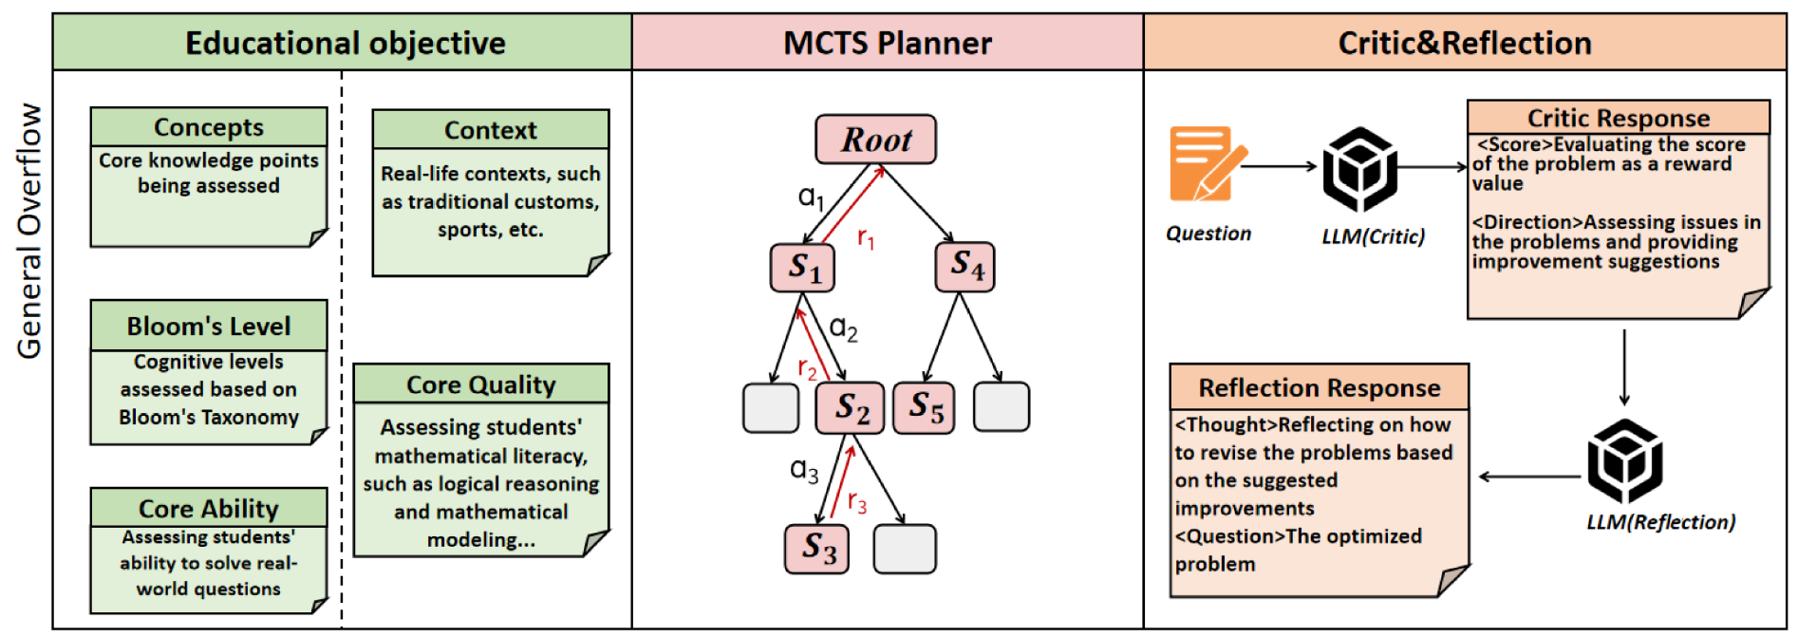
Figure 1. Educational objectives, planning and feedback in EQPR. Reproduced from Cheng et al. [3], original Figure 2, upper framework panel, p. 12839.
Read the figure from left to right: the objective defines the desired question, the planner explores candidate states, and the critic and reflection components guide improvement. The important mechanism is an explicit connection between the objective and revision. The full algorithm also involves search and repeated evaluation, which can require additional model calls.
For Lumori, a manageable first investigation would retain the principle while using a simpler plan, draft, check and revise sequence. It could compare a single generation call with a bounded revision stage under the same tasks and generator. This would test whether objective alignment improves enough to justify the added time and usage, without claiming to reproduce EQPR or its search procedure.

3 Retrieval and the use of course evidence

3 1 Lewis et al 2020
Retrieval Augmented Generation for Knowledge Intensive NLP Tasks [4]
Lewis et al. combine a parametric sequence-to-sequence generator with non-parametric memory accessed through a dense retriever. For an input query, the retriever selects passages from an external index. The generator then conditions its output on the query and those passages. The paper introduces RAG-Sequence and RAG-Token, which differ in how retrieved documents are combined across output generation.
The original system jointly fine-tunes retrieval and generation and evaluates several knowledge-intensive tasks, including question answering, fact verification and question generation. The authors report benefits from combining stored model knowledge with retrieved evidence. These results establish a research foundation for RAG; they are not evidence that simply adding arbitrary passages to an API request guarantees correctness.
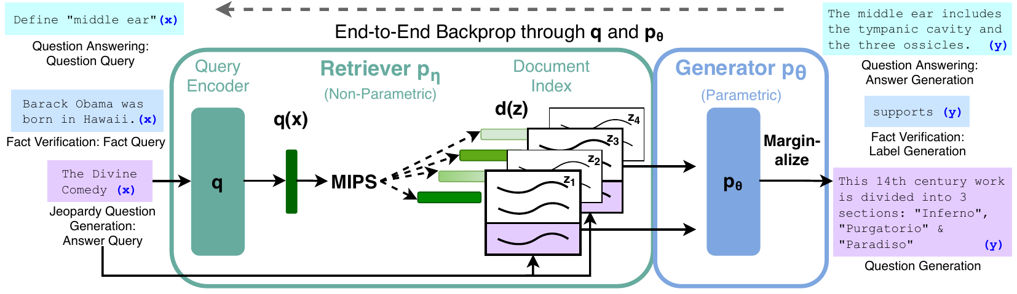
Figure 2. Retriever and generator in the original RAG architecture. Reproduced from Lewis et al. [4], original Figure 1, PDF p. 2.
The figure separates the external document index from the generator’s learned parameters. The query encoder selects candidate evidence, while the generator uses the retrieved documents to produce an output. The training arrow is an important difference from the proposed API-based approach: Lumori would initially retrieve course passages and supply them through prompts, without jointly training these components.
For this project, retrieval provides a way to make the uploaded course collection the primary evidence base. A suitable experiment would compare the same generator with and without retrieved course passages, holding the task and output requirements fixed. It should inspect whether the chosen passages actually support the answer. Retaining document locations would also let a teacher distinguish missing source information, retrieval errors and unsupported generation.

3 2 Liu et al 2024
Lost in the Middle How Language Models Use Long Contexts [5]
Liu et al. investigate whether accepting a long input means that a model can reliably use information throughout it. They vary the location of relevant evidence while keeping the question and supporting information available. The study uses multi-document question answering and synthetic key-value retrieval to separate information availability from the ability to access it.
Their experiments often show stronger performance when evidence appears near the beginning or end of the context and weaker performance in the middle. Figure 3 gives a concrete example for a particular model and a twenty-document condition. The result challenges the assumption that a longer context necessarily produces a better answer. Its magnitude depends on the tested model and setup, so it should motivate testing rather than a universal prediction about later models.
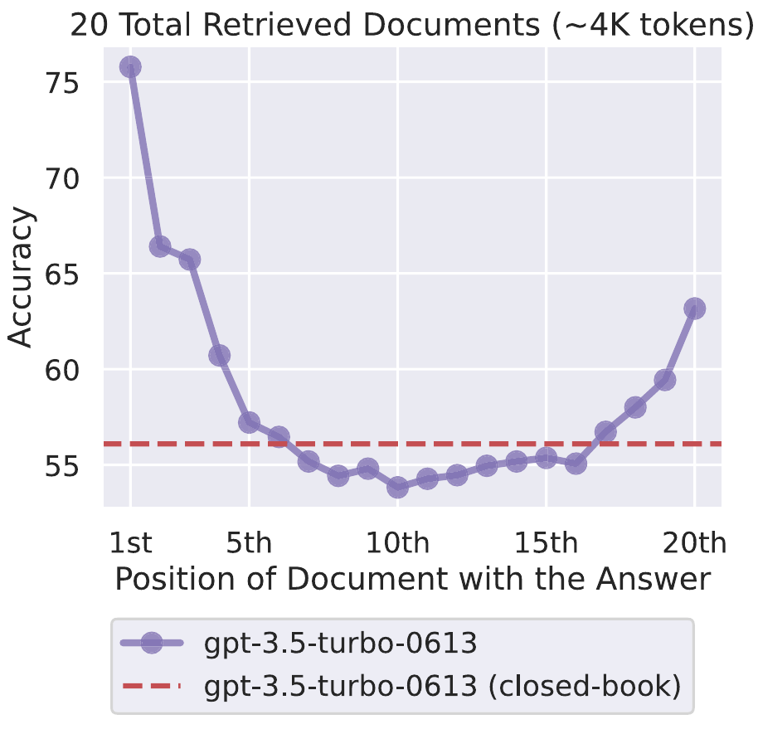
Figure 3. Accuracy as the answer-bearing document changes position. Reproduced from Liu et al. [5], original Figure 1, p. 158. The plot reports the paper’s experiment with GPT-3.5-Turbo-0613 and twenty documents.
The horizontal axis shows the position of the document containing the answer; the vertical axis shows accuracy. The dashed line is the same model’s closed-book baseline. Relevant evidence is present at every tested position, yet performance changes. This is why retrieval quality and the generator’s use of retrieved evidence should be examined separately.
For Lumori, a useful design implication is to select focused passages and preserve their order as part of the experimental configuration. A small evaluation could vary passage count and evidence position while holding the question and model fixed. This would help determine whether adding course context helps, distracts or hides relevant material, before choosing a larger context budget.

4 Difficulty and the intended learner
Park et al 2024 Large Language Models are Students at Various Levels Zero shot Question Difficulty Estimation [6]
Park et al. study how question difficulty can be estimated for learner groups with different abilities. Their LLaSA framework uses item response theory, including a Rasch model, to relate question-solving performance to ability and difficulty. It selects clusters of language models intended to represent student ability patterns, aggregates their responses and estimates difficulty from those patterns.
The paper also proposes a zero-shot variant and evaluates against student-derived information on DBE-KT22 and ASSISTments. The reported results support the possibility of estimating learner-dependent difficulty using model responses. Importantly, the study estimates the difficulty of existing questions. It does not demonstrate that a generator can produce questions meeting a requested difficulty label, and a model population is not automatically representative of a local class.
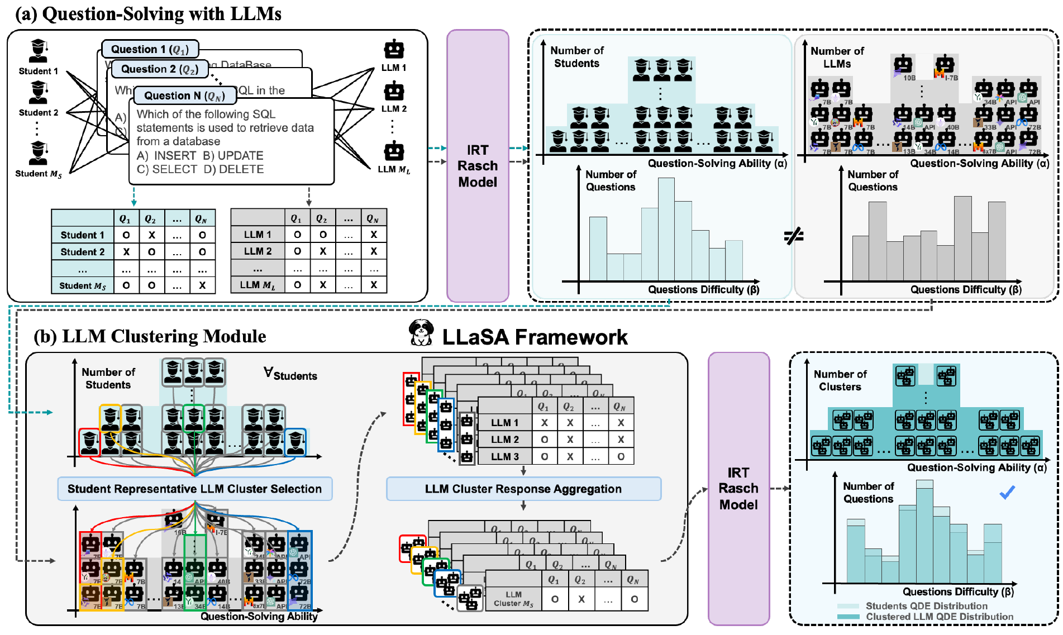
Figure 4. Model response patterns and learner representation in LLaSA. Reproduced from Park et al. [6], original Figure 1, p. 8159. This is the main LLaSA framework; the paper describes its zero-shot variant separately.
The figure illustrates why using several models is more involved than averaging self-assigned difficulty scores. LLaSA analyses solving patterns and selects model groups to represent learners before estimating question difficulty. Its learner representation and response-based calibration are central to the method.
For Lumori, the immediate task should be defined as controlling intended cognitive demand for a stated learner profile. Teacher judgments of that demand can be compared with requested labels. Claims about actual difficulty would require an appropriate student sample and response data. This distinction keeps a question requiring several concepts separate from a question that students empirically find hard.

5 Evaluating evidence and generated content

5 1 Gao et al 2023
Enabling Large Language Models to Generate Text with Citations [7]
Gao et al. introduce ALCE to evaluate generated answers that include citations to retrieved passages. The framework considers output quality and citation quality separately, using tasks including ASQA, QAMPARI and ELI5. Citation assessment examines whether statements receive supporting evidence and whether the supplied references are relevant to that support.
The distinction is useful because a readable answer can contain a citation that does not justify its claim. The study reports that generating well-supported cited answers remains challenging even when systems can access retrieved material. Its automatic evaluation uses entailment-based judgments and task-specific correctness measures; these are useful operational measures rather than a complete account of educational validity.
For Lumori, checking that a source identifier exists should be the first step. The next step is to inspect whether the passage supports the answer or explanation. A teacher should be able to open the exact supporting material. Evaluation should record unsupported claims and unnecessary citations separately, so that adding more reference markers does not appear to improve grounding by itself.

5 2 Es et al 2024
RAGAs Automated Evaluation of Retrieval Augmented Generation [8]
Es et al. propose RAGAs for evaluating retrieval-augmented systems when reference answers are unavailable. The original paper separates faithfulness, answer relevance and context relevance. Its faithfulness procedure decomposes an answer into statements and asks a model whether each follows from the context. Other procedures assess whether the answer addresses the question and whether the retrieved material is focused.
The authors introduce WikiEval to compare evaluation signals with human judgments. This makes the contribution more specific than a single overall quality score: it provides dimensions that help diagnose different failures. However, reference-free evaluation still relies on a judge model and its interpretation of the evidence. Faithfulness to a passage also does not establish that the passage is correct, or that an assessment item has educational value.
For Lumori, these dimensions could organise error analysis. An answer might be supported but off-topic, or relevant but unsupported. A model-based checklist could help identify cases for review, with a human-rated subset used to examine judge agreement. The project should add educational criteria such as answerability, objective alignment and intended demand instead of treating a RAG score as a teaching-quality score.

5 3 Deroy et al 2025
MIRROR A Novel Approach for the Automated Evaluation of Open Ended Question Generation [9]
Deroy, Maity and Sarkar address the cost of evaluating generated educational questions. MIRROR alternates between two language models that score a question and describe its strengths and flaws. The feedback is passed between the models until a convergence criterion is met. The study considers grammaticality, relevance, appropriateness, novelty and complexity.
The experiments use EduProbe and SciQ examples and compare model ratings with judgments from three educators. The authors report closer alignment with human scores and improved correlation for their feedback-based approach compared with direct evaluation prompts. This supports studying assisted evaluation, while leaving the reliability of a particular judge on a new course to be established.
The object being refined is the evaluation of a question. MIRROR should therefore not be described as direct proof that iteratively rewriting a question improves it. Agreement between two models can also reflect shared assumptions. For Lumori, the transferable idea is to request explicit, evidence-based criticism and test whether it helps identify defects. Any question-revision stage would need its own before-and-after evaluation.

6 Synthesis and proposed investigation
Across the studies, four design needs emerge. Generation should be guided by a learning objective and learner background. Retrieved evidence should remain identifiable. Intended demand should be distinguished from measured learner difficulty. Review should assess both source support and educational suitability. These needs connect the components into a teacher-facing authoring workflow.
A first comparison could use a fixed course collection and task set with three conditions: generation without retrieval, generation with retrieved course passages, and retrieval followed by a separate review and bounded revision. The same generator, requested formats and question counts should be used. The effect of explicit cognitive constraints can then be tested in a separate difficulty comparison.
Evaluation should retain all submitted tasks, including failures, and examine correctness, evidence support, answerability, objective alignment and reviewer-rated demand. Completion rate, latency and model usage should accompany quality results. Independent reviewers should see anonymised outputs where practical. If reduced teacher workload is claimed, the time and corrections needed to reach an acceptable version should also be measured.

References
[1] X. Du, J. Shao, and C. Cardie. Learning to Ask: Neural Question Generation for Reading Comprehension. ACL, 2017, pp. 1342–1352.
https://aclanthology.org/P17-1123/
[2] H. Gong, L. Pan, and H. Hu. KHANQ: A Dataset for Generating Deep Questions in Education. COLING, 2022, pp. 5925–5938.
https://aclanthology.org/2022.coling-1.518/
[3] C. Cheng et al. From Objectives to Questions: A Planning-based Framework for Educational Mathematical Question Generation. ACL, 2025, pp. 12836–12856.
https://aclanthology.org/2025.acl-long.628/
[4] P. Lewis et al. Retrieval-Augmented Generation for Knowledge-Intensive NLP Tasks. NeurIPS, vol. 33, 2020, pp. 9459–9474.
https://arxiv.org/abs/2005.11401
[5] N. F. Liu et al. Lost in the Middle: How Language Models Use Long Contexts. Transactions of the Association for Computational Linguistics, vol. 12, 2024, pp. 157–173.
https://aclanthology.org/2024.tacl-1.9/
[6] J.-W. Park, S.-J. Park, H.-S. Won, and K.-M. Kim. Large Language Models are Students at Various Levels: Zero-shot Question Difficulty Estimation. Findings of EMNLP, 2024, pp. 8157–8177.
https://aclanthology.org/2024.findings-emnlp.477/
[7] T. Gao, H. Yen, J. Yu, and D. Chen. Enabling Large Language Models to Generate Text with Citations. EMNLP, 2023, pp. 6465–6488.
https://aclanthology.org/2023.emnlp-main.398/
[8] S. Es, J. James, L. Espinosa-Anke, and S. Schockaert. RAGAs: Automated Evaluation of Retrieval Augmented Generation. EACL System Demonstrations, 2024, pp. 150–158.
https://aclanthology.org/2024.eacl-demo.16/
[9] A. Deroy, S. Maity, and S. Sarkar. MIRROR: A Novel Approach for the Automated Evaluation of Open-Ended Question Generation. PMLR, vol. 264, 2025, pp. 3–32.
https://proceedings.mlr.press/v264/deroy25a.html

