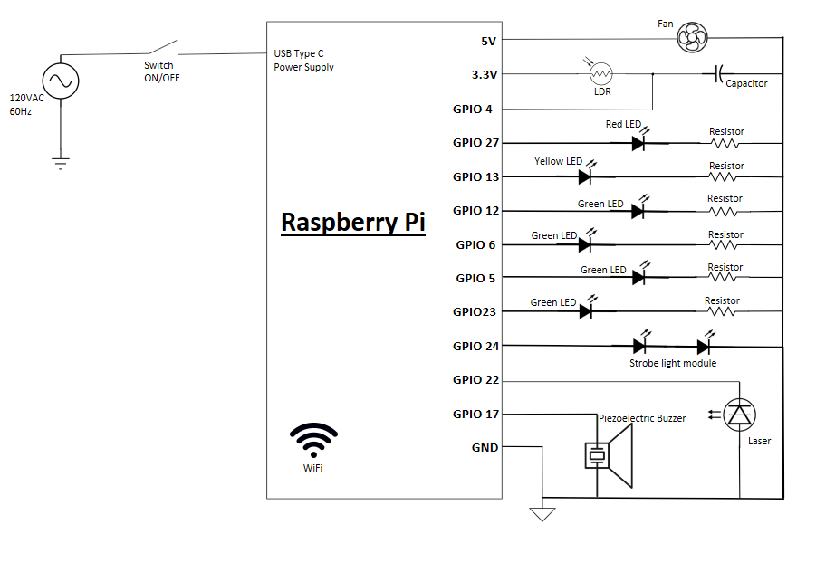

Table 4: Parts List/Cost

|  |  |  |
| --- | --- | --- |
| Materials | Quantity | Cost |
| Raspberry Pi 4  4GB Model | 1 | $55.00 |
| Photoresistor | 1 | $0.50 |
| 330Ω Resistors | 6 | $0.60 |
| 1 µF Capacitor | 1 | $0.45 |
| Laser | 1 | $0.50 |
| Piezo Buzzer | 1 | $1.20 |
| LED’s | 6 | $0.40 |
| Case | 1 | $7.44 |
| Mirrors | 3 | $7.67 |
| Jumper Cables | 26 | $1.51 |
| Neodymium Magnets | 6 | $8.79 |
| Shadow Box | 1 | $23.00 |
| Strobe Light Module | 1 | $9.99 |
| **Total** | 55 | 117.05 |