RDP info screens
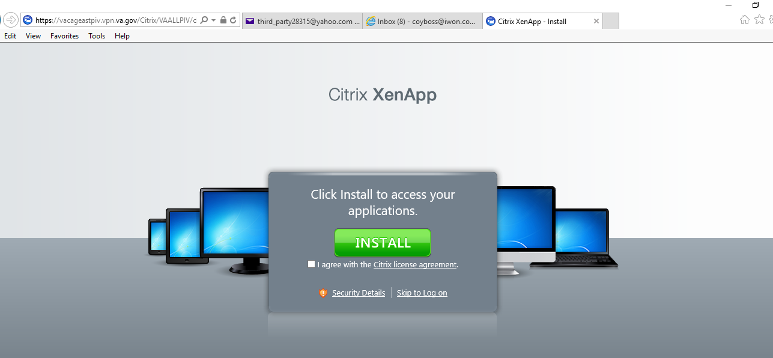
Here I click Skip to Log on
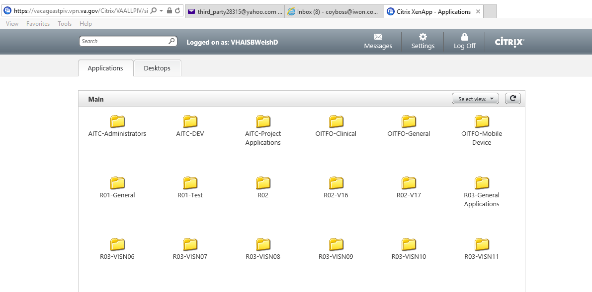
Here I click on Desktops tab
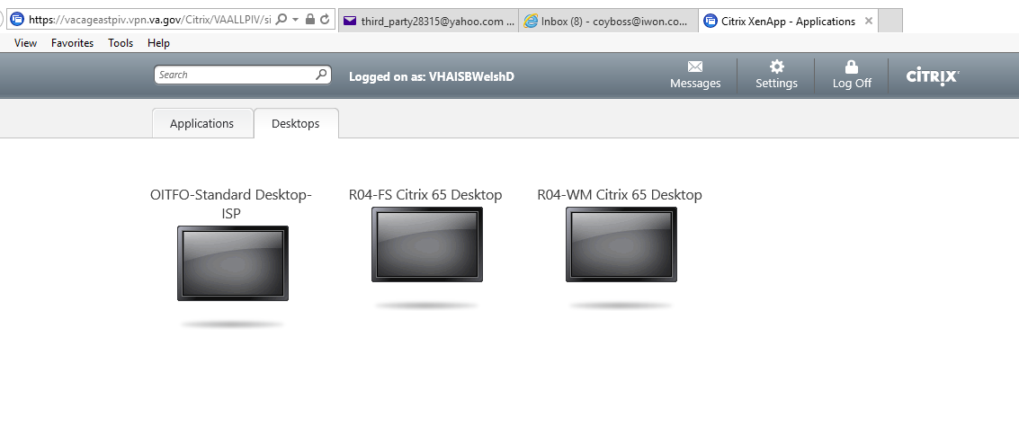
Here I choose OITFO-Standard Desktop ISP
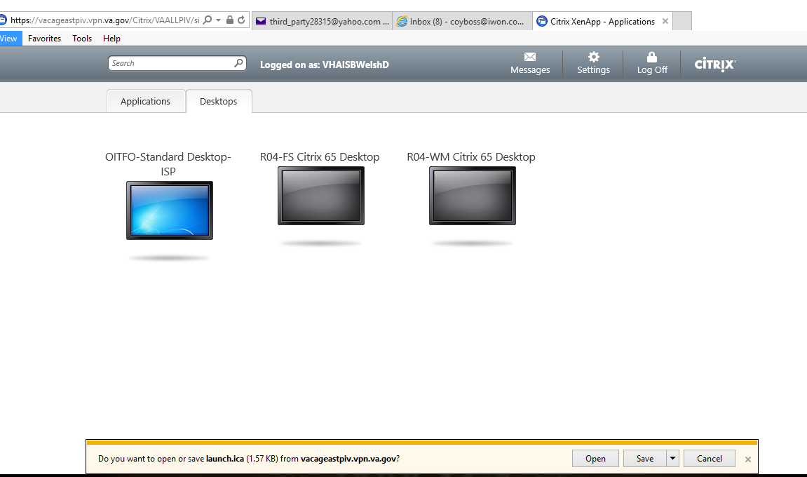
Then I click on OPEN and it makes a remote connection and brings up my Remote log in screen and desktop after successful login.
I am getting the crash when I click on the Desktop in the image above, Before launch.ica comes up

