

PZero: Developer Test

# Conditions of the assessment

Under none of the sections will you be allowed to receive assistance from any other person.

# Time limit

Assessment is to be returned no later than 2 days after receipt. Late submission will be an automatic fail.

## Section 1

* Internet **may not** be used to solve the questions.
* Your computer may not be used to help you solve these questions.
* You may use no reference material or notes to solve these questions.

## Section 2

* Internet **may** be used in this section.
* We will be testing ability to problem solve and learn new skills.

## Section 3 (bonus points)

* Internet **may** be used.
* This will be to test ability to learn new frameworks.

# Section 1

1. You are given a series 1,2,3 … recognize the pattern and write a small piece of php code to print out this series up until *infinity (infinite loop).*

1. *You are given a series 1,3,6,10 … recognize the pattern and write a small piece of php code to print out this series up until infinity (infinite loop).*

1. Explain what it means to define a class as abstract:

You can’t make a new object of that class

--------------------------------------------------------------------------------------------------------------------

1. Briefly explain the difference between private and protected in terms of OOP:

In OOP, protected means that the property can accessed (used) in the class where it was created, or any class derived from the class where it was created – through inheritance. Private allows ONLY the class where it was created to access it and it is blocked from any inheritance.

--------------------------------------------------------------------------------------------------------------------

1. Define the following php functions:

* explode

Explode takes a sting and splits it on a given parameter, that is used as a delimter in the function, into an array that then can be accessed as an array

--------------------------------------------------------------------------------------------------------------------

* stripos

This is a built in PHP function that looks for a search string within a searchable string and displays the first position of the search string within the searchable string.

--------------------------------------------------------------------------------------------------------------------

* rtrim

This is used to remove trailing white space from a string meaning white space the right hand side of a string

--------------------------------------------------------------------------------------------------------------------

* require

This function will include the entire contents of the file that is “required” every time the required function is called.

--------------------------------------------------------------------------------------------------------------------

* require_once

This function works similarly to require but the function first checks if the file has been included previously and will ignore the call if the file is already included.

--------------------------------------------------------------------------------------------------------------------

 6. What would the following code output:

for ($i = 0; $i < 5; $i++) {

echo $i;

continue;

}

01234

__________________________________________

     7. What would the following code output:

do {

echo “1”;

continue;

echo “2”;

break;

} while (false);

1

Basically, the continue pushes the code out of the loop and sets the condition to true and that makes the loop not execute again because it can only execute when the condition is false so the continue is essentially a break

__________________________________

8. You are given 2 tables in a database, a user table and a company table.

|  |
| --- |
| **User** |
| id |
| username |
| company_id |

|  |
| --- |
| **Company** |
| id |
| name |

Write a query to give the following result :

|  |  |
| --- | --- |
| **user_name** | **company_name** |
| Pete | Pzero |

SELECT User.username AS user_name, Company.name AS company_name

FROM User

LEFT JOIN Company ON (User.company_id = Company.id)

--------------------------------------------------------------------------------------------------------------------

10. Briefly describe what JSON is and what php functions you would use to make use of JSON on a day to day basis:

--------------------------------------------------------------------------------------------------------------------

# Section 2

In this section you will be scraping data and putting it into a usable format for further development. With php code read the following web page.

<https://www.worldometers.info/coronavirus/>

Parse and read this table of data.

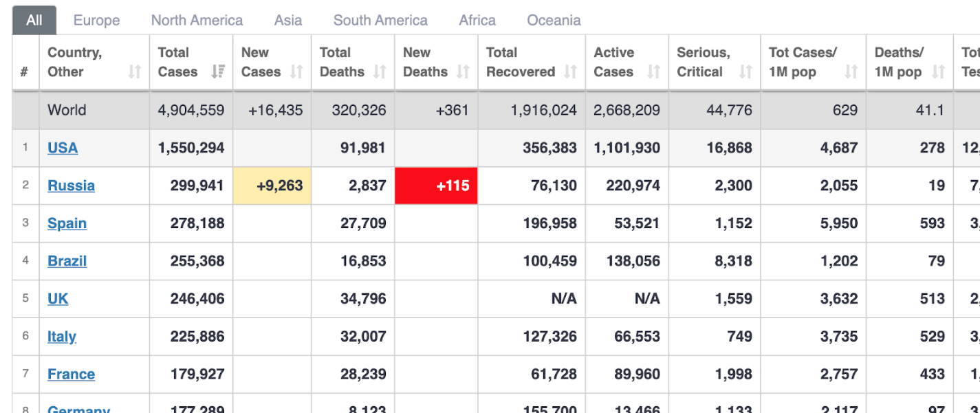

Then format that data into a json string with the following fields.

*Country, total cases, new cases, total deaths, new deaths and total recovered.*

You can structure your json as you like as long as it follows a logical structure and conforms to json standards as you will be needing it in the next section.

Commit your php code either to bitbucket or github and share the link of your code repository to earn credit for this question.

# Section 3 (bonus points)

In this section we will be testing your ability to learn new skills and adapt to be able to take on new challenging projects with new technologies. Create a new laravel project with user authentication using the standard laravel auth feature. Create a basic admin section which reads the json data you created in section 2 and displays it in a table format in your admin section. Be sure to include all your migrations in your code base so that we can create this project by running migrations. Also please make use of a MySql database to store your user credentials. Your data table in the admin section must read from your json file created in section 2 and not from the database.

Commit all your code to bitbucket or github and share the repository url with us.