Technical Report

Semester Project 2

Eirik Andreas Gustavsen

Word count

Summary: 210 | Main text:1230

Table of Contents

1. Summary 3

2. Body 4

2.1. Introduction 4

2.2. Main section of report 5

2.3. Conclusion 7

3. References 8

4. Acknowledgements 10

5. Appendices 11

# 1. Summary

Before I start off, I would like to give a huge thanks to my tutors, my family, but escpecially my mentor, Pål Oliver Kristiansen. Without these, I wouldn’t have made it. So I want to give a huge amount of credit to all of them.

I also want to state something really important. Yesterday I tried to upload my files to github. But what I did instead was to overwrite the new files that I had made with 22 days ago older files. And I didn’t have my files saved anywhere else. The process of doing this though took a long time.

I’ve worked very hard on this semester project. I hope it turns out good and that everything is clean and clear. My work has been unbalanced, but I guess if it wasn’t it wouldn’t really be proper work. I’ve spent hours walking the corridors trying to just solve a simple programming issue, and I’ve had to re-do a lot of the content I’ve created. And I’m not even referring to the content that got deleted. I also done a lot of work that I decided I wasn’t going to include because they were either half finished, or they lacked logical sense.

Link to github repo:

<https://github.com/ThePandaKing94/semester-project-2>

# 2. Body

## 2.1. Introduction

“I didn’t really see the Level 1 Process within a certain amount of days, so let me first start of by saying that the github repository is like that because I didn’t know I had to design sketches and icons before I moved on to coding the site. My vision for the site is to just do the job and not overcomplicate it, otherwise I would probably just do something unrealistic and it would be too time consuming.” This paragraph was something that I wrote in my report which got deleted. My report, along with many other files had gone away with github desktop branching and was replaced by the old one. This was very saddening for me. I had to work a lot the last day, before the 17th May.

I would also like to mention that even though I had written I was going to do this as simplistic as I can and not overcomplicate things, I ended up doing the opposite. I began writing server-side code for the game before I actually begun coding the actual game. I had no experience with express and socket.io, but I decided I was going to give it a shot anyway.

My work session has been unnecessary painful because of some mistakes that I did. When I did such a large task, I should have saved my files in a safer manner, like on google disk. I’m not the person with the most comfortable knowledge about google desktop. But I’m glad that most of my files that were difficult to make, hadn’t been properly deleted. They kind of were, but all my code files could be regretted with ctrl+z thankfully. The only exception to this was the main.css for some reason. I also had to remake all the sketches and images and icons. These things were never that good in the first place.

## 2.2. Main section of report

I really enjoyed what the task was about. Game of Thrones is a TV-series and book series I was a huge fan of until season 8. Unfortunately season 8 ended terribly, and I sincerely just hope the books turn out better. I wouldn’t say my passion for the series however helped me in anyway though. It didn’t really matter what is was about, because I was always focused on the coding and design part of the aspect, and the content that I was actually making.

I had a clear vision of how my sites before I begun to code them. Once I had read what the task required, I already knew what I wanted to make, and I had no trouble remembering what that was. There were going to be 3 sites. One where one could choose the character they wanted to play, second site should be the game site, and the third site was the congratulations site. So even though I hadn’t made the sketches right to begin there was that. I didn’t want to complicate things either. And I felt the simplistic approach was good.

The only font I’ve used is Orbiton. I feel there is no need for any other font language. And it feels like a very game-like font style. My fonts are never too big or too small, which is why the font size have a similar size, but not completely, it depends on which element it is.

When it comes to designing the icons, I will be honest and say that is the most careless consideration I’ve had to my semester project. I just made them as fast as possible so I could prioritize my time with something else, so the self-made icons look very ugly. However, I will say they serve a very symbolic meaning to the game of thrones. Jon Snow has his own **white direwolf** called Snow. Jaime got his hand cut off and got a **golden hand.** Tyrion likes to become smart and read **books** because he is short and he needs to use the best of his abilities to what he can in Game of Thrones. Arya has the sword **needle.** Bran has the **three eyed raven.** Cersei has the **wine cup.** Sam has the **dragonglass dagger** to kill the white walker. The most vague one would be sansa with her **flower.** That’s because Cersei mentioned she was a flower. Theon is a greyjoy and has a **kraken** as house symbol. Varys, like Tyrion and Sam is intelligent and good with writings and books, and is a good counsellor which is why he got a **feather pen.**

Every character was meant to have 2 abilities that they were going to have in game aswell. However, this took too much time, and I had wasted too much time as well as doing unproductive work. Also because the site doesn’t have to be responsive, I’ve only made it so that it’s 1920p and 1080 width desktop resolution size. And it works best with google chrome.

I liked the spacing I had in my design. Spacing is something that could potentially be easy to make, but it depends on what’s being made. In my case, I had a lot of structured, grid content, so for my case, it was easy and I’m very happy with that my index and game sites had a very pleasant look to it. I myself like the spacing at least. And I like the spacing between the routes aswell on the game site.

I’ve tried to take into consideration WCAG guidelines. The websites consists of a lot of black, white, black, red and yellow. I feel these colours are used next to each other and I don’t see how people with disabilities or blindness would have a difficult time trying to figure out what’s what. The only thing they need would be experience in the coding aspect, which is explained in my video tutorial where I go through one game round.

There are 2 things I’ve sort of copied code from. The dice and modal images. I realize that copying this code wouldn’t really be ideal, but their simply small inspirational additions that I’ve used. Having to write the rest of the code is hard and I therefor don’t see this as cheating or copy pasting. It’s just a handful tool, kind of like a framework.

Speaking of frameworks, I know now I could have used more of them. I did try to use the runtime environment Node.JS with express, but like I previously said, I dropped that because it wouldn’t work, the way I wanted to, and it took too much time.

I know I also could have used frameworks such as LESS and typescript. I will be honest and admit that they are a bit complicated to use effectively. If you are good with them, they are useful frameworks, but if not, they might just end up making things worse. LESS and typescript are nice additions, but far from a requirement I would say. But that’s just me. Maybe when working in really large groups SASS or LESS will become a must.

And when it comes to bootstrap, I will just admit that I’m not really a big fan of bootstrap, unless I’m creating something in a fast pace, like for a local restaurant or something. The HTML code ends up looking very ugly with bootstrap, and bootstrap makes it also limited as to what one can do with it, so even if I was really good with bootstrap, I’m not sure if I would use it. I have of course used some JQuery though. I’m starting to really like JQuery I’ve realized. I also stumbled upon mocha, didn’t use it, but learned a bit about it.

My user testing actually went pretty smooth because my mentor told me what my errors were and how to correct them. It was a bit difficult due to javascript problem vs other programming languages. The fact that javascript works like if you write something, you wouldn’t necessarily get an error because javascript is vague and doesn’t see a lot of coding as errors a lot of the time. Not sure what that’s called, but I stumbled upon that.

I’ve never used the syntax **target** before. But that was a pleasantly surprising way of taking in some code from one website to the other. I was also confused about a lot of the code being written, but once my mentor explained his choices for writing what I did, I understood. It’s really just a matter of practice, and I felt I learned a lot with him.

He was very good at using the console to debug and put arrow on functions and working out step by step what he had to do, and I learned a lot from that, like creating breakpoints, stepping over function calls, seeing the pattern and outcalls being made in the code, etc...

My buttons were red with white text. I felt it was a simple nice way of doing it, and it really gives a blood and death like vibe to it, which is what the game is about, because there usually is a lot of dying.

My board game is difficult. But all traps serve one purpose. To roll a dice to get higher than a certain number.

## 2.3. Conclusion

Delivering this semester project feels surreal. It might not look like it, but there is a tremendous number of hours behind this work. I really hope I will succeed in this semester project, it has been difficult to get through, and there were many errors along the way I had to fix.

It’s sad that a lot of my files got deleted. I was able to regret the JS code thankfully. If I had lost that code, I would have failed for sure. I’m very happy to finally be finished so I can just take these bad memories of failures, put them behind me, and move forward. It shouldn’t have to be this annoying, I get that it’s a large task, but it still shouldn’t have that many problems, but it is what it is and I don’t want to think about it anymore. I almost cried when I had lost all my files, luckily, I was able to get most of it back. Had I lost my JS files; it would have been over. Next time, when I’m doing this large of a task, I will save somewhere safer for sure, and more often.

I realize this is an excessively big project, and therefore, I realize that I probably have made many mistakes that I’m not even aware of. I hope therefore this will be taken into consideration when correcting this project. There might have been some things that I’ve forgotten, but with a task this large, it’s hard not to. This is without question, the hardest and most technical project I’ve ever taken myself upon. I understand why its schedule is over a month long.

# 3. References

For creating the dice, I’ve mainly just used this code.

<https://codepen.io/Pyremell/pen/eZGGXX/>

I realize that this is ***almost***copy-paste, but it’s difficult to adjust to design when it’s already perfectly made. I guess my experitise will be shown in other coding areas, especially with the fetching code part.

For creating the confetti after the player finished the game I’ve used

<https://www.npmjs.com/package/confetti-js>

Here is partly the logo I used for the game. As one can see, It’s free.

<https://www.hiclipart.com/free-transparent-background-png-clipart-vozgg/download>

I also used this image for the direwolf token. It’s copyright free. A dire wolf is too hard to design by myself. And I only have to design at least 5 icons, not all.

<https://www.pinpng.com/download/imiJJw_dire-wolf-png-transparent-png/>

The icons that I made by myself which are served as token, bricks that are be used on the board are; Arya’s needle. Bran’s three eyed raven, Cersei’s wine cup, Jaime’s golden hand, Tyrion’s book. The rest that I haven’t made, but are images from the same site, pinpng.com.

<https://www.pinpng.com/picture/owJix_beautiful-pink-rose-png-clipart-pink-rose-clipart/>

<https://www.pinpng.com/download/xoibmi_game-of-thrones-clipart-iron-throne-game-of/>

Sam,s dragonglass dagger:

<https://icons-for-free.com/of+thrones+game+thrones+series+ice+sword+weapon-1320568557491422230/>

Theon’s squid:

<https://www.flaticon.com/free-icon/kraken_2534513?term=kraken&page=1&position=1>

Varys’s feather

<https://www.flaticon.com/free-icon/inkwell_2890709?term=feather&page=1&position=47>

Sansa’s flower

<https://icons8.com/icons/set/flower>

Button Images:

Night King:

<https://wallpapercave.com/w/wp2112838>

White Walker:

<https://wallpaperplay.com/walls/full/5/c/7/68833.jpg>

The Mountain:

<https://wall.alphacoders.com/big.php?i=916410>

Khal Drogo:

<https://www.wallpaperflare.com/khal-drogo-game-of-thrones-jason-momoa-shirtless-one-person-wallpaper-tbawl/download/1920x1080>

Drogo’s Fire:

<https://wall.alphacoders.com/big.php?i=838168>

This 1 belongs to steam so it’s also free.

Blocked Road:

<https://www.google.com/search?q=medieval+bandits+free+image&tbm=isch&ved=2ahUKEwiAivDgpLjpAhUQvioKHXfODzsQ2-cCegQIABAA&oq=medieval+bandits+free+image&gs_lcp=CgNpbWcQAzIECCMQJ1CAIViAIWCSI2gAcAB4AIABTogBTpIBATGYAQCgAQGqAQtnd3Mtd2l6LWltZw&sclient=img&ei=gs-_XoDBKpD8qgH3nL_YAw&bih=888&biw=1920&rlz=1C1ASUM_enNO793NO793#imgrc=nFG0JvmcSmeajM>

These images are all free copyright. Reason I didn’t make more than 5 is because I don’t have to. And my design doesn’t look so good.

I’ve also taken use of modal images from W3Schools

<https://www.w3schools.com/howto/howto_css_modal_images.asp>

Again, this is just to try things out. Copying 1 or 2 things doesn’t make the rest of the semester project work, and its not like I can just copy everything either because I have to adjust the code aswell, so again, it’s mainly just inspiration for the semester project.

# 4. Acknowledgements

I’m going to talk about something that hasn’t been included in the report and that’s socket.IO and Node.express. These were all things I worked with and I regret doing these things before even coding the game. If I began with the game first, things wouldn’t be as stressful. With that said, I would like to thank Michael John Phillips, Connor O’Brien and my mentor Pål, for helping me understand socket.io and express. Even though I didn’t include it in my project, I did learn from it and I plan on becoming a full-stack developer someday and having such experience behind my back is useful for understanding some server-side code, back-end.

MJ Phillips also helped me with understanding how I was going to write my report. And then I’m referring to what were the differences between references, acknowledgements, and appendencies actually were.

When it comes to Pål, he helped with me so much. From JS modal images, going from making that repetetive work, through looping with js code. He showed me a whole world of programming aspects I have never

Pål is a long-time professional senior Full-Stack developer whose known as one of the best programmers in my county, specialized in JS and Java. I’m very lucky to have him helping me and he’s actually the older brother to

# 5. Appendices

Sketches

Congratulations

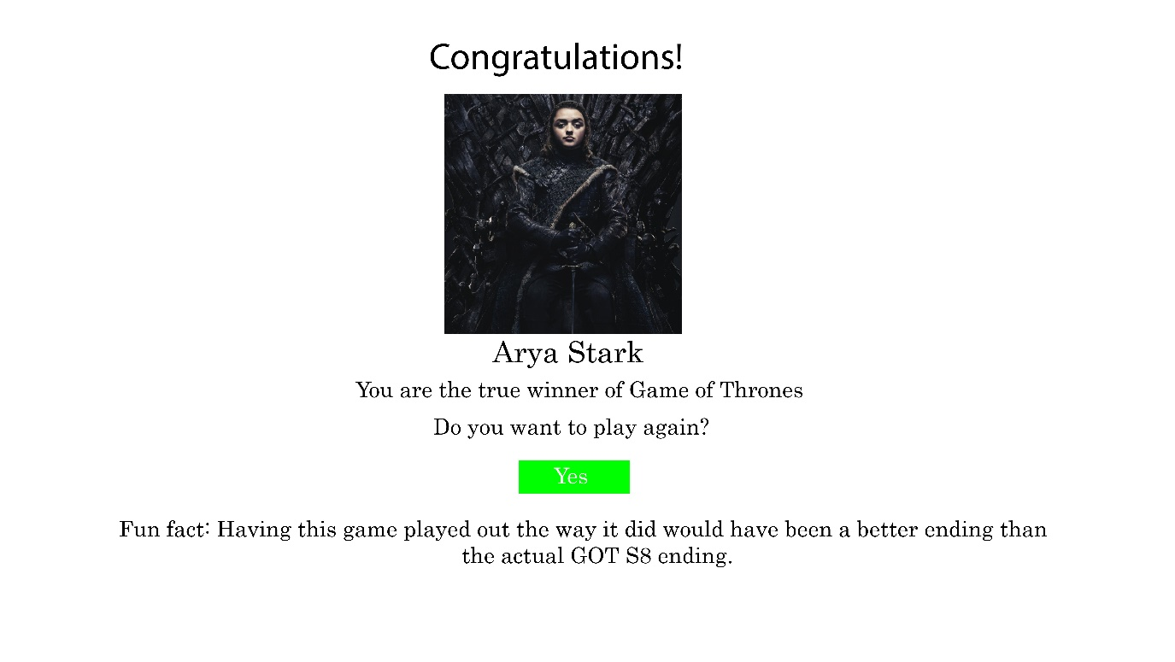

Index

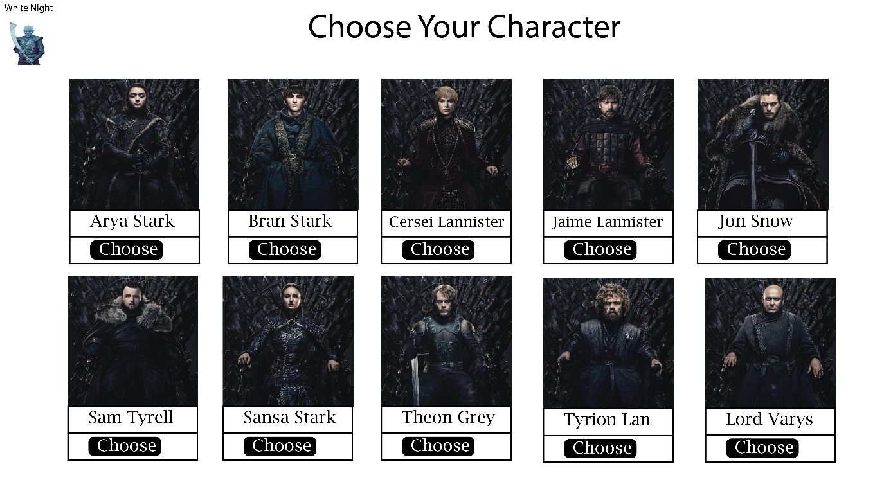

Game

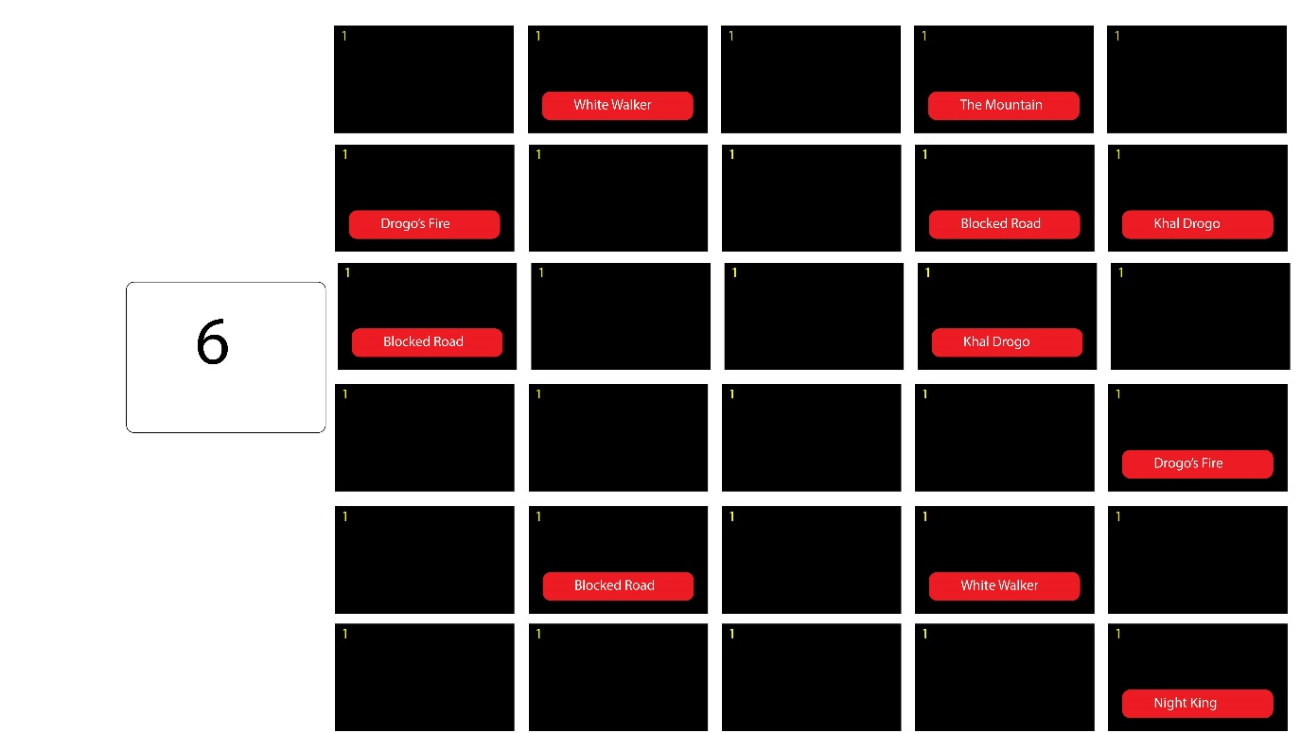

These were roughly how may sketches were before all of it got deleted when overwritten.