[Document title]

[Document subtitle]

PapaG

[Year]

# Table of Contents

Table of Contents 2

Table of Figures 2

1. Introduction 3

2. Literature Review 3

2.1. Frequency Range of Human Speech 3

1.1. Operational Amplifiers 3

1.1.1. Inverting Amplifier 4

1.1.2. Non-Inverting Amplifier 4

1.1.3. Unity Gain Amplifier 4

Design 5

# Table of Figures

Figure 1 - Frequency Range of Human Speech 3

Figure 2 - Intelligibility of Human Speech 3

Figure 3 - Inverting Operational Amplifier Topology 4

Figure 4 - Non-Inverting Amplifier Topology 4

Figure 5 - Unity Gain Amplifier Topology 5

# Introduction

# Literature Review

## Frequency Range of Human Speech

For the engineering design of audio applications, the characteristics of human speech is an important consideration. For this application the frequency range of human speech is important for the design of filtering for clear speech. The frequency range of human speech typically lies between 120Hz – 8kHz with the most important frequency range being 2kHz – 4kHz [1].

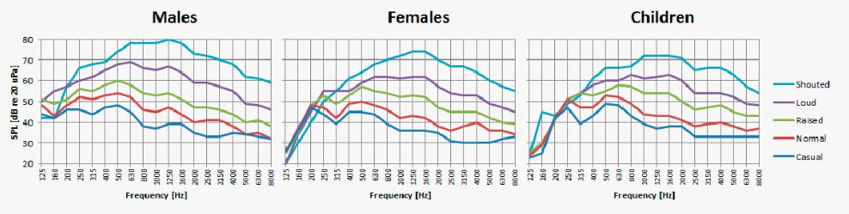

Figure - Frequency Range of Human Speech

In western cultures (non-tonal languages) the intelligibility of human speech lies at an optimal frequency point of around 2kHz. This is depicted in Figure 2 where it is exhibited that human speech predominately lies in the 500Hz – 4kHz range. Speech intelligibility in frequencies lower than 500Hz only accounts for 5% of the total intelligibility [1].

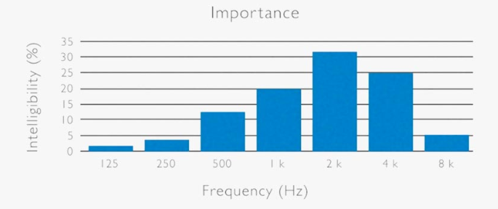

Figure - Intelligibility of Human Speech

## Operational Amplifiers

An operational amplifier (op-amp) is an integrated circuit (IC) known as an active component in electronic design. The advantages to active components are the ability to provide a gain. A gain is the term associated with the change in voltage between the input and output of an op-amp. Concerned with the design of this report is the application of: Inverting amplifiers, non-inverting amplifiers, and unity gain amplifier [2].

### Inverting Amplifier

Inverting Amplifiers[1] are named based on the characteristic they invert the sign of the input voltage to the output. The Inverting Amplifier allows gains as high as $120dB$, however this is not viable in design as it causes an unstable response. This design is exhibited in Figure 3 of which its behaviour is described by:

$$\frac{V_{out}}{V_{in}}= -\frac{R_{f}}{R_{in}}$$

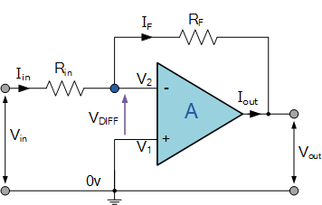

Figure - Inverting Operational Amplifier Topology

### Non-Inverting Amplifier

Non-Inverting Amplifiers[2] are the opposite to Inverting Amplifiers in that they do not invert the input signal. The design of this amplifier can be seen in Figure 4 and described by the relationship:

$$\frac{V_{out}}{V_{in}}=1+\frac{R_{f}}{R_{2}}$$

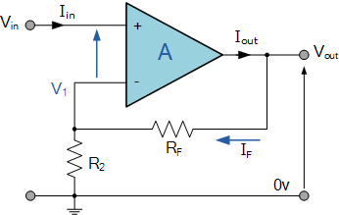

Figure - Non-Inverting Amplifier Topology

### Unity Gain Amplifier

The Unity Gain Amplifier is not so much an amplifier in that the gain of the amplifier always equals 1. Often implementing a non-inverting amplifier design the unity gain amplifier can be seen in Figure 5 and can be described by:

$$\frac{V_{out}}{V_{in}}=1$$

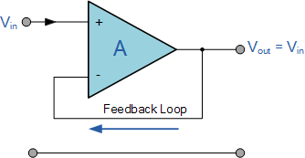

Figure - Unity Gain Amplifier Topology

## Signal Filtering

In signal processing and electronics, a filter is a component that blocks and passes frequencies based on design specifications. There are 4 types of filters: lowpass, highpass, bandpass, and bandstop. As the names describe the filters: pass low frequencies, pass high frequencies, pass a band of frequencies, and stop a band of frequencies. These responses are visualised in Figure 6 [3].

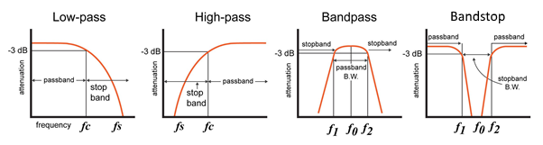

Figure - Frequency Attenuation Characteristics of Filtering

Filters can be presented in two ways based on the consisting components, passive and active. Passive filters are consistent of components that do not require an active supply voltage (like an operational amplifier). Active filters are advantageous as they provide better response than their passive counterparts.

# Electrical Design

## DC Bias Removal and Amplification Filter

Audio applications are more concerned with sinusoidal waveform frequencies than steady state voltage. As per the prior literature review the relevant frequency of human voice is 500Hz-4kHz this application will not be concerned with frequencies far outside this range. For this application a passive high pass filter will be used with $f_{p}=300Hz$. Using the relationship between the cut-off frequency and the component values we can select:

$$ω_{c}=2π300=1884.96 rad/s$$

$$ω_{c}=\frac{1}{RC}$$

$$1884.96=\frac{1}{RC}$$

$$let R=10k ohm$$

$$C=\frac{1}{10000*1884.96}$$

$$C=53nF$$

53nF is not a standard capacitor value so 56nF will be selected instead which now results in:

$$f_{c}=\frac{\left(\frac{1}{10*{10}^{3}*56*{10}^{-9}}\right)}{2π}=284.2Hz$$

This frequency is still viable enough to pass frequencies relevant to the human voice while also attenuating any frequencies inapplicable to the application.

The output of the microphone was experimentally found to have a Vpp of ~50mV. This is an issue as it doesn’t provide a higher resolution to the output. To account for this an inverting amplifier (Figure 3) is used with a gain of:

$$G=\frac{5V}{50mV}$$

$$G=100$$

The relationship of resistor components to gain can be described as:

$$G=\frac{R_{2}}{R_{1}}$$

$$∴let R1=10k$$

$$100=\frac{R_{2}}{10k}$$

$$R_{2}=1M$$

The positive terminal of this amplifier is used to bias the output. Typically, in a DC application this pin would be tied to ground. In this AC application the teensy cannot read a negative voltage, only 0V-5V. For this reason, the positive input pin of the operational amplifier must be biased to 2.5v so that the input signal oscillates between 0v and 5v. This can be done using a voltage divider circuit which can be described by the relationship:

$$V_{Out}=V_{In}*\frac{R_{2}}{R_{1}+R_{2}}$$

In this case $V_{In}$ is 5v and $V_{Out}$ must be 2.5v. For stability reasons the impedance on the positive input pin should be as equal as possible to the impedance on the negative input pin. The impedance on the negative input pin is equal to $R_{1}$. For an application where $V_{Out}$ is half $V_{In}$ the relationship between $R_{1}$ and $R_{2}$ is equal. Therefore let $R_{1}$ and $R_{2}$ equal $R$:

$$R_{1}=\frac{1}{2\frac{1}{R}}$$

$$10k=\frac{1}{2\frac{1}{R}}$$

$$R=20k$$

20kΩ is not a typical value therefore:

$$let R=22k$$

The design of this amplifier is seen in Figure 7 implementing all theoretical justifications previously discussed.

Figure - DC Bias and Amplifier Stage

## Anti-Aliasing Filter

An anti-aliasing filter is used in signal sampling applications to satisfy the Nyquist theorem. This theorem states that to not lose any frequencies, the sampling rate must be at least $2f_{max}$. The sampling rate for this design is $15.625kHz$ therefore the cutoff frequency must be at maximum $7.8125kHz$. Since the DC Bias Removal and Amplification Filter implements a high pass filter of ~284Hz the anti-aliasing filter will implement a low pass filter that also satisfies the Nyquist theorem. Given the literature review finding that the human voice range is 500Hz-4kHz this filter will implement a low pass filter with a $f_{p}=4kHz$. To design the filter the matlab supporting functions were used, this code can be seen in Appendix 1: MATlab Anti-Aliasing Filter Design. This investigation found that to achieve the design characteristics desired, the filter would have to implement a 10th order butterworth or a 6th order 1st chebychev. The optimal design would have been to implement the 10th order butterworth since the filter exhibits a steady state. This would have required 5 operational amplifiers (5 x 2nd order) and so the chebychev filter was chosen for this design.

A chebychev filter exhibits *ripple* during the steady state. This is undesirable as it reduces the quality of the conditioned signal. For the filter design this ripple was capped at 1Db of passband attenuation. This resulted in a 6th order filter (3 x 2nd order) with pole pairs:

|  |  |  |
| --- | --- | --- |
| -1562.77958032653 + 24967.1466856982i | -4269.59321448326 + 18277.2198939559i | -5832.37279480979 + 6689.92679174222i |
| -1562.77958032653 - 24967.1466856982i | -4269.59321448326 - 18277.2198939559i | -5832.37279480979 - 6689.92679174222i |

Given these complex poles can be expanded to real numbers, the relationship between each stages quality and natural frequency can be acquired and is tabulated below:

|  |  |  |
| --- | --- | --- |
|  | Quality | Natural Frequency |
| First Stage | 2.1446 | 8875.3419 |
| Second Stage | 2.9296 | 18769.2886 |
| Third Stage | 8.0037 | 25016.0088 |

For this design unity gain is assumed which states $K=1$ and so $R_{3}$ and $R_{4}$ are equal to 0. Therefore, the relationship of components to quality and natural frequency can be described by:

$$ω_{n}=\frac{1}{\sqrt{R_{1}R_{2}C_{1}C_{2}}}$$

$$Q=\frac{\sqrt{R_{1}R_{2}C_{1}C_{2}}}{C_{1}\left(R_{1}+R_{2}\right)}$$

# References

|  |  |
| --- | --- |
| [1] | E. Brixen, “FACTS ABOUT SPEECH INTELLIGIBILITY,” 20 01 2016. [Online]. Available: https://www.dpamicrophones.com/mic-university/facts-about-speech-intelligibility. [Accessed 20 05 2019]. |
| [2] | Electronics Tutorials, “Operational Amplifier Basics,” [Online]. Available: https://www.electronics-tutorials.ws/opamp/opamp_1.html. [Accessed 20 05 2019]. |
| [3] | N. Davis, “An Introduction to Filters,” All About Circuits, 31 6 2017. [Online]. Available: https://www.allaboutcircuits.com/technical-articles/an-introduction-to-filters/. [Accessed 21 05 2019]. |

# Appendix 1: MATlab Anti-Aliasing Filter Design

close all; clear all; clc;

%% Design

fsamp = 15.625e3;

fs = fsamp/2;

fp = 4000;

wp = 2*pi*fp;

ws = 2*pi*fs;

Amin = 20*log10(1/2^8);

Amax = 1;

[n_but, wn_but] = buttord(wp,ws, Amax, Amin, 's');

[n, wn] = cheb1ord(wp, ws, Amax, Amin, 's');

[b, a] = cheby1(n, Amax, wn, 'low', 's');

G = tf(b,a);

%bode(G);

[z,p,k] = tf2zpk(b,a);

%% First second order design

c1= -p(1)-p(2);

c2 = p(1)*p(2);

wn_first = sqrt(c2)

Q_first = wn_first/c1

%% Second second order design

c3 = -p(3)-p(4);

c4 = p(3)*p(4);

wn_second = sqrt(c4)

Q_second = wn_first/c3

%% Third second order design

c5 = -p(5)-p(6);

c6 = p(5)*p(6);

wn_third = sqrt(c6)

Q_third = wn_first/c5

1. <https://www.electronics-tutorials.ws/opamp/opamp_2.html>
2. <https://www.electronics-tutorials.ws/opamp/opamp_3.html>