Aims/Materials:

The dataset used is the “Ethereum Historical Data” by kingburrito666 on Kaggle.

Ethereum is a cryoptocurrency that was first released in 2015. A cryptocurrency is a list of linked ledgers (blockchain) that hold the entire transactional history within the system. Each ledger (block) requires a validator to find a solution to a cryptographic algorithm in order to approve and add the next block to the list. A reward for finding a solution to the cryptographic hash (and hence validating a number of transactions) is increased supply in the possession of the solution finder. The solution to the cryptographic hash is an NP problem and is assumed to require guess work to solve, thus protecting the validation over the distributed computational power of the system.
The timeseries dataset variables that will be analysed:
- A ~ Number of addresses (holders)
- P ~ Price (how much each unit of ether is worth in USD)
- G ~ Ether Supply Growth (total amount of ether in the system)
- T ~ Transactions (number of transactions that take place on any given day)
Each variable is associated with a timestamp equivalent to one day intervals.

Preprocess Data:

Removed variables (columns) that were not being analysed which included:
- Blocksize (the amount of transactions that each block holds)
- Hashrate (the net rate of how many computations to find a solution to the cryptographic hash were calculated on any given day across all addresses)
- Market Cap (this was removed as it was a direct copy of Ether Supply Growth)
Removed rows that were incomplete, errornous or otherwise, this was all days from 30th July 2015 until the 10th of August 2015. Each day was then converted into an integer starting with day 1 = 11th August 2015 and the final day 672 = 12th June 2017.

Some of the variables are monotonic increasing which is inherently non-stationary and also contains no non-negative results in any difference operator:
- A
- S
As information theoretic measures require the data to be stationary, the data must first be handled in such a way that yields stationary results. The backwards difference operator (BDO) was used as the derivative measure on these variables. As A and S are monotonic increasing, this also limits the BDO operator to yielding strictly positive results and because of this BDO² was applied. The first application of the BDO upon S showed a discontinuity at the date 14th March 2016 (pi day) which coincided with the release of the newer (and current version, Homestead). The BDO², which yielded a much more stationary result for the variables A,P,S,T was taken. This data was then put into a binary format where 1 represented values >=0 and 0 represents values <0. Given BI as the operator for which this represents, the data in question, plotted in Graph (1) is:
- BI(BDO(A))
- BI(BDO²(A))
- BI(BDO(P))
- BI(BDO²(P))
- BI(BDO(S))
- BI(BDO²(S))
- BI(BDO(T))
- BI(BDO²(T))
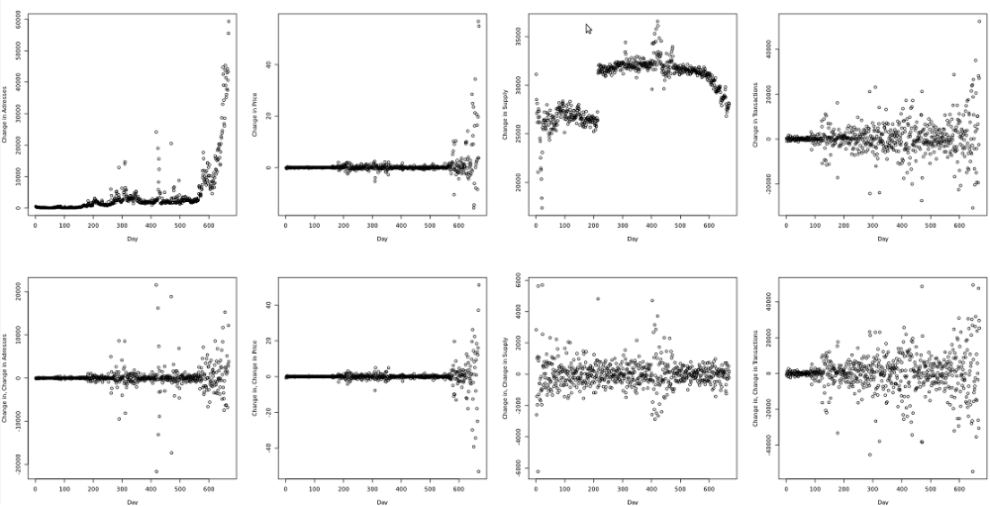
Graph(1)

When looking through the plots of the these values, the stationary data variables are:
- BI(BDO²(A))
- BI(BDO(P))
- BI(BDO²(S))
- BI(BDO(T))

It is expected that there will be relationships between these variables, examples may include:
- The number of Addresses, A will likely be influenced by the Price, P given that investors are likely to respond to this as a key indicator.
- The Price, P will be influenced by the Supply, S as more currency should make the resource less scarce and thus investors may be deterred.
- In turn, the Supply, S will be influenced by the Price, P as miners may turn to other currencies to mine.
- The number of Transactions, T should be related to the supply, S as in order for blocks to be added to the blockchain, transactions must be validated and when that takes place, ethereum units area added to the system in the validators possession.

Method:

The Mutual Information (MI) was first calculated for each pairings of the variables being analysed. MI across all pairings of variables was extremely low except for the trivial case where the pairings were identical and the delay was equal to 0. In the case of delay = 1, the mutual information of the pairing Source = MI(BI(BDO²(S))_{t} ;BI(BDO²(S))_{t+1}) was 0.0768 bits. The maximum value of all pairings across at each time delay was plotted in Graph (2).

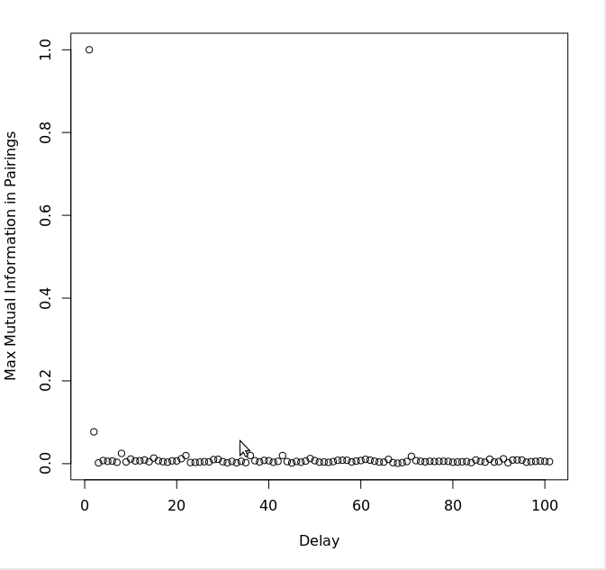
Graph (2)

The Active Information Storage (AIS) was calculated across the four variables for varying history lengths. In Graph (3), the information storage is plotted against the history length for which it is calculated.
- Blue = BI(BDO²(A)) ~ Addresses
- Green = BI(BDO(P)) ~ Price
- Purple = BI(BDO²(S)) ~ Supply
- Cyan = BI(BDO(T)) ~ Transactions
- Red = Empirical Bias

The AIS’ seem to follow the Empirical Bias implying that the variables behave as a random sampling, however in the lower histories (up to 5), the Supply seems to have more storage than the other variables do, confirming the MI result earlier where MI(BI(BDO²(S))_{t} ;BI(BDO²(S))_{t+1}) was 0.0768 bits. The amount of AIS difference between supply and the other variables do not change beyond the initial difference at History Length = 1.

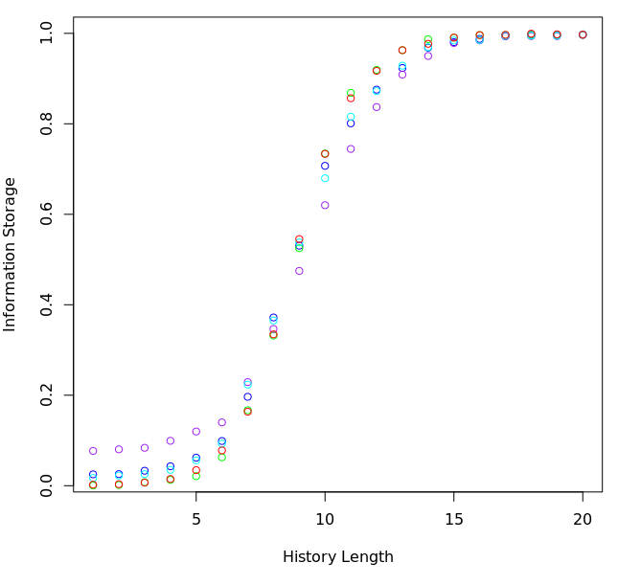
Graph (3)
The Transfer Entropies (TE) for different pairings were then mapped for various Source and Target history lengths. The data appeared to be consistent with the null hypothesis at every Target History Embedding Length and Source Embedded History Length ranging from (0,0) to (10,10) respectively. In Graph (4), the z axis represents the TE in bits, the y axis represents the Source Embedding History and the x axis represents the Target Embedding History. The graphs on the final row are of sample empirical bias estimates to compare the surface shape to other variables. Although only the Source = Price; Target = Addresses and Source = Price; Target = Supply are displayed here, the other combinations of variables at different delays showed almost identical results.

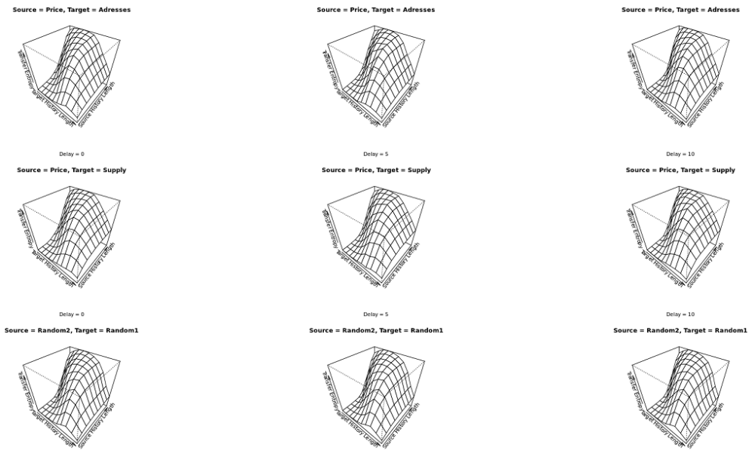
Graph (4)

The TE for the Source Embedding History = 1 and Source to Target Delay = 1 against the Target Embedding History were plotted in Graphs (5,6,7,8) to find the optimal Target Embedding History value and the comparison for each source variable onto the target variable. The trivial case where the Source to Target delay = 0 and the source and target variable were the same variable was also plotted for comparison, as was an empirical bias transfer entropy.

The colours of the source variable were as in graph (3):
- Blue = BI(BDO²(A)) ~ Addresses, Delay = 1
- Green = BI(BDO(P)) ~ Price, Delay =1
- Purple = BI(BDO²(S)) ~ Supply, Delay = 1
- Cyan = BI(BDO(T)) ~ Transactions, Delay =1
- Red = Empirical Bias
- Black = Trivial, Source to Target delay = 0, Source = Target
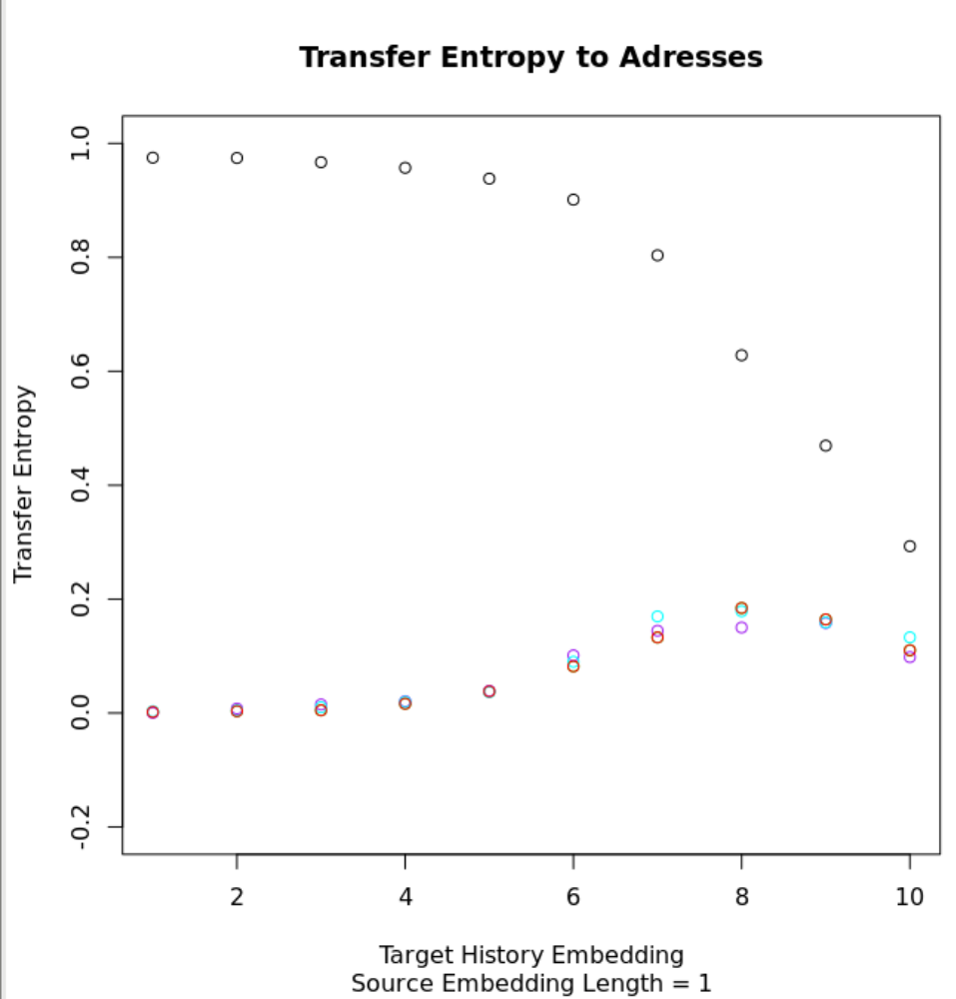
Graph(5)

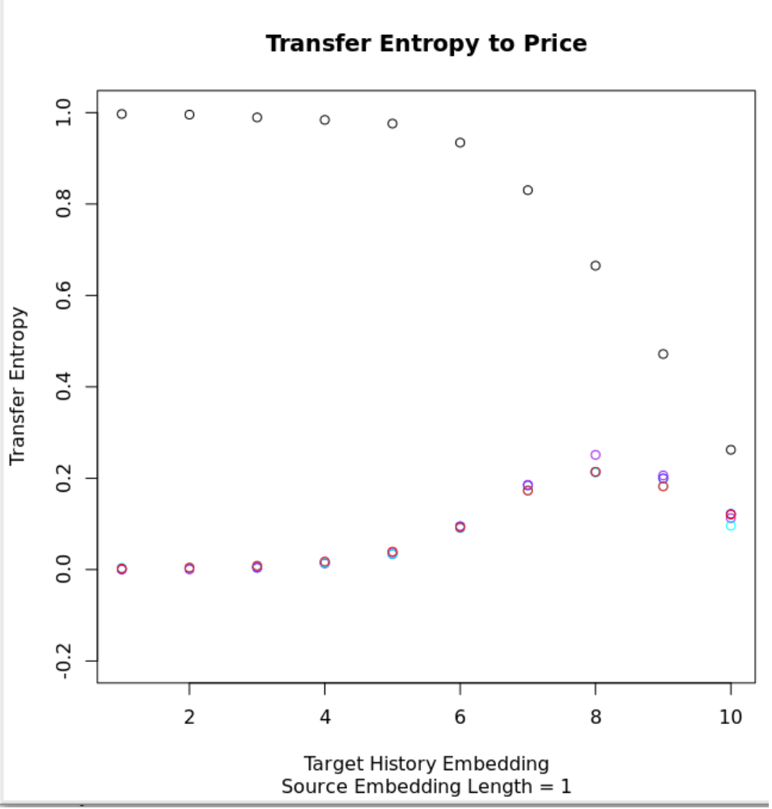
Graph (6)

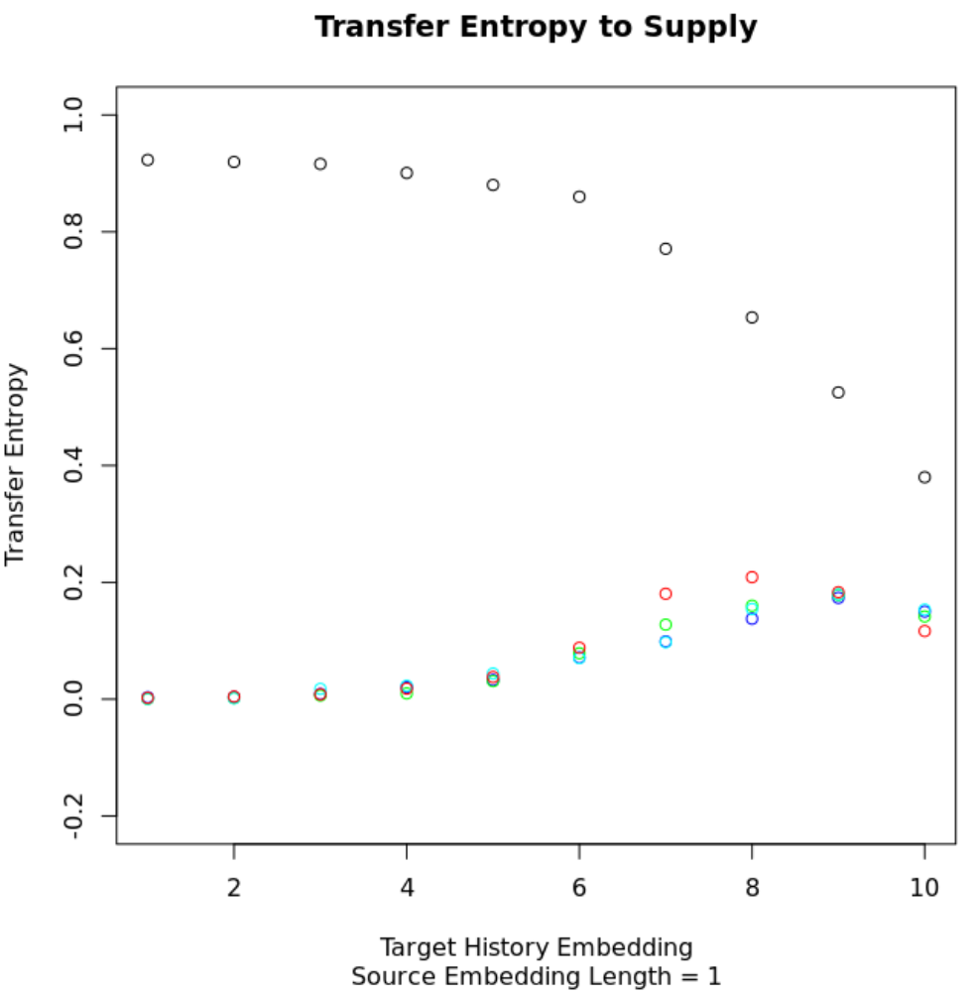
Graph(7)
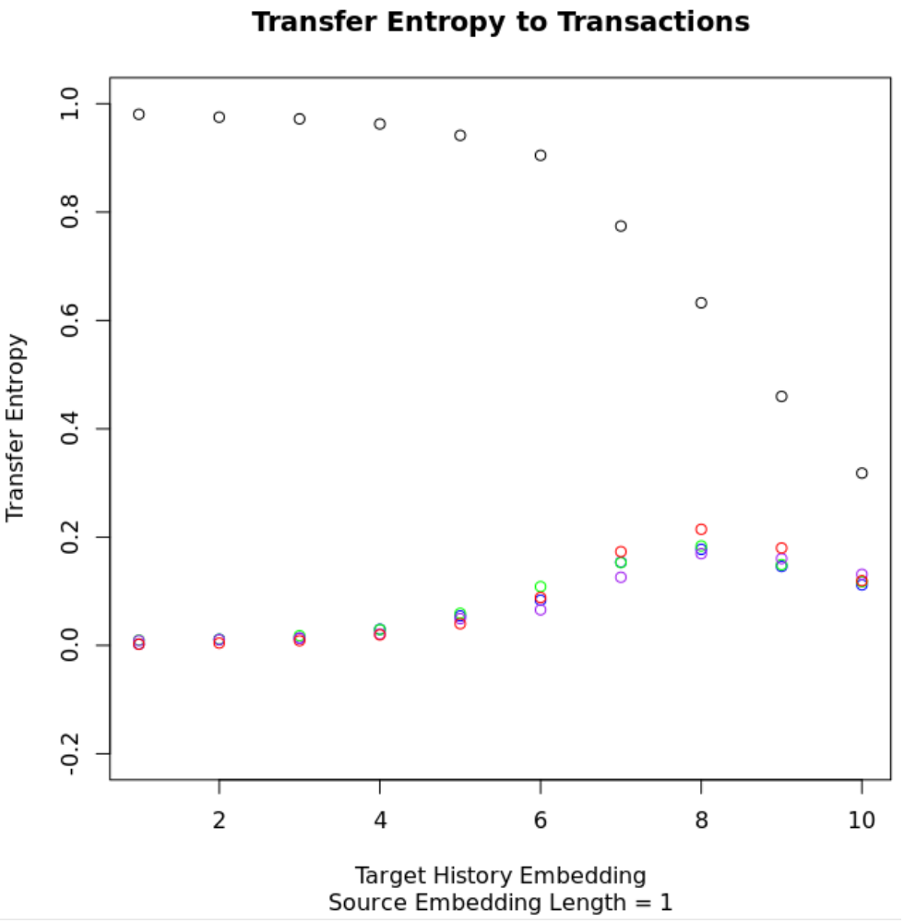
Graph(8)

Results

In the MI measure, the data does not seem to deviate from the Null Hypothesis that the data is uniformly and randomly distributed. The slight deviation from the empirically null case was MI(BI(BDO²(S))_{t} ;BI(BDO²(S))_{t+1}) was 0.0768 bits.

Because of this, the AIS revealed that at history lengths < 5, the BI(BDO²(S) diverges from the empirically null case, however converges at higher history lengths.

The TE does not deviate from the empirically null case, although the shape of the surfaces of both the null case appears to represent the underling bias in the TE Measure function.

The highest value for the Target Embedding History in the TE measure was 8 in all variables, including the empirical bias estimate. None of the variables deviate significantly from the bias estimate, although when Supply is the target, all transfer sources appear to fall below the bias at Target Embedding Histories around 6 and 7, which is consistent with the higher AIS values seen in the Supply.

Discussion

The results did not show any such inter-variable relationships, and little to no intra-variable structure. This was surprising as it was expected there would be social responses to the market that were able to be measured. There is also algorithmic correlation between transactions and supply and as such, it was expected that there would be mutual information between these, although that does not appear to be the case.

One reason the data may appear uncorrelated may be that the data was taken in daily intervals and significant results may be seen in both the more and less frequent interval case.

As Ethereum is a relatively new arrival in both the global market and within the cryptocurrency market, the results may indicate that all behaviour is random speculation as trends may not have had enough time to begin forming.

Comparing the Ethereum data to other markets, especially other cryptocurrency markets may yield significant correlation results.

Looking at the data only from the implementation of Ethereum 2.0, Homestead (day 230) may have given more appropriate results as the discontinuous change in dynamics may have been too large between the before and after, possibly making the results appear indistinguishable from a random sampling.

The binary analysis may also have hidden information and distributing the information around other transformations such as a proportional difference operator: X_{n+1}/X_{n} and then applied KSG estimators may have revealed more related results.

Appendix

Toolkit that was used:

Joseph T. Lizier, "JIDT: An information-theoretic toolkit for studying the dynamics of complex systems", Frontiers in Robotics and AI 1:11, 2014; doi:10.3389/frobt.2014.00011 (pre-print: arXiv:1408.3270)

rJava through and R functions used:

###Takes two data vectors and returns the mutual information between them

MutualInformationDiscrete = function(SourceData,TargetData,AlphabetSize,TimeDiff = 0){
library("rJava")
.jinit()
setwd("/home/think/Desktop/JIDT")
.jaddClassPath("infodynamics.jar")
miCalc = .jnew("infodynamics/measures/discrete/MutualInformationCalculatorDiscrete",as.integer(AlphabetSize),as.integer(TimeDiff))
.jcall(miCalc,"V","initialise")
.jcall(miCalc,"V","addObservations",SourceData,TargetData)
return(.jcall(miCalc,"D","computeAverageLocalOfObservations"))
}

###Takes a data set and returns a matrix of the mutual information between the collumns, requires MutualInformationDiscrete

MutualInformationDiscretePairings = function(DataFrame,AlphabetSize,TimeDiff = 0){
for(i in 1:ncol(DataFrame)){
PairingsCol = c()
for(j in 1:ncol(DataFrame)){
PairingsCol[[j]] = MutualInformationDiscrete(DataFrame[[i]],DataFrame[[j]],AlphabetSize,TimeDiff)
}
if(i == 1){
MIFrame = data.frame(PairingsCol)
}
else{
MIFrame[[i]] = PairingsCol
}
}
return(MIFrame)
}

###Takes a data vector and returns the information storage

ActiveInformationStorageDiscrete = function(StorageData,AlphabetSize,HistoryLength){
library("rJava")
.jinit()
setwd("/home/think/Desktop/JIDT")
.jaddClassPath("infodynamics.jar")
aisCalc = .jnew("infodynamics/measures/discrete/ActiveInformationCalculatorDiscrete",as.integer(AlphabetSize),as.integer(HistoryLength))
.jcall(aisCalc,"V","initialise")
.jcall(aisCalc,"V","addObservations",StorageData)
return(.jcall(aisCalc,"D","computeAverageLocalOfObservations"))
}

###Takes a data vector and returns the information storage for histories up until a certain length, requires “ActiveInformationStorageDiscrete”

InformationStorageHistories = function(StorageData,AlphabetSize,MaxHistory = 20){
AISHistories = c()
for (i in 1:MaxHistory){
AISHistories = c(AISHistories,ActiveInformationStorageDiscrete(StorageData,AlphabetSize,i))
}
return(AISHistories)
}

###Returns a vector of empirical bias estimators for active information storage for history lengths up until 20, requires “ActiveInformationStorageDiscrete”

AISBias = function(){
AISList = c()
for(i in 1:20){
PartialList = c()
for(j in 1:10){
PartialList = c(PartialList,ActiveInformationStorageDiscrete(as.integer(sample(c(0,1),670,replace = TRUE)),2,i))
}
AISList = c(AISList,mean(PartialList))
}
return(AISList)
}

###Takes a source and a target data and computes the transfer entropy from the source to the target

TransferEntropyDiscrete = function(SourceData,TargetData,AlphabetSize,SourceHistory,TargetHistory,SourceToTargetDelay,SourceDelay = 1,TargetDelay = 1){
library("rJava")
.jinit()
setwd("/home/think/Desktop/JIDT")
.jaddClassPath("infodynamics.jar")
teCalc = .jnew("infodynamics/measures/discrete/TransferEntropyCalculatorDiscrete",as.integer(AlphabetSize),as.integer(TargetHistory),as.integer(TargetDelay),as.integer(SourceHistory),as.integer(SourceDelay),as.integer(SourceToTargetDelay))
.jcall(teCalc,"V","initialise")
.jcall(teCalc,"V","addObservations",SourceData,TargetData)
return(.jcall(teCalc,"D","computeAverageLocalOfObservations"))
}

###Takes a source and target data and computes the transfer entropy between them, swept over a range of source and target embedding lengths, requires “TransferEntropyDiscrete”

TEHistoryDimensions = function(SourceData,TargetData,AlphabetSize,SourceHistoryRange,TargetHistoryRange,SourceToTargetDelay, SourceDelay = 1, TargetDelay = 1){
#Frame = data.frame()
for (i in 1:SourceHistoryRange){
TargetCol = c()
for(j in 1:TargetHistoryRange){
TargetCol = c(TargetCol,TransferEntropyDiscrete(SourceData,TargetData,AlphabetSize,i,j,SourceToTargetDelay,SourceDelay,TargetDelay))
}
if(i==1){
Frame = data.frame(TargetCol)
}
else {
Frame[[i]] = TargetCol
}
}
#persp(as.matrix(Frame), theta = 40, phi = 40)
if(SourceHistoryRange==1){
Set = c()
for(k in 1:TargetHistoryRange){
Set=c(Set,Frame[k,1])
}
ReturnVal = Set
}
else{
ReturnVal = Frame
}
return(ReturnVal)
}

###Returns a vector of emperical bias estimators for transfer entropy for target embedding lengths up until 10, source embedding length at 1 and source to target delay at 1

TEBias = function(){
TEList = c()
for(i in 1:10){
SingleEmbeddingLengthList = c()
for(j in 1:100){
SingleEmbeddingLengthList = c(SingleEmbeddingLengthList,TransferEntropyDiscrete(as.integer(sample(c(0,1),670,replace = TRUE)),as.integer(sample(c(0,1),670,replace = TRUE)),2,1,i,1))
}
TEList = c(TEList,mean(SingleEmbeddingLengthList))
}
return(TEList)
}

###

