Initial trajectory for both problems:

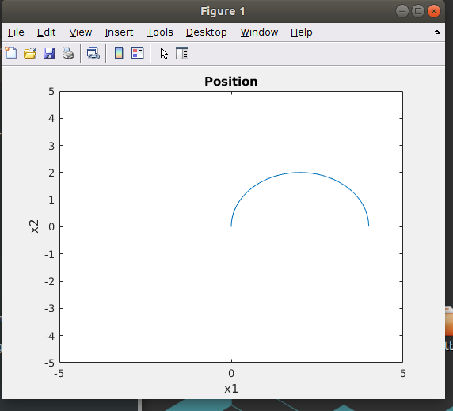

Problem 1:

Trajectory:
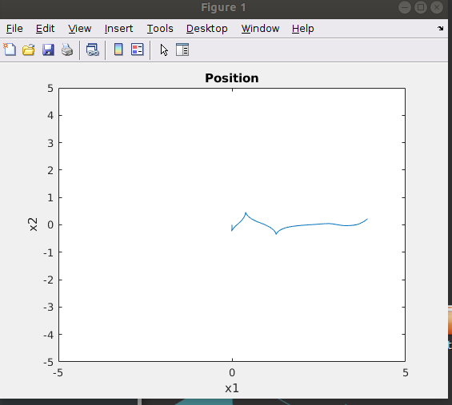

I think there is a bug in my code or in my specific implementation of the ILQR algorithm because of the early control actions followed by a lack of much changing control after that until getting to the end of the sequence.

Controls:

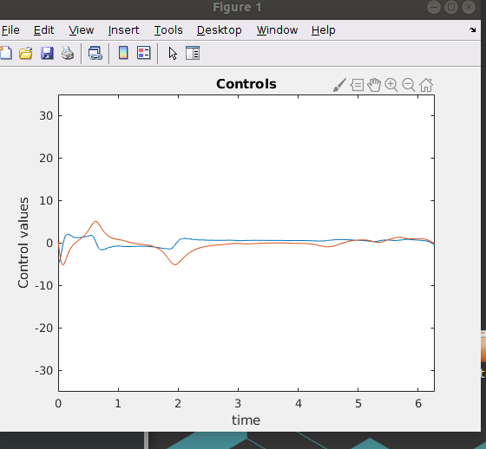

The controls look somewhat reasonable but quite what I would expect from ILQR. So that leads me to believe that I have one or more bugs in my implementation. However, the general behavior is close I think to the expected behavior.

Problem 2:

Trajectory 1:
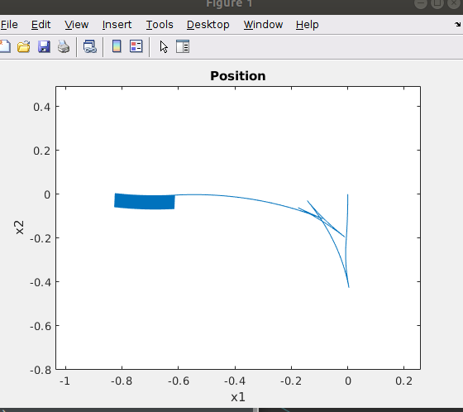
This is reminiscent of the desired behavior although misdirected. I suspect that I have several bugs in my code leading to the misdirection and the failure to reach the end-goal. The movements at the start are similar to those desired in SAC however.

Trajectory 1 controls:
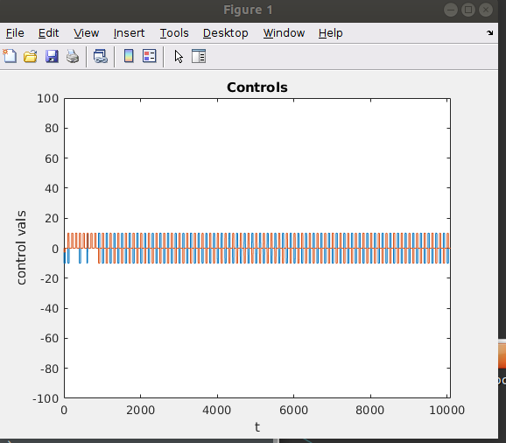

All of the controls here except at the very start are being saturated at a constant max and minimum.

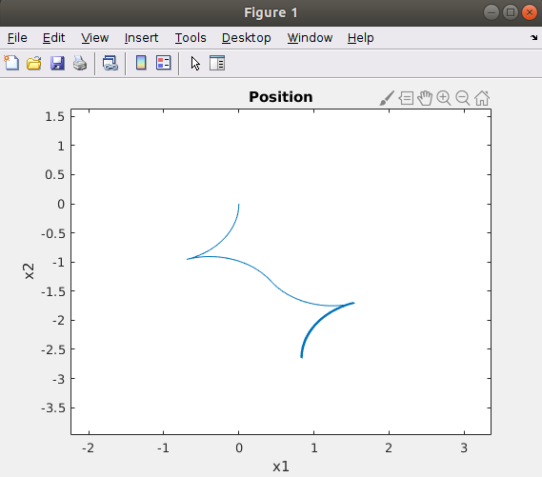
Trajectory2:

This is not the desired outcome, but it is reminiscent a misdirected desired trajectory. The controls are below.

Trajectory 2 controls:
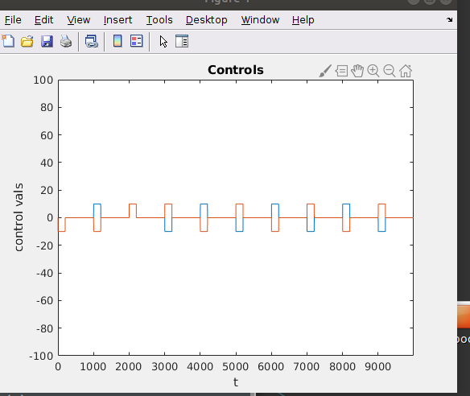

Fun trajectory from debugging:
