Active Learning HW 5 Ergodic Control and Exploration

1)

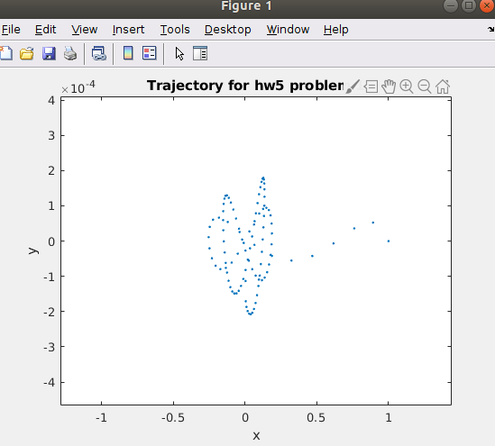
The distribution centered at (0,0) describes the information, so an ergodic trajectory will both explore and go toward higher information as t→infinity. This explains the looping we see. Also, note that although the top left scale says * 10^-4, that only applies to the y-axis. The x-axis is scaled appropriately, and the initial conditions are (1,0).

2)

