Mark Dyehouse
Active Learning
HW3

1)
Particle Filter
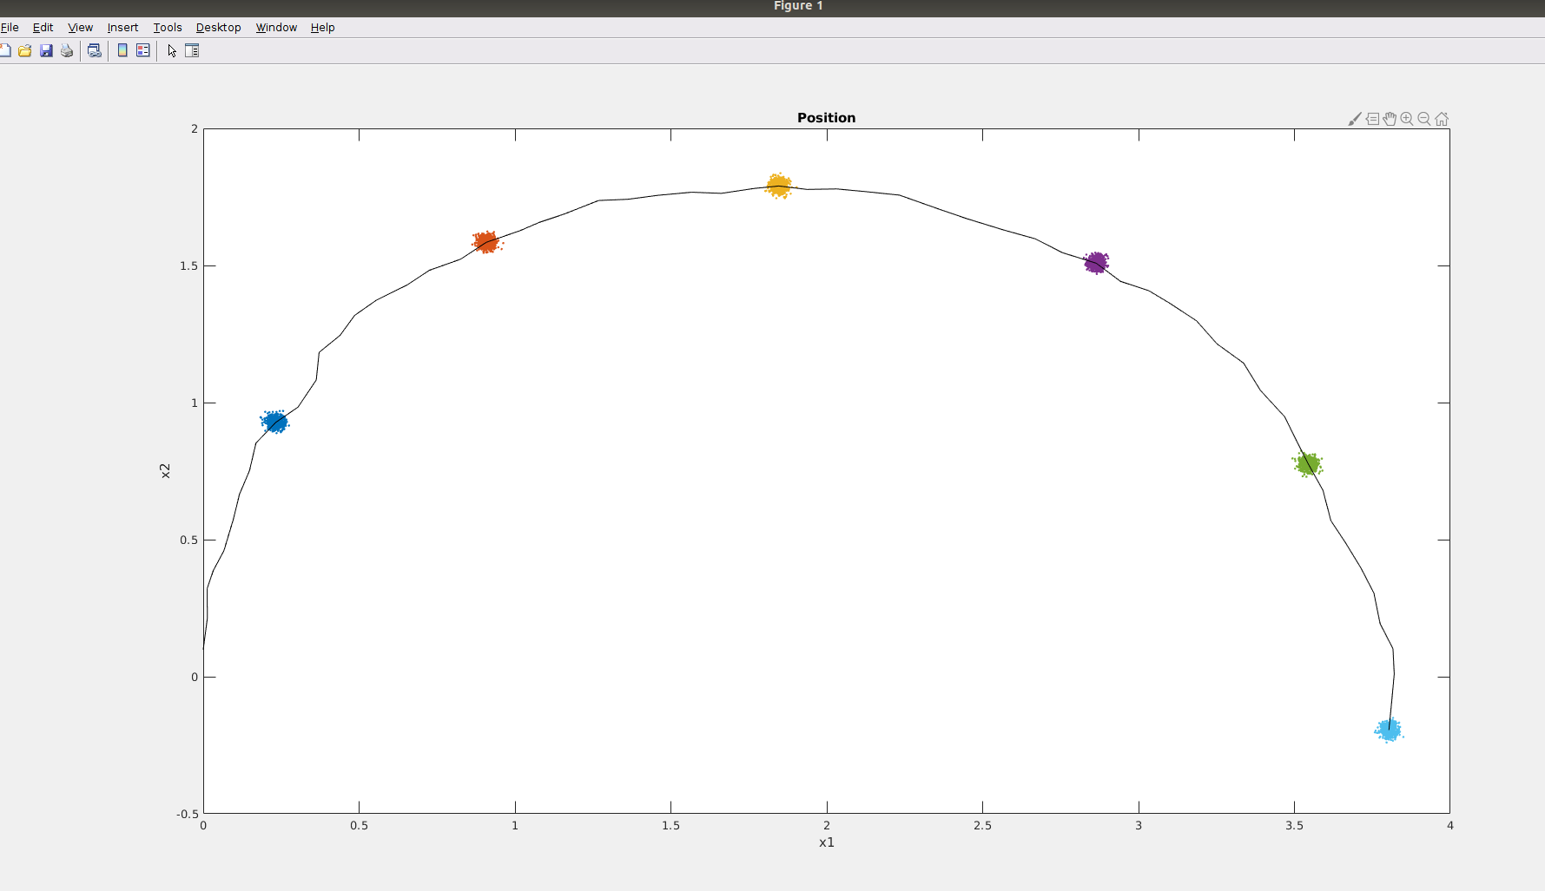

2) Kalman Filter
Trajectory:
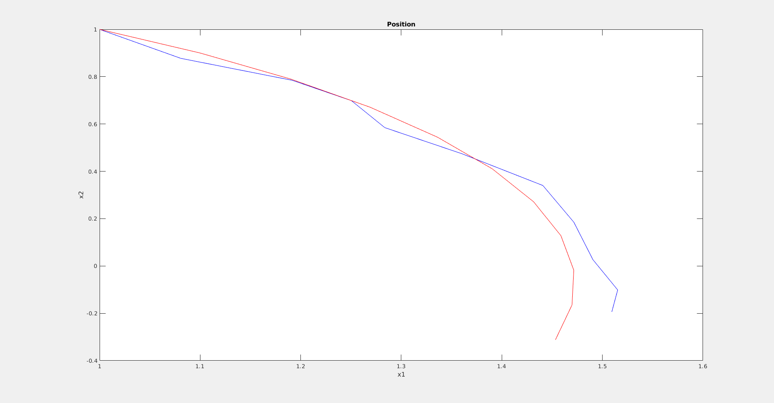
P_k_given_k-1:
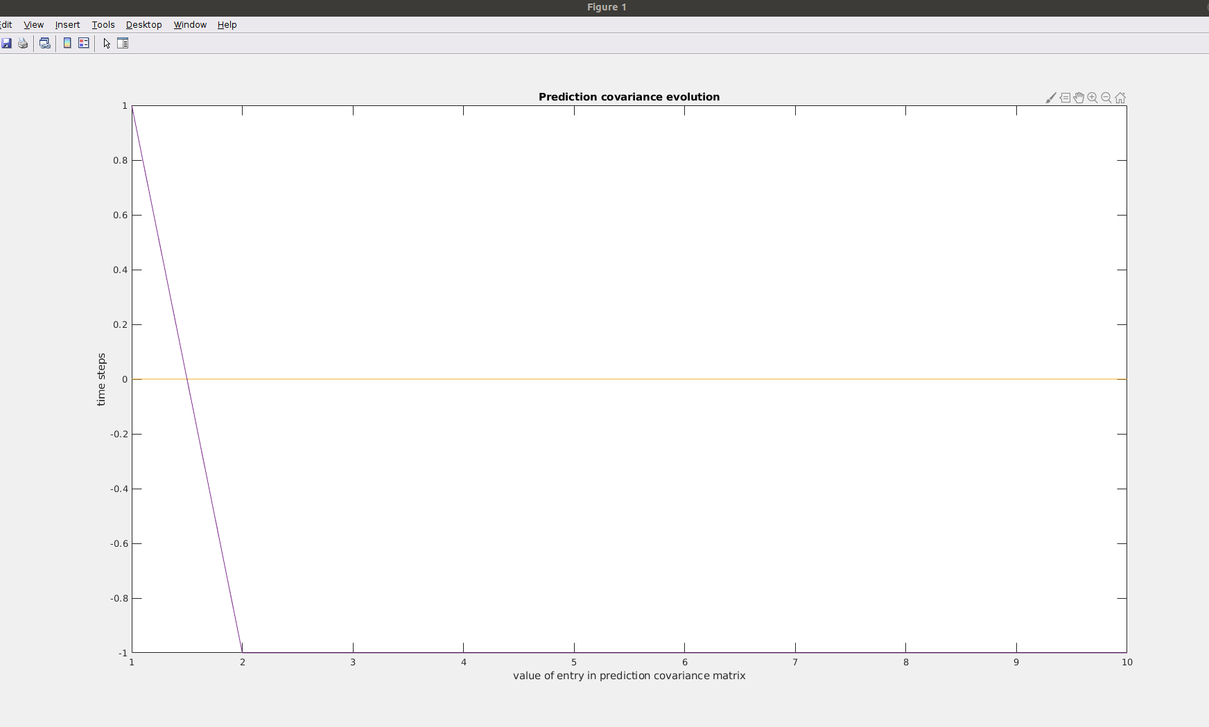

3)
Kalman Filter Optimality Comparison
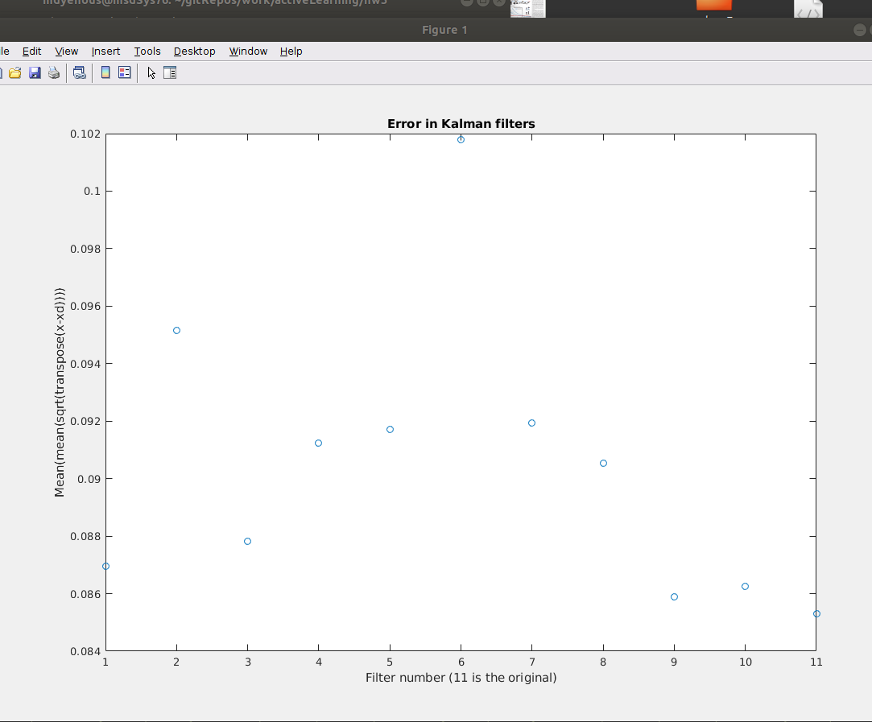
The original, unperturbed Kalman filter is at x=11 on the x-axis. It has the lowest resultant error represented by taking the averaged mean squared error for the filters over 100 trials compared with 10 perturbed (by a small amount) sets of K_k matrices.

