Mark Dyehouse
Active Learning HW4

1) ergodicity

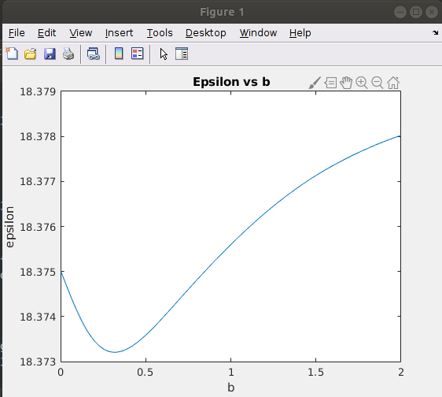
This shows a varying ergodic metric, epsilon, as the independent variable, b, changes. There is a clear minimized epsilon value here around 0.3 b value. Under additional variation of the time horizon, the optimal b value remained close to the same, but knowing that more ergodic behavior should arise as T goes to infinity leads me to question this result and think that I may have a bug in my code.

2)
infotaxis

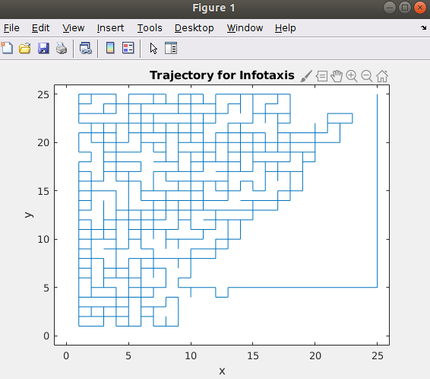

This is a buggy implementation that shows the trajectory reaching the door and then redirecting to go to the top right hand corner. I need to fix these bugs. I’ve narrowed down where they are, but I haven’t gotten to do it yet. The redirection is a bug in my controls. The rest of the bugs are in the way I am updating my posterior and prior values.

