Mark Dyehouse
Active Learning HW4

1) ergodicity

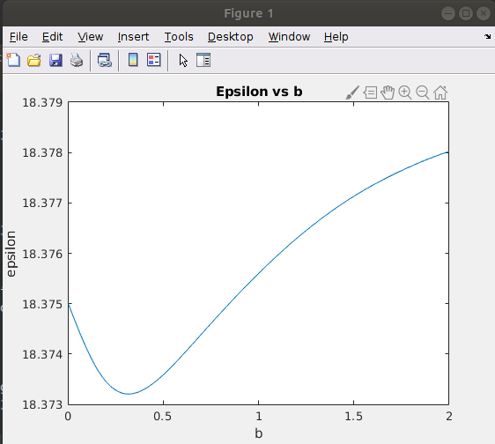
This shows a varying ergodic metric, epsilon, as the independent variable, b, changes. There is a clear minimized epsilon value here around 0.3 b value. Under additional variation of the time horizon, the optimal b value remained close to the same, but knowing that more ergodic behavior should arise as T goes to infinity leads me to question this result and think that I may have a bug in my code.

2)
infotaxis

Some strange behavior happens where my controls prefer vertical motion. This is partially due to a biased randomness in my direction selection. So fixing that would improve the randomness of the direction selection and provide more interesting space coverage.
